**Assignment : Create a Azure SQL database. Create a simple Spring Boot Application that can access this database, package it in a docker container and deploy it to azure app service. After successful deployment, delete all the resources.**

1. Create a Azure SQL data base with SQL authentication (refer to the recording)

2. Update the firewall rules of server so that you can connect to the database.

3. Create a table in newly created database by executing following query in query editor

CREATE TABLE EMPLOYEE (EMP_NAME VARCHAR(100), EMP_SAL INTEGER);

4. Take a note of the connection String for the DB

5. Download the project as a zip from <https://github.com/akshaytiwari0203/azure_learning> and extract it.

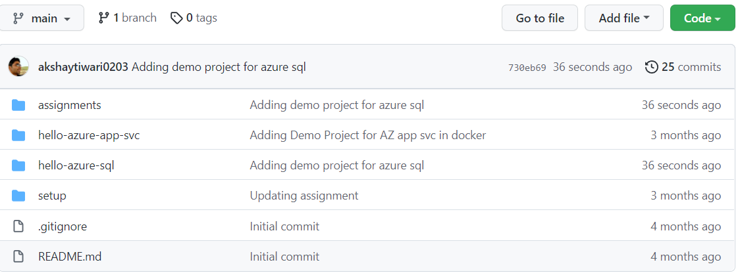

6. Copy the folder hello-azure-sql to a location where you would like to keep your code.

7. Import this folder as a maven project into eclipse.

8. Update the connection String in the EmployeeController. Change the connection string to have correct password.

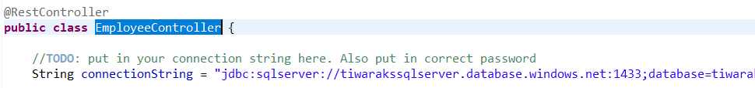

9. On the browser type the URL http://localhost:8080/create/mahendra/2000

This should give an error. Note the ip in the error message and add the ip to firwall rules of the server. Resubmit the same url

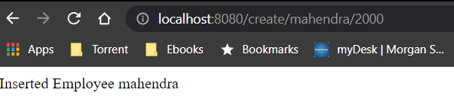

10. On the browser type the URL http://localhost:8080/get/mahendra

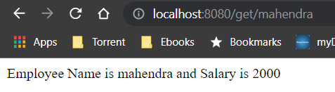

11. Open a command prompt and navigate inside the location where you copied hello-azure-sql

cd <base_path>\ hello-azure-app-svc

7. Build the project using maven

mvn clean install

8. Login to dockerhub

docker login

9. Build the docker image (note there is a . in the end of command.

docker build -t <docker_hub_user_name>/hello-azure-app-svc .

10. Check the image that you have created and note the imageid

docker images

11. Tag the image

docker tag <image_id> <docker_hub_user_name>/hello-azure-app-svc

12. Run the image locally

docker run -p 8080:8080 <docker_hub_user_name>/hello-azure-app-svc

13. On browser, navigate to <http://localhost:8080/><your_name> and check if out put is as expected

14. Execute following to identify the CONTAINER_ID of your container

docker ps

15. Stop the container

docker stop CONTAINER_ID

16. Push the image to docker hub.

docker push <docker_hub_user_name>/hello-azure-app-svc

17. Create an App service instance on Azure.

18. Explore various blades on azure portal for this app service

19. After verification delete the resource group