**Create a Git Hub Account**

1. Go to <https://github.com/>

2. Click on signup

3. Complete the signup process

**Install Git Kraken**

1. Go to <https://www.gitkraken.com/download>

2. Select the release as per your OS and download it.

3. Copy the .exe file downloaded to a convenient location.

4. Execute the .exe file to start the Git Kraken UI. The following screen will appear:

5. Click on Sign In with GitHub. A browser window as follows will appear.

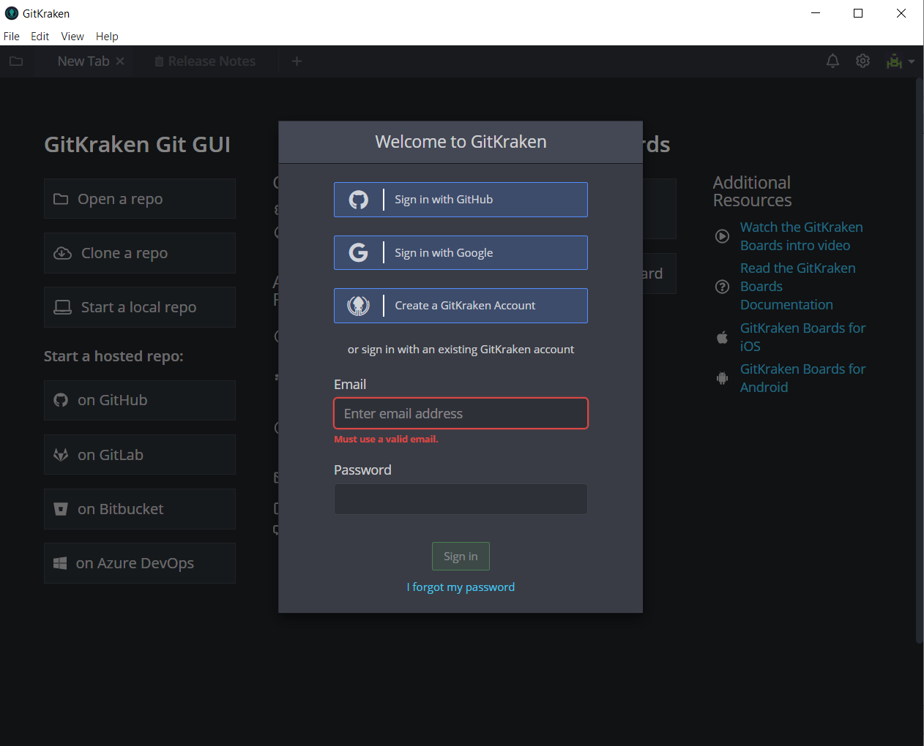

6. Click on Continue authorization.

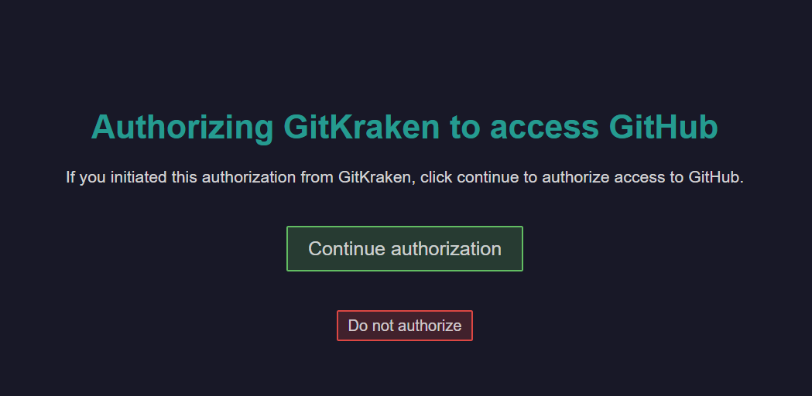

7. Enter username and password on next screen and a success message should appear.



8. Go back to git kraken and setup your profile

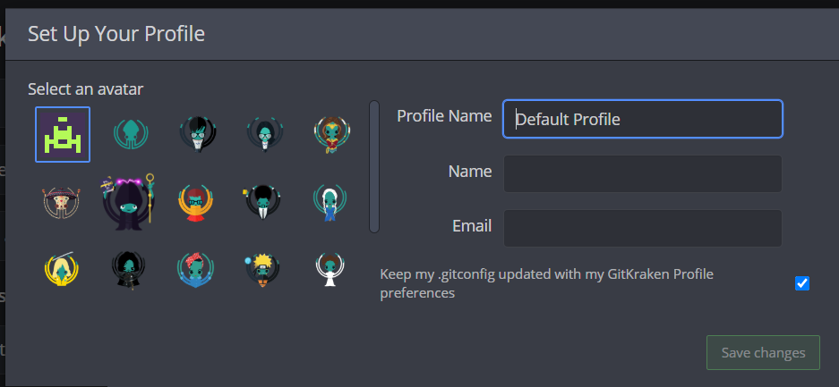

9. Start a new repo on git hub by clicking appropriate button on next screen.

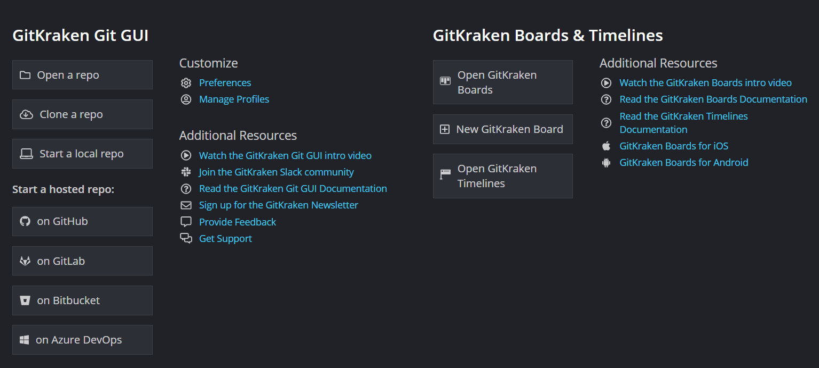

10. On the next screen fill up the values as follows. Please note your account will be different. You can also select other values as per your choice.

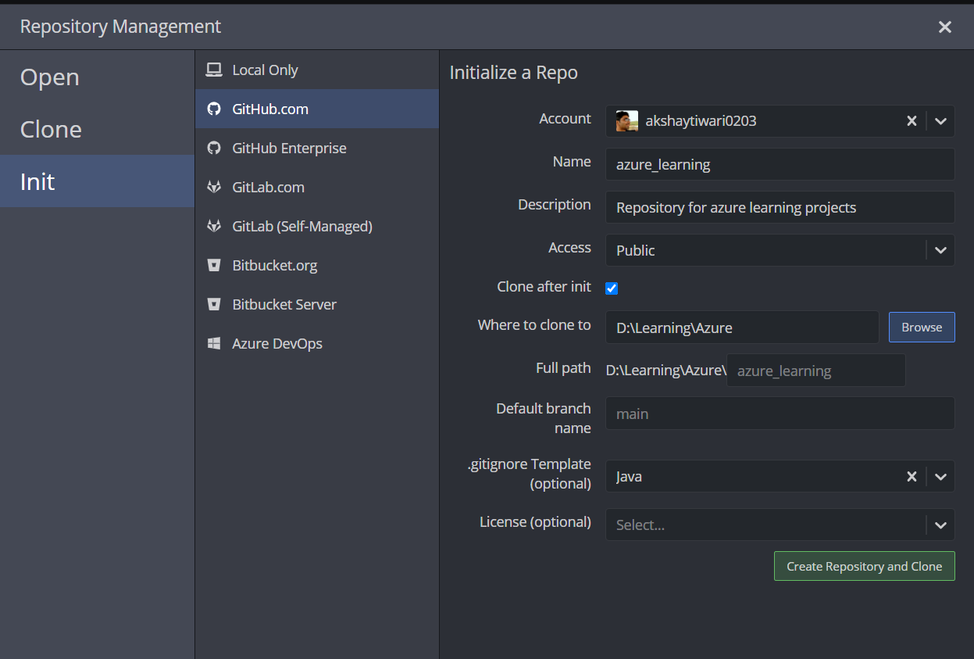

11. Your Repository will be created and you should land on a page as follows:

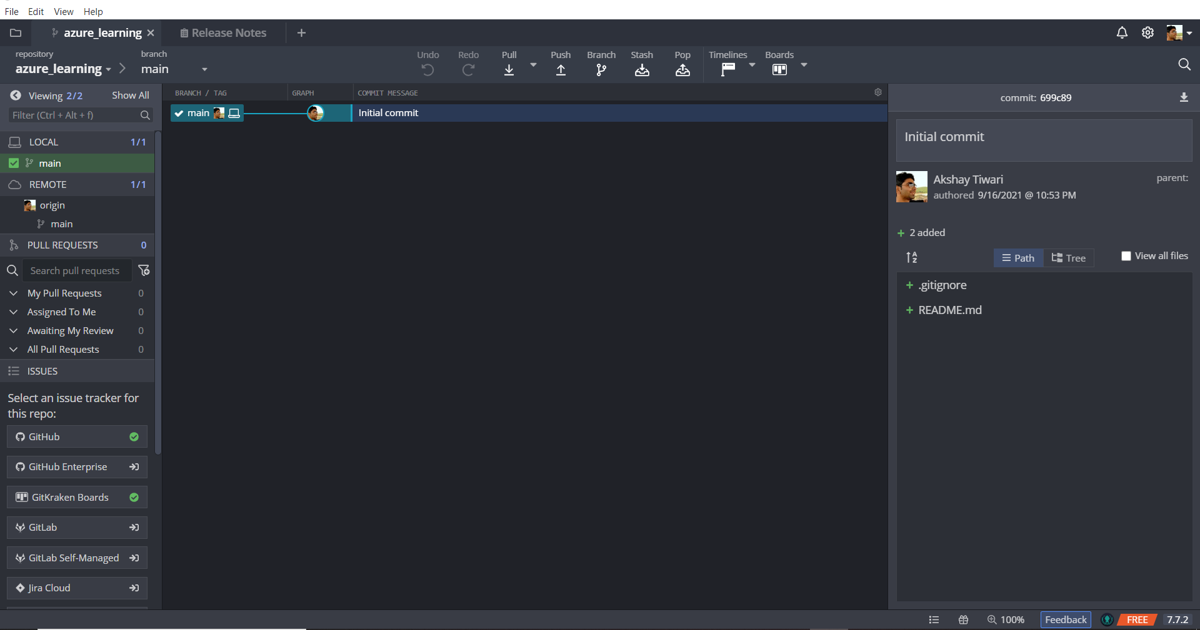

12. Click on Pull button to synch remote with local repo

13. Push the .gitigonre and README file by putting appropriate commit message and clicking Push button (You may have to force push first time)

**Install and Setup Eclipse**

1. Go to <https://www.eclipse.org/downloads/packages/>

2. Download “[Eclipse IDE for Enterprise Java and Web Developers](https://www.eclipse.org/downloads/packages/release/2021-09/r/eclipse-ide-enterprise-java-and-web-developers)” as per your OS. A zip file will be downloaded.

3. Extract the zip file into a location of your choice.

4. Go to the place where you extracted the Eclipse and double click eclipse.exe to launch eclipse. The following screen should appear.

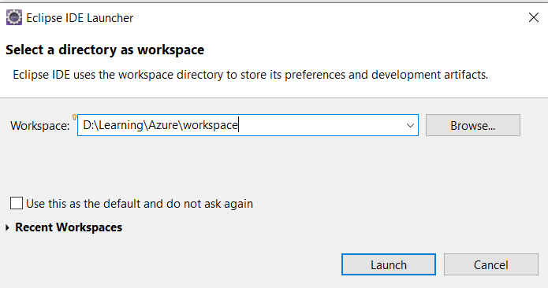

5. For the workspace, browse to a convenient location and click launch

6. Download settings.xml from <https://github.com/akshaytiwari0203/azure_learning/tree/main/setup> and place it at a convenient location. Open the file and search for tag <localRepository>. Modify the value of this tag to appropriate location. Your maven dependencies will be downloaded at this location so ensure you have few Gbs (around 5) of unused space on this drive.

7. In eclipse, go to Windows>Preferences>Maven>User Settings

8. In Global Settings, browse to location of settings.xml and select it. Do the same for User Settings. Make sure Local Repository is of your choice.

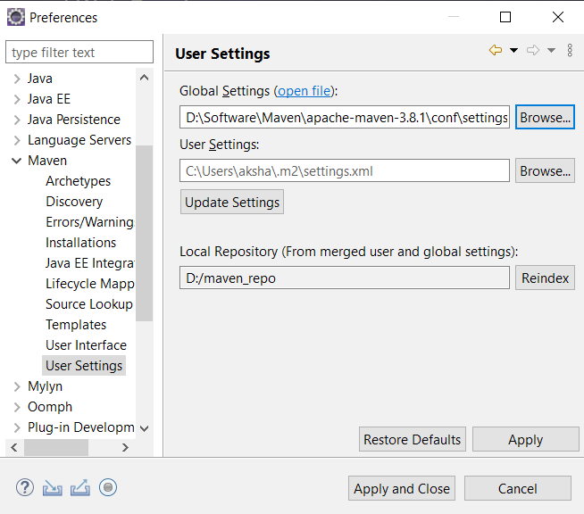

9. Click Apply and Close

**Setting Up Project In Eclipse**

1. Download the project as a zip from <https://github.com/akshaytiwari0203/azure_learning>and extract it.

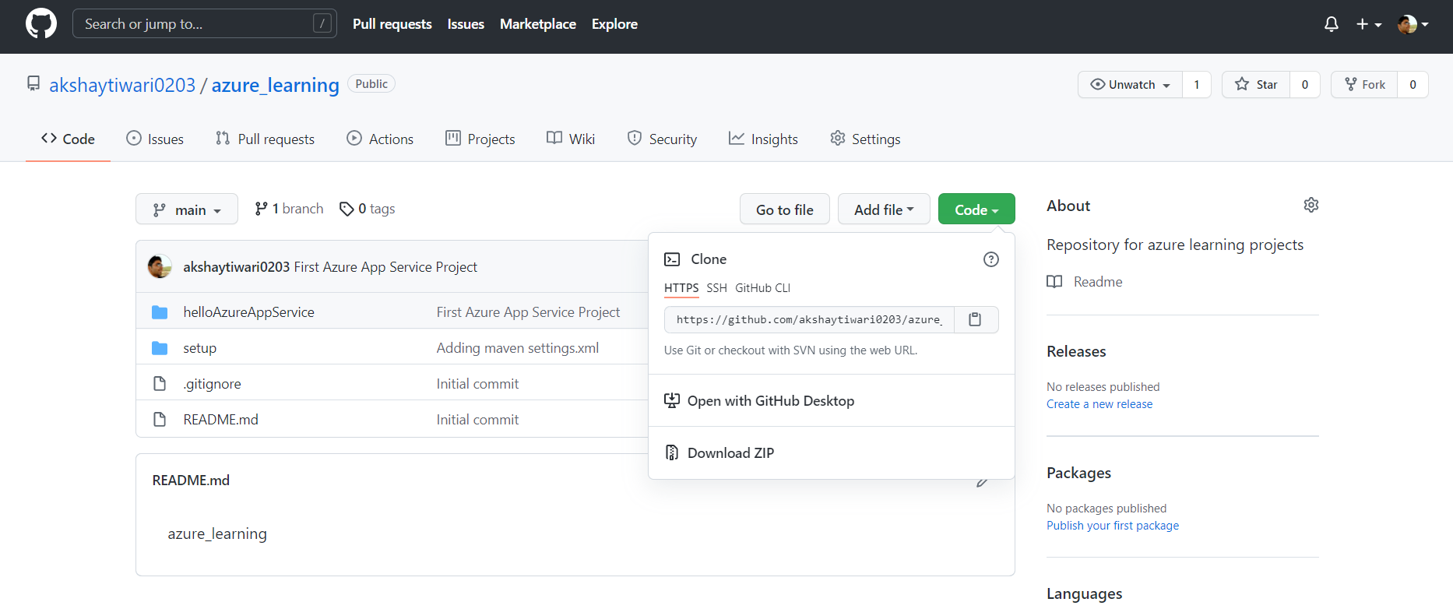

2. Copy the folder helloAzureAppService to your local git repository.

3. Import this folder as a maven project into eclipse.

4. Once project is built, run the project as a java application.

5. Go to the browser and type url http://localhost:8080/Akshay

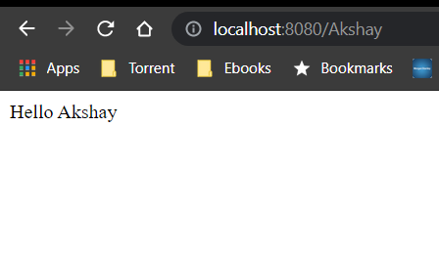

**Push the project to GitHub**

1. Go to your Git Kraken UI, you should see a screen as follows

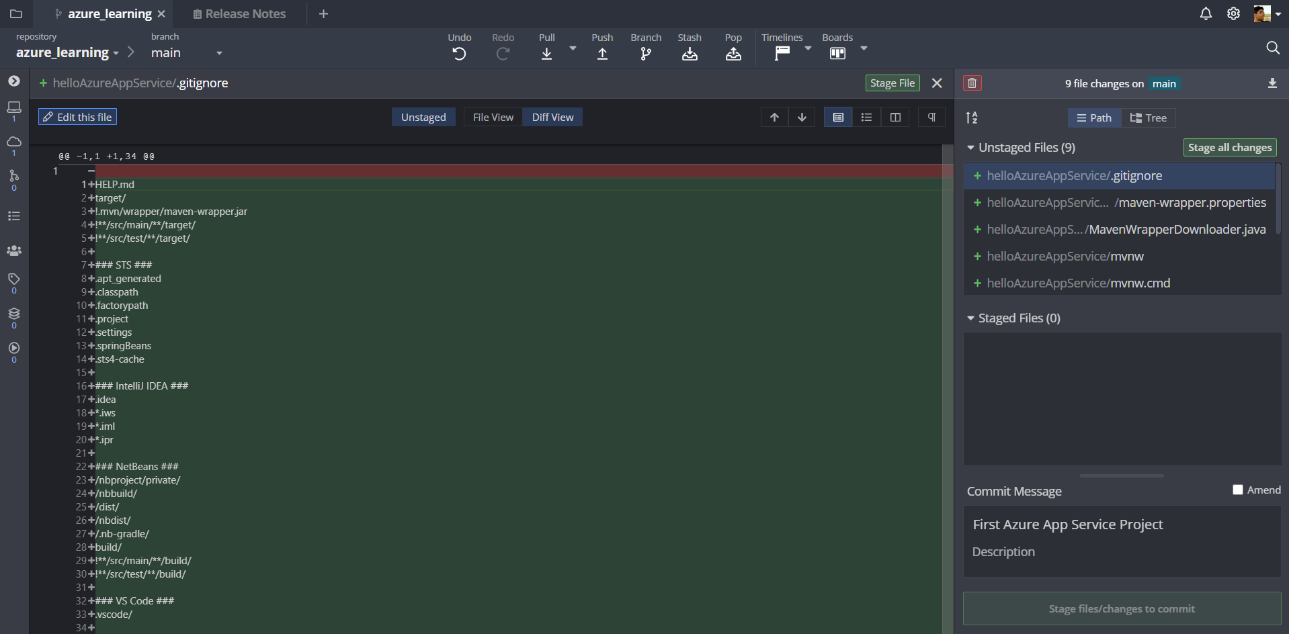

2. Click on Stage All changes.

3. Enter a commit message and commit.

4. Push the changes to remote