**Assignment : Create a simple Spring Boot Application, package it in a docker container.**

1. Download the project as a zip from https://github.com/akshaytiwari0203/docker/tree/main and extract it.

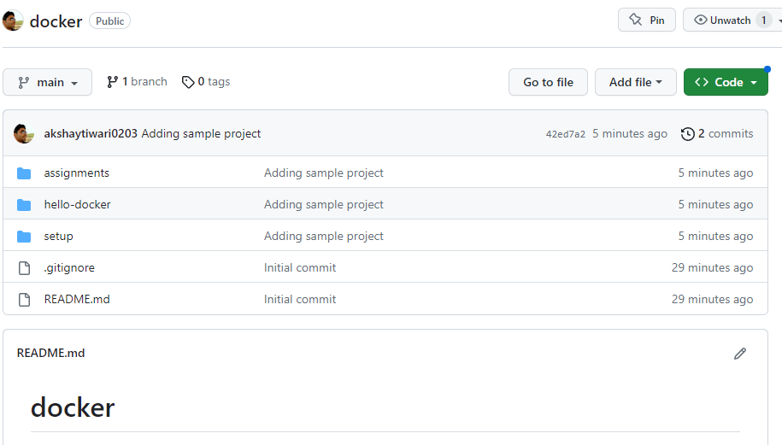

2. Copy the folder hello-docker to a location where you would like to keep your code.

3. Import this folder as a maven project into eclipse.

4. Once project is built, run the project as a java application.

5. Go to the browser and type url http://localhost:9091/akshay

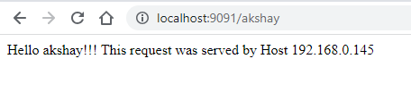

6. Open a command prompt and navigate inside the location where you copied hello-docker

cd <base_path>\ hello-docker

7. Build the project using maven

mvn clean install

8. Execute following command and verify their are no images on your machine

docker images

9. Build the docker image (note there is a . in the end of command.

docker build -t <docker_hub_user_name>/hello-docker .

10. Check the image that you have created and note the imageid

docker images

11. Run the image locally

docker run -p 8080:9091 <docker_hub_user_name>/hello-docker

13. On browser, navigate to <http://localhost:8080/><your_name> and check if out put is as expected

**Execute following on different terminal**

14. Execute following to identify the CONTAINER_ID of your container

docker ps

15. Stop the container

docker stop CONTAINER_ID

16. Execute following to and verify no containers are running

docker ps

17. login to docker hub

docker login

18. Push the image to docker hub.

docker push <docker_hub_user_name>/hello-docker

19. Remove the local image (this should fail)

docker rmi <image_id>

20. See the stopped containers

docker ps -a

21. Remove the containers

docker rm CONTAINER_ID

22. Remove all the images

docker rmi <imageId1> <imageId2>