**Install and Configure Java**

1. Go to https://www.oracle.com/in/java/technologies/downloads/#jdk17-windows

2. Click on x64 Installer.

3. Execute the .exe thus downloaded

4. Install the Java to your location of choice. Also note where it is installed.

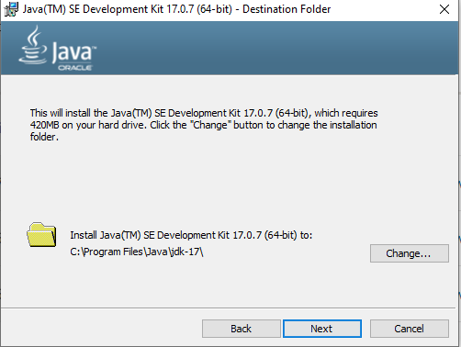

5. Choose the location where you want to install Java and make a note of it.

6. Setup an environment variable JAVA_HOME

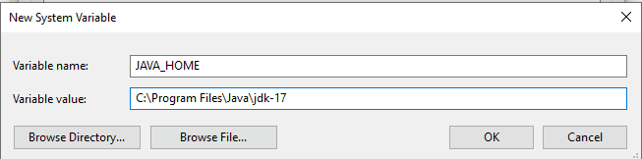

8. Add JAVA_HOME\bin to path as follows

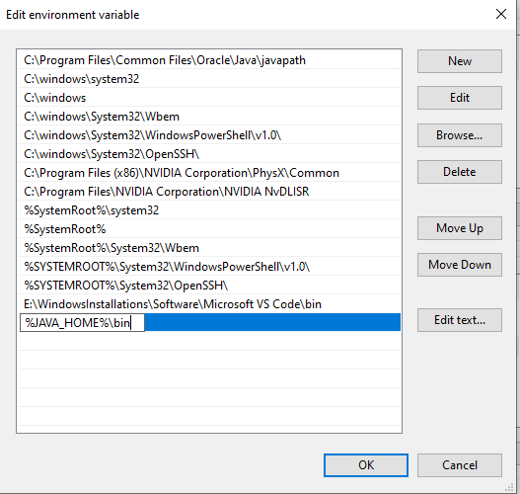

9. Click OK on all the dialog boxes. Open a command window and execute java -version. You should get output as follows.

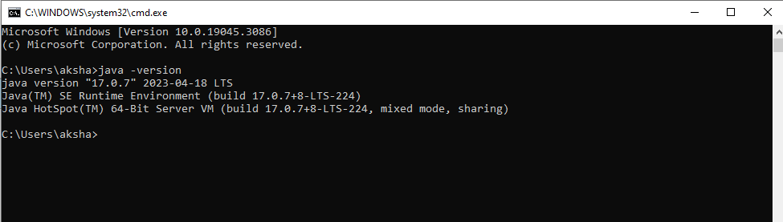

**Install and configure Maven**

1. https://maven.apache.org/download.cgi

2. Click on [apache-maven-3.8.2-bin.zip](https://dlcdn.apache.org/maven/maven-3/3.8.2/binaries/apache-maven-3.8.2-bin.zip)

3. Extract the zip file thus downloaded to a location of your choice and note it.

4. Add a new environment variable MAVEN_HOME as follows

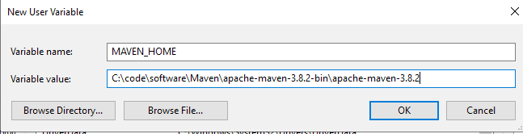

5. Add MAVEN_HOME\bin to path as follows

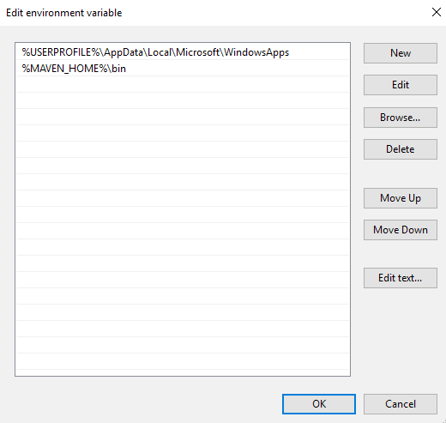

6. Open a new command window and execute mvn -version. You should see an output as follows.

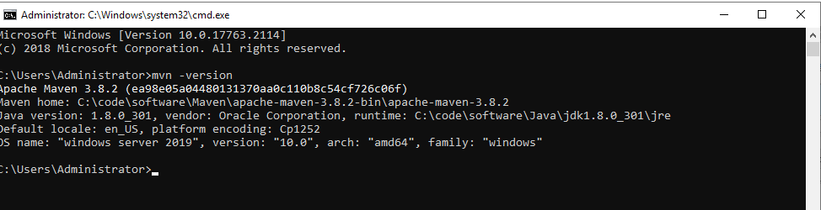

7. Download settings.xml from https://github.com/akshaytiwari0203/docker/tree/main/setup

8. Replace the settings.xml in MAVEN_HOME\conf with the one that is downloaded in step 7.

9. Open the file and search for tag <localRepository>. Modify the value of this tag to appropriate location. Your maven dependencies will be downloaded at this location.

**Install and Setup Eclipse**

1. Go to <https://www.eclipse.org/downloads/packages/>

2. Download “[Eclipse IDE for Enterprise Java and Web Developers](https://www.eclipse.org/downloads/packages/release/2021-09/r/eclipse-ide-enterprise-java-and-web-developers)” as per your OS. A zip file will be downloaded.

3. Extract the zip file into a location of your choice.

4. Go to the place where you extracted the Eclipse and double click eclipse.exe to launch eclipse. The following screen should appear.

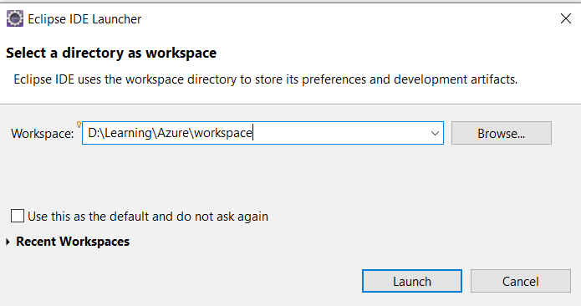

5. For the workspace, browse to a convenient location and click launch

6. In eclipse, go to Windows>Preferences>Maven>User Settings

7. In Global Settings, browse to location of MAVEN_HOME\conf\settings.xml and select it. Do the same for User Settings. Make sure Local Repository is of your choice.

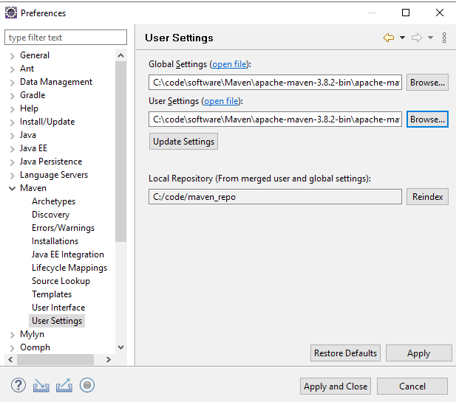

9. Click Apply and Close

**Create a Docker Hub Account**

Follow the instructions as in https://www.youtube.com/watch?v=ty91qhd7L24