AKSHAY TOPARE

Updated on 11/17/2021  Capstone Project

Cyclistic trip data analysis

**Business Task**

Design marketing strategies aimed at converting casual riders into annual members.

**Ask**

Three questions will guide the future marketing program:

1. How do annual members and casual riders use Cyclistic bikes differently?

2. Why would casual riders buy Cyclistic annual memberships?

3. How can Cyclistic use digital media to influence casual riders to become members?

**Findings**

1. How do annual members and casual riders use Cyclistic bikes differently?

1. Annual members contribute large number of rides during and at the end of the week. But number of rides drops significantly on Saturdays and Sundays. As we can see in plot 1.

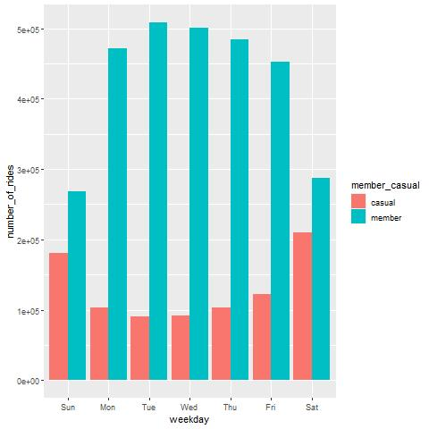

**Plot 1**

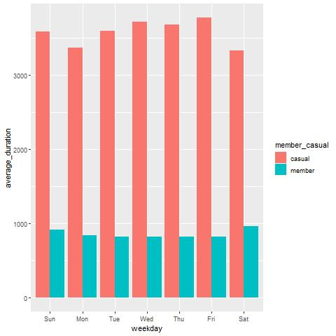

**Plot 2**

1. Annual members average ride length is very less as compare to casual riders as we can see in plot 2.
2. On the other hands Casual members travel for larger duration than annual members.
3. Number of rides of casual riders is significantly less than members.
4. Most probably casual riders travel larger distance than members.
5. Casual riders took large number of rides for long duration on Saturdays and Sundays which is unique as compare to members.

**Inference**

2. Why would casual riders buy Cyclistic annual memberships?

1. Casual riders travel for larger duration than members.
2. Casual riders took large number of rides for long duration on Saturdays and Sundays which is unique as compare to members.
3. Cyclistic could provide tailored annual membership for such riders which will save their extra spending.

**Recommendations**

3. How can Cyclistic use digital media to influence casual riders to become members?

1. Casual rider rides for larger duration, that means they usually travel larger distance as compare to members, so Cyclistic could provide such casual riders a specific plan for such large distance rides like discounts on every incremental mile.
2. Cyclistic could share these interesting findings with the casual riders and promote this specific membership plans by sending emails after completion of a ride.
3. Cyclistic could promote these membership plans by putting ads on local radio, because we are assuming as casual riders are riding for large duration, they might be listening local radios for entertainment.
4. Cyclistic could use social media sites like Facebook, Twitter, Spotify and Instagram to reach out to potential casual riders and promote the ads regarding the plans.
5. Cyclistic could also conduct the feedback on its riding application about how does the riders feel about the new specific plans.
6. Cyclistic could also provide weekend discounts to members so that casual riders could get attracted towards these plans as they took maximum number of rides on Saturdays and Sundays and also traveled for large duration.