1. Here cd ~/lenovo means change directory to a directory called ‘lenovo’ in the home diectory.
cd ~lenovo means change directory to a directory called ‘~lenovo’ in the current diectory.
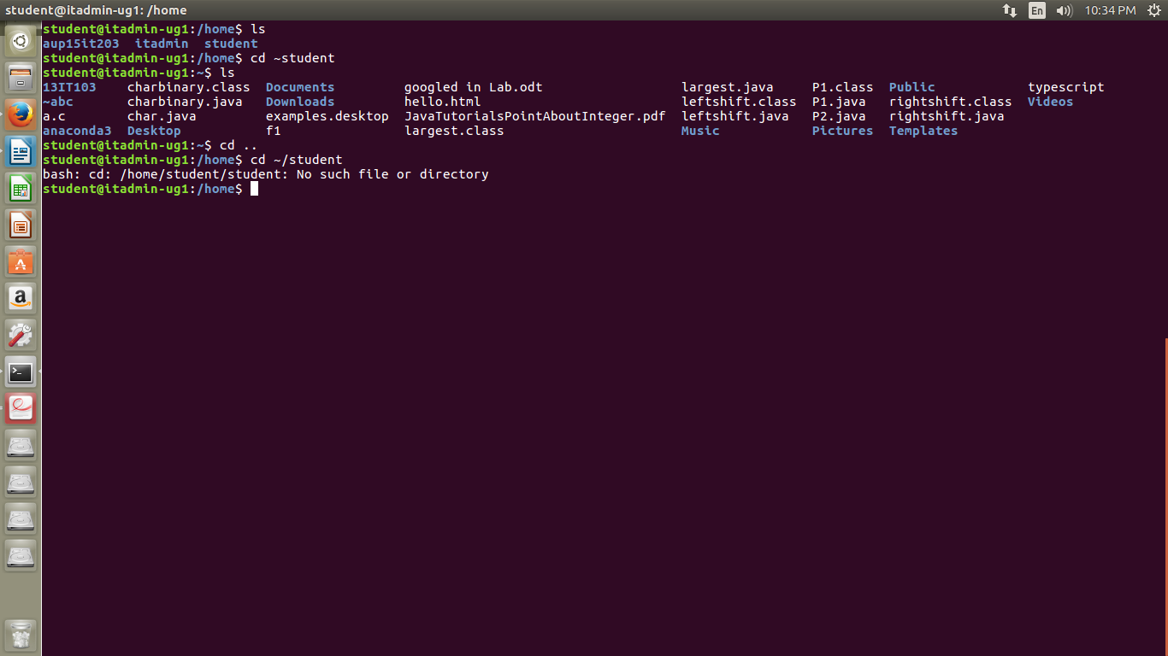

2.
we use the command $ cp -r dir1 dir2
to copy everything including the sub directories (here -r stands for recursive copying of directories)

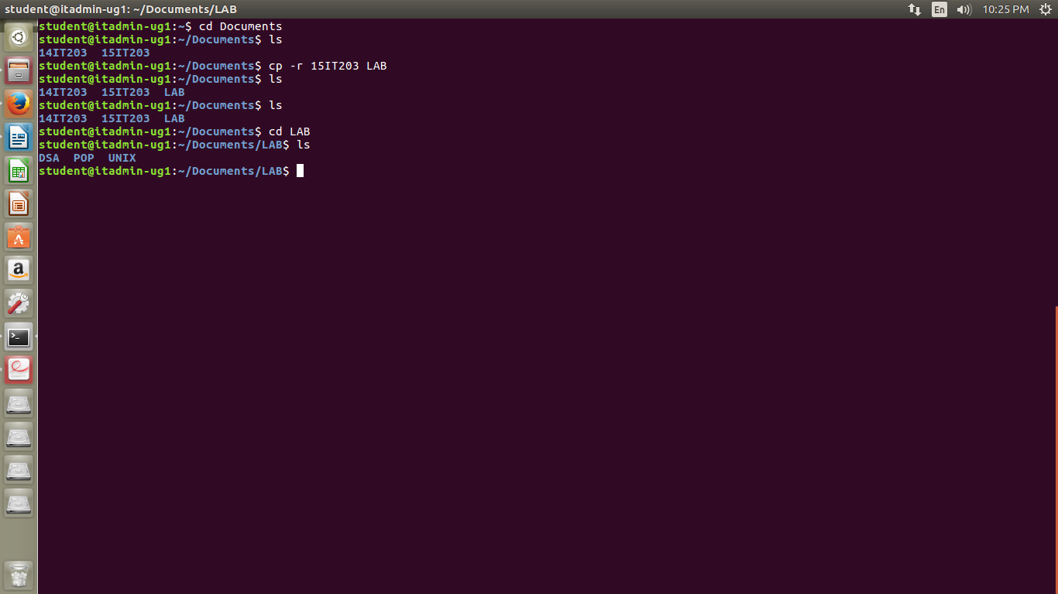

3.
to see the permissions of the file we use ls -l
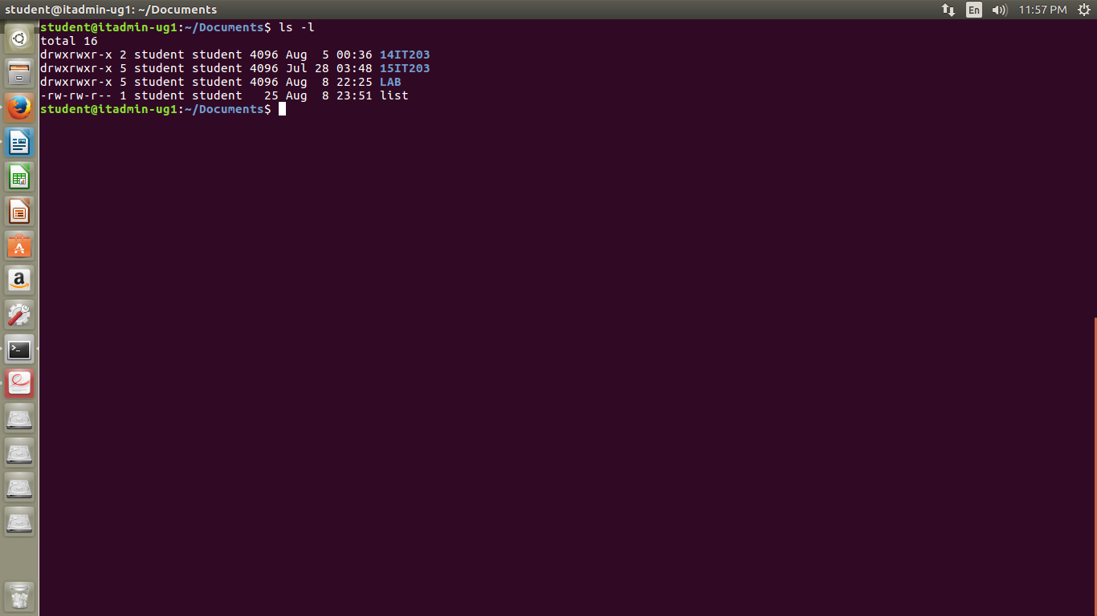

4.to get the size of the directory we use the command
$ du -h -b <directoryName>
if we use only $ du -h <directoryName> we get the directory size in kilobytes
here -h stands for human readable language
-b stands for printing the size of the directory in bytes
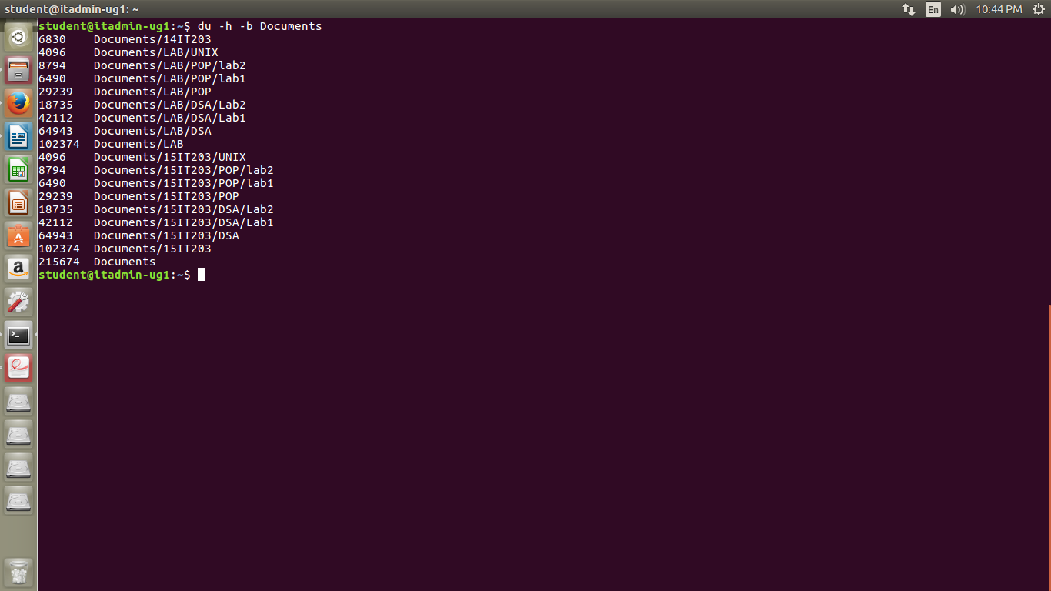

5.for 24 hour format we use %R, for 12 hour format we use %r as format strings
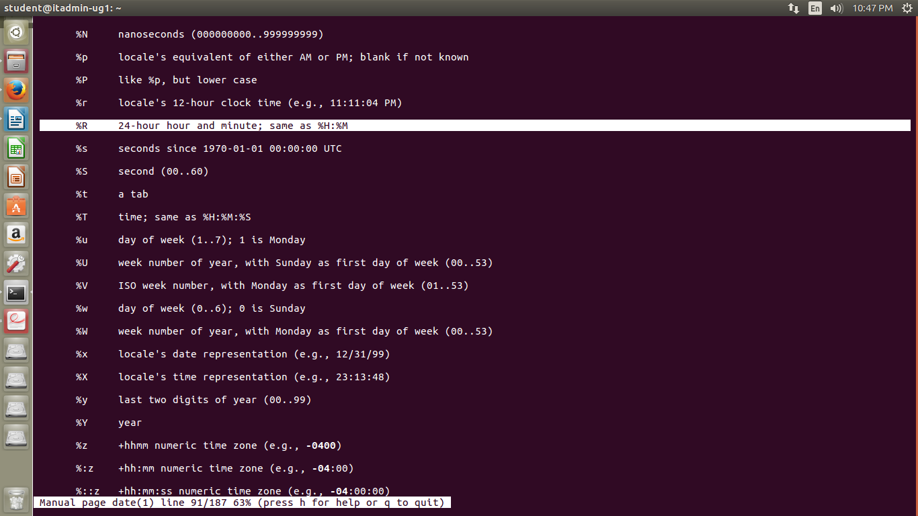

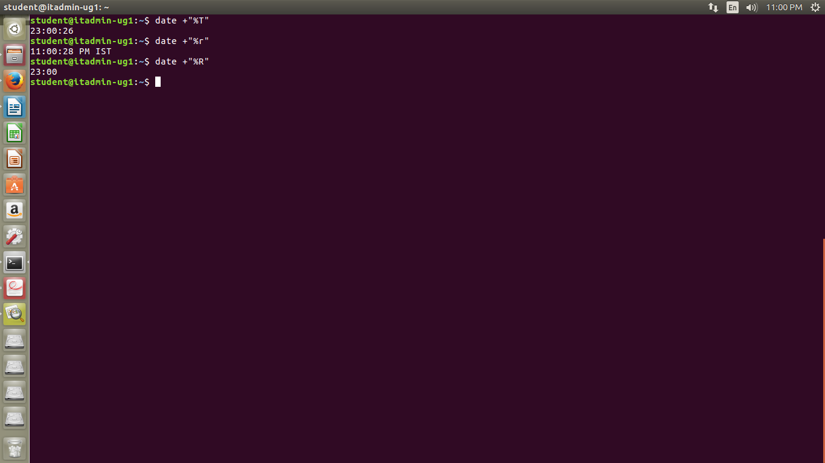
6.
for printing year, month ,date seperated by spaces we use %y for year %m for month and %d for day with $’\t’ inbetween them so that they get seperated by a tab

$ date +”%y”$’\t’”%m”$’\t’”%d”

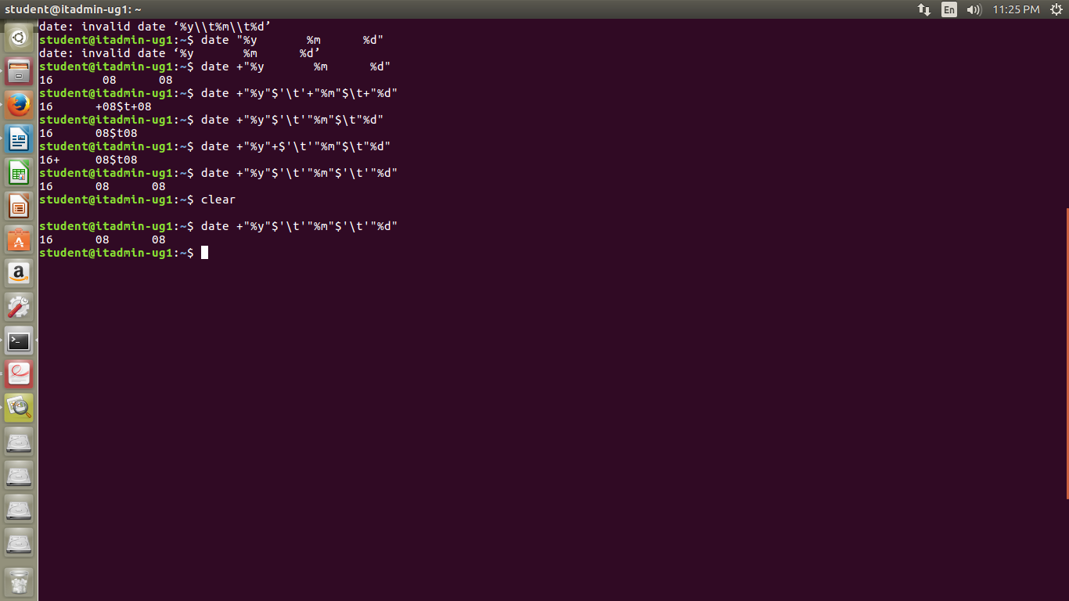

7.
we use ps -e to get the status of all the processes running on the
system

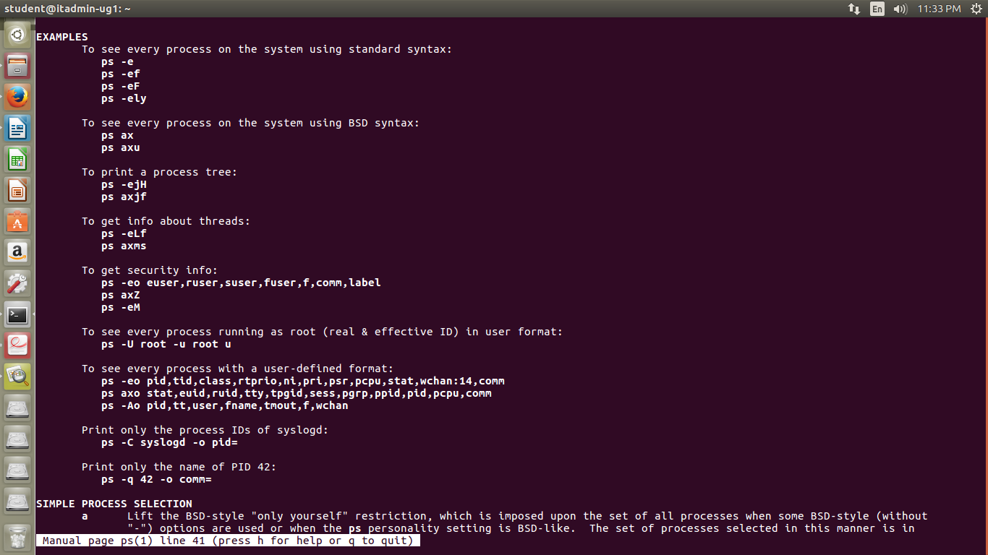

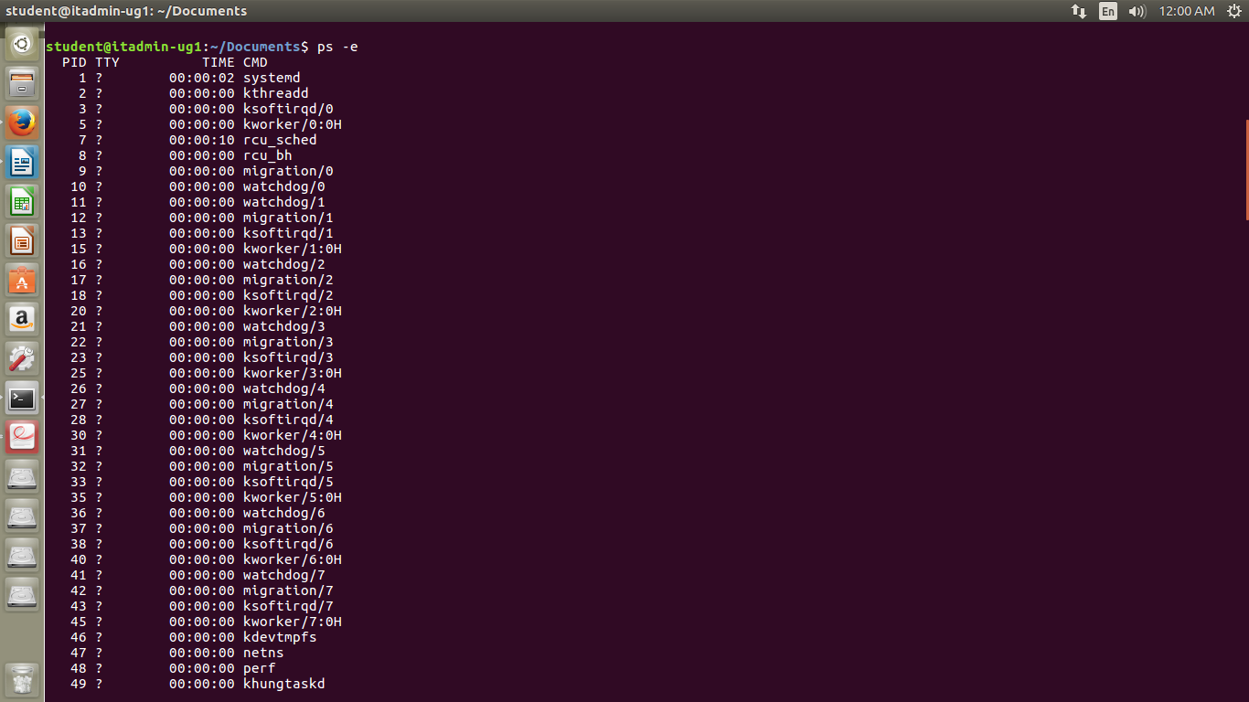

8.
echo * -lists all the files and directories in the current directory without any highlighting the type of files and directories.
-prints * if there is nothing in the current directory
ls -lists directory contents

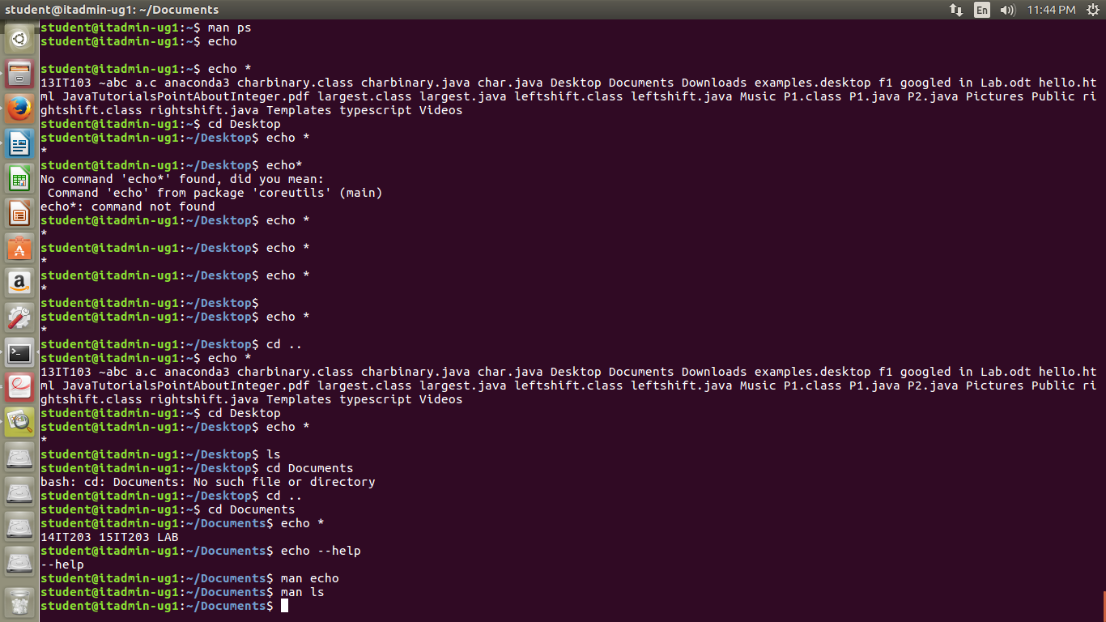

9.
echo '$SHELL' took $SHELL as a string and echoed the same thing
whereas echo "$SHELL" shows the location of the Shell i.e (/bin/bash)

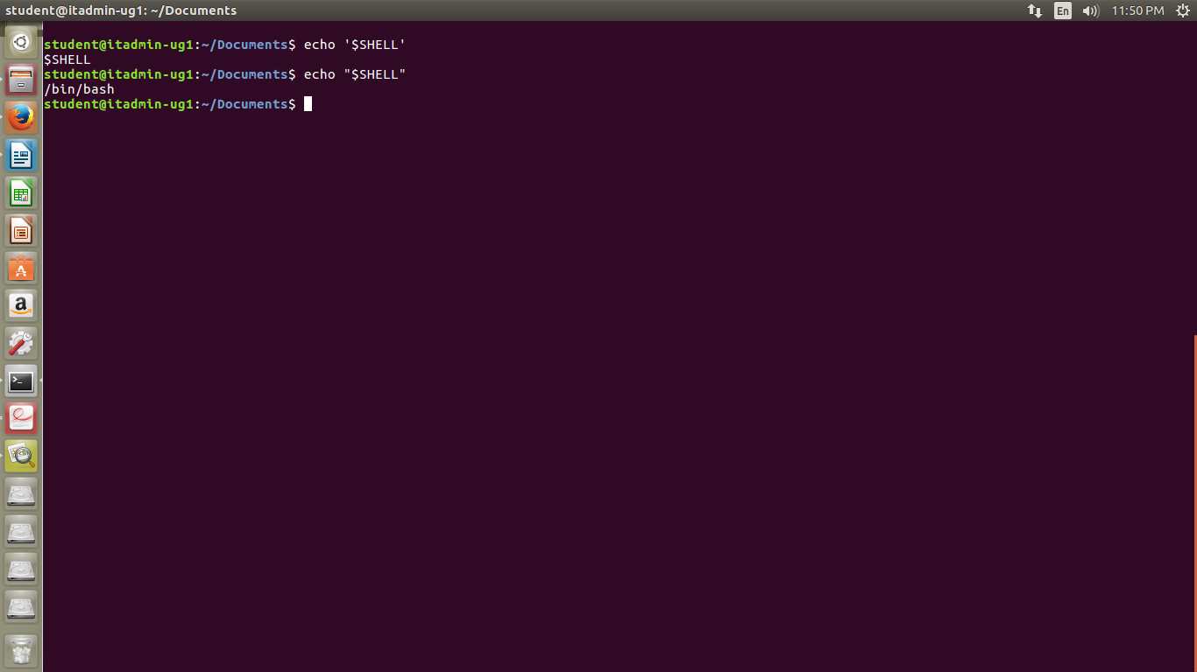

10.ls > list
ls as you know lists the contents of the file ,> directs the output in a text file named
list (in this case) which will be saved in the current directory.
