Software Requirements Specification
for
Student Management System
Version 2.0
Prepared by Akshay U Prabhu (15IT203)
National Institute of Technology, Surathkal
20-Feb-2018
Table of Contents
Table of Contents ii
Revision History ii
1. Introduction 1
1.1 Purpose 1
1.2 Document Conventions 1
1.3 Intended Audience and Reading Suggestions 1
1.4 Product Scope 1
1.5 References 1
2. Overall Description 2
2.1 Product Perspective 2
2.2 Product Functions 2
2.3 User Classes and Characteristics 2
2.4 Operating Environment 2
2.5 Design and Implementation Constraints 2
2.6 User Documentation 2
2.7 Assumptions and Dependencies 3
3. External Interface Requirements 3
3.1 User Interfaces 3
3.2 Hardware Interfaces 3
3.3 Software Interfaces 3
3.4 Communications Interfaces 3
4. System Features 4
4.1 System Feature 1 4
4.2 System Feature 2 (and so on) 4
5. Other Nonfunctional Requirements 4
5.1 Performance Requirements 4
5.2 Safety Requirements 5
5.3 Security Requirements 5
5.4 Software Quality Attributes 5
5.5 Business Rules 5
6. Other Requirements 5
Appendix A: Glossary 5
Appendix B: Analysis Models 5
Appendix C: To Be Determined List 6

Revision History
Name | Date | Reason For Changes | Version
Student Mangement System | 7-Jan-2018 | Created basic SRS | 1.0
Student Mangement System | 20-Feb-2018 | Updated functional and non-functional requirements | 2.0

Introduction

Purpose
This project gives all the services that must be provided to a student over the internet to find course details provided by that administrator of the college.This project contains data regarding student personal details which can be updated by the student and viewed by the administrator. It provides the detailed information about the course details given at the college. It provides the visibility in the design and provides information needed for software support.

Document Conventions
Main topics are bolded in heading (whole numbered) followed by subtopics (decimal numbered)
and bullets. All acronyms have been introduced with their full names, followed by the acronym in
the parenthesis.

Intended Audience and Reading Suggestions
The intended audience for this Student Management System is the internal guides(teachers), administrator of the college/dept and students of the organization.

Product Scope
Online Student Management System(SMS) is developing for general purpose and used to replace old paper work system. The objective is to build upon the existing information system in order to efficiently provide student information to students and school administration. This increase in efficiency of administration, provide details about the courses,make announcements and results. It provides a mechanism to edit the student information form which makes the system flexible.

References
[1] Software Requirements Specification for LNMIIT’s STUDENT MANAGEMENT PORTAL Version 1.0 retrieved from
https://www.slideshare.net/SumanSaurabh9/srs-for-student-database-management-system

[2] The reference for this SRS template is retrieved from https://web.cs.dal.ca/~hawkey/3130/srs_template-ieee.doc

[3] SRM University. (2012 - 2013). CS0411 - Software Engineering Lab - Laboratory Manual.
Retrieved from
http://www.srmuniv.ac.in/sites/default/files/files/SOFTWARE%20Engineering%20LAB-CS0411.pdf

Overall Description

Product Perspective
Student Management System is capable of managing each and every data regarding student, announcements etc. Student Management System helps us in managing in an extremely efficient way.
This Student Management System works in an efficient manner. We have three users in this
project. Admin, Teacher and Student. Admin can maintain the details of students,create the announcements. Teacher can make announcements for their course and add students to the course. Student can edit their personal details and can view the announcements.

The SMS will work with the following hardware interfaces:
- Hard disk : The database connectivity requires a hardware configuration with a fast database system running on high rpm hard disk permitting complete data redundancy and backup systems to support the primary goal of reliability.
- The system must interface with the standard output device, keyboard and mouse to interact with this software.

The SMS will work with the following software interfaces (both system and user interfaces (UI)):
- Back End : Node server..
- Front End : Any compatible Browser.

Product Functions
The Student Management system allows users to perform a series of actions to aid in managing the courses and administration of the students process. These functions include the following:

- Complete details of the student can be stored and retrieved.
- Admin can see all the student’s details and also export to excel sheets.
- The student can view all his details, course details and the announcements made by the admin or the teacher.
- The students can also update their details.
- The Teacher can add students to the course or remove them.They can also make announcements to a particular course.

User Classes and Characteristics
The users of the system are students, teachers and the administrators who maintain the system. The users are assumed to have basic knowledge of the computers and Internet browsing. The administrators of the system to have more knowledge of the internals of the system and is able to rectify the small problems that may arise due to disk crashes, power failures and other catastrophes to maintain the system. The proper user interface, users manual, online help and the guide to install and maintain the system must be sufficient to educate the users on how to use the system without any problems.

Operating Environment
This SMS application has chosen the following elements of the environment for managing the students online:
- Linux or Windows based Operating System (OS) will be used to house the application.
- The language chosen for the deployment of the application would be JavaScript on the server side as well as on the client side
- The UI will be handled by HTML along with JS and CSS.
- The database which holds student,teacher and admin information and course details is deployed in a NoSQL Database.

Design and Implementation Constraints
The following are the constraints laid before utilizing the SMS application in full scale:

- The Student Management System software is designed in such a way that the user can easily interact with the screen because of GUI.
- The information of all the users must be stored in a database that is accessible by the Online Student Information Management System.
- The university Information security systems must be compatible with the Internet applications.
- The Online Student Information Management System is connected to the university computer and is running all 24 hours a day.
- The users must have their correct usernames and passwords to enter into the Online Student Management System.
- Reliability requirements : Data redundancy and use of special characters must be avoided.
- Safety and Security considerations : The user must always exit the application after logging out of their account normally.
- Programming language requirements : The developers and programmers must have experience with JavaScript and NoSQL Database ..

User Documentation
N/A

Assumptions and Dependencies
- The users have sufficient knowledge of computers.
- The University computer should have Internet connection and Internet server capabilities.
- The users know the English language, as the user interface will be provided in English
- The product can access the university student database

External Interface Requirements

User Interfaces
All pages of the system are following a consistent theme and clear structure. The occurrence of errors should be minimized through the use of checkboxes, radio buttons and scroll down in order to reduce the amount of text input from user. JavaScript implement in HTML in order to provide a Data Check before submission. HTML Tables to display information to give a clear structure that easy to understand by user. Error message should be located beside the error input which clearly highlight and tell user how to solve it. If system error, it should provide the contact methods. The page should display the project process in different colour to clearly reflect the various states that student done. Each level of user will have its own interface and privilege to mange and modify the project information such as supervisor able to monitor/manage his student progress and make comment on it, student can change his detail, view the progress, submit project idea. The System should provide a feedback form for all users to give comments or asking questions. It should provide a FAQ to minimize the workload of system administrator.

Hardware Interfaces

Server Side
The web application will be hosted on one of the department’s Linux system using node server and connecting to one of the school Database server. The web server is listening on port 3000.

Client Side
The system is a web based application; clients are requiring using a modern web browser such as Mozilla Firebox 1.5, Internet Explorer 6 and Enable Cookies. The computer must have an Internet connection in order to be able to access the system.

Software Interfaces
The following software interfaces are used in the deployment of the Student Management System :
NoSQL Database, Javascript, NodeJS, Twitter Bootstrap etc.
The Database should have the following specifications:
Name of the Interface Description or Purpose
Type System Dynamic, Static
Architecture Object Oriented Model
Software License Proprietary
Operating System Windows, Mac OS X, Linux, Unix
Max DB Size Unlimited

Server Side
The UOP already has the required software to host a Javascript web application. A NodeJS server will accept all requests from the client. A development database will be hosted locally (using MySQL); the production database is hosted centrally.

Client Side
An OS is capable of running a modern web browser which supports HTML version 3.2 or higher.

Communications Interfaces
The communications functions required by this product are LAN connection within the
whole company so that the Admin, employee, and customer can interact with each other.
We use TCP/IP protocol.

System Features
This section outlines the low level details (implementation) of every system function of the Student Management System application. It sets the priorities of each function so that the developers would have a lucid picture of what will be accomplished first and what functions will be available to review first.

Login
4.1.1 Description and Priority
There are 3 types of logins in this application.
Student login, Teacher login and Admin login.
The users have to enter their respective credentials to login.
4.1.2 Stimulus/Response Sequences
After the user logs in, they are redirected to their corresponding home pages, I.e if the user is an admin he will be redirected to admin home page, similarly teacher will be redirected to teacher home page and student will be redirected to student home page.
4.1.3 Functional Requirements
REQ-1: An input box will be provided to enter the username and the password of the user.
REQ-2: The password entered should be seen as a list of ‘*’.
REQ-3: If either the username or password is incorrect , a popup should be shown saying ‘either the username or password incorrect’.
REQ-4: If both of them match to atleast one of the user in the database then they should be redirected to their respective home pages

Add Students to the Course
4.1.1 Description and Priority
Upon the successful login of the admin or the teacher, they can add the students to a particular course.If the logged in user is an admin he can add any student to any course in the college or department.If the logged in user is a teacher then he/she can add students to only those courses that they are alloted to.
4.1.2 Stimulus/Response Sequences
After the teacher or the admin adds the student to the course, the student can view the course details of the course which he is added to. The student will also be able to get all the announcements made by the admin or the teacher in that particular subject or course.
4.1.3 Functional Requirements
REQ-1: In the Admin home page a link named Student will be provided which on clicked redirects the admin to the student subpage.
REQ-2: In the student subpage a list of names of the students will be provided which upon clicked the admin can edit the students details
REQ-3: A drop down menu will be provided which has a list of courses in the department along with a Add Course button.
REQ-4: The admin can select a course from the dropdown menu and click on the Add Course button provided.
REQ-5: In the Teacher home page a list of the courses that he/she is alloted is displayed in the form of button.
REQ-6: Upon clicking on the course name buttons, he/she will be redirected to the corresponding course page.
REQ-7: In the course page, a input box will be provided to enter the name of the student to be added.

Module Description

Admin: Admin is a person whose responsibility is to maintain the database that
contains each and every data regarding the all the student. Admin can add student
details into the database, can be able to delete student details and can update the student
fee details.
Admin has some other responsibilities they are
• Admin is can maintain the fee details of each and every student.
• Admin can generate the reports of the students and
• Admin can export the details to excel.

User: Here the user means the student. The responsibility of the student is to login into
the site and can view his/her fee details and can able update his/her personal details if
there is any wrong details are present. Whenever the student will register his/her name
then the student will be given by one individual username and password. When the
student will type the correct username and password then the will enter into another
page. In that page, the student can select two options that are updated details and view
details. A student can able to update his/her personal details and can be able to view the
fee details but cannot update the fee details.

Some of the fetures of this system is to view and edit,

Personal Profile
- Student Address
- Student Authentication/Change PIN
- Email/Fax Address
- Stops

Registration
- Registration Status
- Course Status
- Student’s Current Schedule
- Register for a course
- Add or drop a course
- Course Evaluation Guide

Grades
- View past grades earned from each course taken up to the last completed semester.
- View and Print non-official records of grades
- Keep a cumulative count of credits finished
- Display a computed value of current GPA

Registration Assistance
- Stop a registration request course for error conditions:
- Courses have scheduling conflict
- Course does not exist
- Course requires a prerequisite that is not met
- Course has already been registered and or completed

Other Nonfunctional Requirements

RELIABILITY
The system has to be very reliable due to the importance of data and the damages incorrect or incomplete data can do.

Availability
The system is available 100% for the user and is used 24 hrs a day and 365 days a year. The system shall be operational 24 hours a day and 7 days a week.

Mean Time Between Failures (MTBF)
The system will be developed in such a way that it may fail once in a year.

Mean Time to Repair (MTTR)
Even if the system fails, the system will be recovered back up within an hour or less.

Accuracy
The accuracy of the system is limited by the accuracy of the speed at which the employees of the library and users of the library use the system.

Maximum Bugs or Defect Rate
Not specified.

Access Reliability
The system shall provide 100% access reliability.

Other Requirements
<Define any other requirements not covered elsewhere in the SRS. This might include database requirements, internationalization requirements, legal requirements, reuse objectives for the project, and so on. Add any new sections that are pertinent to the project.>
Appendix A: Glossary
N/A
Appendix B: Analysis Models
USE CASE DIAGRAM:

A use case is a methodology used in system analysis to identify, clarify, and organize system requirements. The use case is made up of a set of possible sequences of interactions between systems and users in a particular environment and related to a particular goal. It is represented using ellipse. Actor is any external entity that makes use of the system being modelled. Its
represented using stick figure

For Administrator:
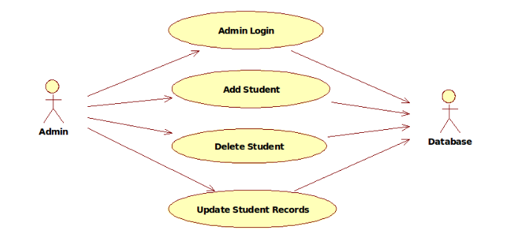

For Student:

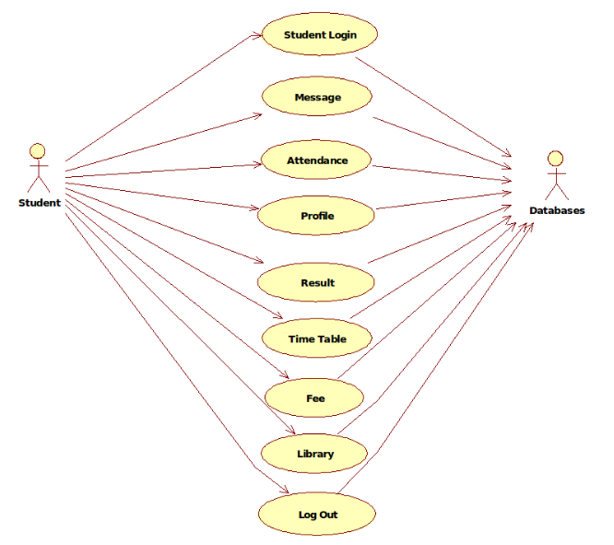

DOCUMENTATION OF USE CASE DIAGRAM

The actors in this use case diagram are Admin, Student, Database. The use cases are the activities performed by actors.
- Admin register login, and store the student records details in database.
- Student Register from the Student Login process.
- Then the database is searched for details and verified.
- Database stores the details and returns acknowledgement

CLASS DIAGRAM:

A class diagram in the unified modeling language (UML) is a type of static structure diagram that describes the structure of a system by showing the system's classes, their attributes, and the relationships between the classes. It s represented using a rectangle with three compartments. Top compartment have the class name, middle compartment the attributes and the bottom compartment with operations.

DOCUMENTATION OF CLASS DIAGRAM

This class diagram has three classes Login, Student details and Update details in database.
-----------------------------------change the class diagram here -----------------------------------
- Students – is the class name. Its attributes are name, Address, DOB, Gender, College, Subjects, Semester, Year, Degree, Branch. The operations Performed in the students class, Store database and Update.
- Administration– is the class name. Its attributes are Login, Password and database. The operations performed are Student Details store in database and send acknowledgement.
- Database – is the class name. The operations performed are storing Search and storing the values.

SEQUENCE DIAGRAM:

A sequence diagram in Unified Modeling Language (UML) is a kind of interaction diagram that shows how processes operate with one another and in what order. It is a construct of a Message Sequence Chart. There are two dimensions.
1. Veritcal dimension represent time.
2. Horizontal dimension represent different objects.

For Administrator:

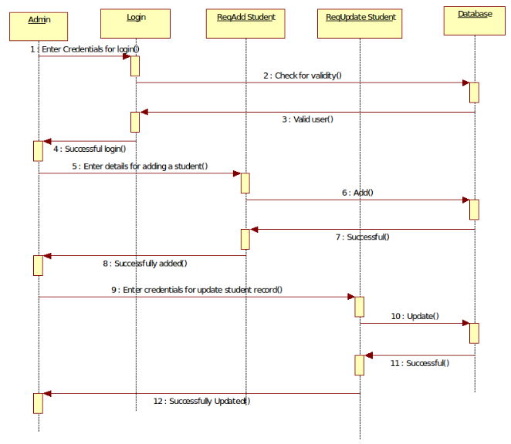
For Student:

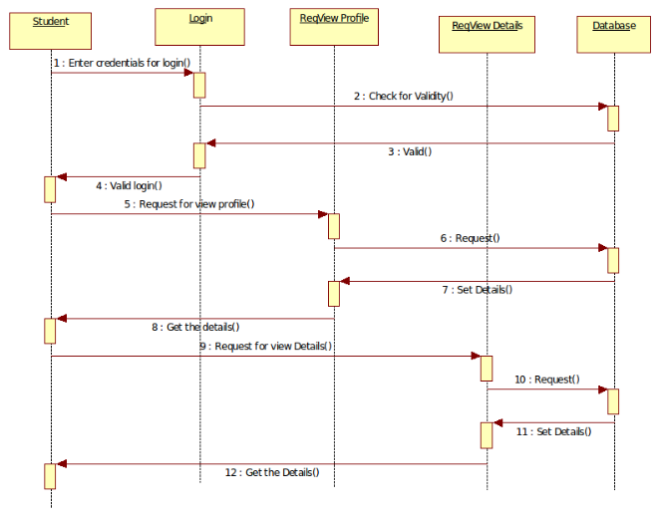
Appendix C: To Be Determined List
N/A
Appendix B: Analysis Models

USE CASE DIAGRAM:

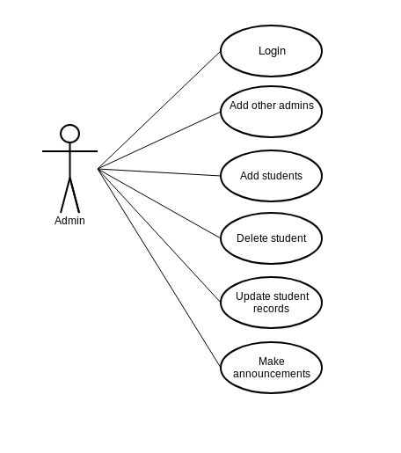

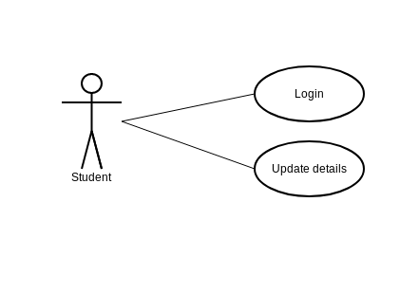
SEQUENCE DIAGRAM:

For the Admin:

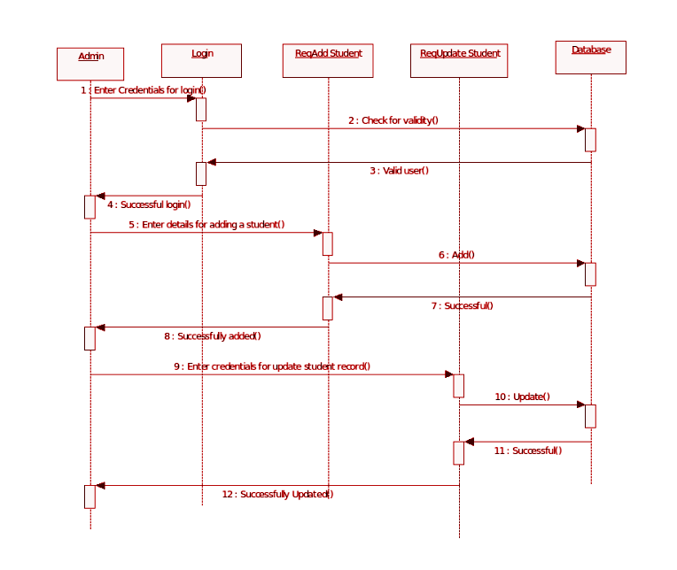

For the Student:
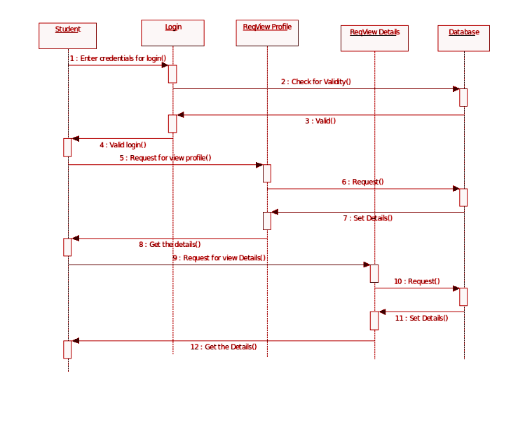

CLASS DIAGRAM:
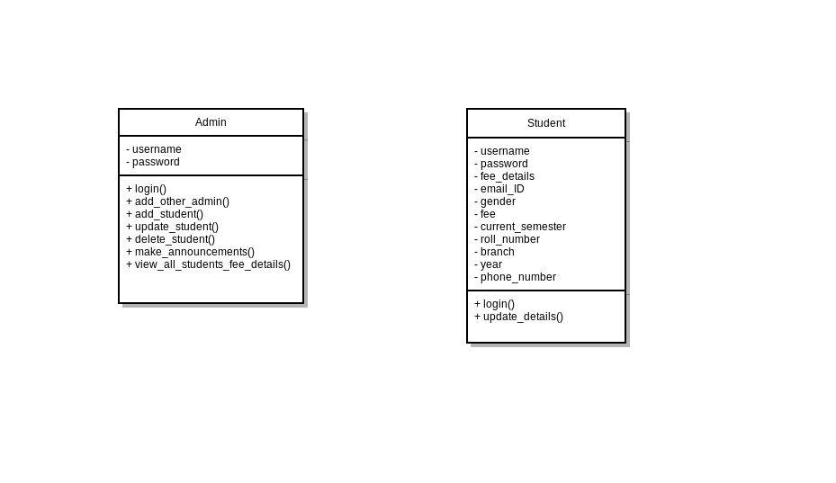
ACTIVITY DIAGRAMS:
Student Activity:

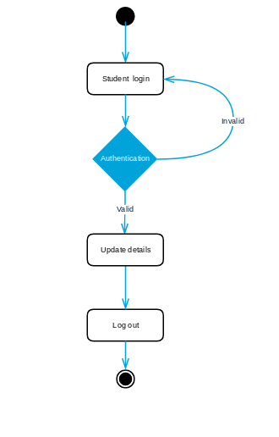

Admin Activity:

