Employer Login Page:-

In attached screen shot values should be in entered text form only in Job Title , qualification …need validation

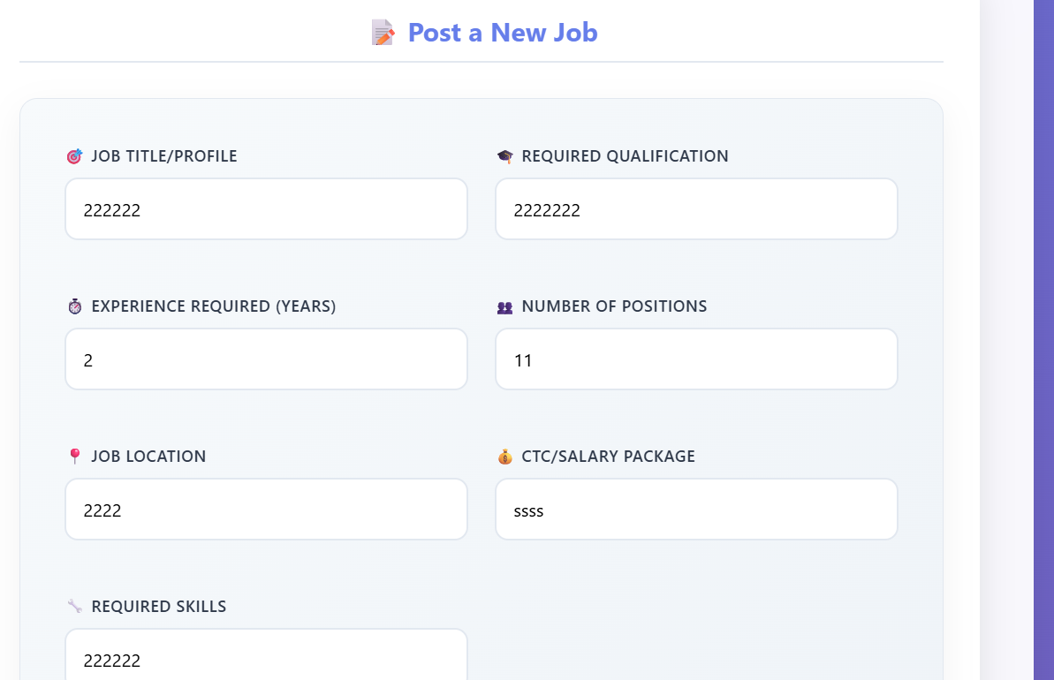

Profile Option is not available after employer Login . also not able to log out.

Payment gate way..

What will happen after posting requirement on portal..is this require approval of admin

Employee Corner:-

Login page missing

In attached screen shot values should be in entered text form …need validation

il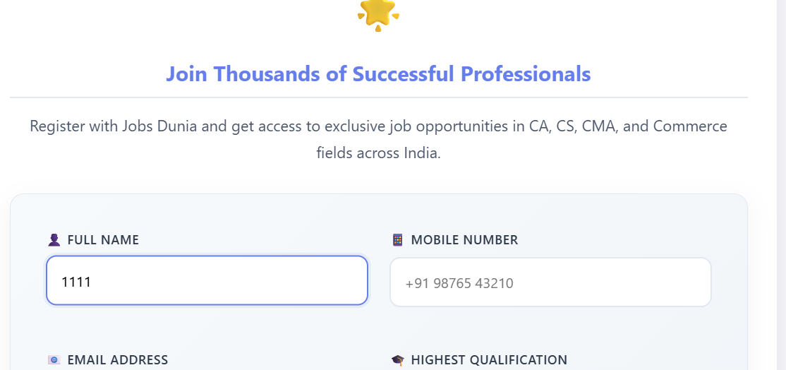

Current Opening Page :

CTC tab is missing.

Filter not working

Also required one separate page for blog/update posting