Introduction
Data visualization is the process of representing data in graphical formats such as charts, graphs, and plots. It helps in converting complex and large datasets into visual forms that are easier to understand and interpret. Instead of analyzing raw numbers and tables, visualization allows users to quickly identify patterns, relationships, and trends in the data. This makes it easier for researchers, businesses, and analysts to make informed decisions based on the insights obtained from the data.
In this project, Python libraries such as Pandas, Matplotlib, and Seaborn are used for data analysis and visualization. Pandas is mainly used for data handling and preprocessing, including reading datasets, cleaning data, and performing basic analysis. Matplotlib is a popular library used to create various types of graphs and charts such as bar charts, histograms, and scatter plots. Seaborn is built on top of Matplotlib and provides advanced statistical visualization with more attractive and informative graphs. These libraries help transform raw data into meaningful visual insights.

Problem Statement
Organizations across different industries provide different parental leave policies for their employees. However, when this information is stored in large datasets, it becomes difficult to understand and compare the benefits provided by each company or industry. Simply viewing the data in tabular form does not clearly show patterns, trends, or differences in maternity and paternity leave policies.
The purpose of this project is to use data visualization techniques to analyze parental leave data and present it in a clear and meaningful way. By creating graphical representations such as bar charts, histograms, scatter plots, and heatmaps, the project helps identify trends in maternity and paternity leave across different industries. This makes it easier to understand which industries provide better parental benefits and how leave policies vary among companies.

Objectives of the Project
1. To analyze the parental leave dataset using the Python programming language.
2. To process and clean the dataset using the Pandas library for accurate analysis.
3. To create graphical representations of the data such as bar charts, histograms, scatter plots, and heatmaps.
4. To understand trends and patterns in parental leave policies across different industries using visualization techniques.
5. To use Python visualization libraries such as Matplotlib and Seaborn to present data in a clear and informative manner.

Tools and Technologies Used
Python:
Python is a powerful and widely used programming language for data analysis, machine learning, and visualization. It provides many libraries that help in processing and analyzing large datasets efficiently.
Pandas:
Pandas is a Python library used for data manipulation and analysis. It helps in reading datasets, cleaning data, handling missing values, filtering data, and performing statistical operations on the dataset.
Matplotlib:
Matplotlib is a popular Python library used for creating basic graphs and charts such as bar charts, histograms, line charts, and scatter plots. It is commonly used for visualizing numerical data.
Seaborn:
Seaborn is a data visualization library built on top of Matplotlib. It provides more attractive and advanced statistical graphs such as heatmaps, boxplots, and count plots, making it easier to understand patterns in the data.
VS Code:
Visual Studio Code was used as the development environment to write and execute Python code, analyze the dataset, and generate visualizations.

Dataset Description
The dataset used in this project contains information about parental leave benefits provided by different companies across various industries. The data is stored in a CSV (Comma-Separated Values) file, which is a common format used for storing tabular data. Each row in the dataset represents a specific company, and each column represents a particular type of information related to parental leave policies.
The dataset includes the following columns:
- Company – The name of the organization providing the leave policy.
- Industry – The industry to which the company belongs (for example: Accounting, Advertising, Business, Consulting, Educational).
- Paid Maternity Leave – The number of weeks of paid leave provided to mothers after childbirth.
- Unpaid Maternity Leave – The number of weeks of unpaid maternity leave available.
- Paid Paternity Leave – The number of weeks of paid leave provided to fathers.
- Unpaid Paternity Leave – The number of weeks of unpaid leave available for fathers.
The values in the leave columns are generally represented in weeks. Some records contain “N/A” values, which indicate that the company either does not provide that type of leave or the information is not available. During the preprocessing stage of the project, these values were handled properly to ensure accurate data analysis.
For better analysis and visualization, only a few industries such as Accounting, Advertising, Business, Consulting, and Educational were selected from the dataset.
Methodology
The methodology of this project explains the steps followed to analyze the dataset and create visualizations. The project was completed in several stages, starting from data collection to interpreting the results obtained from the graphs.
1. Data Collection
The dataset used in this project was collected in CSV (Comma-Separated Values) format. It contains information about parental leave policies provided by different companies across various industries. The dataset was imported into Python using the Pandas library for further analysis.
2. Data Preprocessing
Before performing analysis, the dataset was cleaned and prepared. This step included replacing missing values such as “N/A” with appropriate values, converting data columns into numeric format, and filtering only selected industries for better analysis. Data preprocessing helps improve the accuracy and reliability of the results.
3. Data Analysis
After cleaning the data, basic analysis was performed using Pandas. This included viewing the first few rows of the dataset, checking information about the dataset, and calculating averages and other statistics to understand the data structure.
4. Data Visualization
Different graphs and charts were created using Matplotlib and Seaborn to visually represent the data. These visualizations help identify patterns and trends in parental leave policies across different industries.
5. Result Interpretation
Finally, the visualizations were analyzed to extract meaningful insights. The graphs helped compare parental leave benefits across industries and understand how maternity and paternity leave policies vary among companies.

Implementation (Python Code)
The implementation of this project was done using Python programming language along with libraries such as Pandas, Matplotlib, and Seaborn. Pandas was used for loading and preprocessing the dataset, while Matplotlib and Seaborn were used to create various visualizations for better understanding of the data.
First, the required libraries were imported and the dataset was loaded into Python using the Pandas library. Missing values such as “N/A” were replaced and numerical columns were converted into proper numeric format for analysis.
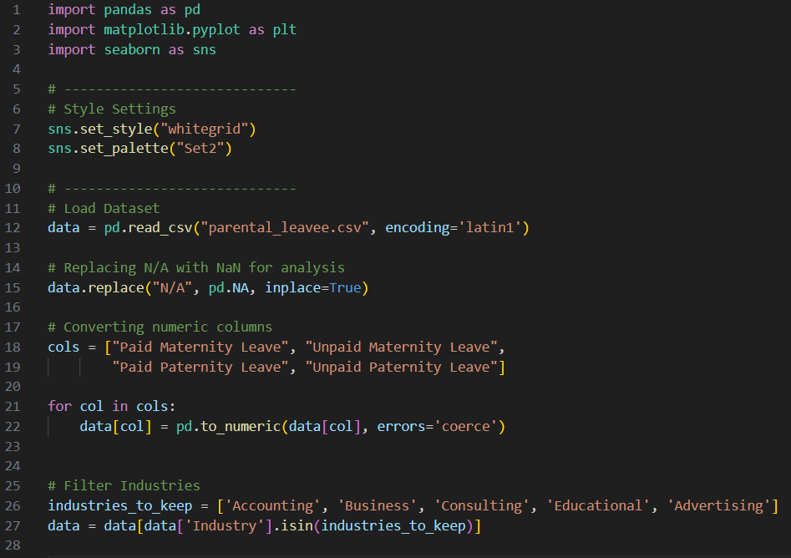After preprocessing the dataset, different types of visualizations were created to analyze the data like:
Bar Chart Example:
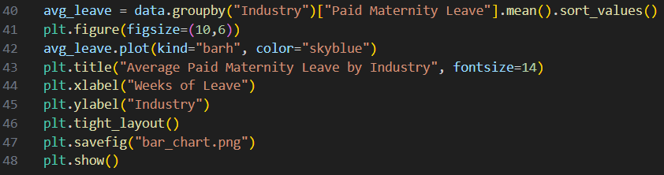
Visualizations Used
The following visualizations were created in this project:
1. Bar Chart
Shows the average paid maternity leave by industry.
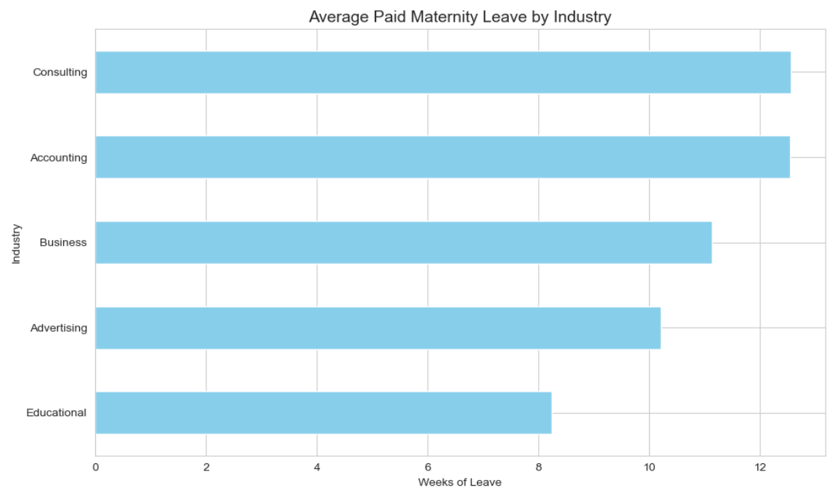
2. Histogram
Displays the distribution of maternity leave weeks.
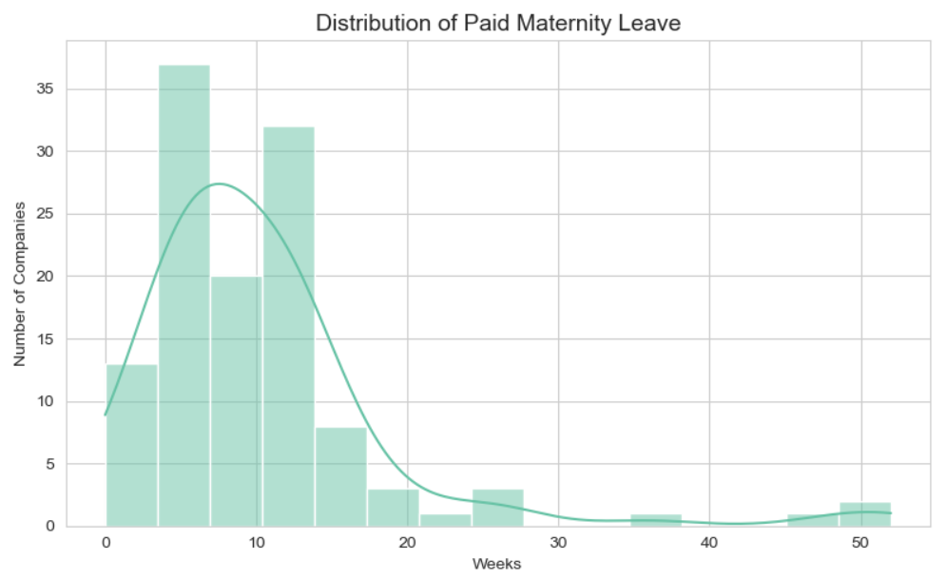

3. Scatter Plot
Shows the relationship between maternity leave and paternity leave.
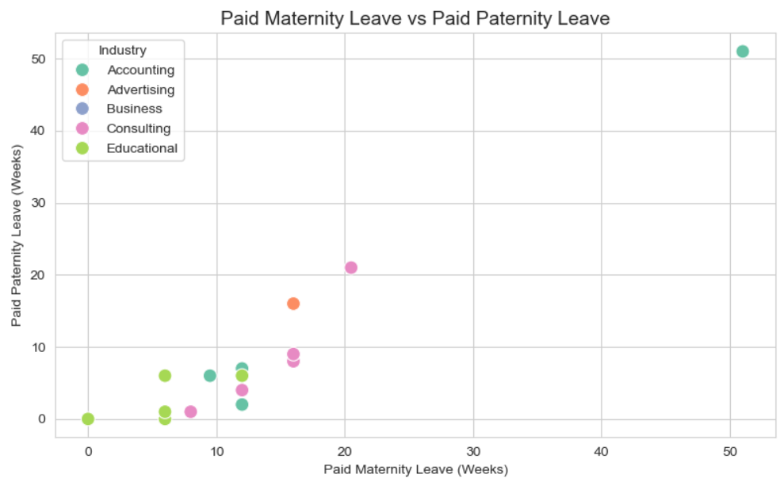
4. Count Plot
Displays the number of companies in each industry.
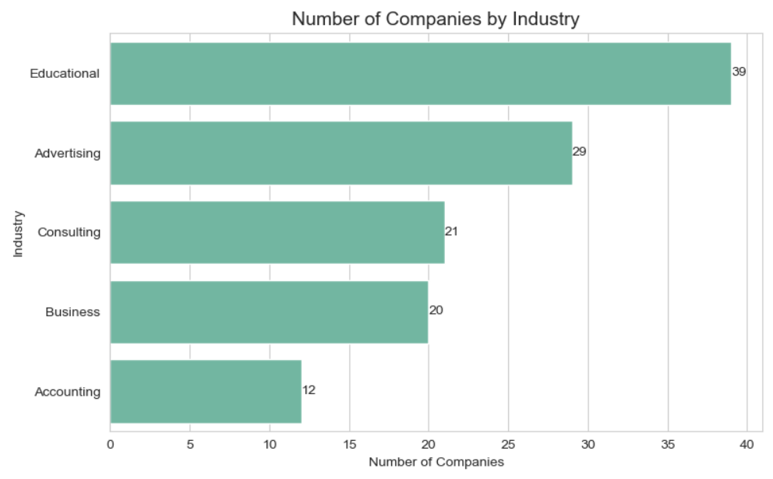

5. Heatmap
Shows the correlation between different leave types.
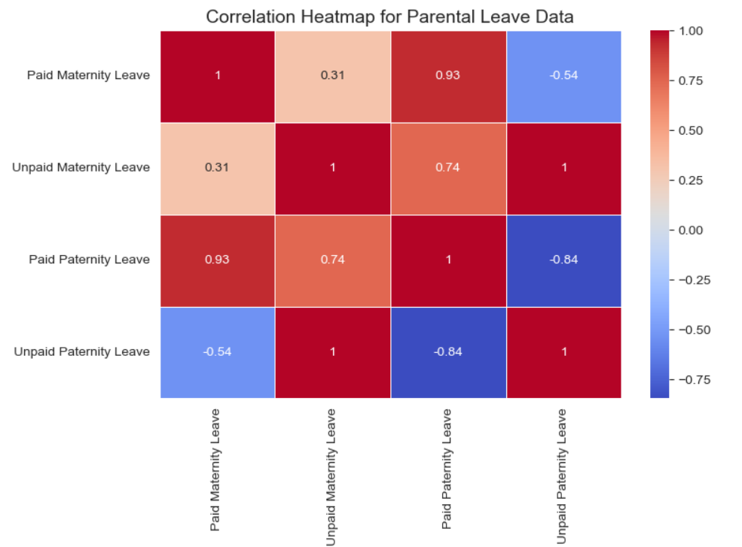

Results and Analysis
The visualizations in this project helped to understand the parental leave policies of different companies and industries. By converting the dataset into graphs, it became easier to see patterns and differences in the data.
The bar chart shows the average paid maternity leave offered by different industries. From this graph, we can see that some industries provide more maternity leave compared to others. This means employee benefits are different in each industry.
The histogram shows how maternity leave weeks are distributed among companies. Most companies provide maternity leave within a normal range of weeks, while only a few companies provide very high maternity leave.
The scatter plot compares paid maternity leave and paid paternity leave. It shows that in some companies, when maternity leave is higher, paternity leave is also higher. This means some companies try to support both parents equally.
The count plot shows how many companies belong to each industry in the dataset. This helps us understand which industries have more companies in the data.
The heatmap shows the relationship between different types of leave such as paid maternity leave, unpaid maternity leave, paid paternity leave, and unpaid paternity leave. It helps to see how these benefits are related to each other.
The pairplot shows relationships between all the numerical columns in the dataset. It helps us visually compare the different leave policies provided by companies.
Finally, the top companies list shows the companies that provide the highest paid maternity leave. Some companies provide very large maternity leave benefits compared to others.

Conclusion
This project helped in understanding how data visualization can be used to analyze and interpret real-world data. Using Python libraries such as Pandas, Matplotlib, and Seaborn, the dataset was cleaned, processed, and converted into meaningful graphs. The visualizations helped identify trends and differences in parental leave policies across different industries. Overall, the project improved understanding of data analysis and showed how graphical representations make complex data easier to understand.

11. References
- Python Official Documentation
https://www.python.org/doc/
- Pandas Documentation
https://pandas.pydata.org/docs/
- Matplotlib Documentation
https://matplotlib.org/stable/index.html
- Seaborn Documentation
https://seaborn.pydata.org/
- Kaggle Datasets
https://www.kaggle.com/

