**Select * from bikes ;**

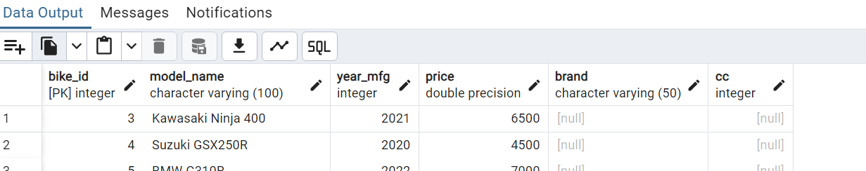

**Adding a new column**



**Changing the data type using alter**

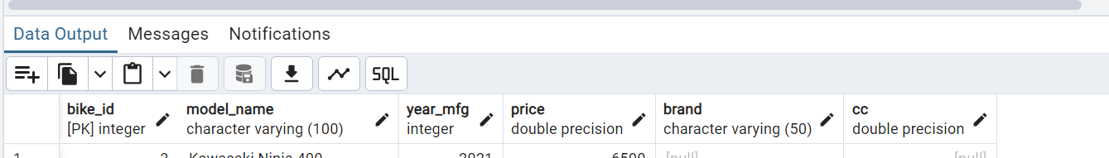

**Drop table cc**

