RETAIL ANALYTICS REPORT
Customer Shopping
Behaviour Analysis
An end-to-end analysis of 3,900 customer transactions —
from Python data cleaning to SQL insights and a Power BI dashboard.

Prepared using Python · PostgreSQL · Power BI
1. Project Overview
This project analyses customer shopping behaviour using transactional data from 3,900 purchases across various product categories. The goal is to uncover insights into spending patterns, customer segments, product preferences, and subscription behaviour to guide strategic business decisions.

3,900  TRANSACTIONS | 18  DATA COLUMNS | $59.76  AVG. PURCHASE | 3.75 / 5  AVG. REVIEW RATING

2. Dataset Summary
- Rows: 3,900 customer transactions
- Columns: 18 attributes
- Missing Data: 37 values found in the Review Rating column

Key Feature Groups
- Customer demographics — Age, Gender, Location, Subscription Status
- Purchase details — Item Purchased, Category, Purchase Amount, Season, Size, Colour
- Shopping behaviour — Discount Applied, Promo Code Used, Previous Purchases, Frequency of Purchases, Review Rating, Shipping Type

3. Exploratory Data Analysis using Python
We began with data preparation and cleaning in Python:
- Data Loading — Imported the dataset using pandas.
- Initial Exploration — Used df.info() to check structure and .describe() for summary statistics.
- Missing Data Handling — Checked for null values and imputed missing values in the Review Rating column using the median rating of each product category.
- Column Standardization — Renamed columns to snake case for better readability and documentation.
- Feature Engineering — Created an age group column by binning customer ages, and a purchase_frequency_days column derived from purchase frequency.
- Data Consistency Check — Verified that discount_applied and promo_code_used were redundant; dropped promo_code_used.
- Database Integration — Connected the Python script to PostgreSQL and loaded the cleaned DataFrame into the database for SQL analysis.

Numeric Summary Statistics
Statistic | Age | Purchase Amount (USD) | Review Rating | Previous Purchases
Mean | 44.07 | 59.76 | 3.75 | 25.35
Std. Dev. | 15.21 | 23.69 | 0.72 | 14.45
Min | 18 | 20 | 2.5 | 1
25% | 31 | 39 | 3.1 | 13
50% (Median) | 44 | 60 | 3.8 | 25
75% | 57 | 81 | 4.4 | 38
Max | 70 | 100 | 5.0 | 50
Table 1 — Descriptive statistics for the dataset's core numeric fields (n = 3,900; Review Rating n = 3,863).
Categorical Summary Statistics
Field | Unique Values | Top Category | Frequency
Gender | 2 | Male | 2,652
Item Purchased | 25 | Blouse | 171
Category | 4 | Clothing | 1,737
Location | 50 | Montana | 96
Size | 4 | M | 1,755
Colour | 25 | Olive | 177
Season | 4 | Spring | 999
Subscription Status | 2 | No | 2,847
Shipping Type | 6 | Free Shipping | 675
Discount Applied | 2 | No | 2,223
Promo Code Used | 2 | No | 2,223
Payment Method | 6 | PayPal | 677
Frequency of Purchases | 7 | Every 3 Months | 584
Table 2 — Distribution overview of categorical fields prior to encoding and feature engineering.

4. Data Analysis using SQL (Business Transactions)
We performed structured analysis in PostgreSQL to answer key business questions:
4.1 Revenue by Gender
Compared total revenue generated by male vs. female customers.
Gender | Revenue (USD)
Female | 75,191
Male | 157,890
4.2 High-Spending Discount Users
Identified customers who used discounts but still spent above the average purchase amount. 839 customers matched these criteria — a sample is shown below.
Customer ID | Purchase Amount (USD)
2 | 64
3 | 73
4 | 90
7 | 85
9 | 97
12 | 68
13 | 72
16 | 81
20 | 90
22 | 62
Showing 10 of 839 total matching rows.
4.3 Top 5 Products by Rating
Found the products with the highest average review ratings.
Item Purchased | Average Product Rating
Gloves | 3.86
Sandals | 3.84
Boots | 3.82
Hat | 3.80
Skirt | 3.78
4.4 Shipping Type Comparison
Compared average purchase amounts between Standard and Express shipping.
Shipping Type | Avg. Purchase Amount (USD)
Standard | 58.46
Express | 60.48
4.5 Subscribers vs. Non-Subscribers
Compared average spend and total revenue across subscription status.
Subscription Status | Total Customers | Avg. Spend (USD) | Total Revenue (USD)
Yes | 1,053 | 59.49 | 62,645.00
No | 2,847 | 59.87 | 170,436.00
4.6 Discount-Dependent Products
Identified the 5 products with the highest percentage of discounted purchases.
Item Purchased | Discount Rate (%)
Hat | 50.00
Sneakers | 49.66
Coat | 49.07
Sweater | 48.17
Pants | 47.37
4.7 Customer Segmentation
Classified customers into New, Returning, and Loyal segments based on purchase history.
Customer Segment | Number of Customers
Loyal | 3,116
Returning | 701
New | 83
4.8 Top 3 Products per Category
Listed the most purchased products within each category.
Category | Rank | Item Purchased | Total Orders
Accessories | 1 | Jewellery | 171
Accessories | 2 | Sunglasses | 161
Accessories | 3 | Belt | 161
Clothing | 1 | Blouse | 171
Clothing | 2 | Pants | 171
Clothing | 3 | Shirt | 169
Footwear | 1 | Sandals | 160
Footwear | 2 | Shoes | 150
Footwear | 3 | Sneakers | 145
Outerwear | 1 | Jacket | 163
Outerwear | 2 | Coat | 161
4.9 Repeat Buyers & Subscriptions
Checked whether customers with more than 5 previous purchases are more likely to subscribe.
Subscription Status | Repeat Buyers
No | 2,518
Yes | 958
4.10 Revenue by Age Group
Calculated the total revenue contribution of each age group.
Age Group | Total Revenue (USD)
Young Adult | 62,143
Middle-aged | 59,197
Adult | 55,978
Senior | 55,763

5. Dashboard in Power BI
Finally, we built an interactive dashboard in Power BI to present insights visually, featuring KPI cards, category and age-group breakdowns, and slicers for subscription status, gender, category, and shipping type.

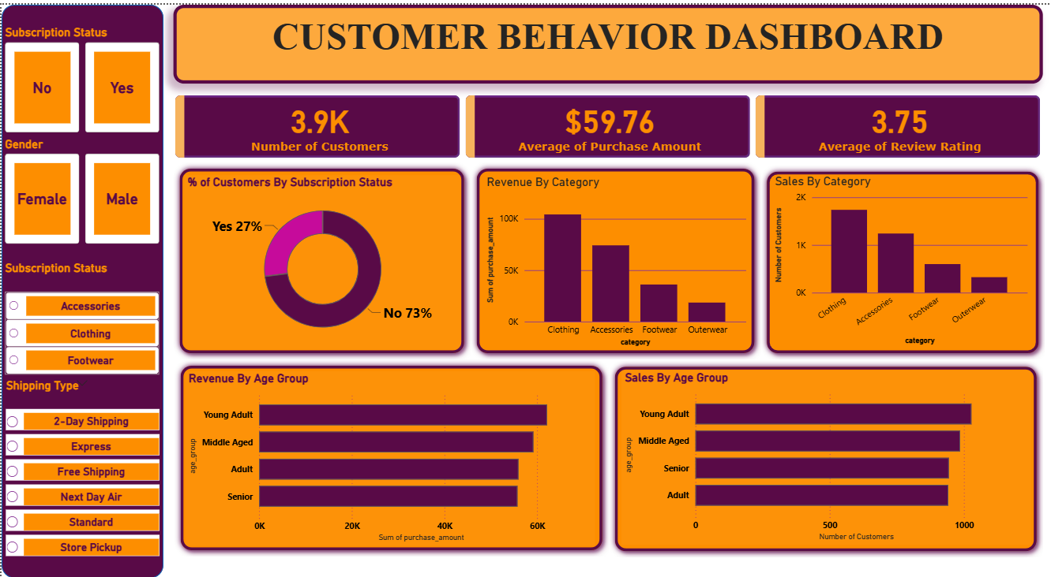
6. Business Recommendations
- Boost Subscriptions — Promote exclusive benefits for subscribers.
- Customer Loyalty Programs — Reward repeat buyers to move them into the “Loyal” segment.
- Review Discount Policy — Balance sales boosts with margin control.
- Product Positioning — Highlight top-rated and best-selling products in campaigns.
- Targeted Marketing — Focus efforts on high-revenue age groups and express-shipping users.

