**Name: Akshita Pathak**

**Roll No: 102203796**

**Subgroup: 2CO18**

**DA Lab Assignment-1**

**Write a program to implement iterative as well as recursive versions of the following algorithms:**

* **Binary search**

//Write a program to implement iterative as well as recursive versions of- Binary search

#include<iostream>

using namespace std;

//iterative

void binSearch(int A[],int n,int key){

int low=0;

int high=n-1;

int mid;

while(low<=high){

mid=(low+high)/2;

if(key==A[mid]){

cout<<"Element "<<key<<" found in array \n";

return;

}

else if(key<A[mid]){

//left

high=mid-1;

}

else{

//right

low=mid+1;

}

}

cout<<"Element "<<key<<" NOT found in array \n";

}

//recursive

int rbinSearch(int A[],int n,int low,int high,int key){

int mid;

if(low<=high){

mid=(low+high)/2;

if(key==A[mid]){

return 1;

}

else if(key<A[mid]){

//left

return rbinSearch(A,n,low,mid-1,key);

}

else{

return rbinSearch(A,n,mid+1,high,key);

}

}

}

int main()

{

int A[]={2,4,6,8,10};

int n=5;

int key;

cout<<"Enter key element to find: \n";

cin>>key;

// binSearch(A,n,key);

int res=rbinSearch(A,n,0,n-1,key);

if(res==1){

cout<<"Element "<<key<<" found in array \n";

}

else{

cout<<"Element "<<key<<" NOT found in array \n";

}

return 0;

}

**Output:**

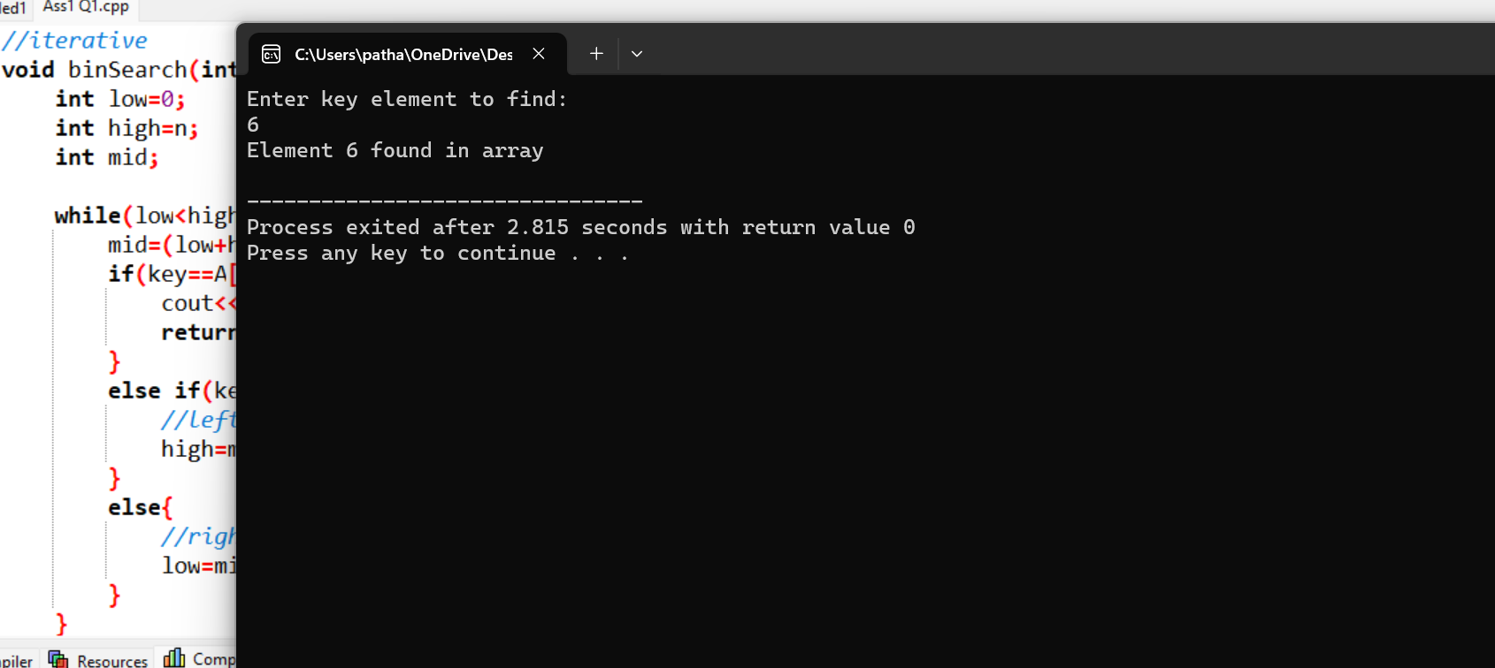

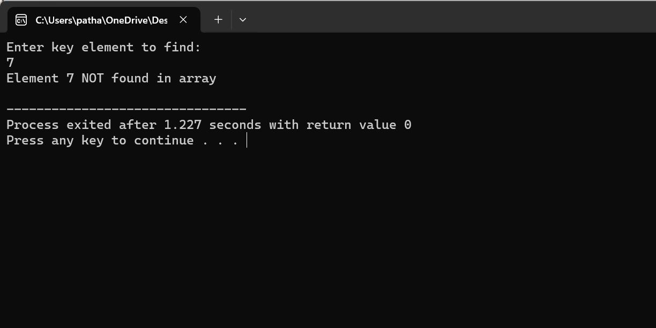

* **Merge sort**

//Write a program to implement iterative as well as recursive versions of- Merge sort

#include<iostream>

using namespace std;

void merge(int A[],int low,int mid,int high){

int i,j,k;

i=low;

j=mid+1;

k=low;

int B[100];

while(i<=mid && j<=high){

if(A[i]<A[j]){

B[k++]=A[i++];

}

else{

B[k++]=A[j++];

}

}

//remaining elements

for(;i<=mid;i++){

B[k++]=A[i];

}

for(;j<=high;j++){

B[k++]=A[j];

}

//copy back

for(i=low;i<=high;i++){

A[i]=B[i];

}

}

//iterative

void iMergeSort(int A[],int n)

{

int pass;

int low,mid,high;

for(pass=2;pass<=n;pass=pass*2){

for(int i=0;i+pass-1<n;i=i+pass){

low=i;

high=i+pass-1;

mid=(low+high)/2;

merge(A,low,mid,high);

}

}

if(pass/2<n){

merge(A,0,pass/2,n-1);

}

}

//recursive

void rMergeSort(int A[],int low,int high){

if(low<high){

int mid=(low+high)/2;

rMergeSort(A,low,mid);

rMergeSort(A,mid+1,high);

merge(A,low,mid,high);

}

}

int main()

{

int A[]={8,3,7,4,9,2,6,5};

int n=8;

for(int i=0;i<n;i++){

cout<<A[i]<<" ";

}

// iMergeSort(A,n);

rMergeSort(A,0,n-1);

cout<<"after merging \n";

for(int i=0;i<n;i++){

cout<<A[i]<<" ";

}

return 0;

}

**OUTPUT:**

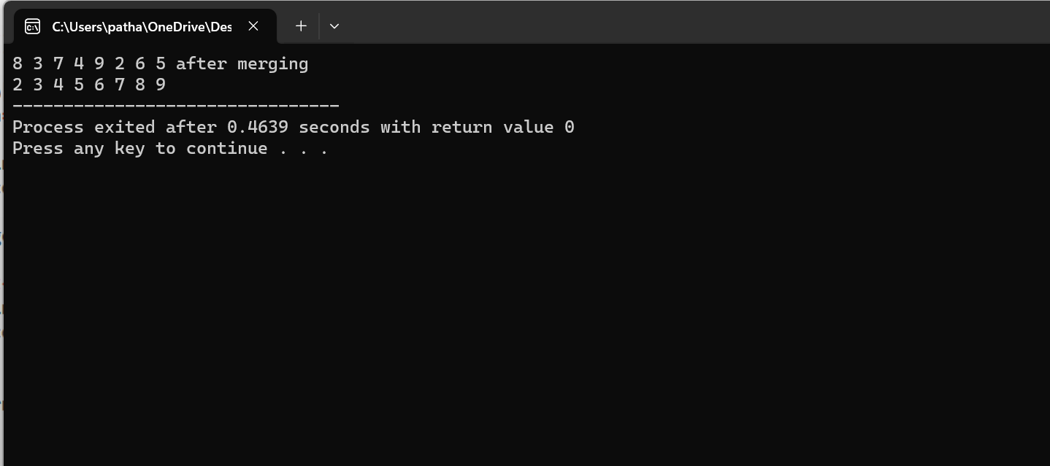

* **Quick sort**

//Write a program to implement iterative as well as recursive versions of- Quick sort

#include<iostream>

using namespace std;

void swap(int *x,int *y){

int temp;

temp=*x;

*x=*y;

*y=temp;

}

int partition(int A[], int l, int h){

int pivot=A[l]; //first element must be pivot element

int i=l;

int j=h;

do{

do{

i++;

}while(A[i]<=pivot);

do{

j--;

}while(A[j]>pivot);

if(i<j){

swap(&A[i],&A[j]);

}

}while(i<j);

//if i>j then swap pivot with j

swap(&A[l],&A[j]);

return j; //j gives partioning position

}

void quickSort(int A[], int l, int h){

if(l<h){

int j;

j=partition(A,l,h);

quickSort(A,l,j);

quickSort(A,j+1,h);

}

}

int main()

{

int n=5;

int A[]={8,5,7,3,2};

quickSort(A,0,n);

for(int i=0; i<n; i++){

cout<<A[i]<<" ";

}

return 0;

}

**Output:**

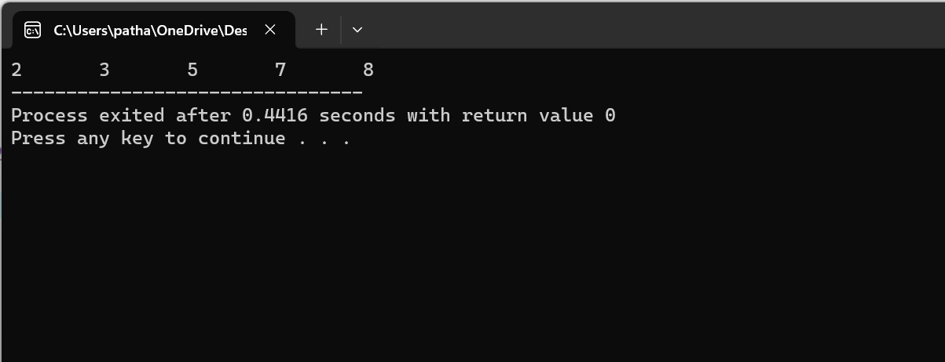

* **Maximum sub-array sum**

//Write a program to implement iterative as well as recursive versions of- Maximum sub-array sum

#include<iostream>

using namespace std;

//find maximum of two integers

int max(int a, int b) {

if(a>b){

return a;

}

else{

return b;

}

}

//find maximum of three integers

int max(int a, int b, int c) {

return max(max(a, b), c);

}

//Find the maximum possible sum in arr[] such that arr[m] is part of it

int maxCrossingSum(int arr[], int l, int m, int h){

int sum=0;

int left_sum=INT_MIN;

for (int i=m; i>=l; i--) {

sum=sum+arr[i];

if(sum>left_sum)

left_sum = sum;

}

int right_sum=INT_MIN;

for (int i=m; i<=h; i++) {

sum=sum+arr[i];

if(sum>right_sum)

right_sum = sum;

}

// Return sum of elements on left and right of mid returning only left_sum + right_sum

return max(left_sum+right_sum-arr[m], left_sum, right_sum);

}

// Returns sum of maximum sum subarray

int maxSubArraySum(int arr[], int l, int h) {

// Invalid Range: low is greater than high

if (l > h)

return INT_MIN;

// Base Case: Only one element

if (l == h)

return arr[l];

// Find middle point

int m = (l + h) / 2;

/* Return maximum of following three possible cases

a) Maximum subarray sum in left half

b) Maximum subarray sum in right half

c) Maximum subarray sum such that the subarray

crosses the midpoint */

return max(maxSubArraySum(arr, l, m - 1),

maxSubArraySum(arr, m + 1, h),

maxCrossingSum(arr, l, m, h));

}

int main()

{

int arr[] = { 2, 3, 4, 5, 7 };

int n = sizeof(arr) / sizeof(arr[0]);

int max_sum = maxSubArraySum(arr, 0, n - 1);

cout << "Maximum contiguous sum is " << max_sum;

return 0;

}

**OUTPUT:**

