Name: [Your Name]

Enrolment Number: [Your Roll Number]

Creating a Git Repository and Organizing with Two Folders

**Introduction:**

This document serves as a guide to creating a Git repository and organizing it with two folders. By following the steps outlined below, you will be able to set up a version-controlled environment for your project and structure it efficiently.

**Step-by-Step Instructions:**

Step 1: Setting Up the Repository

1. Open terminal or command prompt.
2. Navigate to the directory where to create your Git repository.
3. Execute the following command to initialize a Git repository



**Step 2: Creating Folders:**

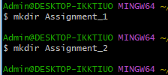

**Step 3: Adding Folders to the Repository:**



Step 4: Committing Changes:



Step 5: adding remote Repository:



Step 6: Pushing Changes:

