- Prefer this option: https://verdant.ioinfotech.com/index.html
- Though we would like to change the pics a bit
- Can the logo be made crisper?
- Make the font for the titles – Principal, What we do, etc a little bit bigger
- Combine Market Entry & Scale up and Advisory – see below
- Philosophy bit – Too green maybe?
- Start the conversation – contact details are repetitive
- Navigation & Contact at the end of the page: reduce spacing
- Who we work with – fit the box to the content?
- Other comments & changes below
Verdant
Building Trusted Pathways Between Global Manufacturing and India
A principal-led platform enabling market entry, distribution, and long-term partnerships across India’s manufacturing ecosystem.
Verdant works with global manufacturing and industrial technology companies to help them enter, scale, and succeed in India — and with Indian OEMs and manufacturers to access differentiated global technologies and partners.
India is one of the world’s most opportunity-rich and execution-intensive manufacturing markets. Success here requires more than market reports or channel partners. It requires operating experience, credibility, and a deep understanding of how decisions are made on the ground. Verdant exists to provide exactly that.
The Founder
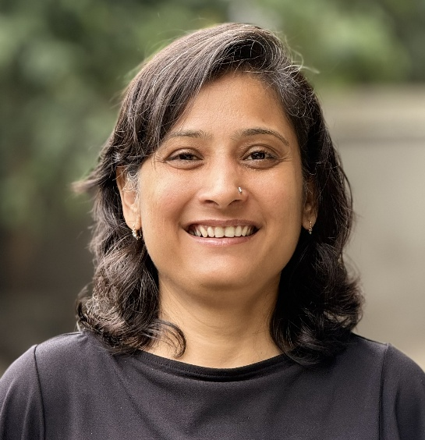
Verdant is led by Nidhi Shah, she has not only introduced but also scaled entirely new manufacturing technologies in India, with over two decades of experience across Indian and international markets.
Across her career, Nidhi has been responsible for bringing advanced manufacturing technologies to India at a time when they were largely unknown — shaping market understanding, building credibility, and guiding customers through adoption until these technologies became established and commercially viable.
She has worked extensively with customers across India, Europe, the US, ASEAN, and ANZ, and was a part of the management team at voxeljet AG (now a part of ExOne Global Holdings) and Imaginarium Solutions.
Verdant reflects this operator-led perspective — focused on market creation, technology adoption, and long-term value, not short-term transactions.

What we do
Verdant supports global manufacturing and industrial technology companies enter, scale & succeed in India.
India Market Entry & Scale-Up
Engagements span the full market-entry and scale-up lifecycle:
- Go-to-market and pricing localisation
- Partner and distributor identification
- Early customer access and reference development
- Ongoing market development and scaling
- India-specific risk, compliance, and execution considerations
The emphasis is on execution and adoption — converting interest into durable market presence.

Distribution & Representation in India
Verdant selectively represents high value, differentiated manufacturing technologies and industrial solutions in India.
This includes:
- Acting as India distributor or commercial representative
- Building and managing key accounts
- Developing long-term sales pipelines
- Positioning offerings for Indian buying behaviour and procurement structures
Representation mandates are chosen carefully, with a clear focus on long-term market creation rather than transactional sales.

Buyer–Seller Connectivity
Verdant connects the right buyers and sellers across borders, with clear commercial intent.
This includes:
- Global suppliers engaging with Indian OEMs and Tier 1 manufacturers
- Indian manufacturers accessing global customers or technology partners
- Structured introductions aligned on readiness, relevance, and mutual value
Connectivity is selective and purpose-driven — not volume-based.

The Network
Verdant operates across the breadth of the Indian manufacturing ecosystem, including:
- Large automotive, aerospace, energy, and industrial OEMs
- Tier 1 and Tier 2 suppliers
- Advanced manufacturing and industrial technology providers
- Family-owned manufacturing groups and professionally managed enterprises
Internationally, Verdant works closely with European and US manufacturing SMEs, industrial technology companies, and investors evaluating India as a growth market.
This network has been built over years of delivery and trust — not cold outreach.

Who Verdant Works With
Verdant works selectively with:
- International manufacturing SMEs entering or expanding in India
- Industrial technology companies seeking long-term representation in India
- Indian OEMs and manufacturers pursuing differentiated global partnerships
- Investors and founders evaluating India as a manufacturing, sourcing, or sales base
Engagements are senior-led, relationship-driven, and outcome-focused.

How Engagements Are Structured
Engagement models are flexible and aligned to client objectives:
- India distributor or commercial representative
- Market entry and scale-up projects
- Ongoing advisory retainers
- Structured commercial or strategic partnerships
Verdant prioritises depth, alignment, and long-term outcomes.

This section can be removed I think…
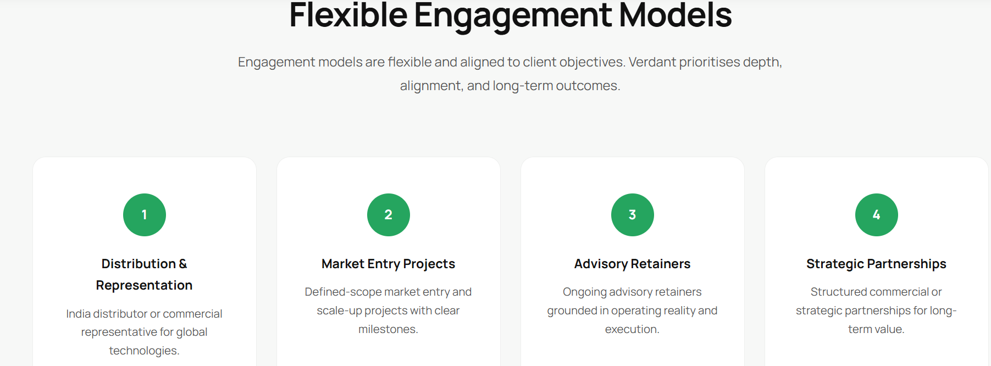

Philosophy
India is not a single market. It is a collection of industries, regions, ownership structures, and decision-making cultures.
Verdant’s approach is based on:
- Respect for local realities
- Alignment between global ambition and Indian execution
- Long-term relationship building
- Commercial discipline
Success in India is rarely fast — but it is durable when done right.

Start the Conversation
If you are a global manufacturing or industrial technology company serious about India — or an Indian manufacturer seeking meaningful global partnerships — Verdant can help you navigate the path forward.
Engagements typically begin with a focused conversation to assess fit, intent, and readiness.
info@globalverdant.com | +91 98331 06710

