LIVE WEBSITE REVIEW
Zhara Website
Copy Review
Section screenshots with exact copy recommendations
https://zhara.io/
Live desktop page reviewed on 11 August 2026

Highest priority changes
The live page has a strong visual structure. The most important changes are about clarity, credibility, and consistency rather than a complete rewrite.
Primary action: The hero says "Install on Shopify" but the link leads to a request access section. Use one action consistently and send it to the correct destination.
Analytics accuracy: The funnel bars do not match the displayed counts. Added to cart should be about 19 percent of searches, and purchases should be about 8 percent.
Predictive example: The input "bla" is too ambiguous to predict "black linen dress" confidently. The displayed results also include products that do not match the prediction.
Sentence style: Remove sentence dashes and replace them with full stops or commas.
Language clarity: Replace abstract phrases such as "what search receives" and "the intent behind each item" with direct language that explains what the product measures or does.

Review scope
Recommendations focus on grammar, sentence structure, product credibility, action consistency, and conversion clarity. Screenshots show the live desktop version captured during this review. The animated hero example may display a different query when viewed later.

SECTION 01

Hero and product foundations
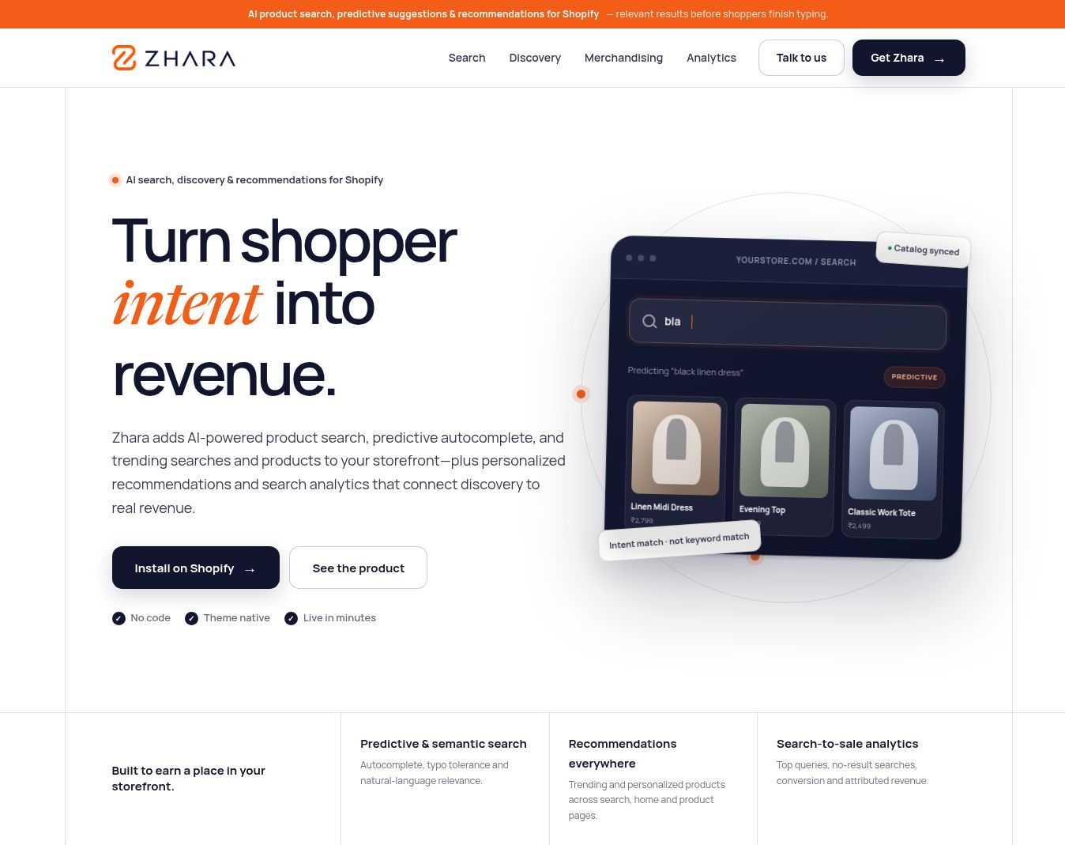

Recommendations
Announcement: Use: "AI product search, predictive suggestions & recommendations for Shopify, with relevant results before shoppers finish typing."
Hero paragraph: Use: "Zhara delivers AI powered product search, predictive autocomplete, trending searches, and product discovery across your storefront, with personalized recommendations and analytics that connect discovery to revenue."
Product proof: Replace "Theme native" with "Matches your theme." Replace "Intent match, not keyword match" with "Matches intent, not just keywords."
Predictive example: Replace "bla" with "black linen dr" and show only dress results. The current input is too ambiguous, and two displayed products do not match the predicted query.

SECTION 02

Search understanding
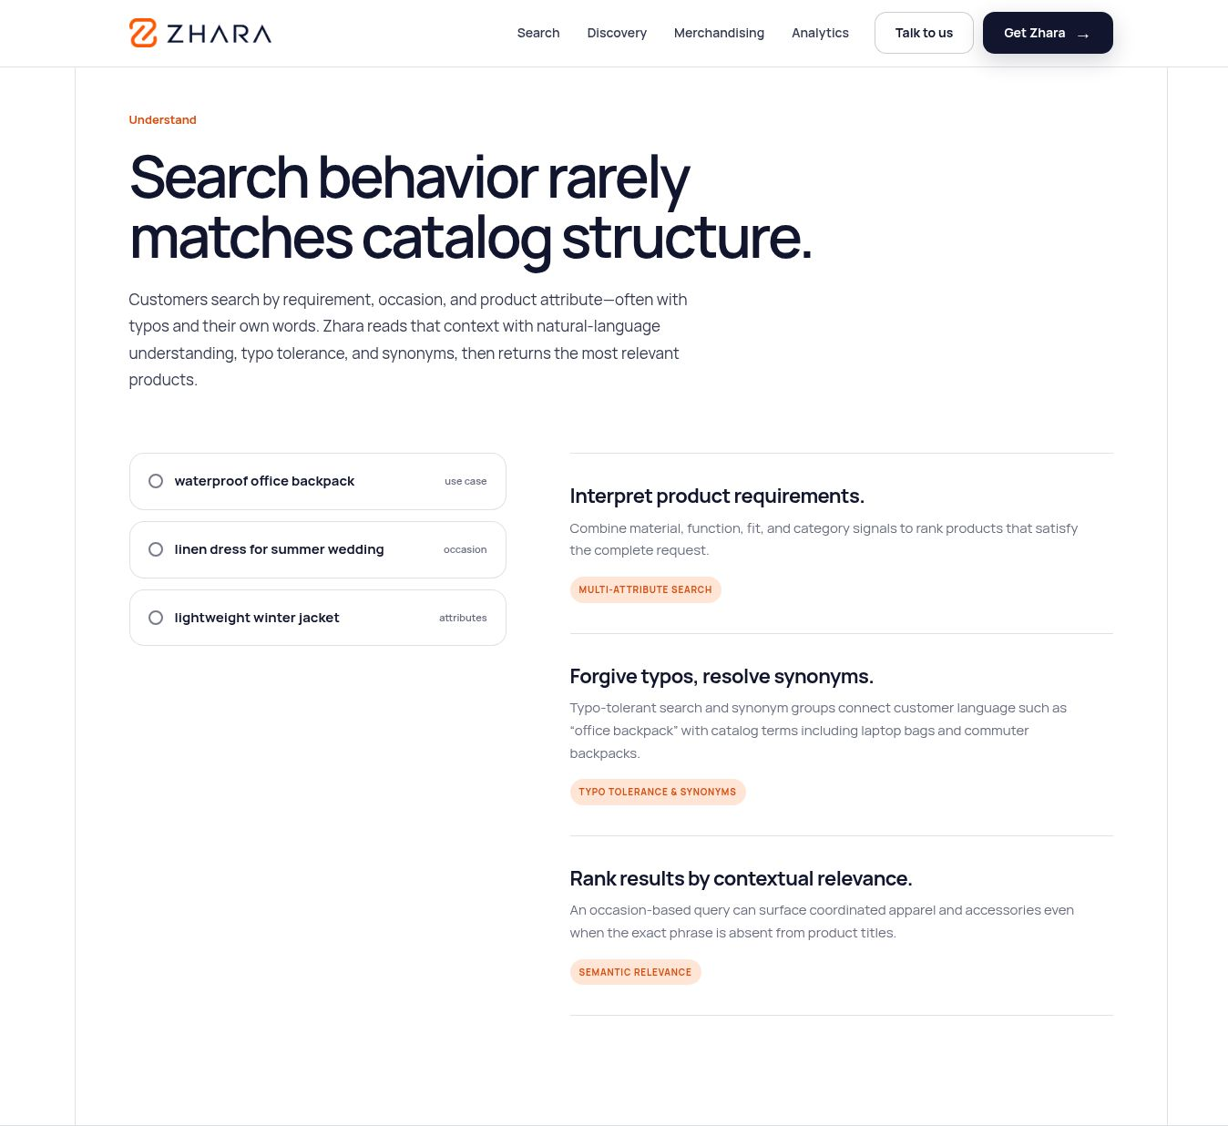

Recommendations
Intro paragraph: Use: "Customers search by need, occasion, and product attributes. They often use typos and their own words. Zhara understands this context through natural language processing, typo tolerance, and synonyms, then returns the most relevant products."
Product requirements: Change "satisfy the complete request" to "satisfy the full request."
Typos and synonyms: Change the heading to "Handle typos and synonyms." Use: "Typo tolerance and synonym groups connect shopper language such as 'office backpack' with catalog terms such as laptop bags and commuter backpacks."
Contextual relevance: Use: "A query for a specific occasion can surface coordinated apparel and accessories, even when the exact phrase does not appear in product titles."

SECTION 03

Product discovery
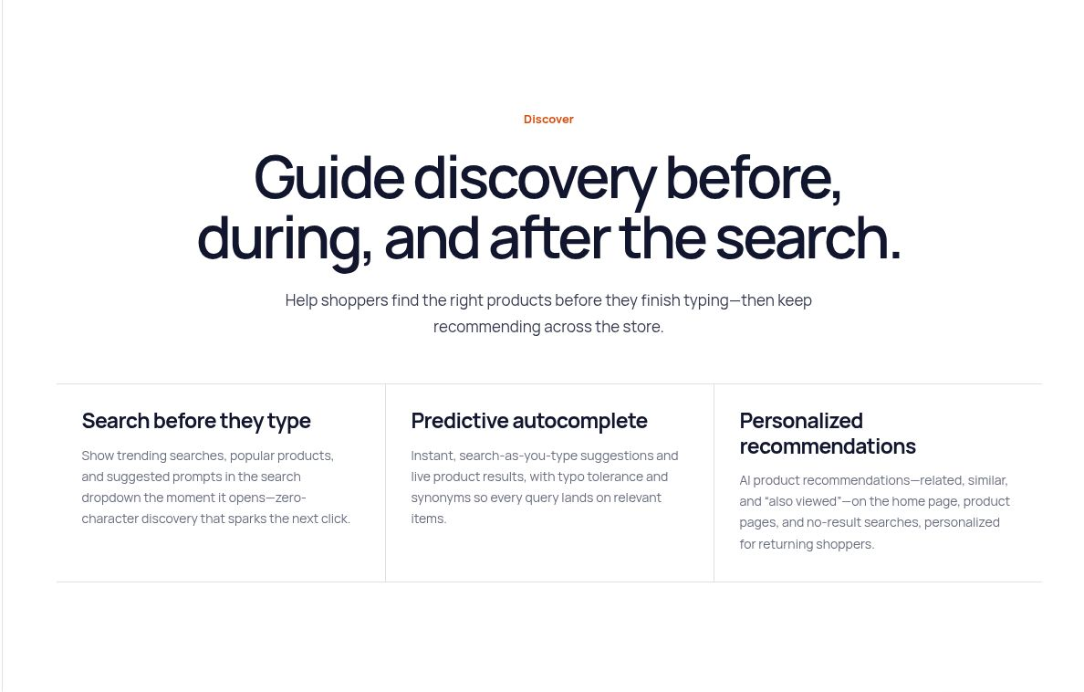

Recommendations
Section intro: Use: "Help shoppers find the right products before they finish typing. Then continue recommending relevant products across the store."

SECTION 04

Merchandising controls
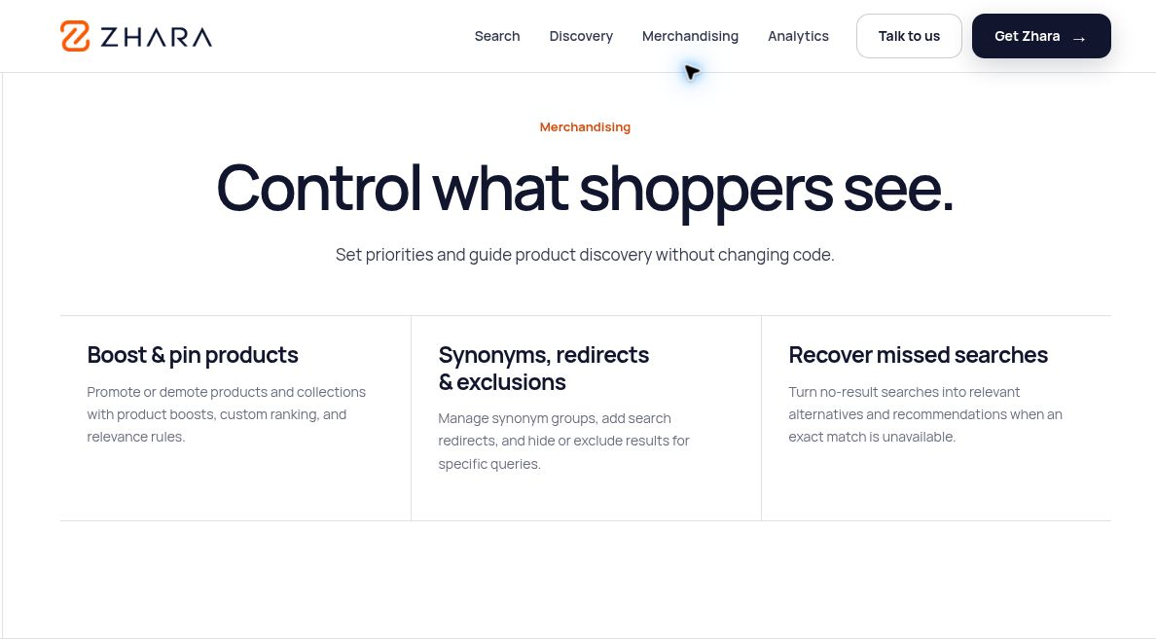

SECTION 05

Analytics and revenue attribution
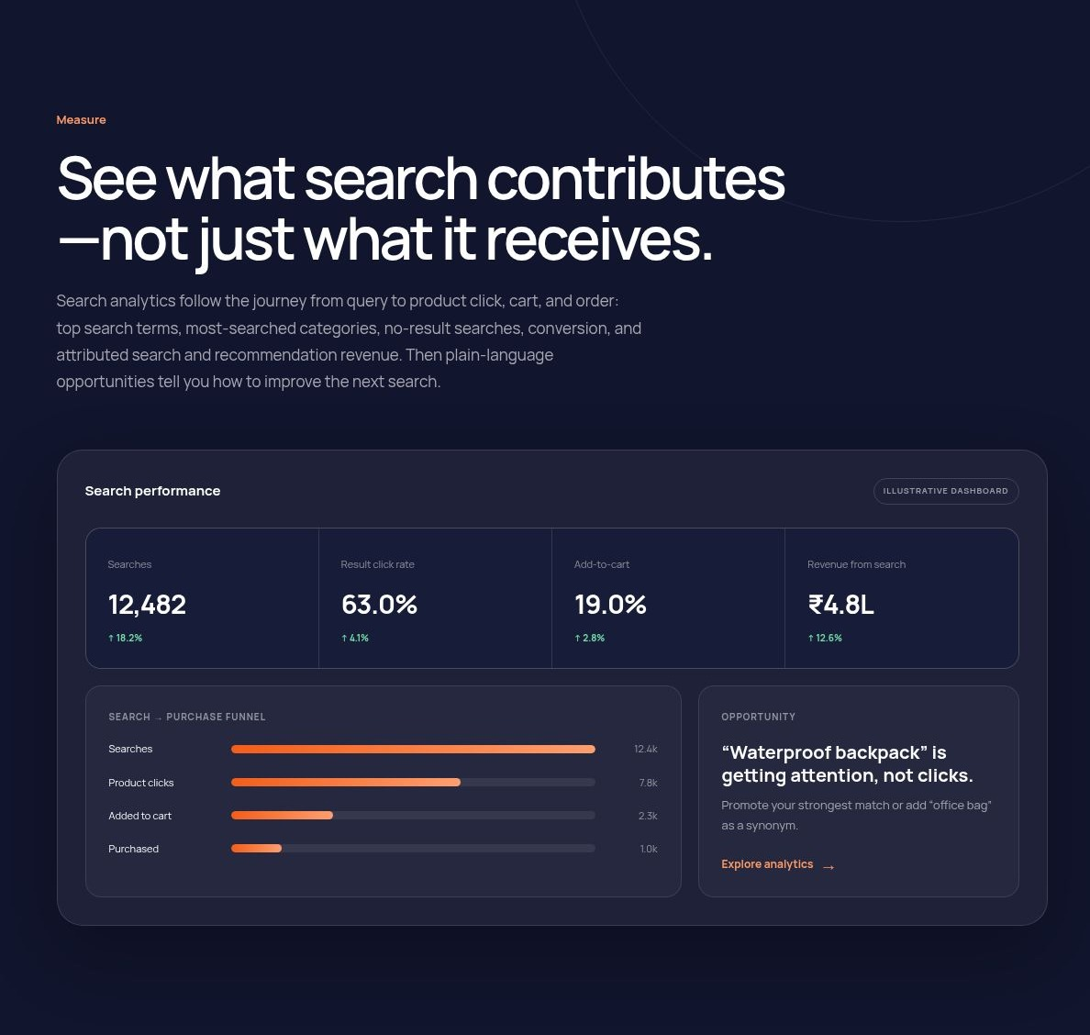

Recommendations
Heading: Use: "See how search contributes to revenue, not just how often shoppers use it."
Analytics paragraph: Use: "Track the complete journey from search query to product click, cart addition, and purchase. See top search terms, popular categories, searches with no results, conversion rates, and revenue attributed to search and recommendations. Clear recommendations then show you how to improve future search performance."
Funnel accuracy: The dashboard shows 12.4 thousand searches, 2.3 thousand cart additions, and 1 thousand purchases. Those numbers equal approximately 19 percent and 8 percent. However, the orange bars visually represent approximately 28 percent and 14 percent. The bar lengths do not match the displayed numbers.

SECTION 06

Trust and evaluation
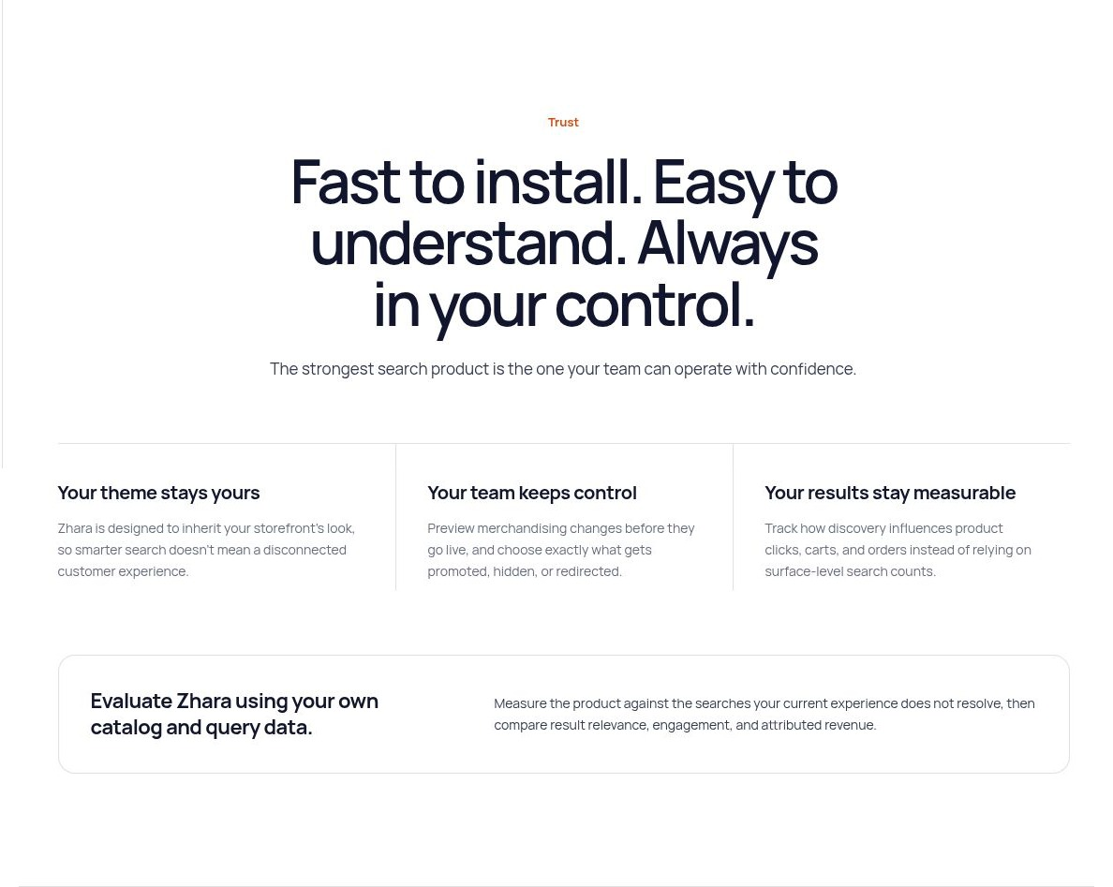

Recommendations
Measurable results: Use "product clicks, cart additions, and orders" instead of "product clicks, carts, and orders."

SECTION 07

Installation and activation
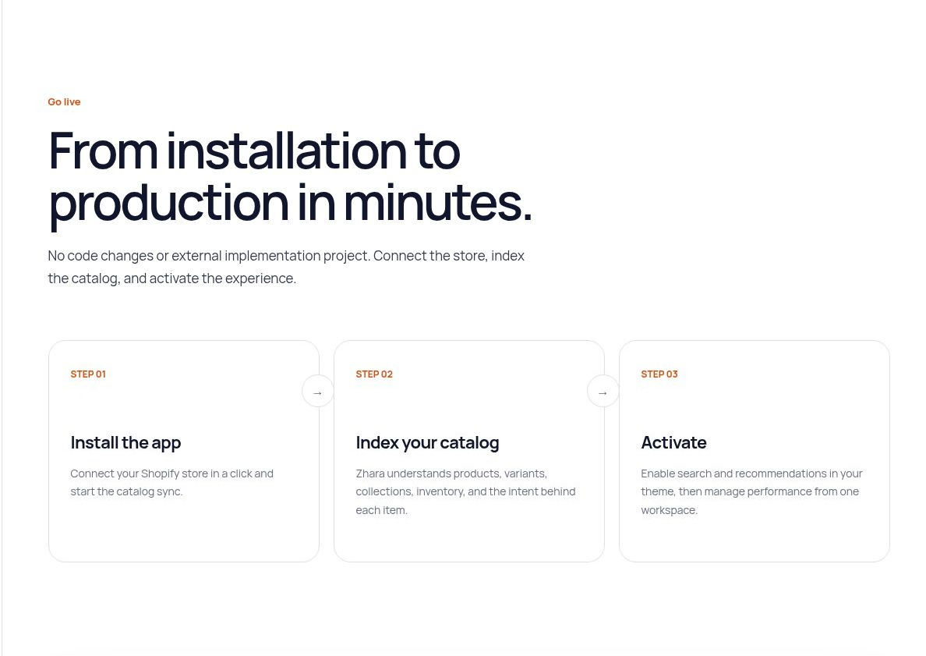

Recommendations
Section intro: Use: "You do not need to change code or manage an external implementation project. Connect your store, index the catalog, and activate the experience."
Installation step: Change "Connect your Shopify store in a click" to "Connect your Shopify store with one click."
Catalog step: Use: "Zhara indexes products, variants, collections, and inventory so it can match products to shopper intent."
Timing claim: Keep "in minutes" only if this is accurate for typical stores. Otherwise use "Go live quickly" to avoid an unsupported promise.

SECTION 08

Final action and footer
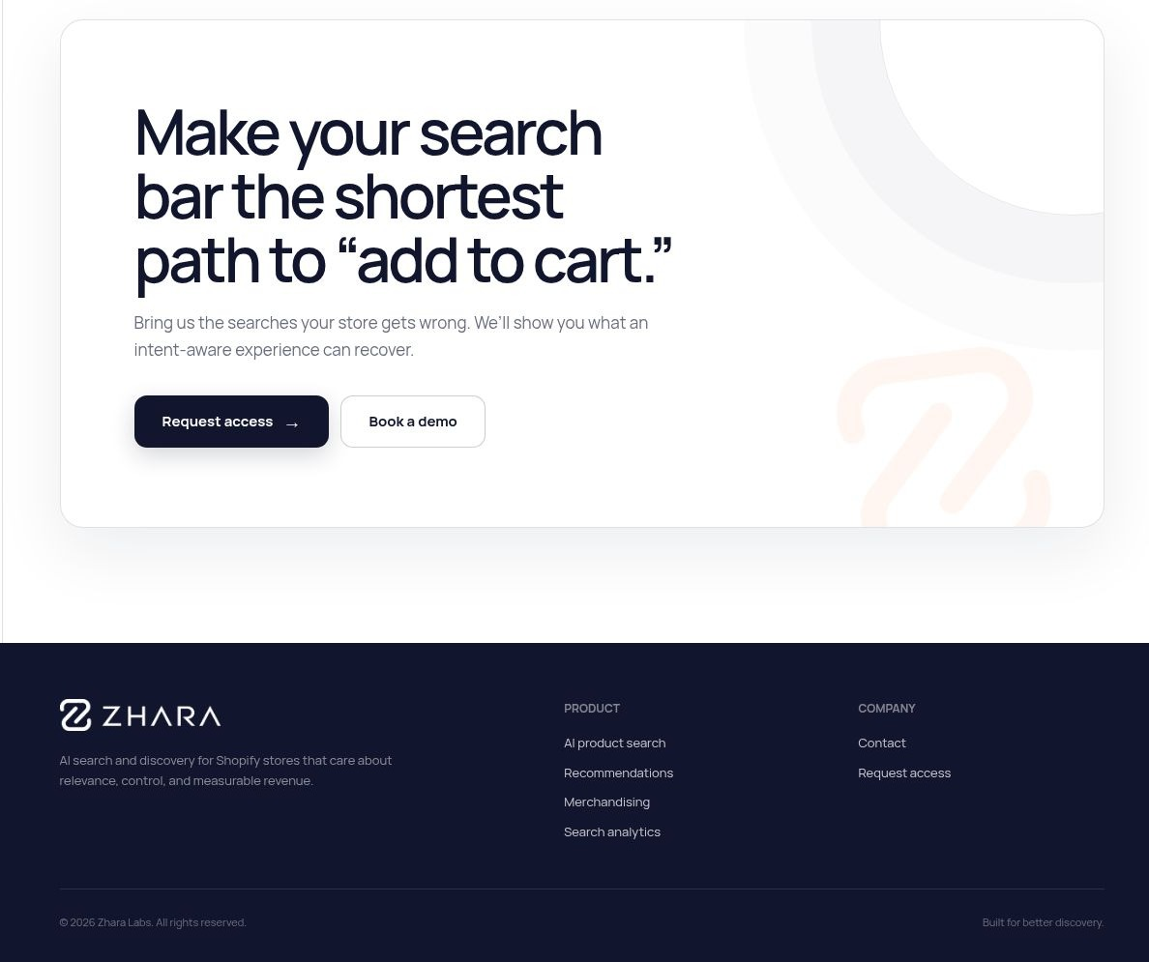

Recommendations
Final heading: Use: "Make your search bar the shortest path to purchase."
Final paragraph: Use: "Show us the searches your store gets wrong. We will show you how AI powered search can turn missed searches into sales."

