- Show the journey of devops from traditional waterfall model

1)Waterfall model
Requirements

Design
Devloment

Test
Release

maintenance

2)Journy of Devops from Waterfall Model

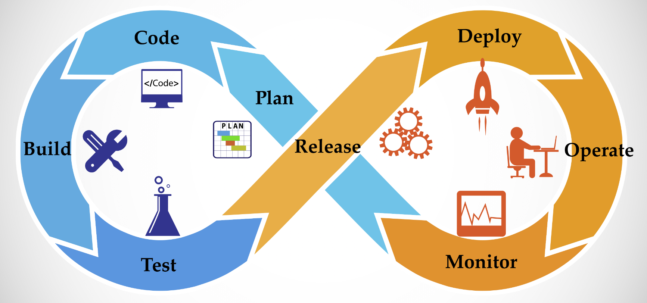
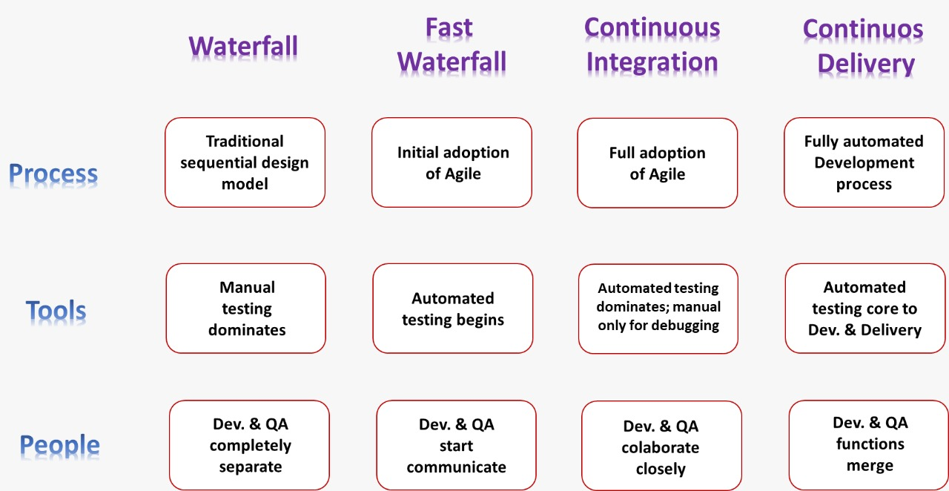

2. Advantages of devops over agile development
1) The differences between these models will starts after development of the project. Agile methodology always talks about software development,testing and deployment. Once deployment completed agile methodology has no role. But Devops model will continue after deployment also and it is also responsible for operations and monitoring.
2) In Agile Model, separate people are responsible for developing, testing, and deploying the software. But, in DevOps, the DevOps engineer is responsible for everything; development to operations, and operations to development.
3) Agile model won't force us to use automation tools. But devops model is completely based on automation.
4) Agile model always giving highest priority for speed, where as Devops giving proirity for both speed and automation.
5) In Agile, client is responsible to give the feedback for the sprint. But in Devops, immediate feedback is available from the monitoring tools.

3. Benefits of using the devops
1. Faster Delivery
2. Stable Operating Environment
3. Improved Effectiveness
4. Collaboration between Teams
5. Defects Correction
6. Digital Transformation
7. Enabling Business
8. Business Agility
9. Visibility to Run Modern Applications
10. Innovation
11. Continuous Delivery
12. Quality
13. Reduced Risk of Change
14. Optimizing the Processes

4. Explain lifecycle of devops
1. Plan: In this stage, teams identify the business requirement and collect end-user feedback. They create a project roadmap to maximize the business value and deliver the desired product during this stage.
2. Code: The code development takes place at this stage. The development teams use some tools and plugins like Git to streamline the development process, which helps them avoid security flaws and lousy coding practices.
3. Build: In this stage, once developers finish their task, they commit the code to the shared code repository using build tools like Maven and Gradle.
4. Test: Once the build is ready, it is deployed to the test environment first to perform several types of testing like user acceptance test, security test, integration testing, performance testing, etc., using tools like JUnit, Selenium, etc., to ensure software quality.
5. Release: The build is ready to deploy on the production environment at this phase. Once the build passes all tests, the operations team schedules the releases or deploys multiple releases to production, depending on the organizational needs.
6. Deploy: In this stage, Infrastructure-as-Code helps build the production environment and then releases the build with the help of different tools.
7. Operate: The release is live now to use by customers. The operations team at this stage takes care of server configuring and provisioning using tools like Chef.
8. Monitor: In this stage, the DevOps pipeline is monitored based on data collected from customer behavior, application performance, etc. Monitoring the entire environment helps teams find the bottlenecks impacting the development and operations teams’ productivity.5. Various tools used for each phase of devops

5. Various tools used for each phase of devops
1. Gradle

A reliable build tool is needed for your DevOps tool stack. Until 2009, when Gradle showed up, Ant and Maven were the pioneers of the automated build tools. The versatility of Gradle allows you to write code in any language such as Java, Python, C++, and so on. Eclipse, NetBeans, and other IDE’s also support Gradle. A Groovy-based DSL instead of XML is used by Gradle to describe the build tools. Scripts would also be written in Kotlin. The Maven’s repository format is used by Gradle, which includes the familiarity with dependency management. It has decent compile-time and incremental builds. Gradle is faster than Maven by hundred times because of cache and daemon. Shipping is faster in Gradle as well.
2. Git

Git is widely used in the software industry and is a popular DevOps tool. The open-source contributors love this source code management tool. You could keep track of your work using Git and find any version necessary. The creation of branches and the merging of features are some of the other features of Git. For people to push their work, repositories need to be hosted, which would allow Git’s integration with the workflow. GitHub and Bitbucket are two of the most common services right now.
3. Jenkins

For many software development teams, the go-to automation tool of DevOps is Jenkins. The different stages of the delivery pipeline could be automated by this CI/CD server. The enormous plugin ecosystem of Jenkins is the reason behind its popularity. From Docker to Puppet, Jenkins could integrate with almost all the tools of DevOps. It has over a thousand plugins.
4. Bamboo

Bamboo is the solution of CI/CD of Atlassian’s, bearing a lot of similarities with Jenkins. The automation of the delivery pipeline could be achieved by both. Unlike Jenkins, Bamboo has a price associated with it. Several manual functionalities in Jenkins are pre-built in Bamboo, which results in lesser plugins than Jenkins, but its out-of-the-box capabilities don’t need that many plugins. Integration with Bitbucket and Jira could be done seamlessly with Bamboo. A lot of configuration time could be saved with Bamboo. The user interface in Bamboo is interactive and intuitive as well. Several features like the tips of the tool, auto-completion, and so on are present in the UI.
5. Docker

Since its inception in 2013, the container platform which has the number one is Docker, and it is still continuously improving. A highly important DevOps tool, the distributed development ability of Docker has made containerization popular in the technological world. The app’s deployment could be also be automated with Docker.
Applications are made secure and portable by isolating them into separate containers. It is Operating system-oriented. It is an alternative to VirtualBox. All dependencies could be shipped as an independent unit using Docker, which takes them away from the hassle of dependency management and making it possible to run the apps on any platform. The delivery workflow could be improved if integrated with Jenkins and Bamboo servers. Cloud providers like Amazon Web Services, Google Cloud have extended support for Docker. Docker can ease the process of cloud migration.
6. Kubernetes

The containerized application’s deployment, scaling, and management could be automated by an open-source system known as Kubernetes; 2019 is the year of Kubernetes. The containerization has been taken to the next level by the Kubernetes platform. It could be easily integrated with other tools like Docker. The idea behind Kubernetes was to manage containers at scale, and thus a solution was found in 2015 by two Google engineers. Containers could be grouped into logical units using Kubernetes.
7. Puppet Enterprise

A configuration management platform that is also cross-platform is known as the Puppet Enterprise. As a code, the infrastructure could be managed by the Puppet tool. The software could be delivered faster and more securely as infrastructure management is automated. An open-source tool for smaller projects could also be provided to the developers by Puppet. Puppet Enterprise’s extra features could be found when dealing with a large infrastructure.
8. Ansible

Similar to Chef and Puppet, a configuration management tool is Ansible. Deployment could be automated, and the infrastructure could be configured using the Ansible tool. Its simplicity and ease of use are the main features compared to other tools. The Puppet’s infrastructure as code approach is followed by Ansible as well. The simple YAML syntax is used by Ansible. Tasks could be defined in Ansible with YAML while there is a declarative advantage in Puppet.
A DevOps monitoring tool that is free and open-source is Nagios. Problems could be found and fixed with the Nagios tool as it helps to monitor the infrastructure. Records of failures, events, etc., could be tracked with the help of this tool. Nagios’s graphs and charts help to track the trends. Security threats could be detected, and errors could be forecasted as a result of this. Nagios’s plugin system makes it stand out for infrastructure monitoring. There is a huge community for Nagios since its emergence in 2002. All translations, tutorials, etc., along with plugins, are also free. The Nagios Core, Nagios Log Server, Nagios XI, and Nagios Fusion are monitoring solutions of Nagios, which are open-source.
9. Raygun

Raygun is a platform that reports crashes and monitors errors. The recent product of Raygun is APM. The performance issues could be diagnosed using the Raygun tool and tracked as well. The problems with the highest priority are identified, and issues are created. Development and Operation are brought together by Raygun and provided the errors and performance problems causes for the whole team by linking errors back automatically to the source code.

6. Difference between DVCS and CVCS
CVCS | DVCS
1) Centralized Version Control System | 1) Distributed Version Control System
2) Central Repository is the only place where everything is stored, which causes single point of failure. If something goes wrong to the central repository then recovery is very difficult. | 2) If something goes wrong to any repository there is a chance to recover. There is no failure because local repository are present and they have backup of data.
3) All commit and checkout operations should be performed by connecting to the central repositoty via network. If network outage, then no version control to the developer. | To perform checkout and commit operations network is not required. Hence if there is any network outage, still version control is applicable.
4) No local operations and every version control operation should be remote operation. | 4) each operatin is local operations and every version control operation should be local repository and this operation pull to remote repository.
5) All commit and checkout operations should be performed by connecting to the central repositoty via network and hence these operations will become slow, which causes performance issues | 5) The checkout and commit operations will be performed locally. Hence performance is more.
6) Oranization of central repository is very complex if number of developers and files increases. | 6) Oranization of central repository is very simple because only latest version is pushed onto remote repository so number of developers and files decreases.

