Privacy-Preserving Multi-Modal WSN for Real-Time Occupancy and Flow Analysis

1. Abstract
This project presents a privacy-preserving Wireless Sensor Network (WSN) for real-time occupancy and crowd flow estimation in campus public spaces such as the labs, mess, gymnasium, and badminton courts. Using a network of TelosB motes and an STM32 Nucleo-F446RE as the sensor interface, the system fuses data from three sensor modalities: millimeter-wave radar, vibration, and acoustic to compute a real-time congestion index for each monitored zone. The system implements TPSN for time synchronization and GEAR for energy-aware geographic routing to the base station.

2. Introduction
Campus facilities such as dining halls, gyms, and courts are routinely overcrowded at peak hours. Camera-based systems can be effective but raise significant privacy concerns and require heavy infrastructure. This project addresses that gap by deploying a WSN that estimates occupancy using only non-identifying physical signals: sound level, floor vibration, and radar-based presence detection.
The system consists of 3–4 TelosB motes: one base station (BS) that aggregates data, and the sensing motes interfaced to the STM32 and all sensors via UART. The STM32 reads all three sensors, computes a weighted congestion index, and forwards it to the sensing mote, which relays it to the BS over the WSN.

3. Sensor Modalities
- Millimeter-wave (mm-wave) radar: A short-range mm-wave radar module detects the presence and movement of individuals.
- Vibration sensor: A vibration/shock sensor mounted on the floor or a structural surface captures footfall-induced micro-vibration.
- Acoustic sensor: A sound sensor measures ambient noise level (SPL) in the monitored space.

4. Hardware Components
4 × TelosB motes (1 base station, 1 primary sensing mote, 2 dummy motes), 1 × STM32 Nucleo-F446RE development board, 1 × millimeter-wave radar module (to be bought), 1 × vibration/shock sensor, 1 × sound/acoustic sensor, connecting wires and breadboard, USB cables for programming and power, 1 × LCD screen module (for base station live congestion display).

5. Overall Design
The STM32 continuously polls all three sensors at a fixed sampling interval. It computes a normalized congestion index CI = α·R + β·V + γ·A, where R, V, and A are normalized radar, vibration, and acoustic readings respectively, and α, β, γ are empirically tuned weights (initially equal). This index is serialized and sent over UART to the primary TelosB sensing mote.
The sensing mote, synchronized to the network via TPSN, appends a timestamp and forwards the packet toward the BS using GEAR routing. The BS receives packets from the sensing mote and the dummy motes, logs them, and displays the live congestion index on the LCD.

Operational cases:
Normal operation: All motes active; BS receives periodic timestamped packets; LCD regularly updates.
High congestion: CI exceeds a threshold; BS flags the zone and triggers an alert output (relay/LED).
Sensing mote failure: GEAR reroutes through available motes if a path exists, BS logs failure.
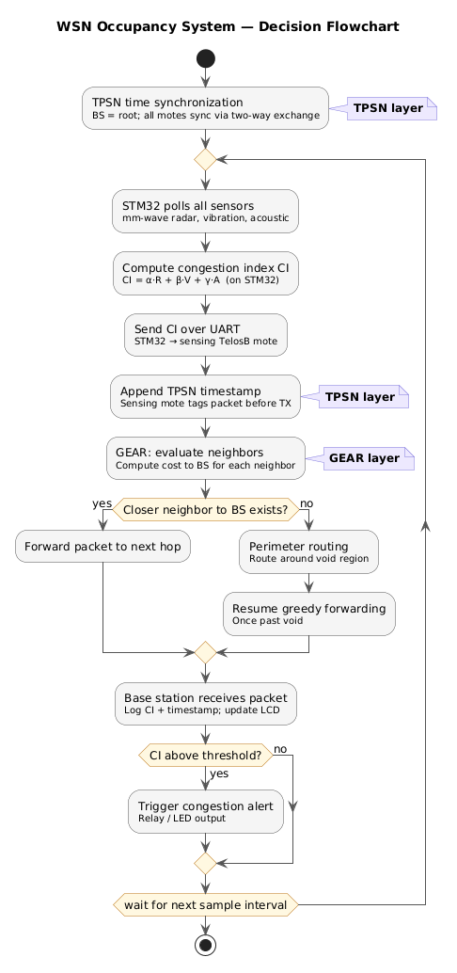
Dummy mote failure: Network load changes; no functional impact on sensing.
Figure 1: Decision Flow Chart

6. Protocol Descriptions
TPSN (Timing-sync Protocol for Sensor Networks): TPSN establishes a network-wide time reference by synchronizing all motes to a designated root node (the BS) using pairwise two-way message exchange. In this project, level discovery is skipped since the BS is manually assigned as root. Multi-modal sensor fusion requires temporally aligned samples from the STM32; without synchronization, acoustic, vibration, and radar readings cannot be meaningfully correlated across time.
GEAR (Geographic and Energy Aware Routing): GEAR routes data packets toward a target geographic region (the BS location) using a combination of geographic greedy forwarding and learned routing costs that account for residual energy. Each mote maintains an estimated cost to reach the BS and selects the neighbour that minimizes this cost. The to-be monitored zones (mess, gym, courts) span distinct physical locations across campus.

7. Conclusion
This project demonstrates that meaningful, actionable occupancy intelligence can be extracted from a lightweight WSN without any compromise to user privacy. By fusing mm-wave radar, vibration, and acoustic sensing at the edge and transmitting only derived indices, the system is practically deployable in real campus environments.

