**Flutter Installation**

Go to   
🡪It gives you rar or zip file. So, just double click it and it will be download.

🡪Extract it.

🡪Set environment variable (Bin folder path).

🡪Flutter doctor

🡪This command tells you which software installed and what you need.

🡪Install android studio.

🡪Tick on AVD.

🡪Start, go below configure -> SDK manager. (Don’t use path with spaces)

🡪android emulator

🡪android SDK build-tools

🡪android SDK platform-tools

🡪Android SDK tools

🡪Google USB driver

🡪Intel *86 Emulator acceleration

🡪You are installing os on top of os, it will reduce the performance. This software accelerate-improve the performance.

🡪configure -> plugins   
 🡪Install dart & flutter

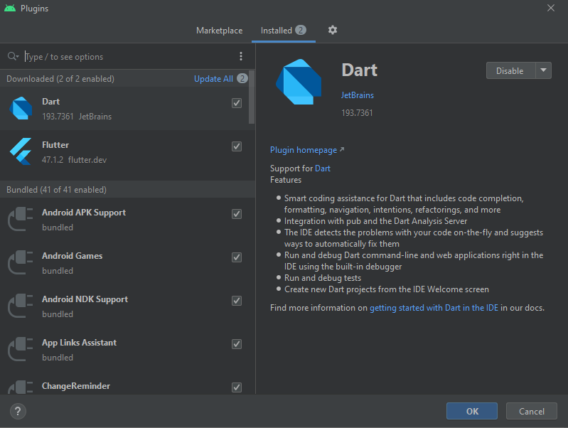

🡪Set path for this.

🡪new path-> ANDROID_SDK_ROOT,path.

🡪variable name=ANDROID_SDK_ROOT

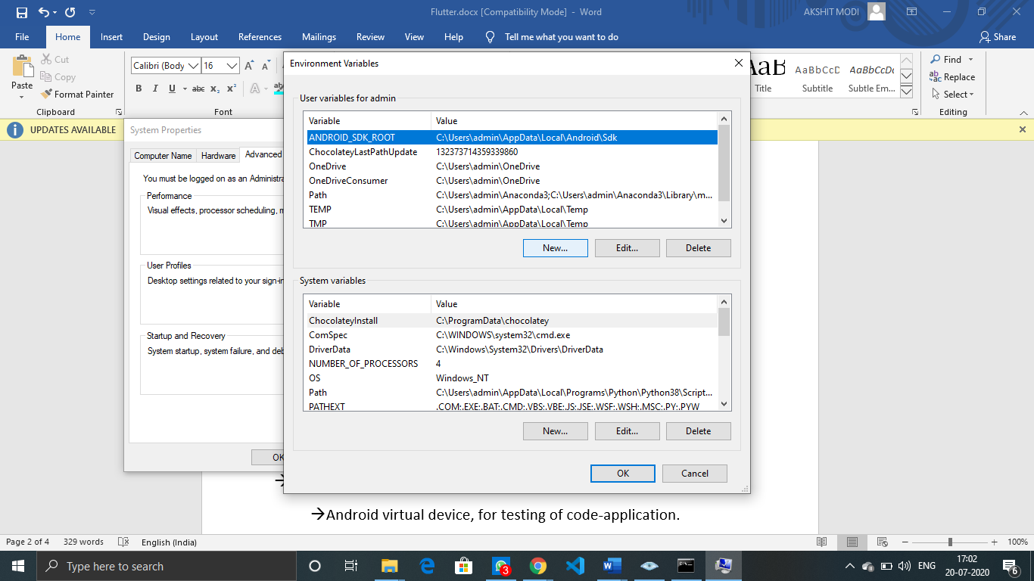

🡪Flutter doctor

🡪flutter doctor --android-licenses

🡪flutter emulators

🡪Go to AVD manager.

🡪Android virtual device, for testing of code-application.

🡪category=phone we use nexus 5X (playstore symbol has playstore installed in mobile).

🡪release=pie

🡪flutter emulators

🡪flutter devices

🡪It only detect running OS.

🡪flutter created one test code – test app for you, so you can know setup is perfectly configured or not.

🡪flutter emulators --launch <device id>

🡪flutter create test_app

🡪flutter run

🡪In android we use **gradle** as a build tool

🡪Without this you cannot build, create apk.

Why flutter is fast?

1. Development is fast.

🡪language is simple, small code can do multiple things.

🡪One single code run in multiple platforms.

🡪It provides hot reload.

🡪If you change something on the code, it will detect and only compile that part (not complete code) and within some second.

🡪press r and within millisecond your app launch (change on the fly).

1. App is fast.

🡪it uses skia engine, graphic rendering engine.

🡪When you want to convert your mobile app code into the Android app there is two way.

🡪you need android SDK.

🡪Here instead of SDK we use IDE (android studio) (It also give SDK).

🡪Flutter has 3 IDE.

🡪VS Code

🡪Intellij

🡪Android studio.

🡪Here we use VS Code. We install android for getting some tools.

🡪Here when ever you press ctrl s it will do hot reloading.

🡪install plugins

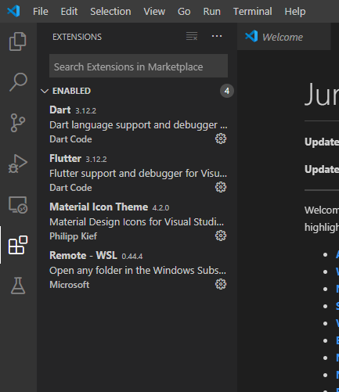

**Run app inside your phn**

Enable developer mode  
🡪 Go to settings -> about phone -> software information  
 ->press multiple time at build number (samsung)

->MiUI version (redmi)

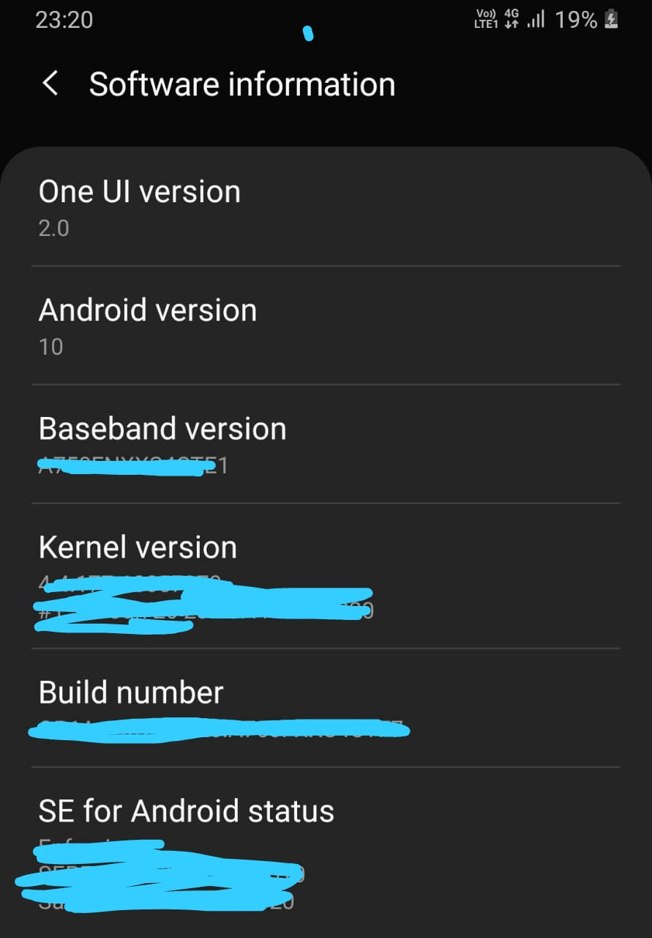

🡪It popup developer mode enable.

🡪now one more option (developer option) come inside setting.  
🡪allow USB debugging inside.  
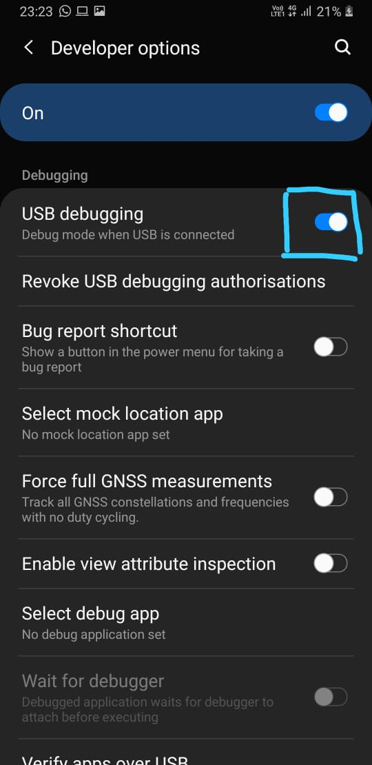  
🡪Connect the cable with laptop.  
 🡪Your cable must have file transfer capacity.  
🡪It asks you allow USB debugging, allow it.  
 🡪Now it will use mobile ram, CPU

**Dart Language**

🡪For using dart you have to install dart interpreter.  
 🡪go to <https://dart.dev/get-dart> and get dart then download it (250mb).  
 🡪double click and extract in same folder of flutter.  
 🡪create path for this.  
 🡪User variable ->path ->copy path till bin  
🡪 dart --version

🡪dart uses DVM (dart virtual machine).  
🡪give .dart extension (not compulsory).  
🡪For running this use… dart demo.dart  
  
🡪Instead of writing all the the code in one file, use functions.  
 🡪create multiple files for multiple functions.  
 🡪for this import files inside main file.  
 🡪This extra files are known as module.

🡪In this module functions are known as methods.  
🡪flutter is a framework; someone has created modules and you can use them.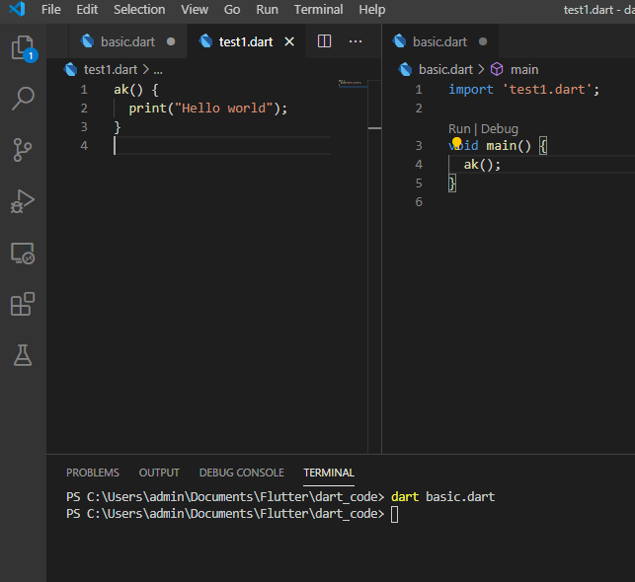🡪Sample demo of today’s class.