1. Whoami  
   🡪It gives you username.
2. Uname  
   🡪 it gives informatiob about OS.

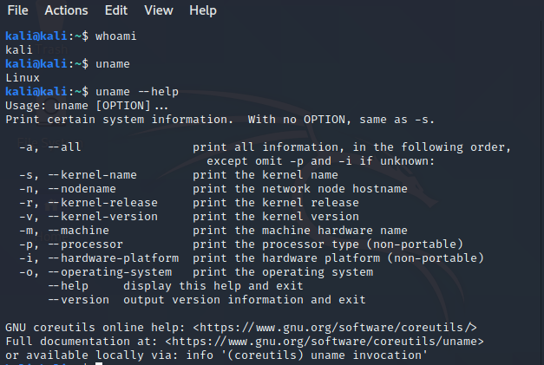

1. Pwd  
   🡪It gives you path.
2. ls
   1. Ls  
      🡪 list all files and folder.
   2. Ls -l  
      🡪 long list.  
      🡪 show size, when it is created.
   3. Ls -a  
      🡪 list all (hidden + showable).
   4. Ls -al  
      🡪Both hidden with long list.
3. Clear

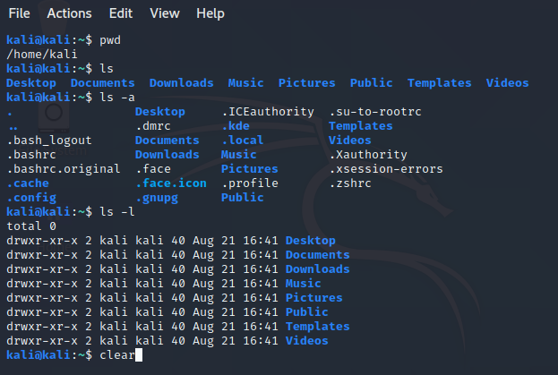

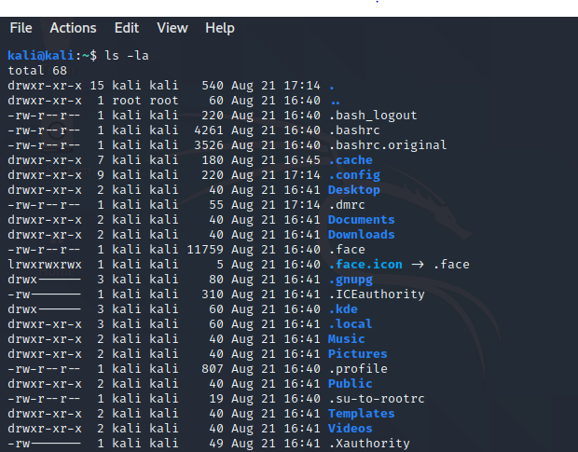

1. Mkdir
   1. Mkdir <foldername>  
      🡪 Create a directory.
   2. Mkdir -p kesha/akshit/sanvi  
      🡪 create directory inside directory.  
      🡪folder inside folder.
2. Cd
   1. Cd <filename / foldername>  
      🡪Go inside file / folder.
   2. Cd <name> / <name> / <name>   
      🡪Go inside multiple folder.
   3. Cd ..  
      🡪Go one directory back.
   4. Cd ../../  
      🡪Go multiple directory back.

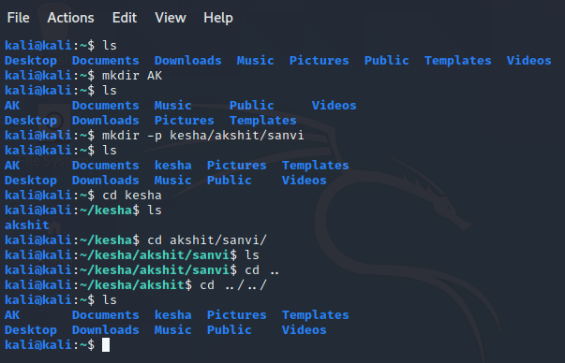

1. Touch <filename>  
   🡪 create empty file.
2. Vim <filename>  
   🡪 create file if there is no file and open file.
   1. i for insert mode.
   2. Esc for escape sequence.
      1. w to save file
      2. q for exit
      3. wq save and exit.
      4. q! exit forcefully.
      5. yy to copy
      6. p to paste
      7. dd cut/remove
      8. 5  
         🡪go to line 5

🡪vim +20 a.txt  
🡪automatic start from 20 line.

