**TOPIC: PVC(Persistent Volume Claim)**

* Kubectl run p1 –image=httpd
* Kubectl get pods
* Kubectl exec -it -p1 -- bash

🡪Here storage is emphremal

* kubectl delete pods –all  
  🡪Data of pod is gone 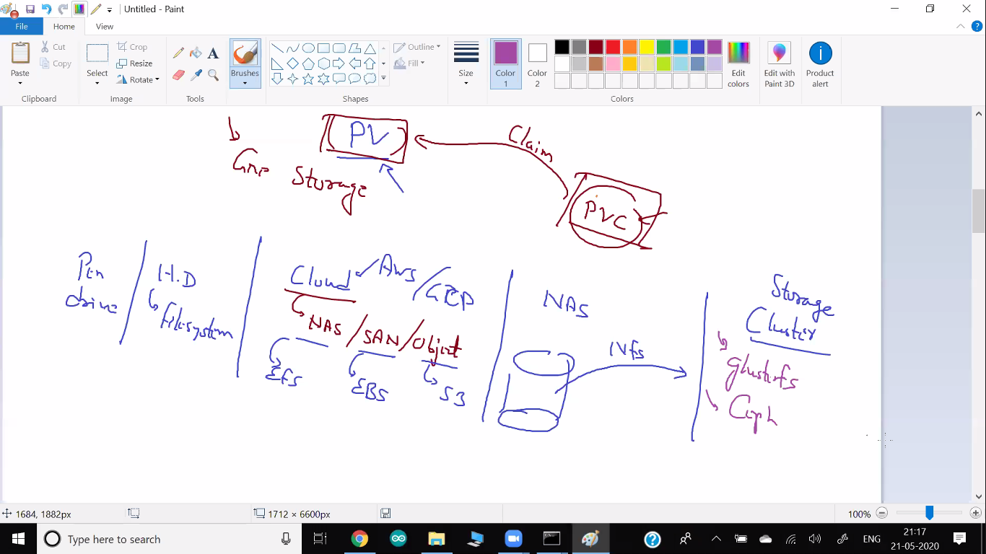

🡪PV – Persistent volume  
 🡪Before pvc you have to create pv.  
 🡪In dynamic pv already created automatically.

* YML code for this.

🡪Kubectl get pvc