Monitoring

* There are mainly 4 ways for monitoring.

1. Profiling
2. Tracer
3. Log
4. Metrics

* For metrics very famous tool in OpenSource world is Prometheus.

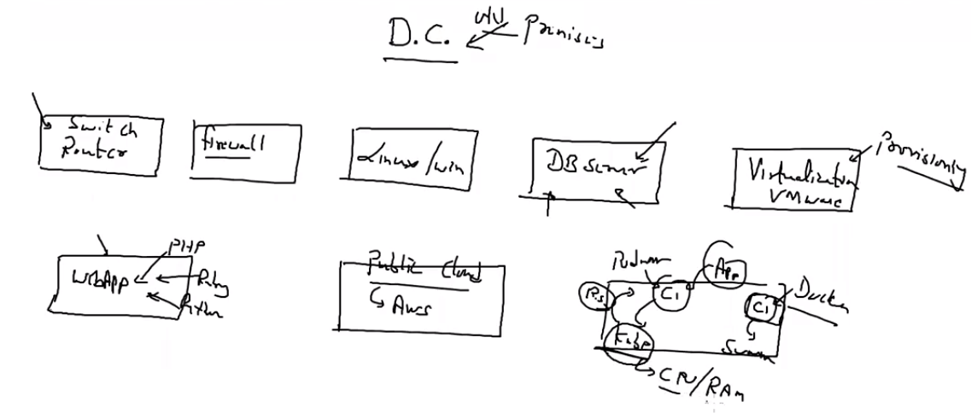

* In company many times we have hydrogenous environment, with big infrastructure.
* Now if something fails then it is harder to track why it is failing, we can relaunch setup again, but we have to also find why our setup is not working.
  + We have to also go to internal level and checking what is the error.
  + For all of this only one solution is keep on monitoring.
* Prometheus is a **metrics Collection** tool.
  + You can also monitor through Prometheus, but we have some great tool for monitor.
  + You can monitor almost all thing using Prometheus.
* Suppose your Prometheus server is running on IP 100, and our target system is 101.
  + Normally target system has agent which collect real time data and push it to the server but in Prometheus server go to agent program and **pull** data from there.
  + By default interval for pull is **15 seconds**.
  + In Prometheus world this agent program is known as exporter.
* Prometheus go to there target node, go to exporter pull / download data and store in their internal storage.
  + This complete process is known as **Job**.
  + Prometheus collect data in real time and also store time along with data in the table.
  + This kind of database is known as **Time Series database**.
  + For doing query from this DB we have to use promQL language.
* You can download it for linux from <https://github.com/prometheus/prometheus/releases/download/v2.28.0/prometheus-2.28.0.linux-amd64.tar.gz>
* You can download exporter from this site also.
  + Linux node exporter = <https://github.com/prometheus/node_exporter/releases/download/v1.1.2/node_exporter-1.1.2.linux-amd64.tar.gz>
* For starting the server you have to extract this file go inside folder and run **./Prometheus**.
  + Prometheus also has one **WebUI** which will run on port 9090.
* Extract node exporter in target node.
  + Run ./node_exporter
* In other world agent program is keep on running, but here when someone ask it to run then only it will run.
  + Prometheus **scrap** data before storing into database.
* You can add target node in Prometheus config file.

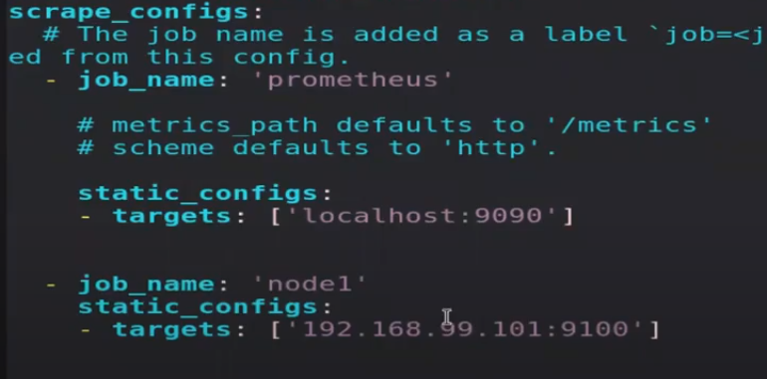

* We can use monitoring for different things.

1. Troubleshooting
2. Decision
3. Tuning

* Here we want to use docker as our target node, but Prometheus does not support any type of exported for docker.
  + So you have to do one thing.
  + Go to /etc/docker/daemon.json
  + Add follow commands.
    - {
    - “metrics-addr”: “192.168.43.100:3434”,
    - “experimental”: true
    - }
  + Systemctl restart docker

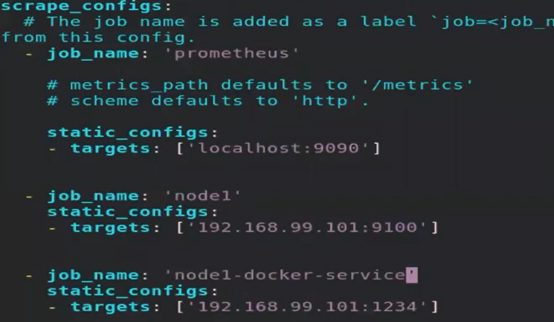

* You have changed something in the config file, so you have to press ctrl + c.
  + But it will terminate the process and some downtime come to Prometheus client.
  + So instead of this we can reload the process, for this first get process ID.
    - Ps -aux | grep Prometheus
    - Kill -HUP <process_id>
      * -HUP is for reload process.
  + Now you refresh site then on the fly one more node has been added.
* For monitoring / visualize we use one more tool with Prometheus.
  + Name of this tool is Grafana.
  + You can download Grafana using,
    - wget <https://dl.grafana.com/oss/release/grafana-8.0.3-1.x86_64.rpm>  
      sudo yum install grafana-8.0.3-1.x86_64.rpm
  + After this follow these commands.
    - Systemctl daemon-reload
    - Systemctl start Grafana-server
    - Systemctl enable Grafana-server
  + Default,
    - Port = 3000
    - Username = admin
    - Password = admin