EFS

🡪Here NFS protocol used.

🡪In aws NFS server known as mount target.

🡪EFS is a regional service.

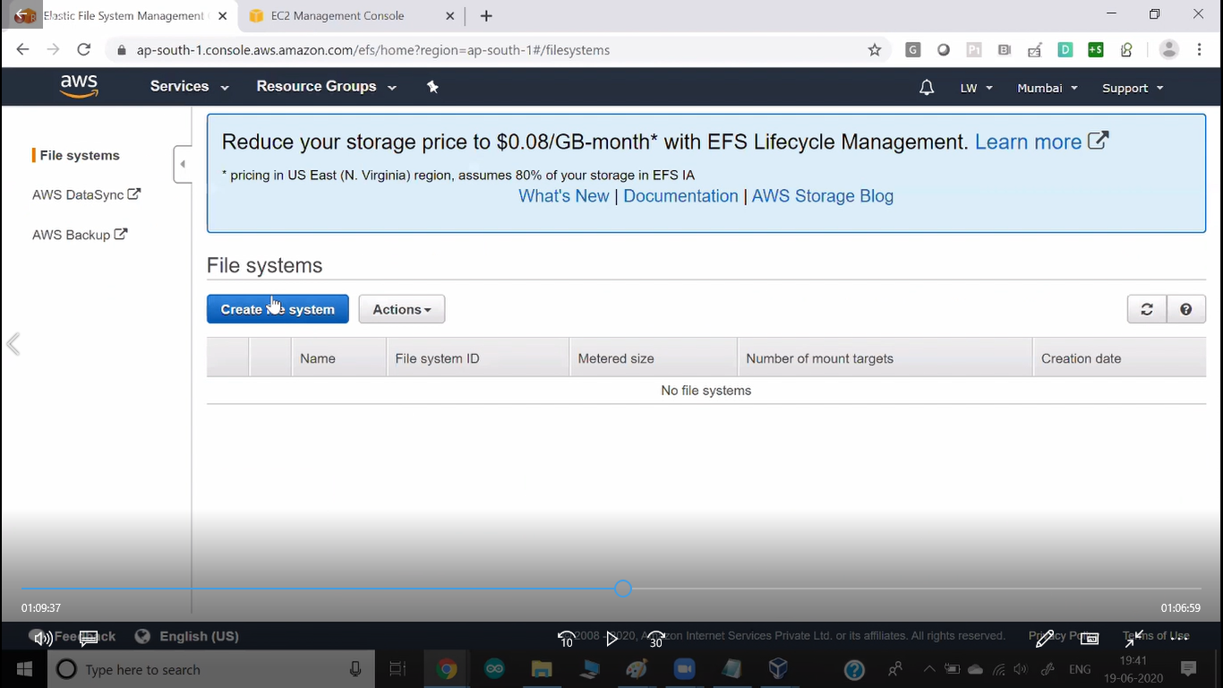

🡪Create SG enabled NFS protocol.

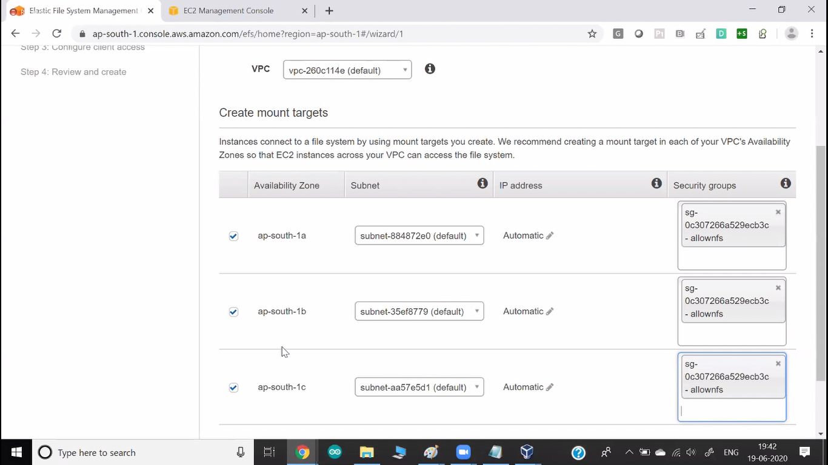

🡪In next slide do not change anything. Press net step.

🡪Click next.

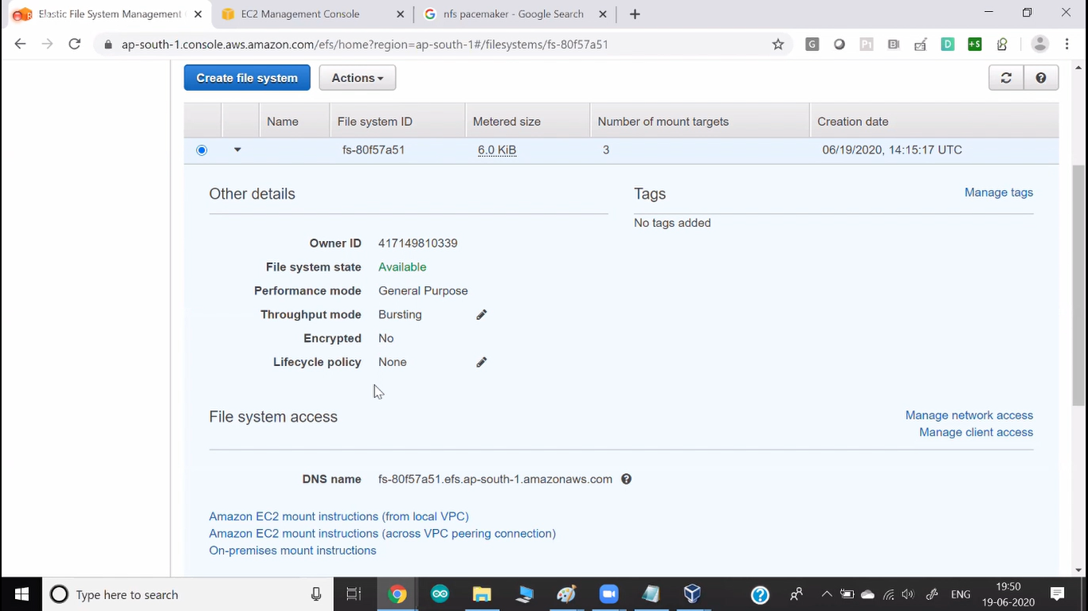

🡪You can use DNS name to manually mount.

🡪For additional info see efs inside storage file.

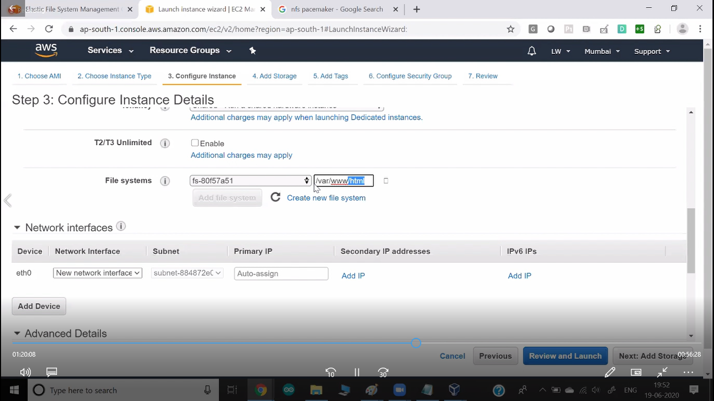

🡪Here you can attach (Mount) this EFS server.

🡪You can give the folder name where you want to mount.