* IF you want to implement k8s we have to ways.
  + Manage by own
  + Manage by some cloud provider
* EKS stands for Elastic Kubernetes Services, it is fully managed service by AWS.

First lets talk little bit about docker and k8s.

* For launching any app or web we require OS (Env), here we can use power of docker.
  + With the help of docker we can launch any env within a second.
  + Docker is also a software so we require some base OS to run this software.
* We can also provide base OS things using AWS Ec2.
* But here one problem is if base OS goes down due to any reason our app fails, so for solving this we create cluster of multiple OS and manage this using Kubernetes.

Google & azure also have same services like GKE and AKS.

**Custom requirement & auto scaling**

* Suppose you want 3 worker node with t2.small.
  + You just have to tell this thing to EKS and in just one click it will launch complete cluster for you.
  + Master is fully managed by EKS.
  + If you ask EKS to launch 3 worker nodes, it will launch 3 nodes in different az.
* EKS has high availability setup for master.
* We have to create a new user for programmatic access.
  + We can use aws eks list-clusters to check all clusters.
  + **AWS eks command don’t have much options, so instead of this we have one more command eksctl.**
  + It has many options, for downloading this
    - curl --silent --location "https://github.com/weaveworks/eksctl/releases/latest/download/eksctl_$(uname -s)_amd64.tar.gz" | tar xz -C /tmp
    - sudo mv /tmp/eksctl /usr/local/bin
  + also set path for this command.
* Master Node completely managed by AWS from auto scaling to HA.
  + But for worker node you have to tell what you want.
  + And for this you have to create a script.
  + Notepad cluster.yml

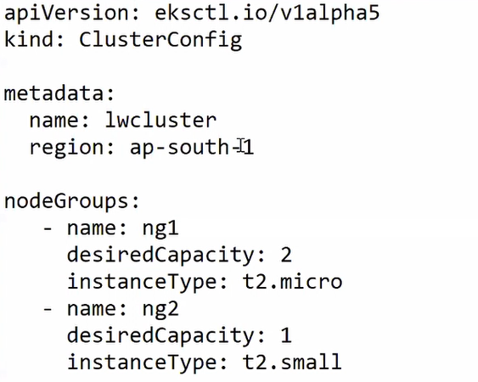

* + Eksctl create cluster -f cluster.yml
* Behind the seen eksctl connect to cloudformation and create stack there.
  + They will not show you master node.
  + You can give SG name so you can connect to cluster.

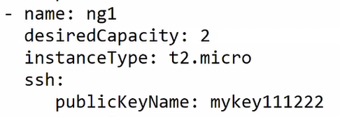

* For connecting to cluster we have to use kube config file.
  + Aws eks can auto create this file for you.
    - **Aws-eks update-kubeconfig –name lwcluster**
  + Now you can use kubectl commands and run your cluster.
  + If you want to change namespace as a best practice you have to use this command.
    - **Kubectl config set-context --current --namespace=lwns**
    - This will update kube config file.
* To check cluster is working properly or not.
  + **Kubectl cluster-info**
* Here we can do one more thing.
  + We have external load balancer, and here we can directly use ELB facility here.
  + This load balancer has capacity to get which cloud we are using and automatically launch their respective load balancer (ELB).
    - By default, ELB type is classic.
    - ELB have public facing IP to connect to cluster.
* Kubectl expose deployment myweb --type=LoadBalancer --port=80

**How to change any page outside the pod?**

* We cant connect to instances because we don’t have given key.
* Still we can connect to pod using,
  + kubectl exec -it myweb-9686hs bash
* if you want to change one of the page of pod, you can overwrite page from outside the pod also.
  + Kubectl cp index.php IP:/var/www/html
    - Can multiple pod change using if we change deployment?

**How to take storage from EBS & connect to pod.**

* But we know pod has a temporary storage, so instead of this we want to use EBS volume as a external HD.
  + For this we have to use **persistent volume/ Storage class** concept.
  + By default EKS has created SC namely Gp2, we just have to configure it.

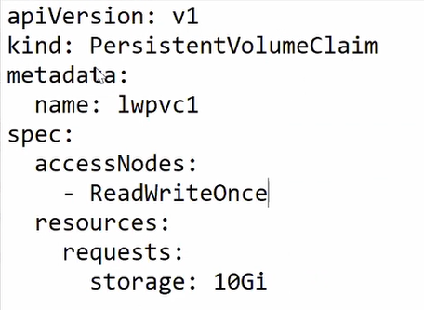

* + So we have to create a PVC claim and on the fly PV will be created.
    - And PV get storage from GP2 (EBS).
    - Kubectl create -f pvc.yml
  + But you can see PV is still not created. Actually in gp2 description you can see it will be created when consumer request.

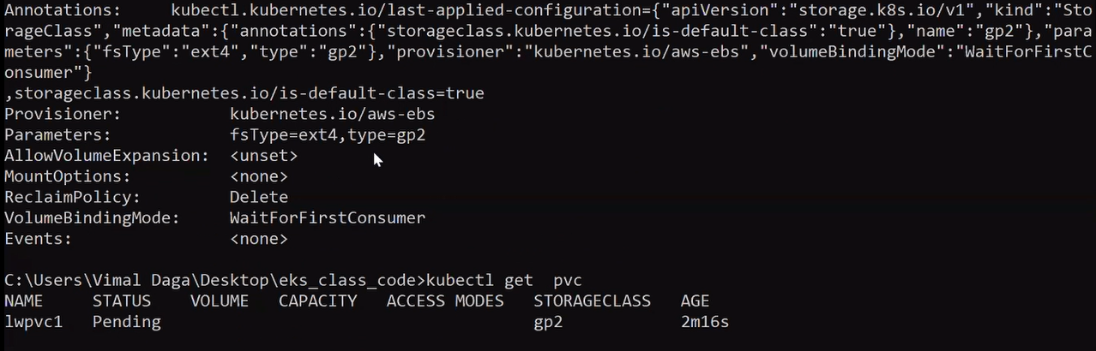

* + So for this your pod or deployment has to request storage from ebs.
  + For this you have to edit deployment, in specification you have to add volumes and in containers block you have to mount it with any folder.

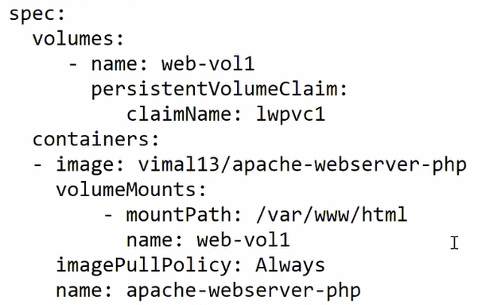

**How to use different EBS type?**

* When you describe SC, there you can see that, our default EBS type is set to gp2, but we can also change this.
* For this you have to create a storage class and mention which type of EBS you want to use.
  + Here by default **reclaim policy** is delete so as soon as you delete PV, storage (EBS) is also deleted.
  + But for safety lets use reclaim policy called retain at this time.
  + Lets create SC for this.

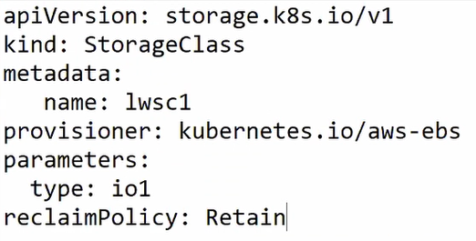

* + So for this you have to add storageclassname in pvc.yml

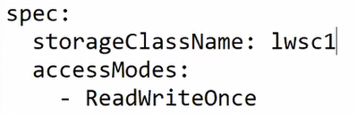

Try to connect all worker node in different AZ.

Master Node completely managed by AWS from auto scaling to HA.

EKS has pre-created AMI.

<https://drive.google.com/drive/folders/1uXCcwI_jF0Qknftf29rWhzEct-MTU_mn>