OpenStack

🡪It is open source software.

🡪Oppenstack is stack of services.

🡪In aws – public cloud you can not able to know what is going behind the seen.

🡪They don’t provide you software.

🡪But in private cloud world --openstack we can get the code and know what is happening behind the seen.

🡪We have to use our own resources.

🡪You can think cloud computing as a one layer – one program.

🡪Instead of contacting different different component and learning about them. This one layer is contact with them and give you resource.

🡪Eg. For storage Dell emc, and many other platforms are available, so instead of learning about them. This program behind the seen go and get storage for us.

Configuration

🡪Here we are using redhat flavour of openstack.

🡪Install redhat (7.5) CLI.

🡪Go for minimal installation and disable kdump, give atleast 6 GB ram, 2 CPUS, 40 GB HD (12, 4 CPU,50 recommended).

🡪mount /dev/cdrom /dvd

🡪For permanent use /etc/rc.d/rc.local

🡪chmod +x /etc/rc.d/rc.local

🡪configure yum repo for base dvd.

🡪Use winscp and transfer that three iso files inside redhat.

🡪Mount all the iso files inside some folder so we can go inside iso file.

🡪Mount three iso file in three different folders.

🡪Now copy all the software from three folders to one single folder (/software).

🡪configure yum for this.

🡪configure same dvd.repo file baseurl=file:///software, make gpgcheck=0

🡪yum install createrepo

🡪createrepo -v .

🡪From software folder.

🡪Your yum repo has folder inside another folder.

🡪For this you have to crate database for yum of that files.

🡪yum clean all

🡪Yum use some cache data so clean it.

🡪Now check yum repolist, there is around 7000 software.

🡪Yum install openstack-packtack

🡪Openstack is not compatible with one system so stop it.

🡪systemctl stop NetworkManager.

🡪systemctl disable NetworkManager

🡪Set local hostname.

🡪vi /etc/hosts

🡪192.168.43.202 openstack

🡪make ip permanent

🡪For making IP permanent

🡪 cd /etc/sysconfig/network-scripts/

🡪 vim ifcfg-enp0s3

🡪Change 4th line to static

🡪 BOOTPROTO="static"

🡪After this add below command at bottom.

* IPADDR=192.168.43.202

NETMASK=255.255.255.0

GATEWAY=192.168.43.1

DNS1=192.168.43.1

🡪yum install python-setuptools

🡪packstack --gen-answer-file=a.txt

🡪Generate this only one time, else it will not run.  
🡪If you want to generate second time then remove /root/.ssh complete folder.

🡪packstack is a command helps us to install entire openstack cloud.

🡪You can go inside and give yes or no option

🡪In this lec. we change swift,cellometer,AODH to no.

🡪We are performing lots of copy operation, so it creates lots of cache.

🡪Remove this cache, so we can get more ram.

🡪Use free -m so you can show your rame usage.

🡪echo 3 > /proc/sys/vm/drop_caches

🡪packstack --answer-file=a.txt

NOVA

🡪OpenStack, they support Qcow2 image.

🡪Glance is a one of the services for manage images.

🡪For login through WebUI, use your IP address in browser.

🡪source keystonerc_demo

🡪Use this to login using CLI

🡪This file contains user-id, password for demo account.

🡪glance image-list

🡪glance image-show <imageid>

🡪nova flavor-list

🡪It will manage compute for you.  
 🡪It us launch instance for you.

🡪nova list

🡪Nova is one service and it also has a stack of services.

🡪nova service-list

🡪nova boot --flavor m1.small --image fedoralinux32 --nic net-name=private myos10

🡪All the major log for nova are in nova-compute.log

🡪It is in /var/log/nova file

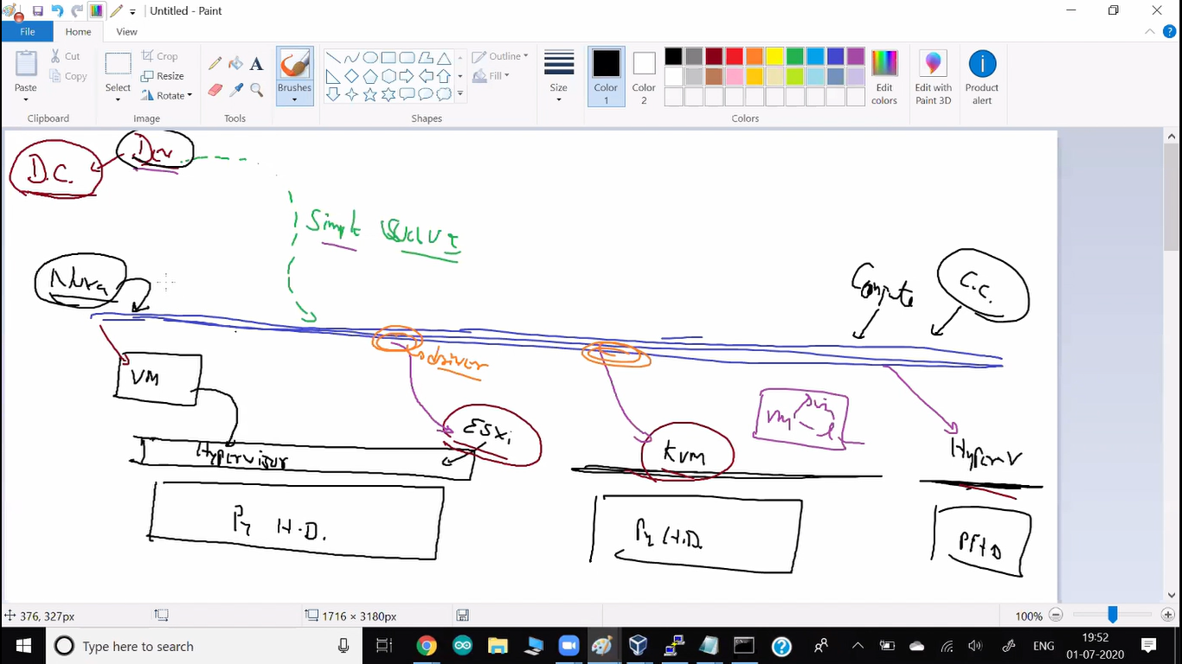

🡪nova know how to launch vm.

🡪They have internal driver to contact to vm.

🡪nova hypervisor-list

🡪openstack hypervisor list

🡪nova hypervisor-show <id>

🡪In our case RHOSP – Qemu kvm running as a hypervisor.

🡪So you can launch vm using Qemu kvm commands also.

🡪virsh list

🡪client connect to the nova – API service.

🡪nova schedular decides where to launch vm.

🡪nova compute program takes the request from the schedular.

🡪neutron net-list

🡪openstack service list

🡪There are two types of hypervisor.

1. type 1

🡪Above physical resouces, one hypervisor running it is known as type 1.

🡪eg. vmware ESxi, hyper-v, kvm

1. type 2

🡪Above physical resources, your OS is running and above that hypervisor running.

🡪Eg. Qemu-kvm, oracle vbox, vmware.

1. There is also type 0 hyperviser.

🡪Here you don’t need any OS and also you don’t need any hypervisor.

🡪Directly on the top of your resouces, multiple vm can be launched.

🡪They have set some configure inside bios of your hardware.

Ovs (OpenV switch)

🡪It created switched for you.

Ovs-vsctl show

🡪it shows total router and switched you have.

Additional information:

* Time synchronization installation was skipped. Please note that unsynchronized time on server instances might be problem for some OpenStack components.

* File /root/keystonerc_admin has been created on OpenStack client host 192.168.43.202. To use the command line tools you need to source the file.

* To access the OpenStack Dashboard browse to http://192.168.43.202/dashboard .

Please, find your login credentials stored in the keystonerc_admin in your home directory.

* The installation log file is available at: /var/tmp/packstack/20200628-215813-ChQ0eo/openstack-setup.log

* The generated manifests are available at: /var/tmp/packstack/20200628-215813-ChQ0eo/manifests