STORAGE

🡪Ram/CPU --compute unit

🡪HD, pendrive --storage unit

🡪There is a three types of storage avaliable

1. Block Storage

🡪If you want to like to attach a local HD, FS go to EBS.

🡪It is local file system.

🡪It is not shareble.

1. Object Storage

🡪If you want to store big data, log file, static file, movies, which does not change.  
🡪Use s3, object storage.

🡪S3 works on https protocol.

🡪S3 is a global service.

1. File system

🡪This gives EC2 instance feel it comes from local FS, but data come from centralized.

🡪It come from centralized, so data is permanent.

🡪one storage can be mount to multiple OS, so both time and cost saved.

🡪lets think one movie of 10 Gb, and our ram is 1 Gb.

🡪Still we can watch the movie because behind the seen it only take some part of a movie inside ram.

🡪In EFS also we can edit the data/files.

🡪We can get only some part of a file and change it. So we don’t have to download complete big files, change it and upload it.

🡪Use EFS for this.

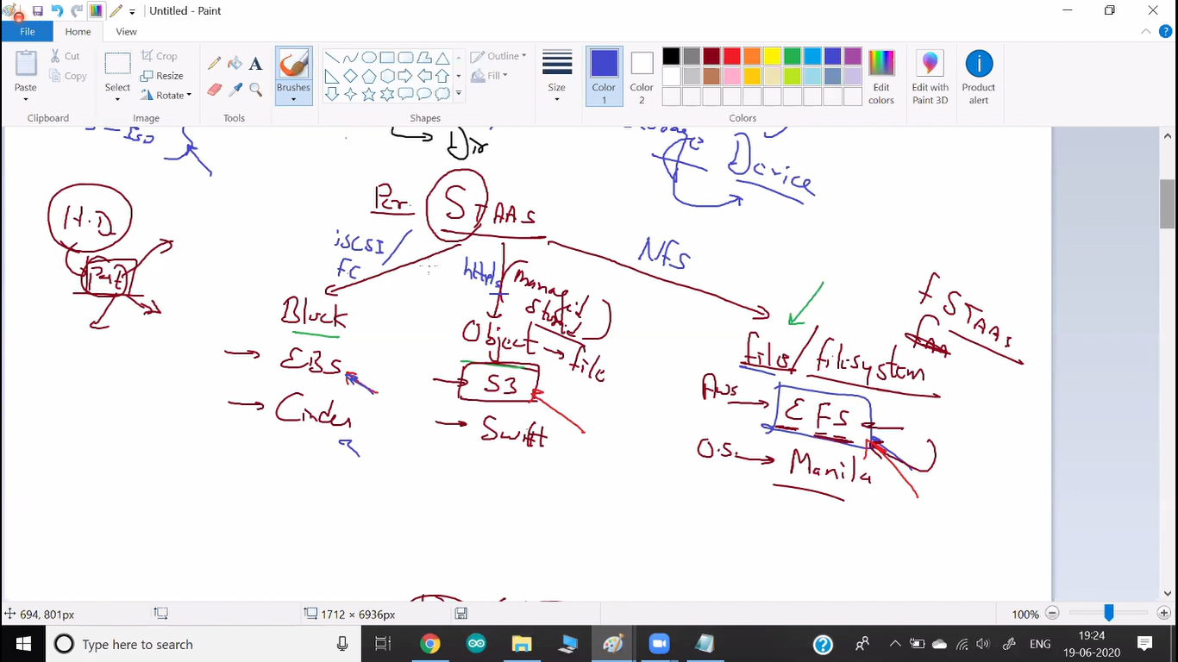

🡪If you want to get any storage over a network it uses iSCSI protocol or FC (fiber channel) protocol.

🡪Because physical USB port is known as SCSI port.

🡪For block storage we use this protocol.

🡪Area of storage come via network known as SAN (Storage Area Network)

🡪When you go to EBS, they getting the storage from here (SAN).

🡪AWS uses FC protocol. It is more powerful.

🡪EBS is a regional service.

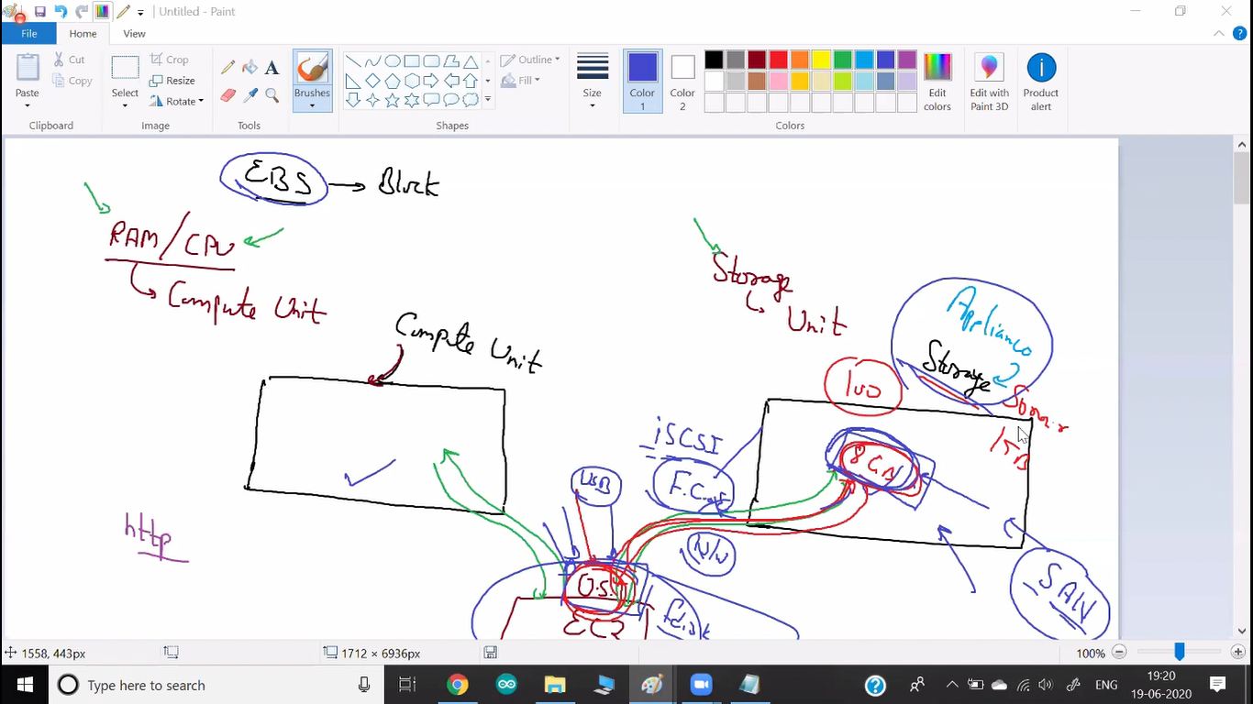

🡪For File system we uses NFS protocol.

🡪Here we are not creating HD.

🡪So we can not create partition.

🡪We can only share a folder.

🡪We are only creating a folder and mount in a way that OS feels it is local storage.

🡪Team who manages this storage unit for sharing the folder via NFS are known as NAS.

🡪In aws NFS server known as mount target.

🡪EFS is a regional service.

🡪If you want to connect EFS from your local system, then you have to use one of the services Direct connect and VPN (Its available inside vpc).

* Connecting from Ec2 instance.

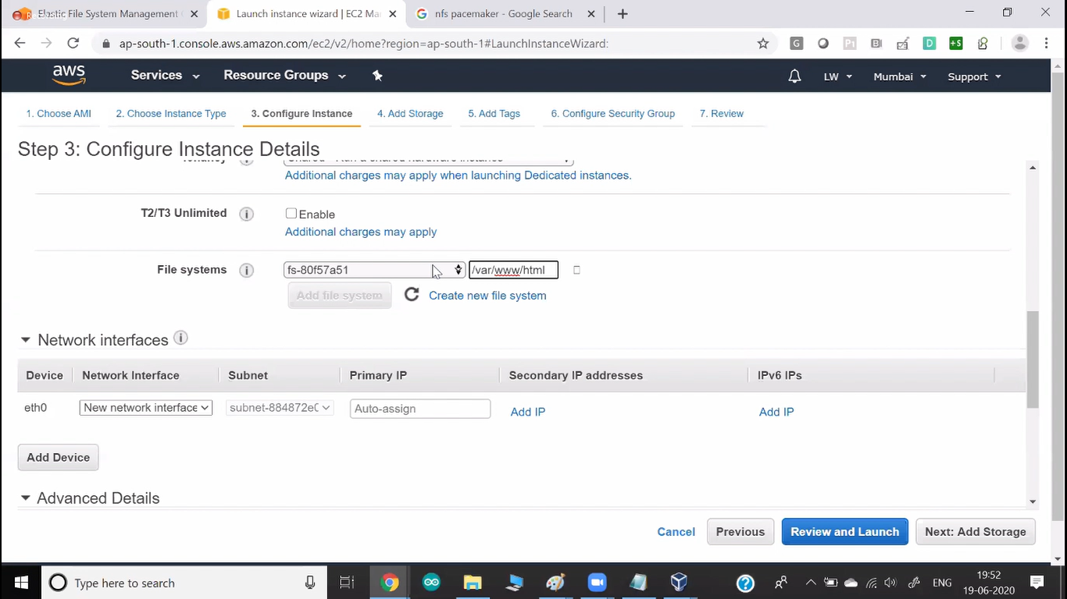

🡪Here you can attach (Mount) this EFS server.

🡪You can give the folder name where you want to mount.

🡪Main power of EFS is we can attach one EFS storage to multiple OS.