Visual Studio Code  
🡪plugins:

1. Hashicorp terraform
2. Terraform Autocomplete

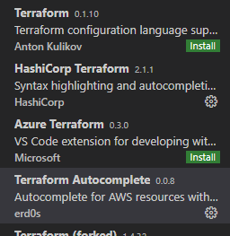

🡪It is good practice to do dry run before actual applying code.  
🡪Terraform plan  
🡪It will go to code and check what is the final impact on your code.

🡪Terraform maintain the current state inside terraform.tfstate file.  
🡪This file stored in your local HD.  
🡪You can also store this in remote location.  
🡪whenever you again use terraform apply, they go to aws and get current information and then check with file.  
🡪use terraform refresh before running old file again.  
🡪This will update your local file.

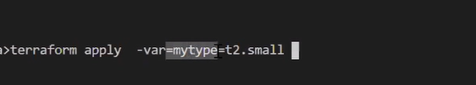

🡪Terraform also have repository.

Output “myvar” {

Value = “ec2 start at ${timestamp()}”

}

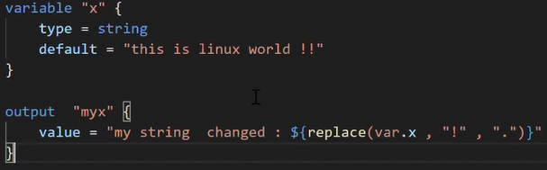🡪They replace ! with .

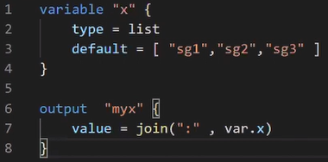  
🡪Sometimes we want to attach multiple SG to the ec2.  
🡪We can use this, we can also format it and get below output.  
🡪myx = sg1:sg2:sg3

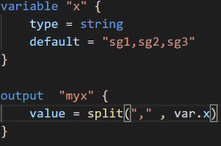  
🡪reverse above statement.  
🡪You get this data and want to convert into the list.

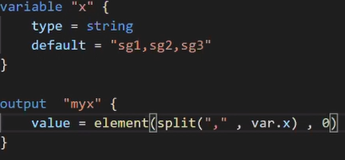  
🡪Create a list and then give first element.  
🡪myx=sg1

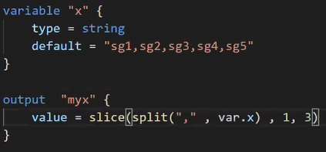  
🡪slice function to give range.

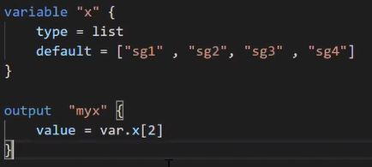

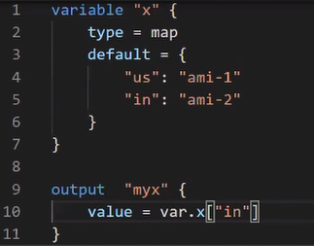  
🡪It is used for create map.  
🡪We can retrieve instance of IN.  
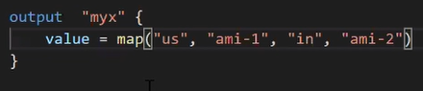  
🡪It is same as above but here we used map function.   
🡪First one would be key second is value, third key fourth value.  
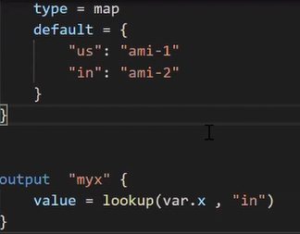  
🡪same as above.

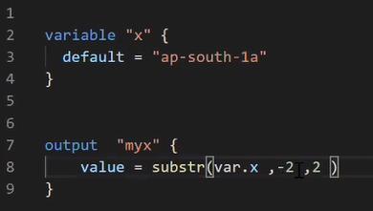  
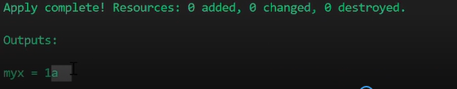

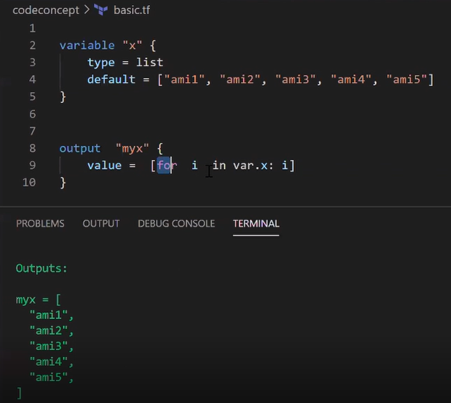  
🡪It retrieve one by one from list.

