Domain

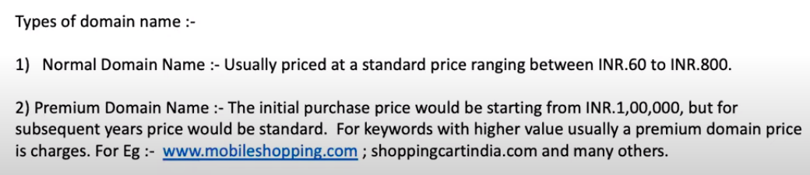

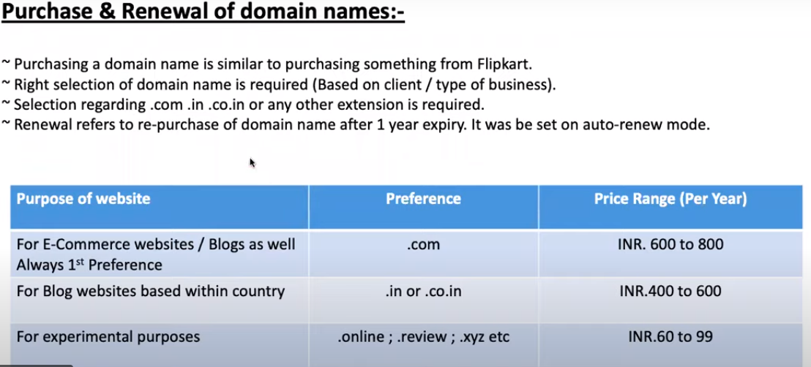

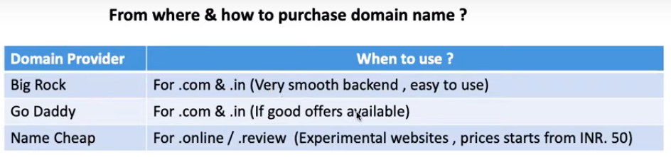

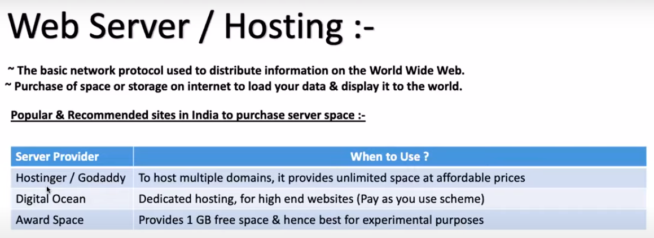

Theme and plugins

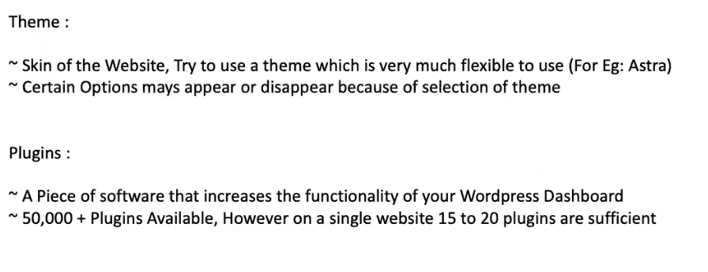

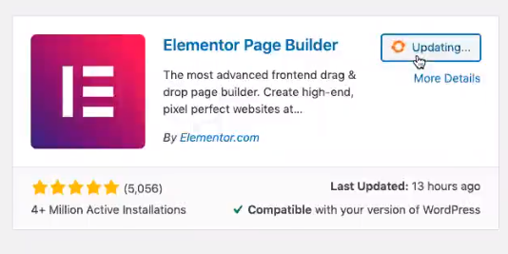

Install and Activate it.

Extra-plugins.

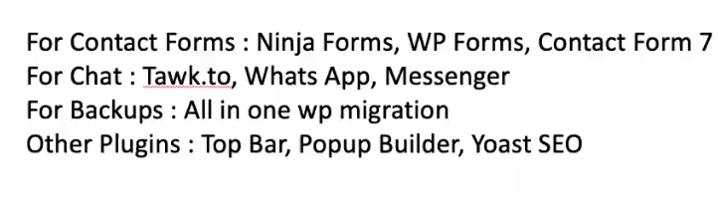

E-commerce website

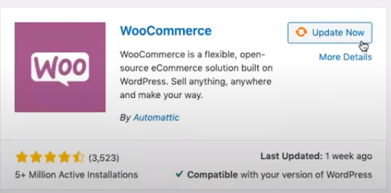

Plugin for GST

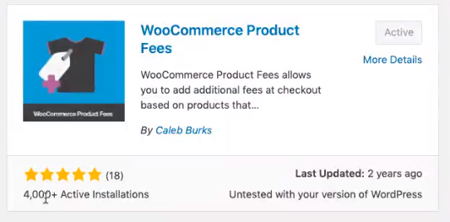

Plugin for invoice

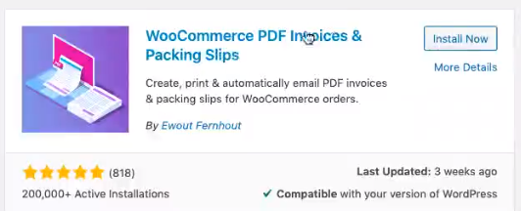

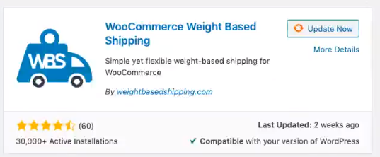

Ship Rocket  
🡪You don’t need to manually write costs per region.  
🡪It is highly recommended.

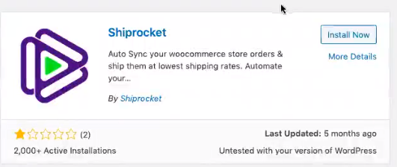

For sms

🡪Don’t go with sms in starting days upto 3-4 months.

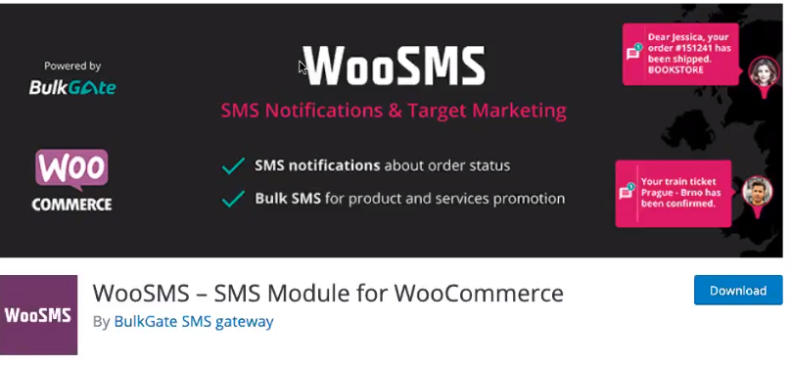

Payment:

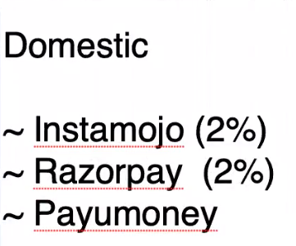  
International:  
🡪paypal

🡪CC Avenue  
 🡪They charge you percentage and annual fees both.

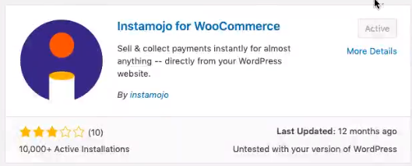

🡪Create a account in Instamojo.  
 🡪You can use saving account  
 🡪Limit: 10,000 per month  
 🡪After pancard  
 🡪Unlimited  
 🡪when you cross 40lakh from instamojo, then they ask for GST.

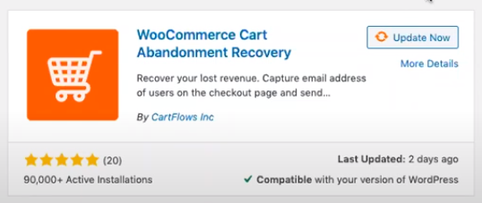

WooCommerce Lucky wheel

Buying SSL certificate  
🡪<https://www.ssls.com/>

🡪When screen shows download, button download that time.

For chat bot  
🡪<https://app.continual.ly/>

Checking from where traffic is coming.  
🡪Similar web  
🡪<https://www.similarweb.com/>

🡪GA google analytics plugin