**Wireless Power Transfer**

In Octave

horizontal line

# 

# Introduction

The K-nearest neighbours algorithm was used to find the optimal value of coupling coefficient ‘K(p/s)’ . A data set of 3500 samples was split into 2500 and 1000 samples for training and testing respectively.

The essence of the algorithm is to find a certain number of neighbours which are nearest to a fixed query point . For computational purposes the value of ‘k’ in knn has to be chosen such that it’s not a factor of the number of training examples .

As compared to other algorithms KNN takes a considerable amount of time as it involves more loops of O(n2) time complexity . However, this problem can be overcome by vectorizing the code .

**Code**

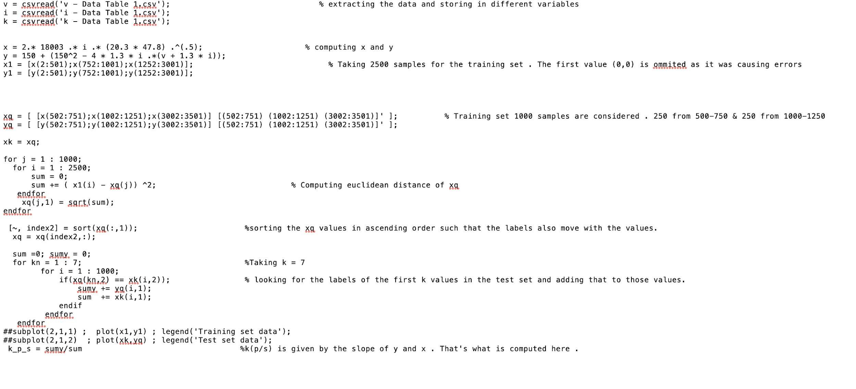

**Results**

Based on the code the training and test data are plotted and the final result obtained is shown below .

