1. **Print the interger form user**.

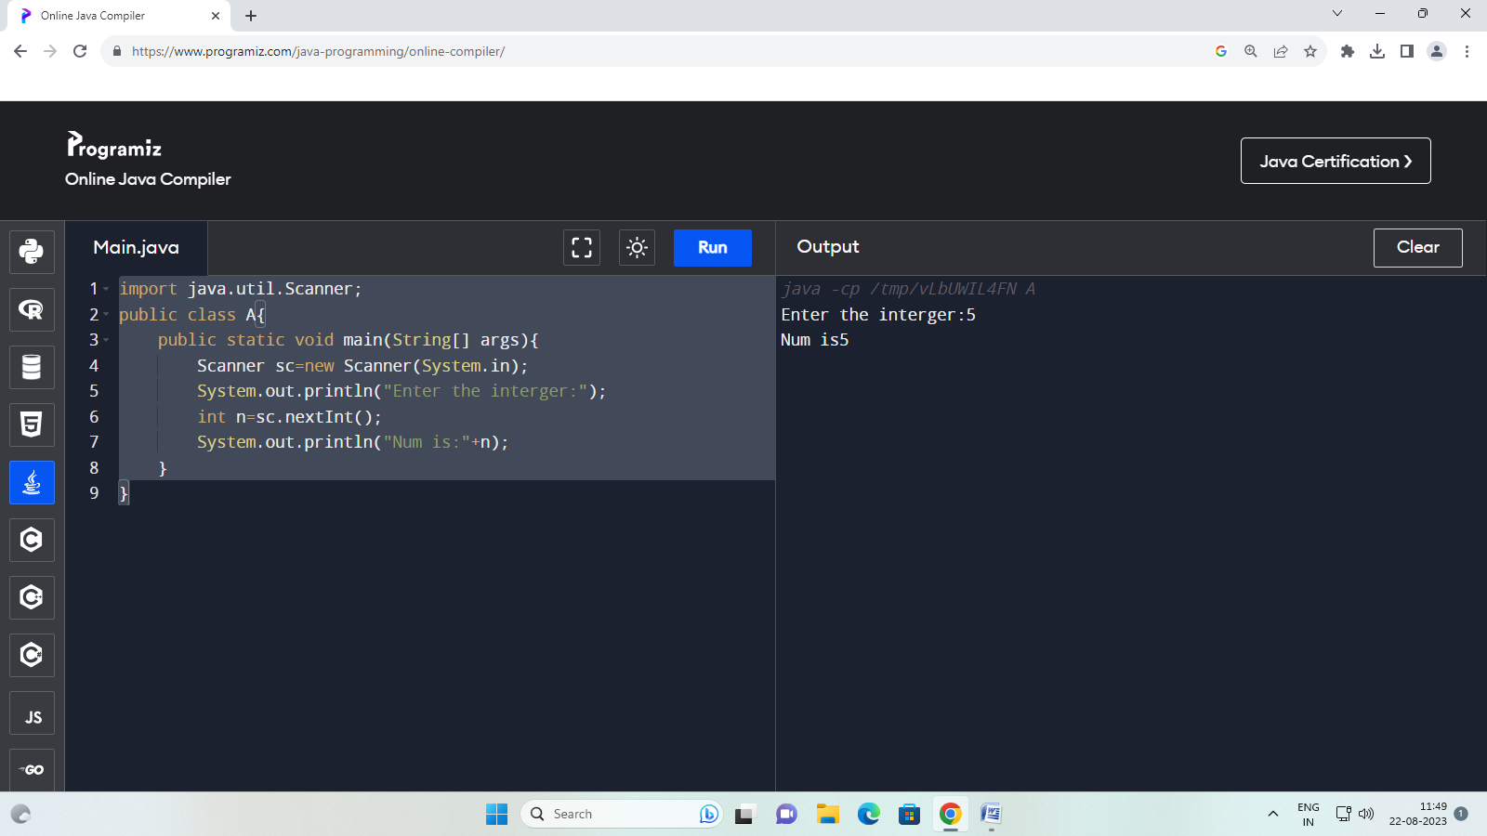

1. **To check wether the given number is even or odd.**

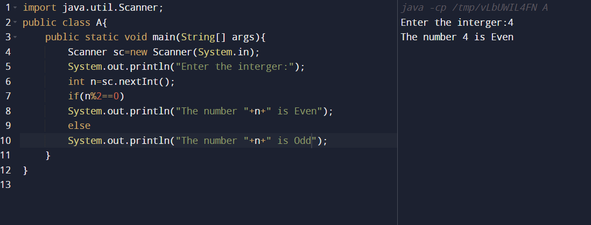

**3.Write a program to check whether a give character is vowal or consonant.**

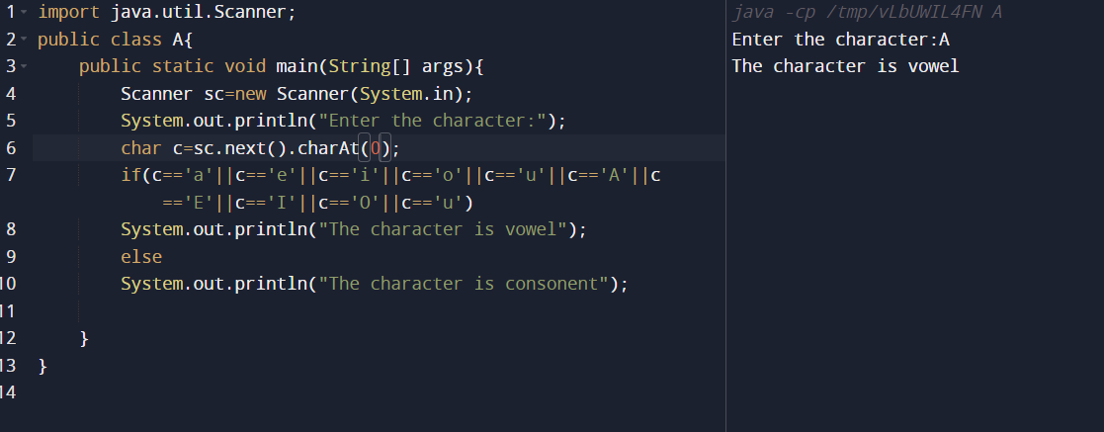

**4.Write a program to sum all the number form 1 to given interger number.**

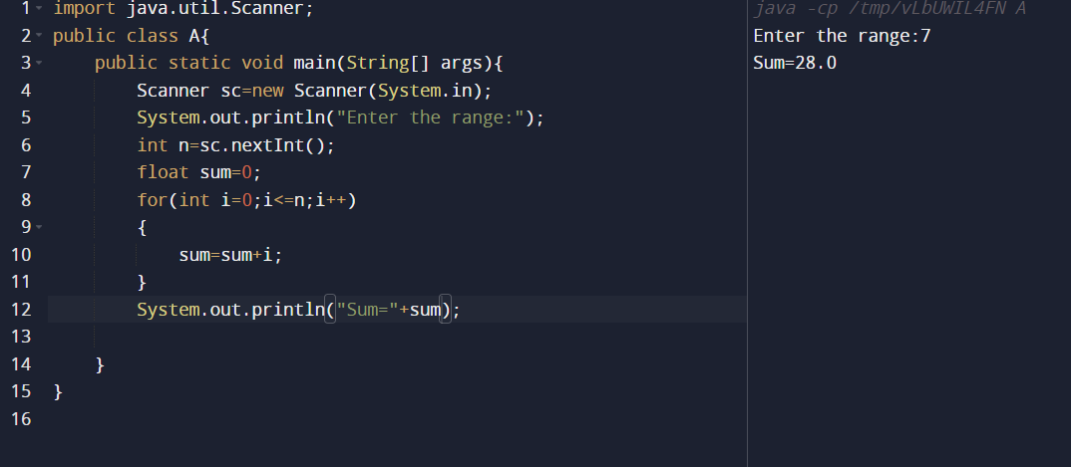

**5. Factorial of a number.**

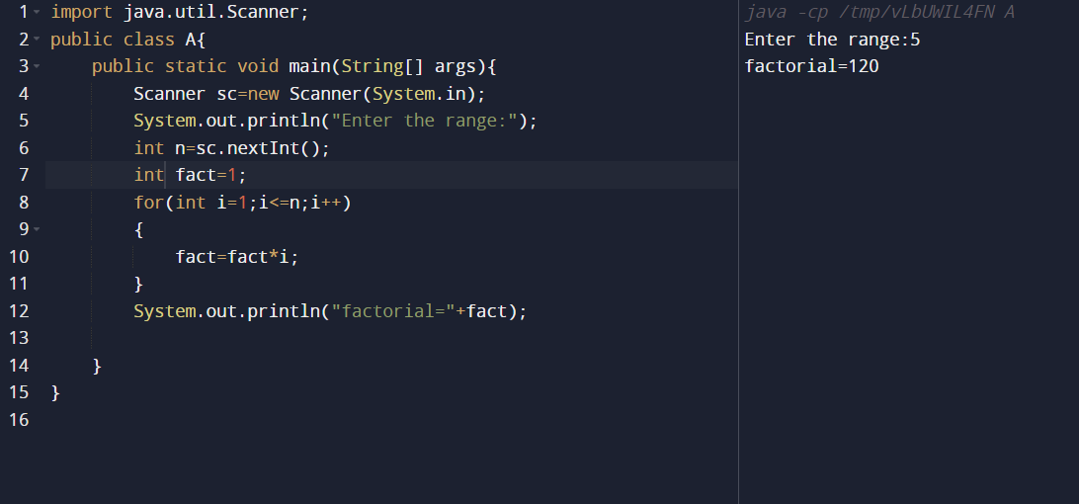

**6.print vowel from A to Z.**

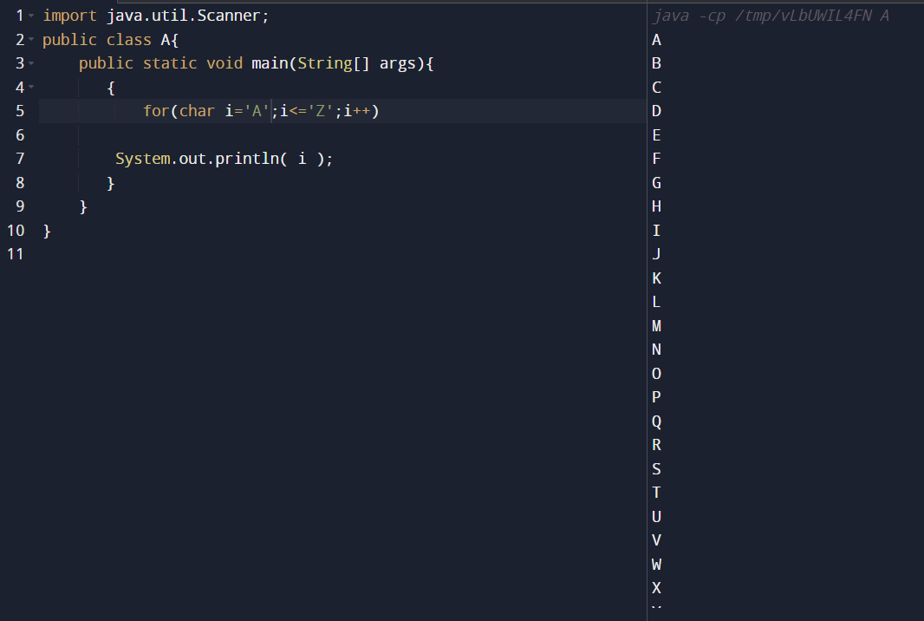

**7. Write a program to print greatest common divisor of two number.**

**8. table.**

