JAVA WORK IDE COMPILER

public class MyClass {

public static void main(String args[]) {

for(int i=0;i<args.length;i++)

System.out.println(args[i]);

}

}

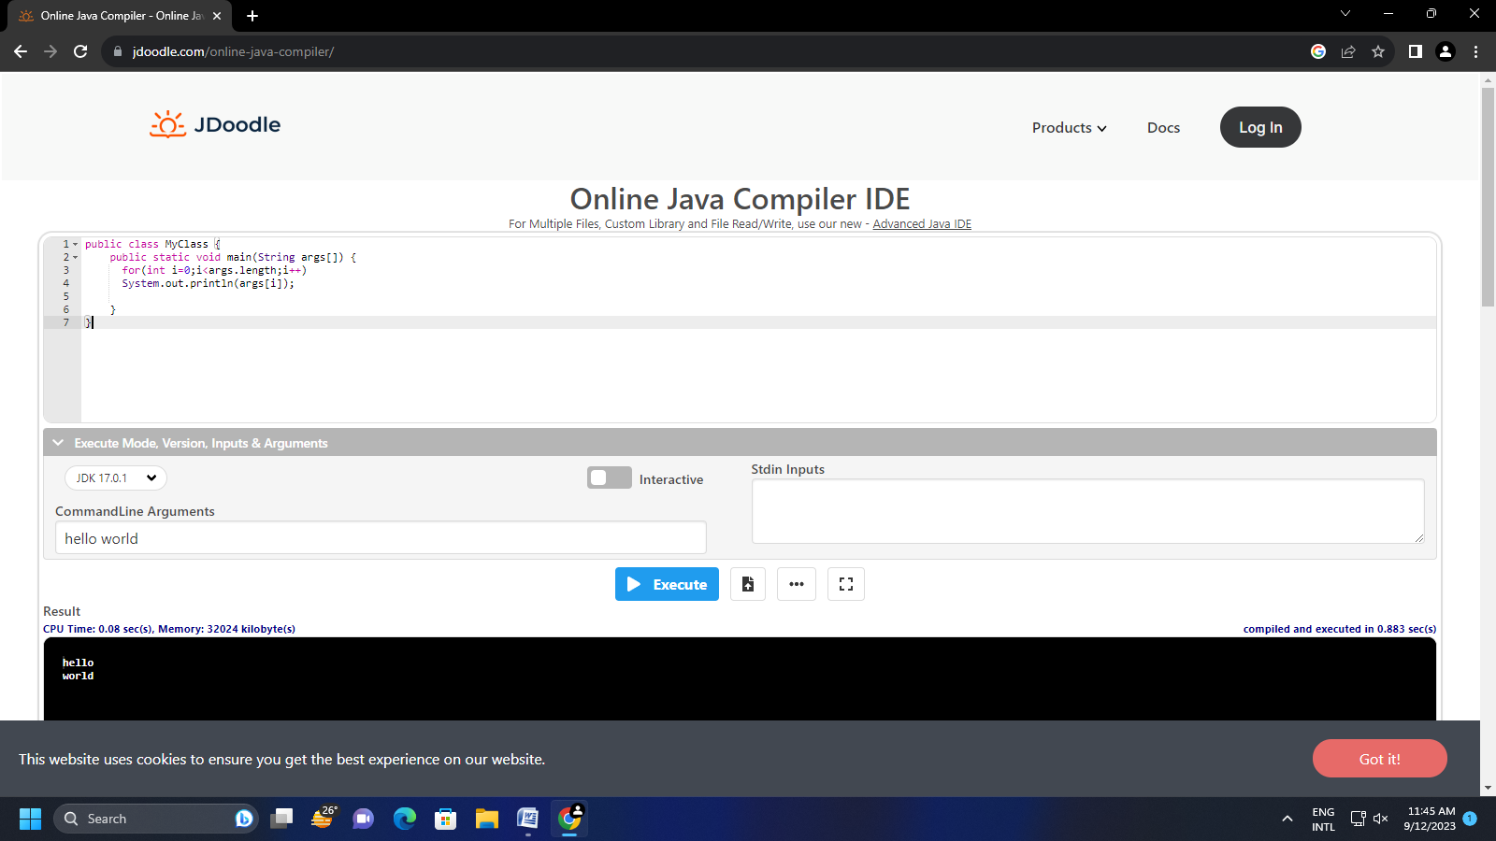

public class MyClass {

static int sum=0;

public static void main(String args[]) {

System.out.println(args.length);

for(int i=0;i<args.length;i++)

{

sum=sum+Integer.parseInt(args[i]);

}

System.out.println("the sum is"+sum);;

}}

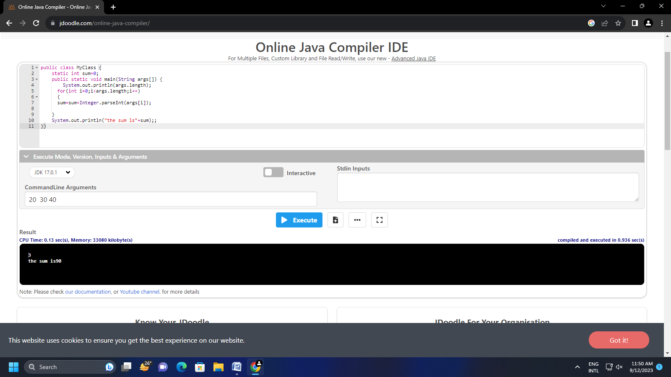

class Complex {

int real;

int img;

public Complex(int i,int j)

{

real =i;

img=j;

}

static Complex add(Complex ob1,Complex ob2 )

{

return new Complex(ob1.real+ob2.real,ob1.img+ob2.img);

}}

public class atul{

public static void main(String args[]) {

Complex ob1=new Complex(6,3);

Complex ob2=new Complex(9,6);

Complex z=Complex.add(ob1,ob2);

System.out.println(z.real+"+"+z.img+"i");

}}

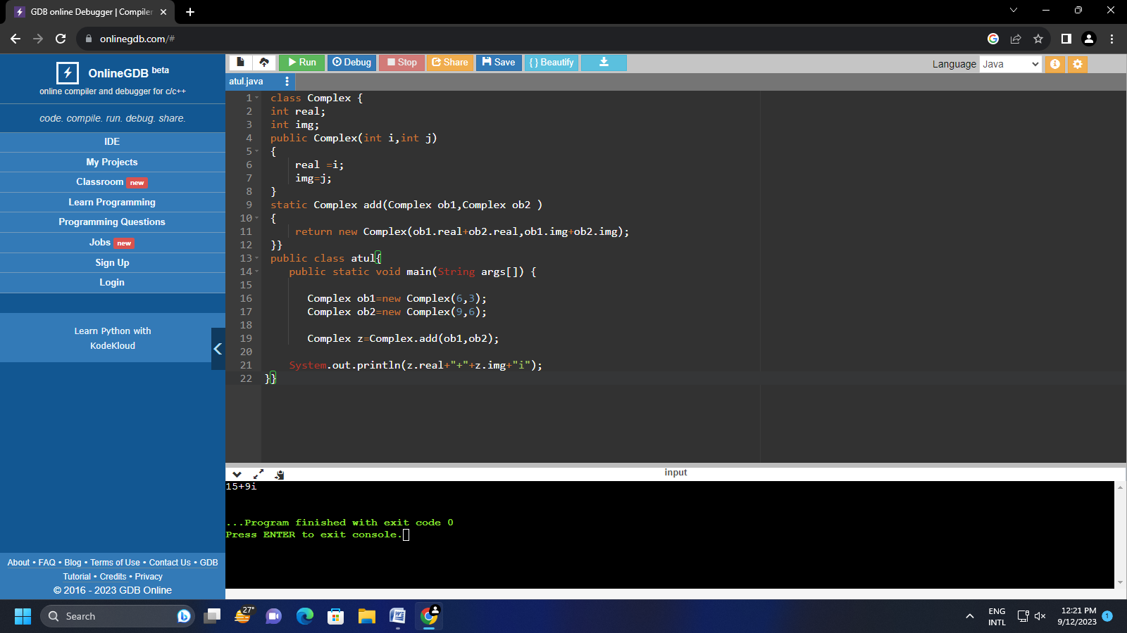

class Complex {

int real;

int img;

public Complex(int i,int j)

{

real =i;

img=j;

}

static Complex sub(Complex ob1,Complex ob2 )

{

return new Complex(ob1.real-ob2.real,ob1.img-ob2.img);

}}

public class atul{

public static void main(String args[]) {

Complex ob1=new Complex(9,8);

Complex ob2=new Complex(4,6);

Complex z=Complex.sub(ob1,ob2);

System.out.println(z.real+"-"+z.img+"i");

}}

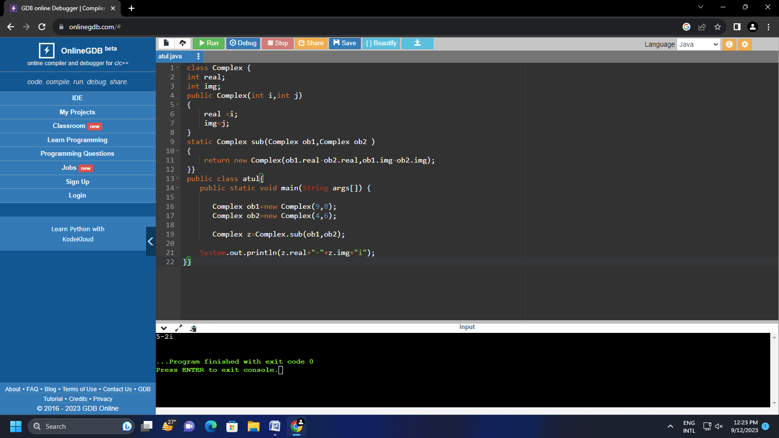

class Name {

String name ;

String sname;

public Name(String name,String sname )

{

this.name=name;

this.sname=sname;

}

public static Name add(Name x,Name y )

{

return new Name(x.name+y.name,x.sname+y.sname);

}}

public class atul{

public static void main(String args[]) {

Name x=new Name("Aishwarya","Rai" );

Name y=new Name("Abhishek","Bacchan");

Name z= Name. add(x,y);

System.out.println(z.name+" "+z.sname+"i");

}}

