**Precipitation over Indian region**

1. **Time series:**

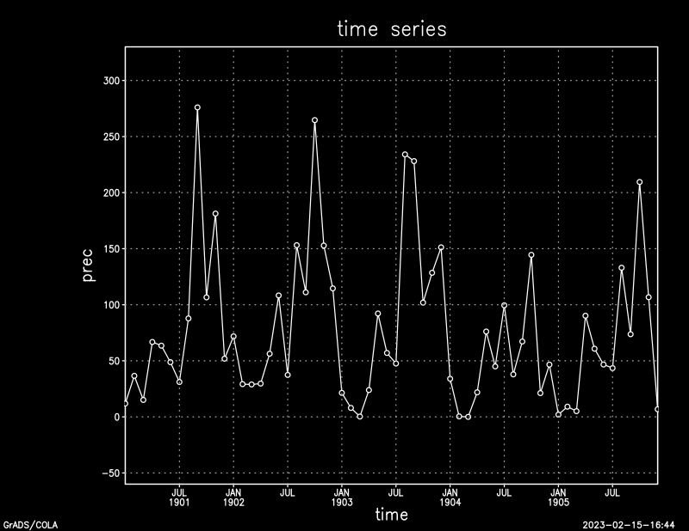

1. **Spatial:**

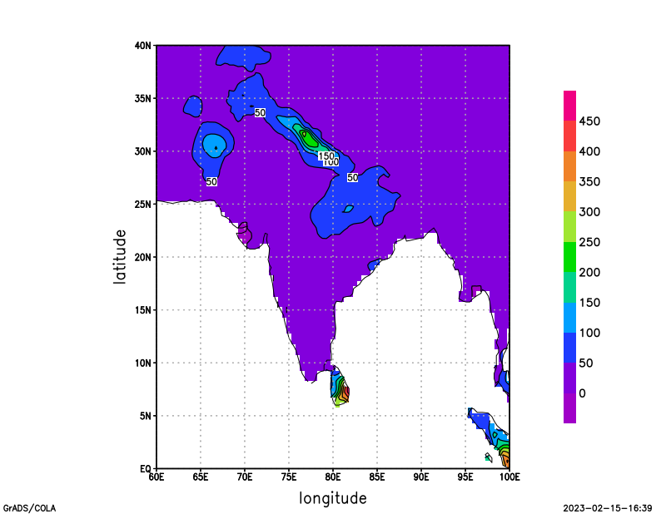

**Global Precipitation**

