Akshit kumar

Roll number : 2428cse1708

Web Design Lab

Program : Create A portfolio using HTML and CSS

CODE : <!DOCTYPE html>

<html lang="en">

<head>

<title>My Portfolio</title>

<link rel="stylesheet" href="styles.css">

<style>

body {

font-family: Arial, sans-serif;

margin: 0;

padding: 0;

line-height: 1.6;

}

header {

background-color: #333;

color: #fff;

padding: 10px 0;

text-align: center;

}

.nav-menu {

list-style: none;

padding: 0;

margin: 0;

display: flex;

justify-content: center;

}

.nav-menu li {

margin: 0 15px;

}

.nav-menu a {

color: #b080ed;

text-decoration: none;

font-weight: bold;

}

.nav-menu a:hover {

text-decoration: underline;

}

/\* Sections \*/

.section {

padding: 40px;

text-align: center;

}

#about {

background-color: #f4f4f4;

}

#projects {

background-color:beige;

}

.project-list {

display: flex;

justify-content: space-around;

flex-wrap: wrap;

}

.project {

background: #6f4f4f;

padding: 20px;

margin: 10px;

border: 1px solid #ccc;

border-radius: 5px;

width: 30%;

box-shadow: 0 2px 5px rgba(0, 0, 0, 0.1);

}

.project h3 {

margin: 0 0 10px;

}

/\* Footer \*/

footer {

background-color: #333;

color: #fff;

text-align: center;

padding: 10px 0;

}

</style>

</head>

<body>

<header>

<nav>

<ul class="nav-menu">

<li><a href="#about">About</a></li>

<li><a href="#projects">Projects</a></li>

<li><a href="#contact">Contact</a></li>

</ul>

</nav>

</header>

<section id="about" class="section">

<h1>Welcome to My Portfolio</h1>

<p>Hello! I'm Akshit Kumar, a passionate Web Developer.</p>

</section>

<section id="projects" class="section">

<h2>My Projects</h2>

<div class="project-list">

<div class="project">

<h3>Project 1</h3>

<p>Medicines Purchasing Website.</p>

</div>

<div class="project">

<h3>Project 2</h3>

<p>Weather Forecast Website.</p>

</div>

<div class="project">

<h3>Project 3</h3>

<p>News Website.</p>

</div>

</div>

</section>

<section id="contact" class="section">

<h2>Contact Me</h2>

<p>Email: <a href="mailto:yourname@example.com">akshit.2428cse1708@kiet.edu</a></p>

</section>

<footer>

<p>&copy; 2024 Akshit Kumar. All Rights Reserved.</p>

</footer>

</body>

</html>

OUTPUT : 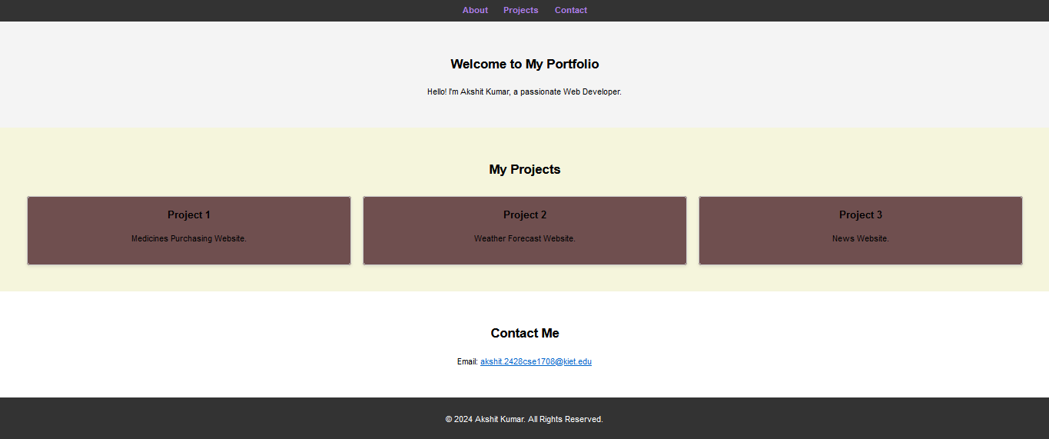

OUTPUT :