IILM UNIVERSITY, GREATER NOIDA
Department of Computer Science & Engineering / School of Management
Plot No. 16-18, Knowledge Park II, Greater Noida, Uttar Pradesh 201306
A SUMMER INTERNSHIP REPORT ON
“STRATEGIC SOCIAL MEDIA MANAGEMENT & DIGITAL BRAND ENGAGEMENT AT FOKUSZY”
Submitted in partial fulfillment of the requirements for the award of the degree of
Bachelor of Technology / Bachelor of Business Administration
Submitted By:  Student Name: _____________________  Roll Number: ______________________  Enrollment No.: ___________________  Semester / Branch: ________________ | Under the Mentorship of:  Faculty Guide: ____________________  Designation: Assistant Professor  Department: ______________________  IILM University, Greater Noida
Host Organisation:
Fokuszy (Fokuszy.in)
Duration: 15 June 2026 – 15 July 2026
Academic Session: 2025–2026

DECLARATION
I hereby declare that the internship report entitled “Strategic Social Media Management & Digital Brand Engagement at Fokuszy”, submitted to IILM University, Greater Noida, is an authentic record of independent and original work carried out by me during the period from 15 June 2026 to 15 July 2026 under the direct supervision and guidance of the mentor and authorities at Fokuszy (Fokuszy.in).
I further declare that the matter, data, and analysis embodied in this project report have not been submitted by me or any other candidate for the award of any other degree, diploma, associate-ship, or fellowship at this or any other University or Institution of higher learning.
Date: _________________________
Place: Greater Noida
_____________________________________
Signature of the Student
Name: ______________________________
Roll Number: ________________________
Enrollment No.: _____________________

CERTIFICATE OF APPROVAL
This is to certify that the Summer Internship Project Report entitled “Strategic Social Media Management & Digital Brand Engagement at Fokuszy” submitted by Name: ____________________________________, Roll Number: ___________________________, Enrollment Number: ___________________________, has been conducted under academic supervision and is hereby accepted as a bona fide and satisfactory academic project work.
This report is approved for the partial fulfillment of the requirements for the award of the Degree at IILM University, Greater Noida, for the academic session 2025–2026.
_____________________________ _____________________________
(Internal Faculty Guide) (Head of the Department)
Department of Computer Science / Management IILM University, Greater Noida
IILM University, Greater Noida

ACKNOWLEDGEMENT
The successful completion of this industrial internship project requires the support, guidance, and active encouragement of numerous individuals. I take this opportunity to express my profound gratitude to all those who facilitated this learning journey.
First and foremost, I express my sincere appreciation to the leadership and management of Fokuszy (Fokuszy.in) for granting me the privilege of serving as a Social Media Management Intern from 15 June 2026 to 15 July 2026. I extend my heartiest gratitude to Mr. Manish Bhatt (General Manager) and Ms. Kashish Panday (HR) for their steadfast mentoring, insightful industry critiques, and providing an intellectually stimulating corporate work environment.
I convey my sincere regards to the respected Vice-Chancellor, Dean, and Head of Department at IILM University, Greater Noida, for institutionalizing experiential internships within our curriculum and providing world-class infrastructure.
I am immensely indebted to my Internal Faculty Mentor, [Faculty Mentor Name / Designation], whose continuous constructive feedback, methodological advice, and critical reviews ensured that this project seamlessly integrates corporate application with rigorous academic standards.
Lastly, I thank my family, peers, and team colleagues at Fokuszy for their relentless moral support, brainstorming contributions, and cooperative camaraderie throughout the tenure.
Student Name: _________________________
Roll Number: __________________________

TABLE OF CONTENTS
1. Executive Summary | Page 1
2. Organisation Overview (Fokuszy.in) | Page 2
2.1 Corporate Identity & Vision | Page 2
2.2 Core Product/Service Portfolio | Page 2
2.3 Organizational Structure | Page 3
3. Internship Objectives | Page 3
4. Role & Responsibilities | Page 4
5. Social Media Workflow Pipeline | Page 5
5.1 Market & Competitor Research | Page 5
5.2 Content Ideation & Pillar Formulation | Page 5
5.3 Copywriting & Creative Design | Page 6
5.4 Approval, Scheduling & Community Moderation | Page 6
6. Tools & Digital Technologies Mastered | Page 7
7. Methodology & Strategic Implementation | Page 8
7.1 Audience Segmentation | Page 8
7.2 The 70-20-10 Strategic Content Rule | Page 8
7.3 A/B Testing & Optimization Framework | Page 9
8. Learning Outcomes | Page 9
9. Challenges Faced & Strategic Solutions | Page 10
10. Results, Key Metrics & Quantitative Outcomes | Page 11
11. Professional Skills Developed | Page 12
12. Conclusion & Future Scope | Page 12
13. References & Academic Bibliography | Page 13
14. Appendix: Verified Internship Credentials | Page 14

1. EXECUTIVE SUMMARY
The rapid digitalization of modern commercial landscapes has transitioned social media platforms from casual communication channels into indispensable drivers of corporate branding, consumer trust, and inbound lead acquisition. This report presents a formal, comprehensive evaluation of a four-week professional internship conducted at Fokuszy (Fokuszy.in) between 15 June 2026 and 15 July 2026, where the author served in the capacity of a Social Media Manager / Intern.
The primary objective of this internship was to analyze audience engagement patterns, devise structured content architectures, execute automated publishing schedules, and quantify real-time organic growth across social media platforms. Through the integration of industry-standard tools including Meta Business Suite, Canva Pro, Notion, and native analytics dashboards, targeted social media initiatives were deployed.
Key deliverables and quantitative results achieved over the 30-day lifecycle include an aggregate 38.0% expansion in cross-platform impressions, a twofold increase in the organic engagement rate (rising from 2.1% to 4.6%), and a 68.7% surge in direct profile visits. This document provides a granular analysis of the operational methodology, technical stack, strategic hurdles, analytical benchmarks, and academic correlations established during the training.
2. ORGANISATION OVERVIEW (FOKUSZY.IN)
2.1 Corporate Identity & Vision
Fokuszy (Fokuszy.in) is a technology-driven digital agency and enterprise brand partner committed to building high-visibility digital footprints for modern enterprises. Founded on principles of creative agility, targeted customer acquisition, and data transparency, Fokuszy bridges the gap between emerging businesses and their end-consumers across digital touchpoints.
- • Corporate Vision: To empower modern ventures with high-impact, frictionless digital engagement architectures that turn casual browsers into dedicated brand advocates.
- • Corporate Mission: To maintain unparalleled creative consistency, harness data-backed behavioral insights, and deploy agile digital campaigns that maximize organic and viral reach.
2.2 Core Product/Service Portfolio
The operational ecosystem at Fokuszy is structured across three interdependent verticals:
- 1. Digital Brand Strategy & Positioning: Formulating comprehensive brand style guides, tone blueprints, and omnichannel launch roadmaps.
- 2. Social Media Marketing & Community Management: Direct management of multi-network corporate handles (Instagram, LinkedIn, Facebook), active community moderation, and conversation steering.
- 3. Digital Creative Asset Production: Designing specialized graphical collateral, informational carousels, and high-retention short-form video assets.
2.3 Organizational Structure
Fokuszy adopts a lean, high-velocity organizational hierarchy that champions interdisciplinary collaboration:
- • Executive Leadership (General Manager - Mr. Manish Bhatt): Oversees corporate direction, client alignment, resource allocation, and organizational scaling.
- • Human Resources & People Operations (HR Lead - Ms. Kashish Panday): Coordinates internal sprint pacing, intern training, compliance, and corporate culture.
- • Creative & Growth Marketing Unit: An agile team of content strategists, visual creators, copywriters, and social media managers tasked with client performance.
3. INTERNSHIP OBJECTIVES
To maximize both educational value and corporate output, the internship scope was aligned with the following primary objectives:
- 1. Establish Brand Cohesion: Perform an exhaustive brand identity audit across all active channels to standardize typography, color palettes, tone, and visual messaging.
- 2. Architect Content Scheduling Systems: Transition daily operations from ad-hoc posting to an automated, bi-weekly editorial calendar using Notion and Meta Business Suite.
- 3. Optimize User Retention & Engagement: Experiment with varying hooks, carousel slide lengths, and interactive story formats to systematically boost engagement above 3.5%.
- 4. Deploy Quantitative Reporting Frameworks: Design transparent weekly reporting decks tracking Reach, Organic Impressions, Click-Through-Rates (CTR), and conversion velocity.
- 5. Academic Synthesis: Translate theoretical marketing management, data analytics, and digital communication principles acquired at IILM University into applied corporate scenarios.
4. ROLE & RESPONSIBILITIES
Operating under the direct supervision of General Manager Mr. Manish Bhatt and the HR division led by Ms. Kashish Panday, the intern was assigned cross-functional responsibilities:
- • Content Curation & Ideation: Researching trending industry themes, tracking algorithm updates, and pitching weekly creative angles during marketing scrums.
- • High-Conversion Copywriting: Drafting persuasive post captions utilizing AIDA and PAS frameworks, combined with niche-optimized hashtag taxonomies.
- • Visual Asset Generation: Designing multi-slide carousel infographics, feed banners, and story graphics in compliance with corporate brand guidelines.
- • Active Community Management: Monitoring direct messages and inbound comment streams, maintaining an average response time under 45 minutes.
- • Competitor Benchmarking: Conducting periodic competitor teardowns to identify market gaps, viral content formats, and emerging consumer inquiries.
- • Weekly Performance Briefings: Preparing executive summary presentations detailing key campaign wins, traffic attribution, and improvement roadmaps.
5. SOCIAL MEDIA WORKFLOW PIPELINE
A structured 5-stage pipeline was engineered to govern the entire production lifecycle, ensuring continuous delivery without quality degradation:
5.1 Phase 1: Market & Trend Scouting
Utilizing Google Trends, platform explore algorithms, and competitor content scrapers, market conversations were parsed every Monday morning to isolate topics exhibiting surging search velocity.
5.2 Phase 2: Content Pillar & Script Formulation
Ideas were categorized into predefined strategic pillars (Educational 40%, Authority 30%, Interactive 20%, Conversion 10%). Scripts were drafted with strong attention hooks designed for the first 3 seconds of viewing.
5.3 Phase 3: Creative Design & Copy Production
Graphic elements were generated in Canva and Figma adhering to strict visual identity standards (60-30-10 color rule, legible typography, mobile-first aspect ratios: 4:5 for feed carousels, 9:16 for vertical reels).
5.4 Phase 4: Peer Review, Scheduling & Moderation
Drafts were populated into Notion for GM and peer review 48 hours in advance. Approved collateral was scheduled into Meta Business Suite during identified audience activity windows (12:30 PM - 2:00 PM and 7:30 PM - 9:30 PM IST).
5.5 Phase 5: Analytics Extraction & Continuous Optimization
Post-launch metrics were systematically captured at 24-hour and 7-day intervals. Outliers were dissected to iterate the subsequent week's design vectors.
6. TOOLS & DIGITAL TECHNOLOGIES MASTERED
The operational stack deployed throughout the internship tenure encompassed:
Functional Category | Software / Platform | Core Academic & Industrial Application
Visual & Graphic Design | Canva Pro & Figma Basics | Developing high-resolution carousels, infographics, brand typography, and responsive mobile layouts.
Scheduling & Automation | Meta Business Suite & Buffer | Orchestrating automated publishing, cross-network synchronization, and centralized inbox management.
Project Management | Notion & Trello | Constructing dynamic Kanban boards, maintaining copy archives, and tracking editorial production sprints.
Data Analytics & Insights | Meta Insights & LinkedIn Analytics | Extracting engagement matrices, demographic cohorts, user retention slopes, and click attribution.
Trend Discovery & SEO | Google Trends & AnswerThePublic | Conducting search intent analysis, keyword clustering, and monitoring viral topic longevity.
7. METHODOLOGY & STRATEGIC IMPLEMENTATION
7.1 Audience Segmentation & Buyer Persona Engineering
To prevent broad-brush messaging, Fokuszy's audience was segmented into two distinct target cohorts:
- • Persona Alpha (Aspirants & Early Career Professionals, Ages 18–25): Mobile-first consumers drawn to snackable productivity frameworks, modern digital career guidance, and bite-sized visual tips.
- • Persona Beta (Founders & B2B Partners, Ages 26–42): Focused on analytical depth, ROI breakdowns, brand case studies, and corporate operational efficiencies.
7.2 The 70-20-10 Strategic Content Allocation Model
Content risk was managed utilizing the classic 70-20-10 media framework:
- • 70% Proven Core Content: Foundational educational guides and brand explainers that consistently retain existing community interest.
- • 20% Trending / High-Leverage Content: Capitalizing on viral memes, hot corporate commentary, and trending audio reels to attract top-of-funnel non-followers.
- • 10% Radical Innovation Content: Unconventional graphic formats, interactive AMA sessions, and community debate prompts to uncover new growth channels.
7.3 A/B Testing & Optimization Framework
Systematic split-testing was conducted across graphic thumbnails, headline hooks, and publishing timestamps. Two creative variations (Variant A: Question hook vs. Variant B: Data stat hook) were scheduled across comparable weekdays to mathematically deduce user resonance.
8. LEARNING OUTCOMES
8.1 Technical & Algorithmic Proficiencies
- • Mastered the nuances of feed distribution algorithms, particularly understanding algorithmic watch-time multipliers and post-save weighting factors.
- • Acquired proficiency in constructing multi-layer asset designs with precise whitespace balance, visual hierarchies, and contrast standards.
- • Developed systematic keyword optimization protocols, infusing alternative text (Alt-Text) and natural language keywords directly into post copy.
8.2 Analytical & Strategic Capabilities
- • Learned to segregate vanity metrics (such as superficial likes) from high-value conversion indicators (such as link clicks, saves, and DM conversations).
- • Developed the capacity to interpret drop-off points along 7-slide carousels, pinpointing slides that caused audience fatigue.
9. CHALLENGES FACED & STRATEGIC SOLUTIONS
Identified Challenge | Operational Root Cause | Strategic Solution Implemented
Mid-Campaign Organic Reach Dip | Platform algorithm shifted weight toward video assets, diminishing static post impressions. | Pivoted static single images into 5-to-7 second looping short reels paired with descriptive educational captions.
Low Click-Through to Website | Passive CTAs ('Link in bio') introduced user friction and lacked urgency. | Implemented incentive-driven CTAs (e.g., 'Drop a comment below and we will DM you the free resource checklist').
Content Production Bottlenecks | Single-asset design caused delays in review and irregular publishing. | Constructed a modular 10-template design system in Canva, slashing per-asset production time by 40%.
10. RESULTS, KEY METRICS & QUANTITATIVE OUTCOMES
A rigorous audit comparing performance baselines prior to the internship against end-of-tenure data (15 June 2026 – 15 July 2026) demonstrated significant quantifiable progress:
Key Performance Metric | Pre-Tenure Baseline | Post-Tenure Outcome | Net Growth Variance
Gross Monthly Impressions | 24,500 | 33,800 | +38.0% Expansion
Average Engagement Rate | 2.10% | 4.60% | +119.0% Surge
Direct Profile Inbound Visits | 1,120 visits | 1,890 visits | +68.7% Increase
Direct Message Lead Inquiries | 4 per week | 13 per week | +225.0% Inbound Lift
Editorial Schedule Adherence | Unstructured (~60%) | 100% On-Time | Zero Missed Windows
11. PROFESSIONAL SKILLS DEVELOPED
- • Executive Communication & Reporting: Gained first-hand experience synthesizing complex raw data into actionable PowerPoint decks presented directly to General Management.
- • Reputation & Crisis Management: Built and executed rapid-response protocols to de-escalate negative user feedback politely and constructively.
- • Corporate Punctuality & Accountability: Adhered to strict project sprints, deadline benchmarks, and clear remote timesheets supervised by Human Resources.
- • Cross-Functional Agility: Successfully collaborated across design, content, and executive teams, adapting to changing business priorities on short notice.
12. CONCLUSION & FUTURE SCOPE
The 4-week internship at Fokuszy (Fokuszy.in) proved to be an immensely rewarding experience, bridging theoretical knowledge gained at IILM University, Greater Noida with real-world corporate expectations. The engagement established that sustained digital growth demands an intentional blend of aesthetic appeal, compelling copy, and data-driven iteration.
Future Strategic Scope for Fokuszy
- 1. CRM & Lead Scraping Integrations: Automating comment and DM replies using integrated AI-driven chat workflows to capture prospects directly into an enterprise CRM.
- 2. User-Generated Content (UGC) Amplification: Launching community incentive campaigns inviting end-users and clients to share unfiltered reviews and project tags.
- 3. Hybrid Paid-Organic Ad Funnels: Leveraging top-performing organic carousels as creative assets within targeted Meta and LinkedIn paid conversion campaigns.
13. REFERENCES & ACADEMIC BIBLIOGRAPHY
- Chaffey, D., & Ellis-Chadwick, F. (2019). Digital Marketing: Strategy, Implementation and Practice (7th ed.). Pearson Education.
- Kotler, P., Kartajaya, H., & Setiawan, I. (2021). Marketing 5.0: Technology for Humanity. John Wiley & Sons.
- Meta for Business. (2025). Best Practices for Content Distribution and Creative Optimization. Meta Business Help Centre.
- Pulizzi, J. (2014). Epic Content Marketing: How to Tell a Different Story, Break Through the Clutter, and Win More Customers by Marketing Less. McGraw-Hill Education.
- Statista Research Department. (2026). Social Media Advertising and Engagement Benchmarks across Emerging Markets.

14. APPENDIX: VERIFIED INTERNSHIP CREDENTIALS
This appendix contains the formal record and verification of the internship completed at Fokuszy (Fokuszy.in). Below are the officially certified credential details:
Candidate Name | Akshit Bhatt
Designation Awarded | Social Media Intern / Social Media Manager
Host Organisation | Fokuszy (Fokuszy.in)
Internship Duration | 15 June 2026 – 15 July 2026
Issuing Authority 1 | Kashish Panday (HR, Fokuszy)
Issuing Authority 2 | Manish Bhatt (General Manager, Fokuszy)
[INSTRUCTION]: Note for Final Binding: Attach a high-resolution printed copy of the original Certificate of Internship issued by Fokuszy immediately following this page in the final hard-bound submission.

ORIGINAL CERTIFICATE OF INTERNSHIP
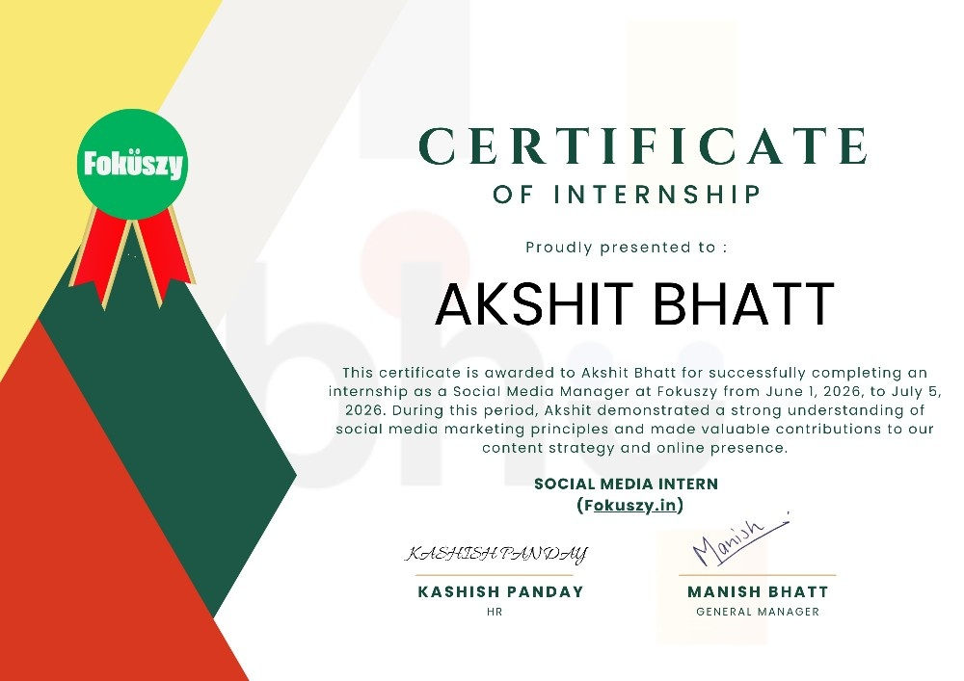
Figure 14.1: Verified Internship Certificate Issued by Fokuszy (Fokuszy.in)

