DAV Sr. Sec. Public School
Lakkar Bazar, Shimla


Session : 2020-2021

Informatics Practices Project
on
HRD Department


Submitted by:
Roll No. :
Name:
Class:

Acknowledgement

I would like to express my special thanks of gratitude to my teacher Ms. Mamta Panwar
who gave me the golden opportunity to do this wonderful project on the topic HRD DEPARTMENT,
which also helped me in doing a lot of Research and I came to know about so many new things I am really thankful to them.
Secondly, I would also like to thank my parents and friends who helped me a lot in finalizing this project within the limited time frame.

PROJECT ON HRD DEPARTMENT

SOURCE CODE

MY SQL PYTHON CONNECTIVITY

-MENU DRIVEN PROGRAM

import mysql.connector as mc

db=mc.connect(host="localhost",

user="root",

password="destiny",

charset='utf8',

database="employee1")

mc=db.cursor()

print("****************************************************")

print(" HRD DEPARTMENT")

print("****************************************************")

print()

print(" 1. DISPLAY EMPLOYEE DETAILS")

print(" 2. SEARCH RECORD")

print(" 3. INSERT RECORD")

print(" 4. Exit")

print()

print("****************************************************")

choice=int(input("Enter your choice : "))

if choice==1:

mc=db.cursor()

qr="select * from employee"

mc.execute(qr)

for i in mc:

print("--------------- Employee Details ----------------")

print("Record number : ", i)

print()

print("Employee ID : ", i[0])

print("Employee Name : ", i[1])

print("Designation : ", i[2])

print("Date of joining : ", i[3])

print("Basic Salary : ", i[4])
print("Commission : ", i[5])
print("Department ID : ", i[6])
print()

elif choice==2:
nam=input("Enter Name of employee you want to search : ")
qr="select * from employee where empname=%s"
mc.execute(qr, (nam,))
for i in mc:
print(i)
#Displaying total number of records
print("Total Records in employee table are : ", mc.rowcount)
elif choice==3:
EmpId=int(input("Employee ID : "))
EmpName=input("Employee Name : ")
desig=input("Designation : ")
qr="insert into employee (EmpId, EmpName, desig) values(%s,%s,%s)"
val=(EmpId, EmpName, desig)
mc.execute(qr,val)
db.commit()
print(mc.rowcount, " record inserted")
elif choice==4:
exit()
else:
print("Invalid choice!!!")

MYSQL TABLE EMPLOYEE:

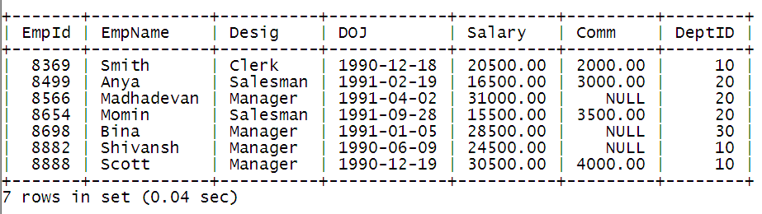

OUTPUT WINDOW

#TO DISPLAY EMPLOYEE DETAILS

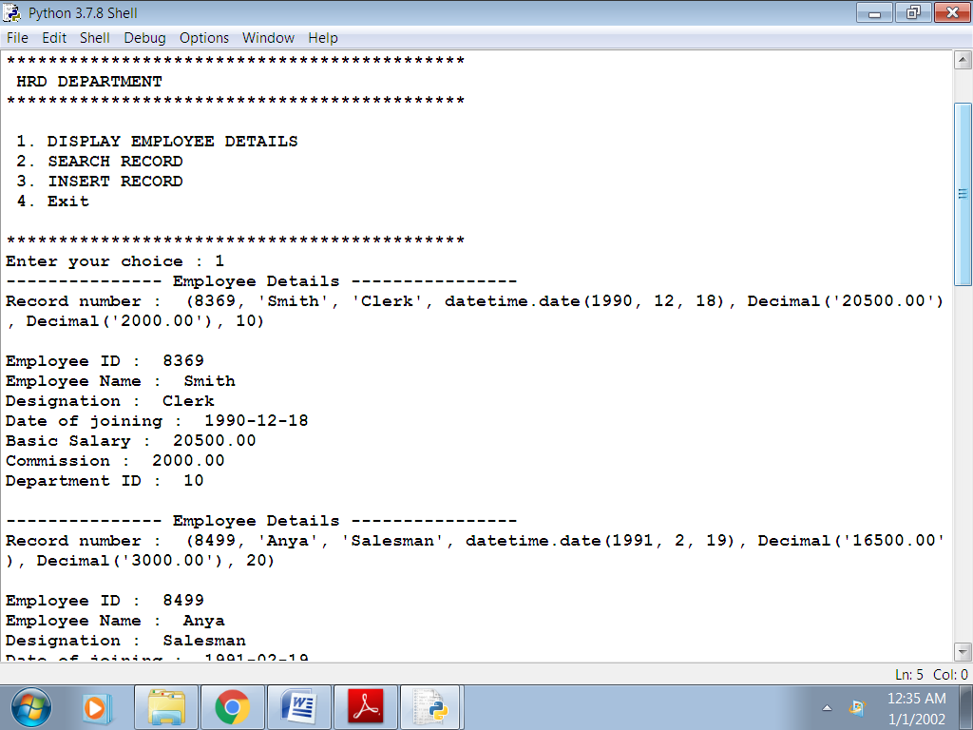
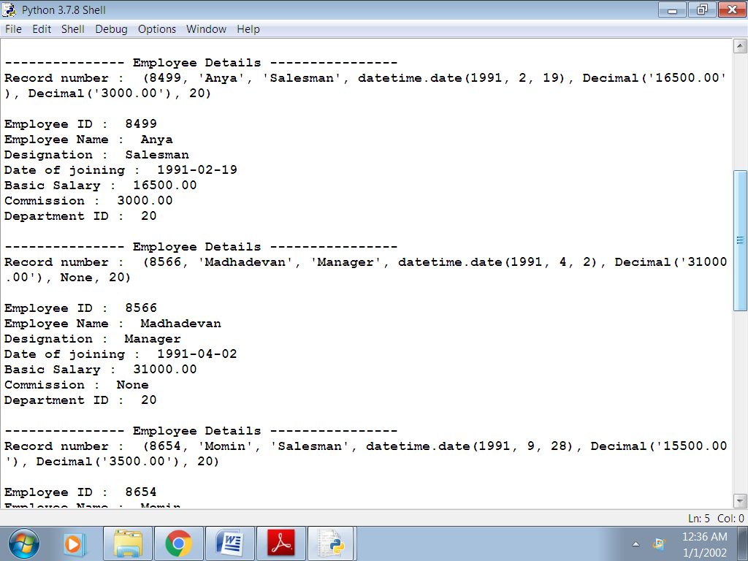

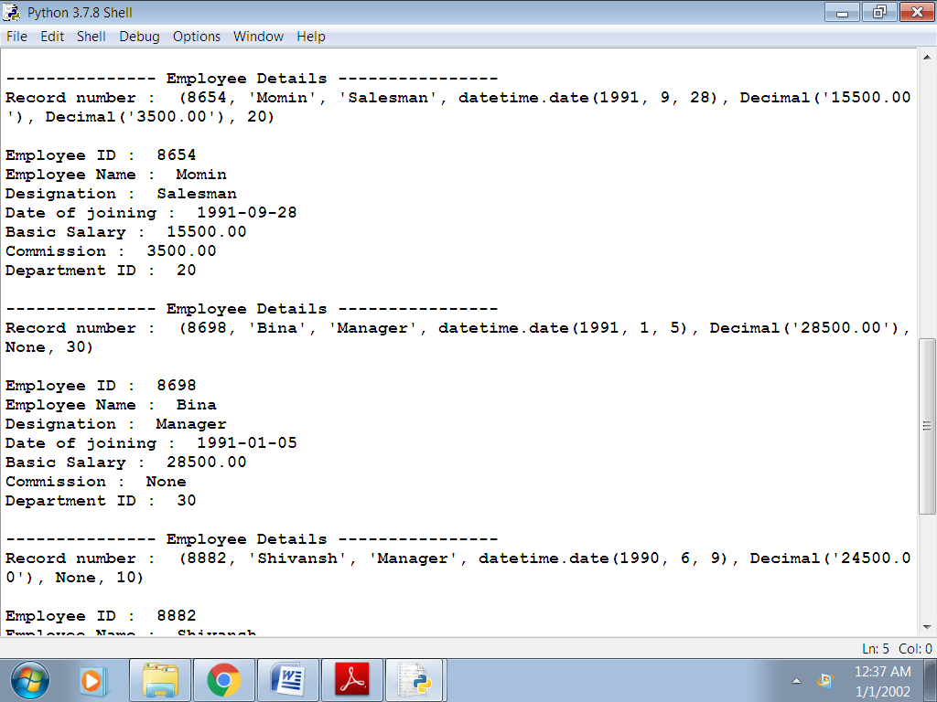
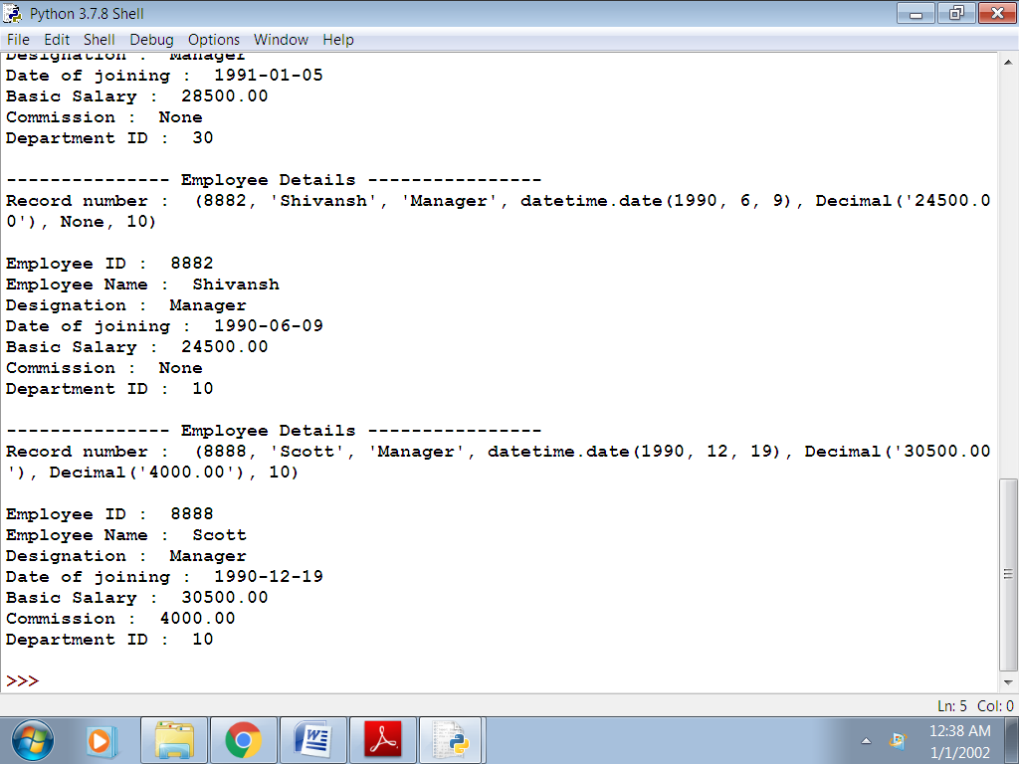

#TO SEARCH RECORDS

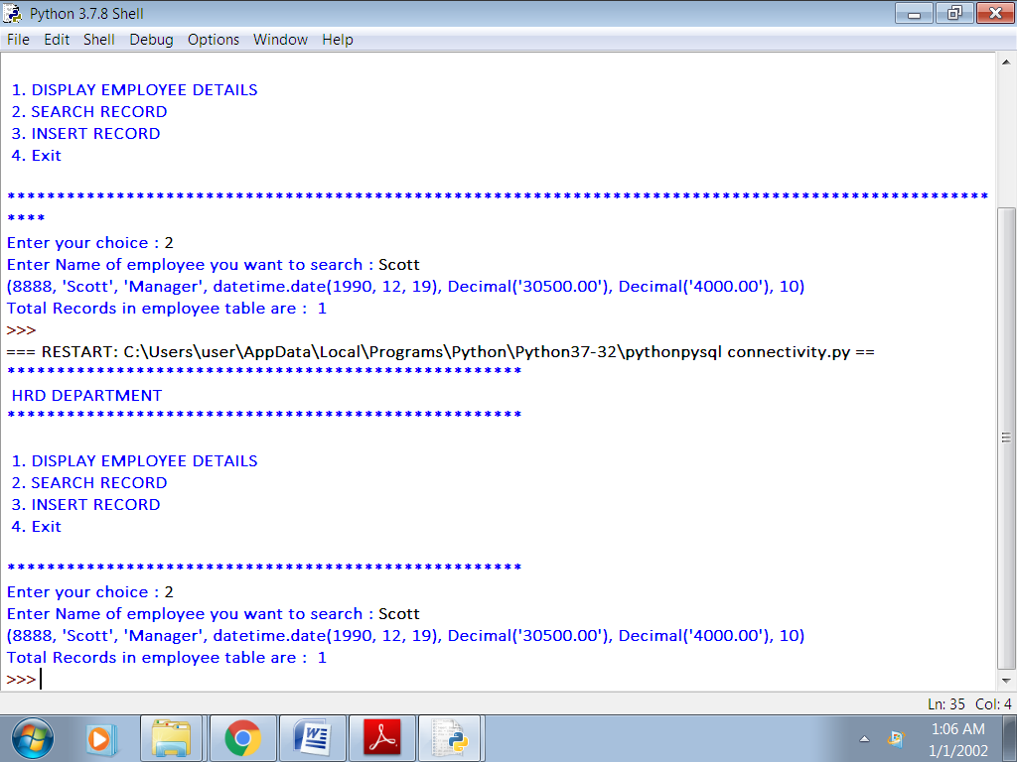

SIMILARLY:

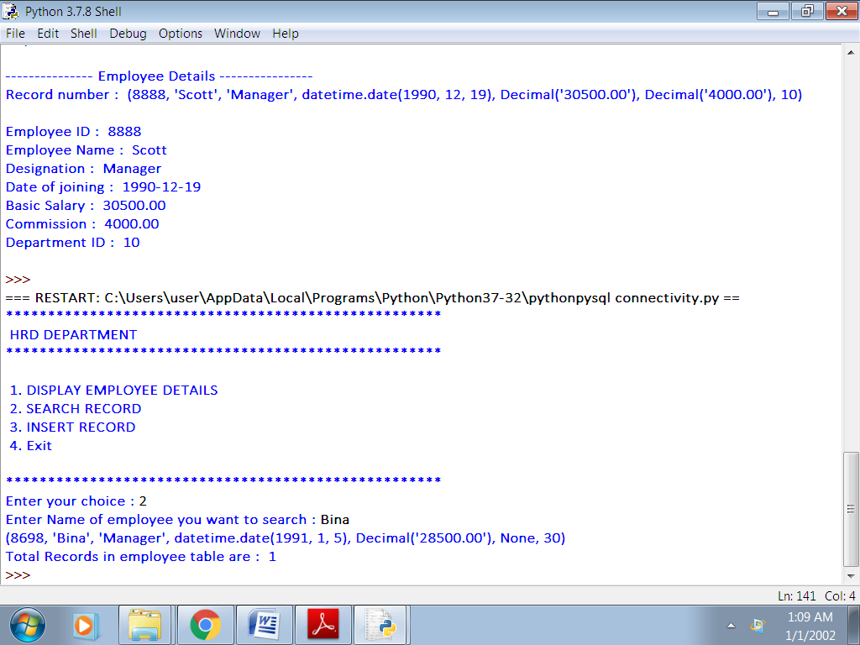

#TO INSERT RECORDS

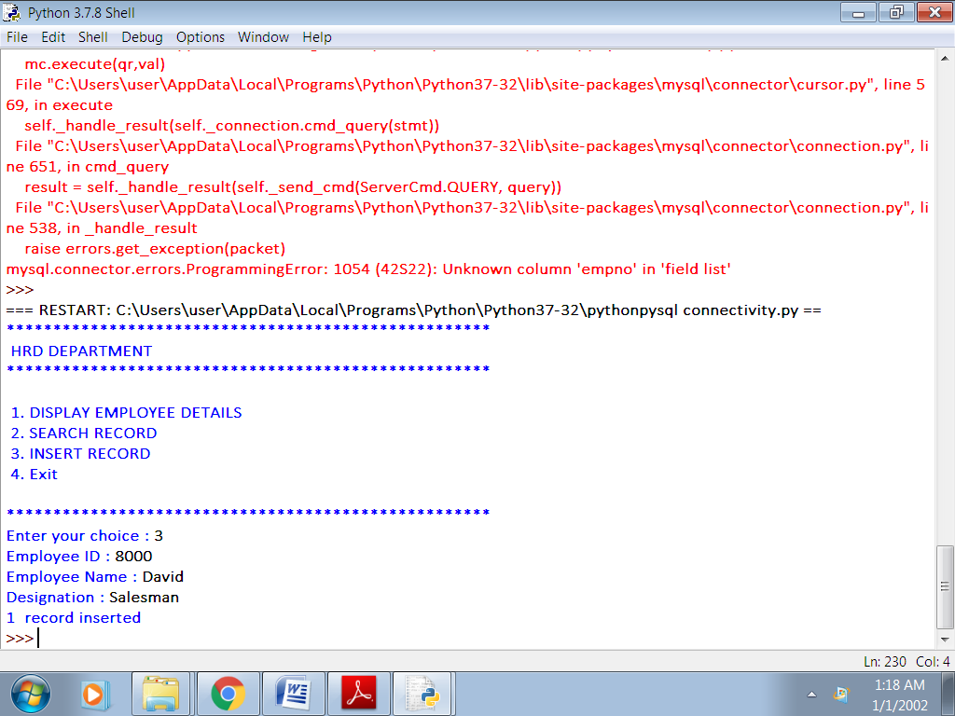

RECORD ADDED IN THE MY SQL EMPLOYEE TABLE:

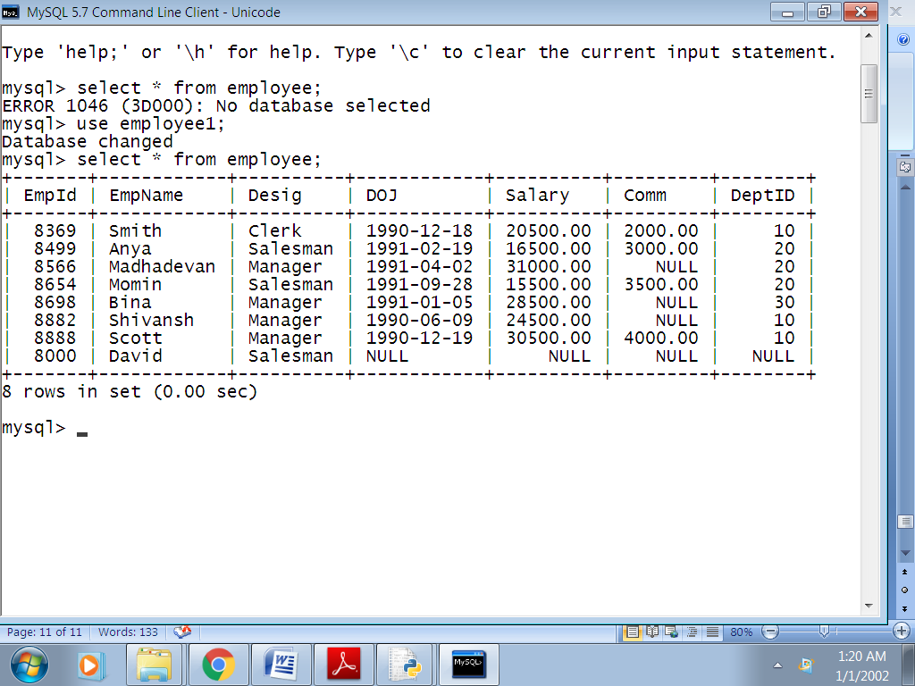

BIBLOGRAPHY

