PE02_Submission
Input
The application takes TextInput as input from the user (his/her favorite course). This course can be entered whether with the name of the course as CS 624 or by directly entering the course code. The program also loads icons. Png from assets. In addition, the capstone, core or depth courses values are obtained. These are loaded with an array for easy usage while displaying values.
Process
Using the useState hook to save the text when user typed some text, the CoreComponents arrow function uses the map-to-map items from array created a Text of the name of each course into 5 times the ScrollView is to make the screen vertically scrollable and StyleSheet to apply reusable style. The styles are applied to the image and heading but can be applied over input section, to the courses list created via loop, to the favorite course section etc.
Output
The display illustrates the icon, the course input field as well as the user's favorite course entry. Eight core courses and two courses for depth of study and capstone respectively were displayed. Titles were used to provide boundaries between courses with clear divisions that make it easier to read. The scrollable screen allowed courses to be viewed on smaller mobile screens.

Mobile Screenshots
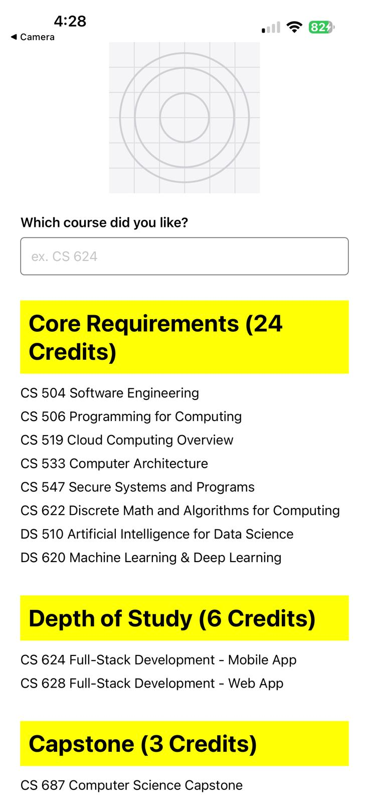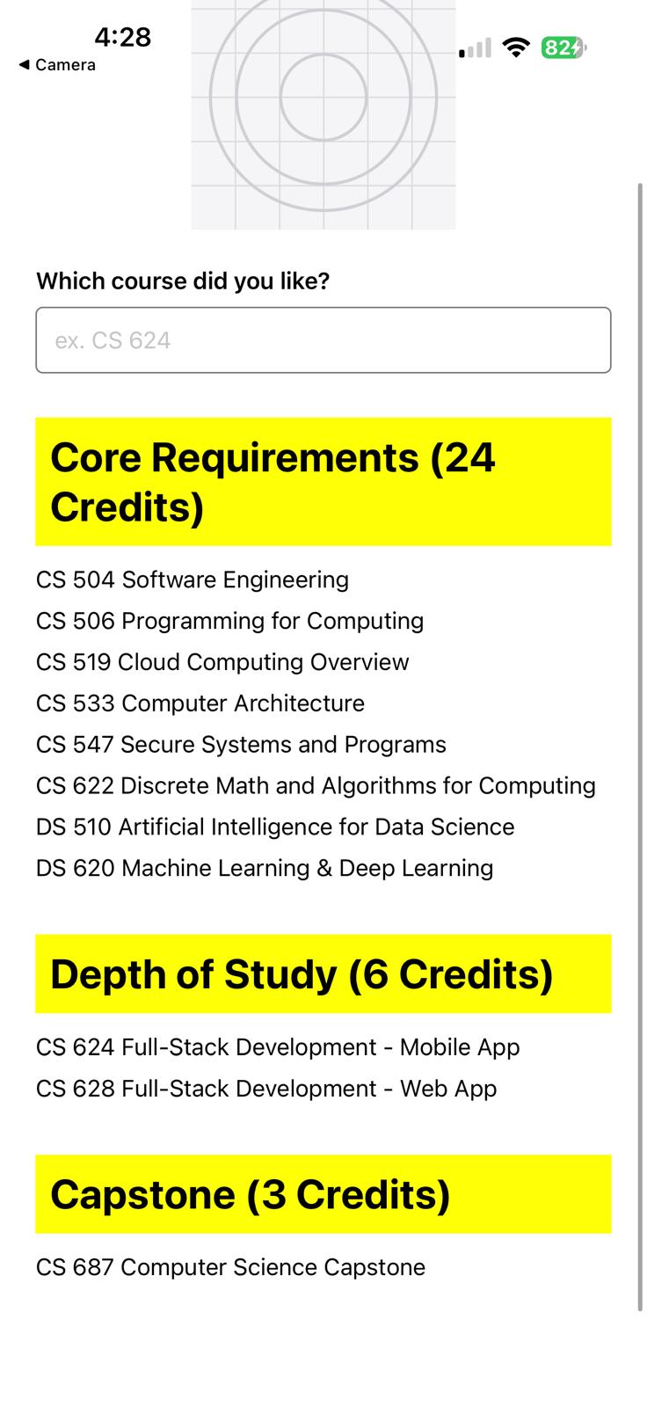

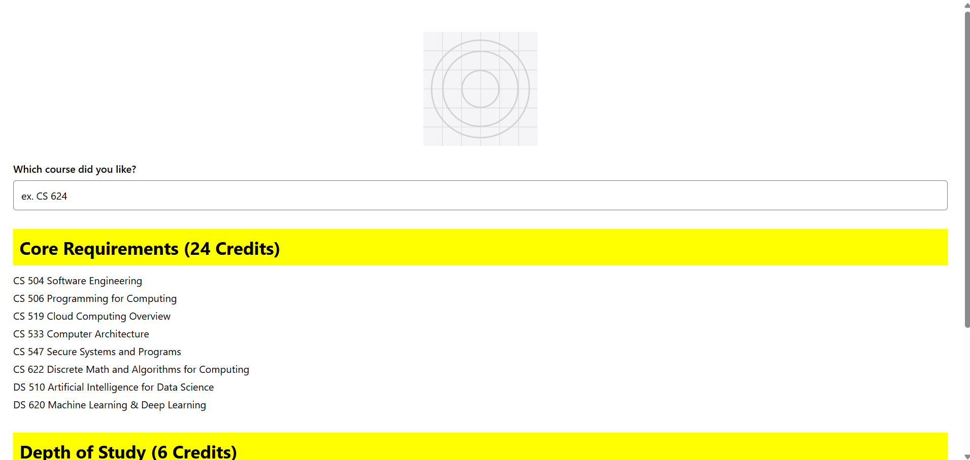

Web screenshots

