PE01_Submission
Input
The user does not give any input in the application. As soon as the app launches, it populates the screen with my personal information such as name, my degree program name and my school’s name. No buttons or textfield or interaction are required from the user, as the information is already preset in the native application.
Process
The app is developed by using React Native. It used one View component which contains three Text which displaying the information. StyleSheet is used for styling and includes yellow background, centered alignment, bold text and suitable font size. When the native app launches React Native renders View and Text components as per styled and displays the information.
Output
The screen then shows up as a simple screen with a yellow image. Three messages are shown on the yellow background at the centre of the screen - my name, my current degree (MS Computer Science) and City University of Seattle. The output generated is neat and easy to read. This satisfies the requirement asked for in the assignment as only one View component, three Text components and one StyleSheet is used.

Screenshot from the mobile
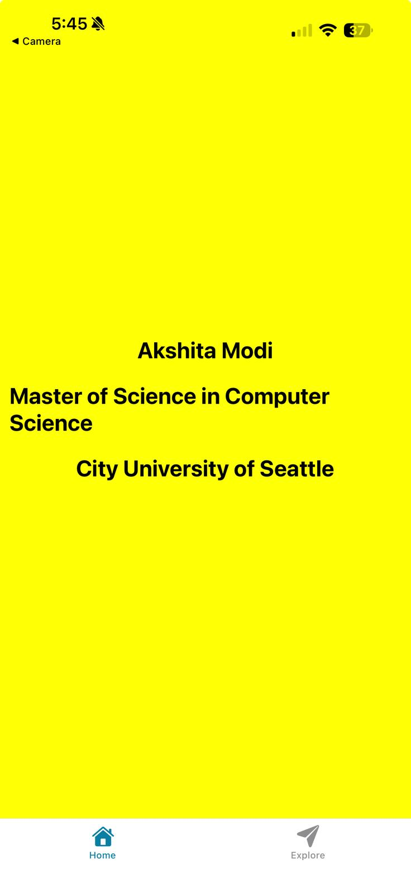

https://github.com/akshita-creates/cs624-pe-akshita

