**Introduction to AI and ML**

**CSL236**

Project Report



Student name :Akshita,Isheeta,Rohit,Akhil

Roll No.:20csu233,20csu313,20csu287,20csu200

Semester: Vth

Group:FS-V-B

**Department of Computer Science and Engineering**

**The NorthCap University, Gurugram- 122001, India**

**Session 2021-22**

**Table of Contents**

|  |  |  |
| --- | --- | --- |
| **S.No** |  | **Page No.** |
| **1.** | **Project Description** | **03** |
| **2.** | **Problem Statement** | **04** |
| **3.** | **Analysis**  **3.1 Hardware Requirements**  **3.2 Software Requirements** | **05-06** |
| **4.** | **Design**  **4.1 Data/Input Output Description:**  **4.2 Algorithmic Approach / Algorithm / DFD / ER diagram/Program Steps** | **07** |
| **5.** | **Implementation and Testing (stage/module wise)** | **08** |
| **6.** | **Output (Screenshots)** | **09-13** |
| **7.** | **Conclusion and Future Scope** | **14** |

Automatic Number Plate Recognition

(ANPR)

1. INTRODUCTION

In this project, a prototype based on digital image processing is developed. Actions such as image acquisition, enhancement which is pre-processing, license plate segmentation and then OCR (Optical Character Recognition) are used to store the number in text form. The license plate is displayed as text on the terminal using the OCR principle using easyocr. It can be seen that the security forces and authorities face problems whenever the security forces chase the vehicle or cannot catch the vehicle that has violated the traffic rules. The authorities find it very hectic to manually record vehicle numbers in the parking lot on a busy day. To make the whole process autonomous, we can install this system in such a way that it automatically detects a vehicle violating road traffic rules, takes a photo of it and stores the number in the database, so that it can subsequently fine the relevant owner.

Automatic Number Plate Recognition (ANPR) is a technology that uses optical character recognition on images of vehicle registration plates to read the vehicle’s registration number. An automatic license plate recognition system applies different image processing techniques to quickly and automatically identify vehicles in video or photo footage from cameras.

An automatic license plate recognition system can be used for a variety of purposes, such as tracking the movement of vehicles, identifying specific cars, automated parking enforcement, and so on.

PROBLEM STATEMENT

It can be seen that security forces and authorities face problems whenever security forces chase a vehicle or cannot catch a vehicle that has violated traffic rules. The authorities find it very hectic to manually record vehicle numbers in the parking lot on a busy day. To make the whole process autonomous, we can install this system in such a way that it automatically detects a vehicle violating road traffic rules, takes a photo of it and stores the number in the database, so that it can subsequently fine the relevant owner. The system can be used when parking to take a photo of the vehicle and register the vehicle number to a database (or the cloud if connected to the internet). This technology reduces the unnecessary hectic manual work required on a busy day, saves labour costs and is far more efficient than humans. Any vehicle number, once obtained as text, can be displayed, stored in a database or searched throughout the database for details. This project is so versatile that when converted to software it can be used as an entire application or used as part of any large project.

III. ANALYSIS

* Hardware Requirements
* Software Requirements

1. **Opencv** - an open source library that is very useful for computer vision applications such as video analysis, CCTV video analysis, image analysis. OpenCV is written from C++ and features over 2,500 optimized algorithms. If you're writing a computer vision application that you don't want to start from scratch, this library lets you focus on real-world problems. Many companies are using this library today, including Google, Amazon, Microsoft, and Toyota. Many researchers and developers have contributed to this. Easy to install on any operating system like Windows, Ubuntu, macOS.
2. **EasyOCR**- a Python package that can be used to convert images to text. It's the easiest way to implement OCR, with access to over 70 languages ​​including English, Chinese, Japanese, Korean, and Hindi, with more being added. EasyOCR is developed by Jaided AI company.
3. **Matplotlib**- This is a python library used for visualizing the data and graphical plotting of dataset
4. **Numpy**- Arraya can be subjected to a wide range of mathematical operations with Numpy. It provides a vast library of high level mathematical functions that work on these arrays and matrices, as well as strong data structures that ensure efficient calculations with arrays.
5. **Pandas**- Makes it easy to do many of the tedious, time consuming activities involved in working with data, such as:

* Data cleaning
* Data fill
* Data normalization
* Merges and Joins
* Data Visualization

1. **Imutils**- A series of convenience functions to make basic image processing functions such as translation, rotation, resizing, skeletonization, and displaying Matplotlib images easier with OpenCV

IV. DESIGN

* Data Input Output Description

An image of the vehicle whose number plate is to be recognized is taken from a digital camera, which is then uploaded to a local computer for further processing. OpenCV (Open Source Computer Vision) is a library of programming functions focused primarily on real-time computer vision. In simple language, it is a library used for image processing. It is mainly used to perform all operations related to Images. Python, which is a versatile language, is used here as the programming language. Python and its modules like Numpy, Scipy, Matplotlib and other special modules provide optimal functionality to cope with the flood of images. To further improve license plate recognition, we use a median filter to remove noise, but not just to remove noise. It also focuses on high frequency. So it is more important in detecting the edges in the image, generally the license plates are rectangular in shape, so we need to detect the edges of the rectangular table.

* Algorithm

1. Capture the car image
2. Identify the number plate from the image
3. Marking its coordinates
4. Resizing the image
5. Reading characters from the image
6. Matching the obtained data to the dataset

V. IMPLEMENTATION

After importing all the libraries we read our image using open cv and convert the image to gray scale. We use bilateral filtering function of opencv to reduce noise in our images, canny is used to detect edges in our images. Canny uses a multi stage algorithm the first being noise reduction then finding intensity gradient of image, next we do non maximum suppression and finally do Hysteresis thresholding. We use contour function for finding curves that are joining all the continuous points. Imutils is used to detect the number plate from the canny image and then we find the coordinates of the number plate. We select the coordinates of the number plate and then we blacken the entire area other than this part. We then zoom in to the number plate and crop the selected area. Now we have the number plate and we use easyOCR to read the characters present in it. We highlight the number plate on the original image using a blue rectangle and also paste the license number. We also save this number in csv as well as text format.

VI. OUTPUT (SCREENSHOTS)

1. Importing Required libraries –

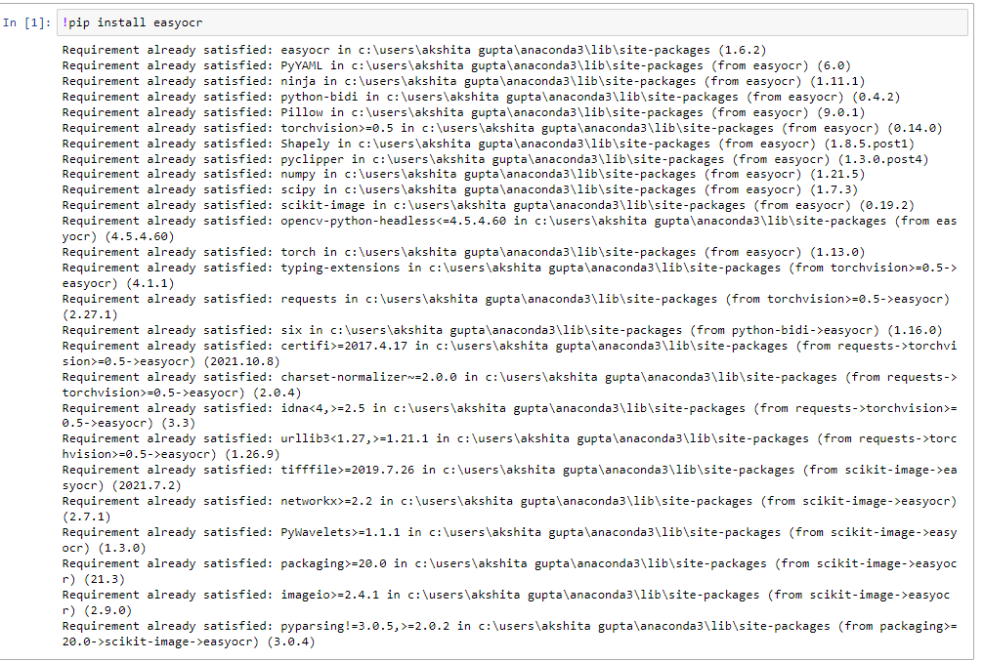

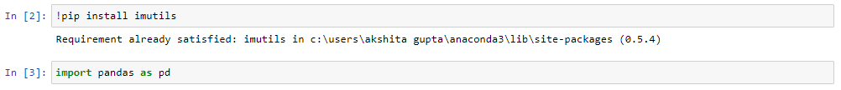









1. Converting image to Gray Scale –

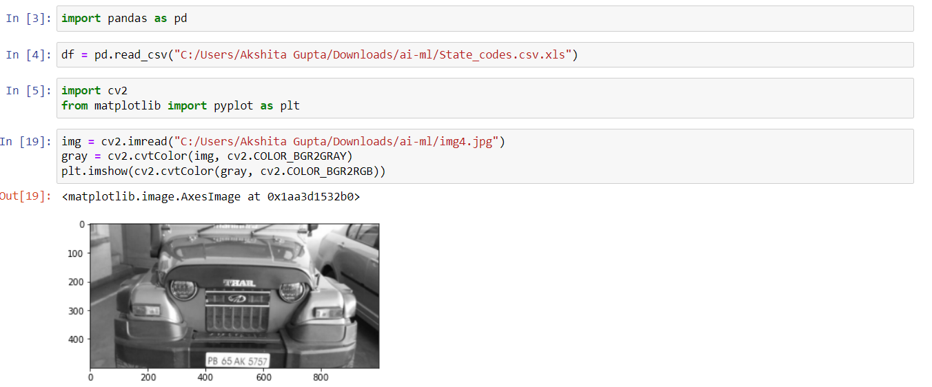

1. Noise Reduction and edge detection –

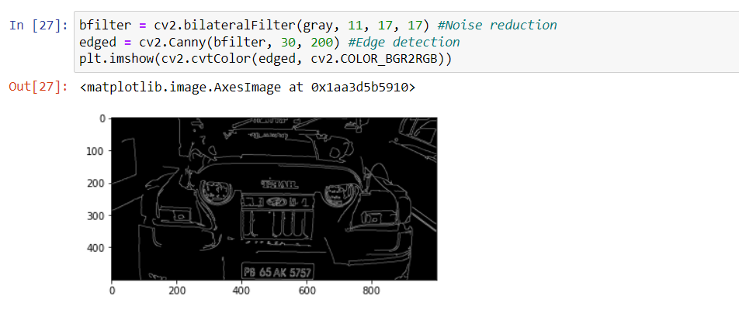

1. Getting the number plate co-ordinates-

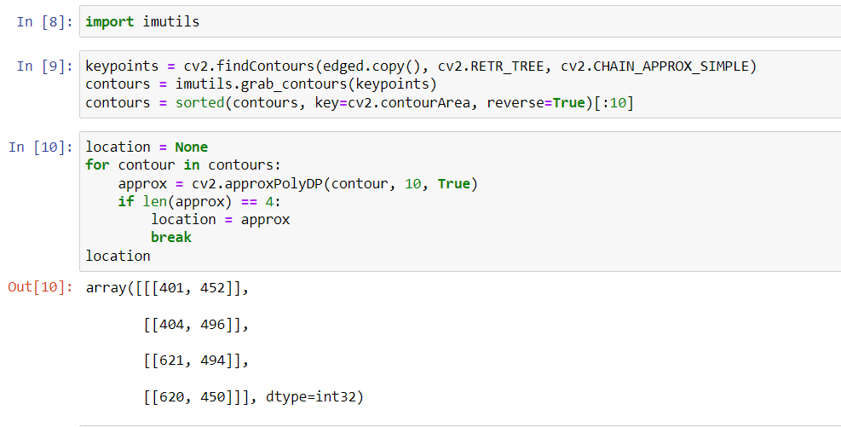

1. Image of number plate-

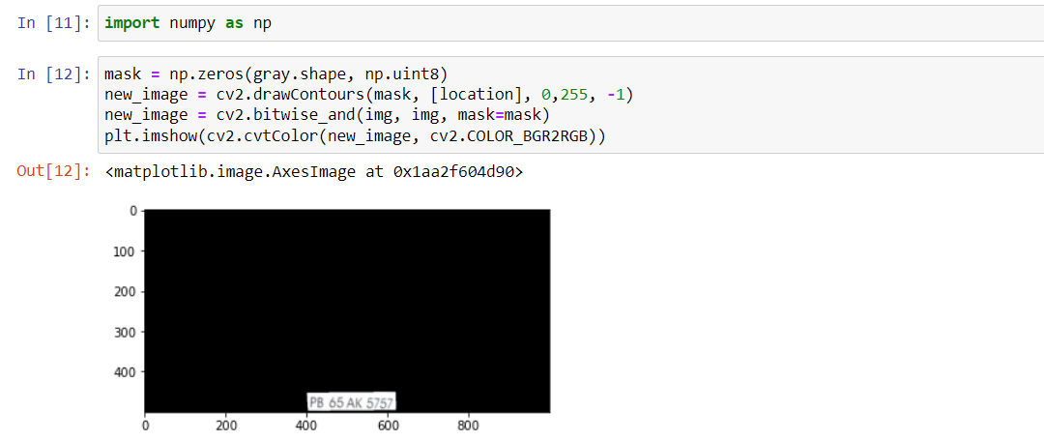

1. Cropped Image of number plate-

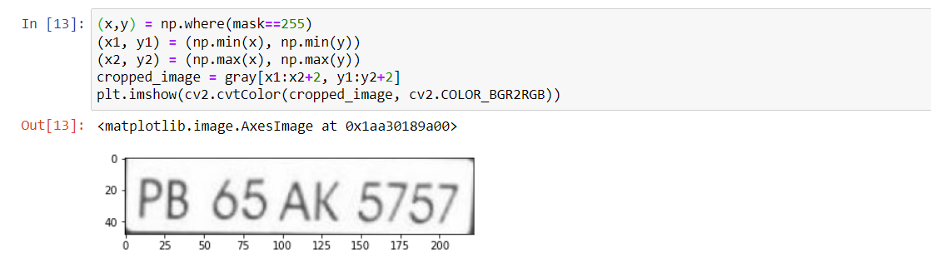

1. Fetching number plate using easyOCR-

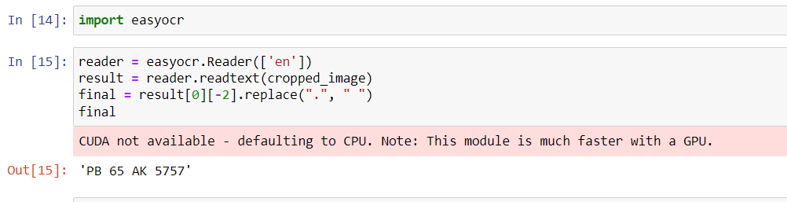

1. Fetching state name from database in output.txt file-

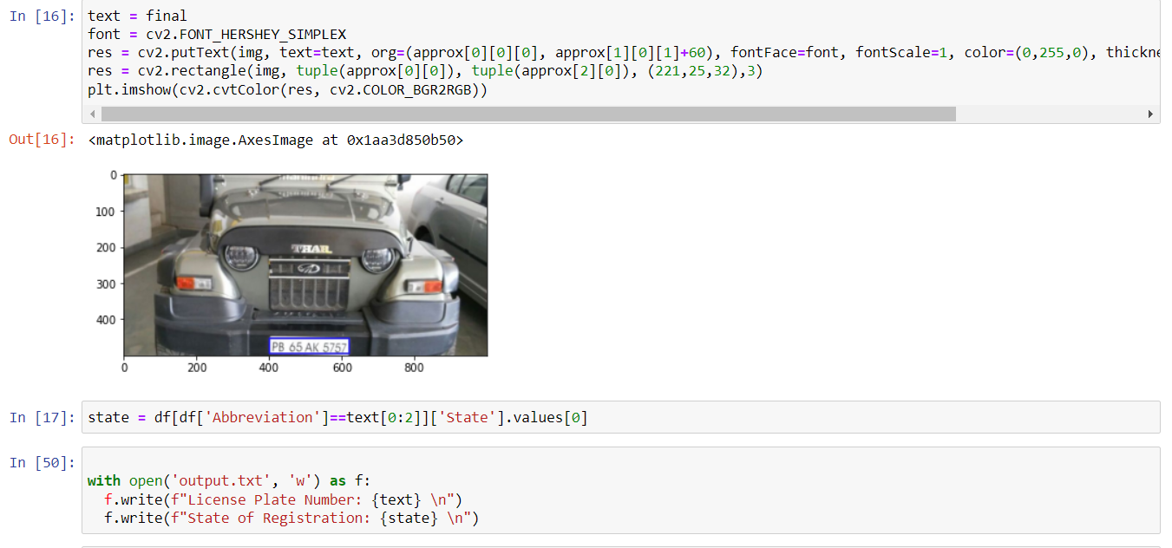

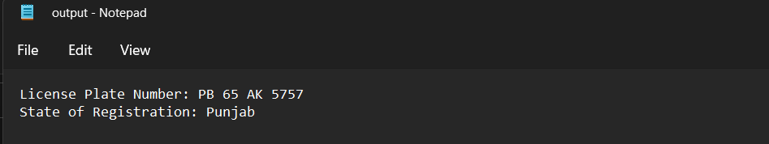

VII. CONCLUSION AND FUTURE SCOPE

This project helped us a learn a lot about how to use different image processing libraries and tools more effectively in order to serve our purpose better. Presently it is not possible to be 100% accurate as accuracy depends on many factors such as lighting condition, shadow of the vehicles and irregular license plate.

Benefits of Automatic Number Plate Recognition ANPR offers numerous advantages that are the basis for real-world applications. Most benefits of ANPR come with automating manual tasks, highly efficient space management, governance, and increasing the customer experience.

1. Automation: The automated recognition of number plates allows automated alerts and controls for facilities. Hence, ANPR is a key technology for smart cities or toll stations.
2. Accuracy: ANPR systems can achieve very high accuracy, and can quickly and easily identify vehicles by their license plates.
3. Analytics: The generated data can be used for traffic flow analytics. This is particularly important for operating Intelligent Transportation Systems (ITS), where data processing technologies are used to improve the mobility of people and goods, demand management, increase safety, reduce traffic congestion and manage incidents effectively.