RUTE SunTracker — Field Deployment Procedure
OpenMV + ESP32 Solar Tracking Prototype — Wiring, Flashing, and Testing
Prepared by: Akshita Gangiredla
Status: Tested prototype, individual subsystems validated

Overview
This document is a step-by-step procedure for reproducing the RUTE SunTracker prototype at a field site. It covers physical wiring, flashing each microcontroller with the correct file from the accompanying code package, and testing each piece before relying on it.
The system uses a camera at the pitch pole to measure the Blume's tilt angle, and relays that reading wirelessly to a controller in the Operations Shed. The shed controller compares the measured angle against a schedule (10am / 2pm / 7pm) and drives a relay-controlled winch to correct the angle in 1-second pulses, rechecking after each pulse until the Blume is within tolerance. Rain, wind, and cable-tension sensors add safety interlocks on top of this core loop: they can pause a move or override the schedule entirely to drive the Blume to a safe stow position.
Three physical zones are involved:
- Pitch Pole — OpenMV Cam + one ESP32 ("the sender")
- Operations Shed — one ESP32 ("the controller"), relay module, and all weather/tension sensors
- Winch / Rotary Drive — connected to the relay's output, not directly to any microcontroller

1. Code Package Contents
This document refers to files by name. All files below are included alongside this document.

Production Files (flash these for permanent field operation)

Requires software Arduino IDE (.ino files) and OpenMV IDE (.py files).
Filename | Goes On | Purpose
openmv_tracker.py | OpenMV Cam | Measures Blume tilt angle, streams it over UART
pitchpole_sender.ino | Pitch-pole ESP32 | Relays the camera's angle to the shed over ESP-NOW
shed_controller.ino | Shed ESP32 | Full tracking logic + relay control + all sensor interlocks

1.2 Utility File
Filename | Goes On | Purpose
esp32_mac_finder.ino | Both ESP32s (temporarily, one at a time) | Reads out the board's permanent hardware MAC address

1.3 Test Files (flash temporarily, one at a time, during setup only)
Filename | Goes On | Tests
test_esp_now_sender.ino | Pitch-pole ESP32 | Wireless link to the shed (pairs with the receiver test file)
test_esp_now_receiver.ino | Shed ESP32 | Wireless link from the pitch pole
test_rain_gauge.ino | Shed ESP32 | Rain gauge tip counting
test_anemometer.ino | Shed ESP32 | Wind speed reading
test_windvane.ino | Shed ESP32 | Wind direction voltage — also used to calibrate
test_loadcell.ino | Shed ESP32 | Load cell wiring — also used to calibrate
Relay wiring and the full tracking loop are tested using commands built into shed_controller.ino itself (see Section 7) — no separate test file is needed for those.

2. Powering the Boards

2.1 Operations Shed
Power the shed ESP32 from a regular outlet via a standard 5V USB supply.

2.2 Pitch Pole (Camera + Sender ESP32)
There is no AC power at the pitch pole per the site diagram, and this location needs to run unattended 24/7. The recommended approach is a small sealed 12V battery (SLA or LiFePO4) with a small PV trickle charger — the same concept already used for the shed's battery bank, just scaled down for two low-power boards — feeding a buck converter stepped down to 5V for both the OpenMV Cam and the pitch-pole ESP32.
- This avoids manual battery swaps/recharging trips that a plain USB power bank would require.
- Confirm the OpenMV Cam's accepted input voltage/current before wiring it to the buck converter's output — verify against the board's documentation rather than assuming.
- Both boards and the battery/charger should be in a weatherproof enclosure at the pitch pole.

3. Pitch-Pole Wiring Procedure

3.1 Mount the OpenMV Cam
- Mount the OpenMV Cam H7 R2 so it has a clear, stable view of the side profile of the Blume it will track.
- Confirm the mount is rigid — the camera measures angle relative to its own frame, so any camera movement between readings will corrupt the measurement.
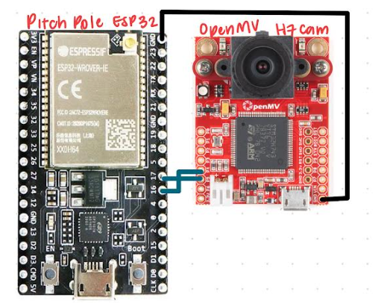

3.2 Wire the OpenMV Cam to the Pitch-Pole ESP32
Both boards need soldered pin headers for reusable jumper-wire connections — the OpenMV's through-holes do not ship with headers installed.
OpenMV Pin | Signal | Connects to ESP32 Pin
P4 | UART3 TX | GPIO16 (RX2)
P5 | UART3 RX | GPIO17 (TX2)
GND | Ground | GND
TX connects to RX, and RX connects to TX (crossed) — this is the most common wiring mistake. Confirm grounds are tied together or the link will be unreliable.

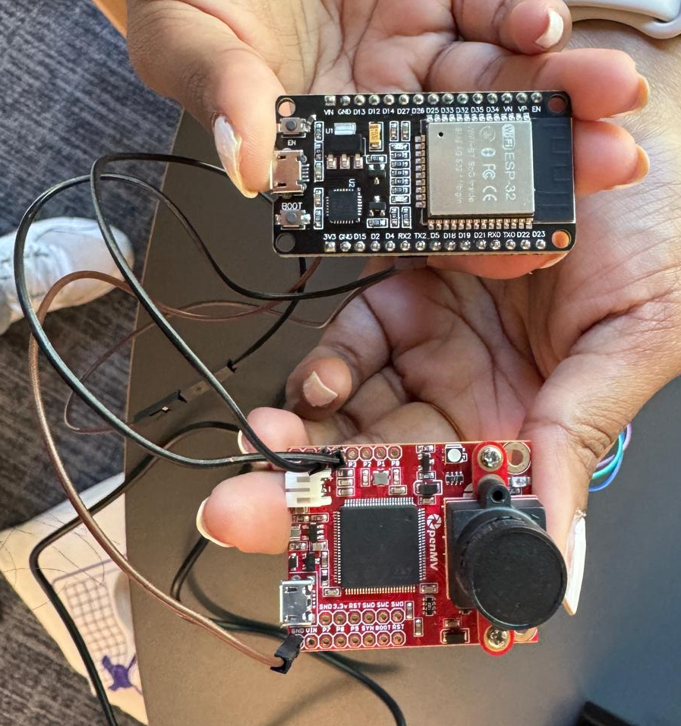

3.3 Power Both Pitch-Pole Boards
Connect the OpenMV Cam and the pitch-pole ESP32 to the pitch-pole power supply described in Section 2.2.

4. Finding the ESP32 MAC Addresses
Before flashing the production sender code, you need the shed ESP32's permanent hardware MAC address, since the pitch-pole ESP32 must be told exactly which board to send its data to.
- Connect the SHED ESP32 to your laptop and flash esp32_mac_finder.ino to it.
- Open its Serial Monitor (115200 baud) and record the printed "Hardware MAC Address” and write it down exactly.
- Repeat on the PITCH-POLE ESP32 with the same esp32_mac_finder.ino file and record its address too (kept for your records — not currently needed by any other file, but useful if the system later needs to send data back to the pitch pole).
- You will paste the SHED's MAC address into pitchpole_sender.ino in the next section.
Some ESP32 core versions report an unreliable MAC via WiFi.macAddress() immediately after boot. esp32_mac_finder.ino reads the address directly from the chip's hardware fuses instead, which is more reliable — use its printed value, not one read any other way.

5. Flash the Pitch-Pole Sender
- Open pitchpole_sender.ino in Arduino IDE.
- Edit the shedAddress[] array near the top of the file, replacing the placeholder bytes with the shed ESP32's MAC address from Section 4.
- Select the pitch-pole ESP32's COM port under Tools -> Port.
- Click Upload.
- Leave this board running — it will now automatically read from the OpenMV Cam and transmit over ESP-NOW every time it powers on.

6. Operations Shed Wiring Procedure
Complete the following wiring before flashing the shed controller code. A full pin reference table and diagram is in Section 6.6 for quick lookup.

6.1 Relay Module
ESP32 Pin | Connects To
GPIO25 | Relay module IN1 (FWD)
GPIO26 | Relay module IN2 (REV)
5V / VIN | Relay module VCC
GND | Relay module GND
Most relay modules are active-LOW (a LOW signal turns the relay ON). This will be verified empirically in Section 7 — do not assume either way before testing. The relays provided in the ESP32 starter kit were used for testing and were active low.

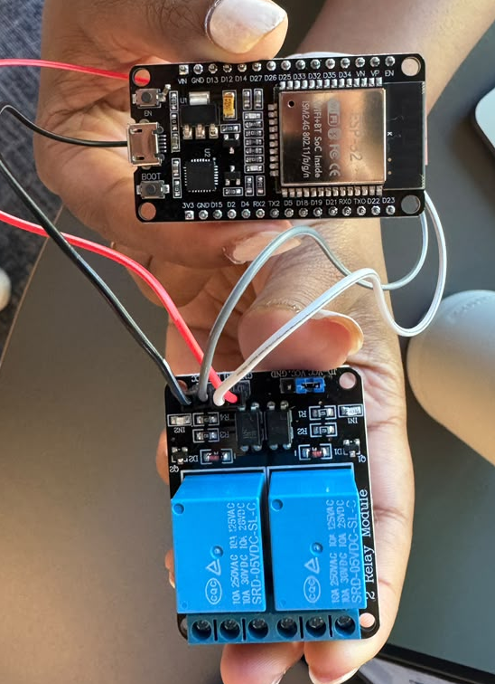

6.2 Rain Gauge
Connect the RJ11 connector cable to the RJ11 connector and confirm the correct pair of RJ11 active pins with a multimeter in continuity mode by identifying which 2 of the 6 pins show a closed circuit when you manually tip the bucket mechanism. The one linked in Section 8.1 and used by me will be Pins 3 & 4.
Rain Gauge (confirmed pin) | ESP32 Pin
Active pin 1 | GPIO27
Active pin 2 | GND

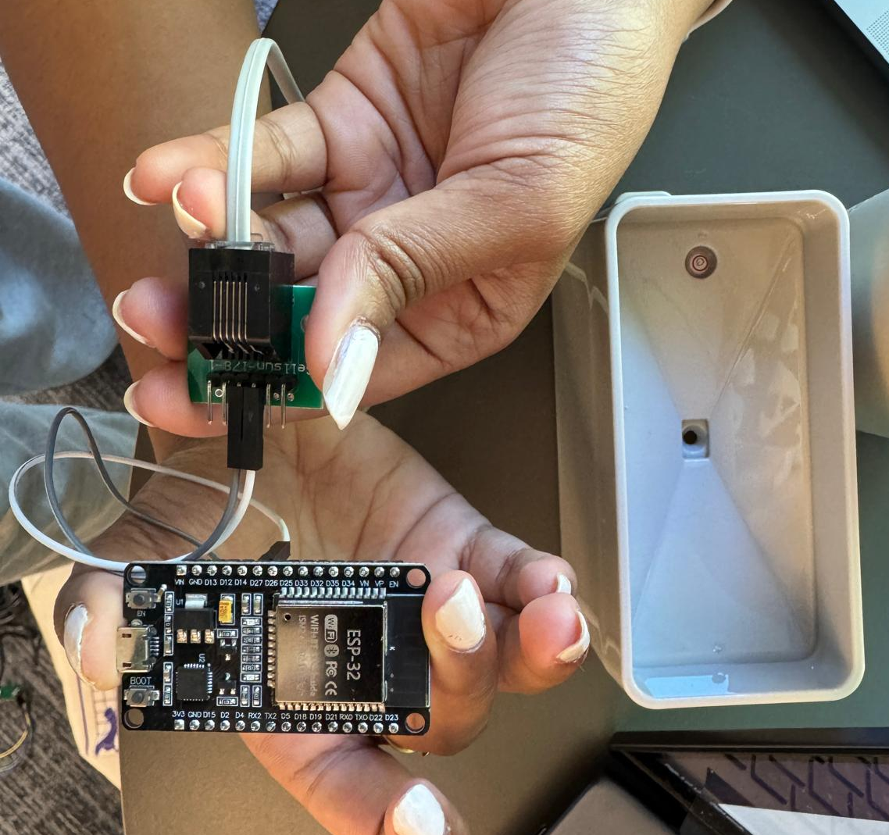

6.3 Anemometer and Wind Vane
Confirm each sensor's correct pin pair with a multimeter (continuity mode for the anemometer's switch (same and rain gauge), resistance mode for the wind vane) before wiring. For the wind vane, test across different pin pairs while manually rotating the vane through several positions. You're looking for the pair where resistance changes as you rotate — record several actual resistance readings at different known positions (e.g., point it N, E, S, W) as you go. With the specific connectors used for testing, the middle pins (3 & 4) related to the anemometer and the ones outside that (2 & 5) related to the anemometer. Refer to the diagram in Section 6.6 for more information.
Sensor | ESP32 Pin | Notes
Anemometer | GPIO14 | Switch closure — needs INPUT_PULLUP, no external resistor
Wind Vane signal | GPIO34 | Must be an ADC1 pin (GPIO32-39) — ADC2 is unreliable whenever WiFi is active, and this system runs WiFi continuously
Wind vane voltage divider (look at Section 6.6 for clearer diagram):
- ESP32 3.3V -> 10k ohm resistor -> node (this node also connects to GPIO34) -> Wind Vane -> ESP32 GND

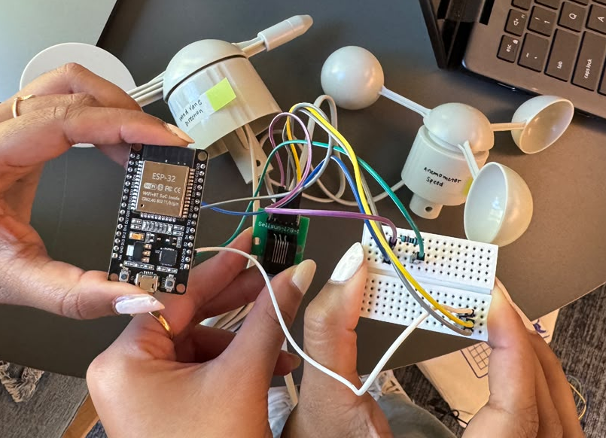

6.4 Load Cell
Solder the load cell's wires onto the HX711 board's J1 header:
Load Cell Wire | HX711 Pin (J1)
EXC+ (red) | E+
EXC- (black) | E- (twist together with shield, solder as one joint)
SIG+ (green) | A+
SIG- (white) | A-
Shield (bare) | E- (see above)
Solder a 4-pin header onto the HX711's output side, then wire to the ESP32:
HX711 Pin | ESP32 Pin
VCC | 3.3V
GND | GND
DT | GPIO4
SCK | GPIO5

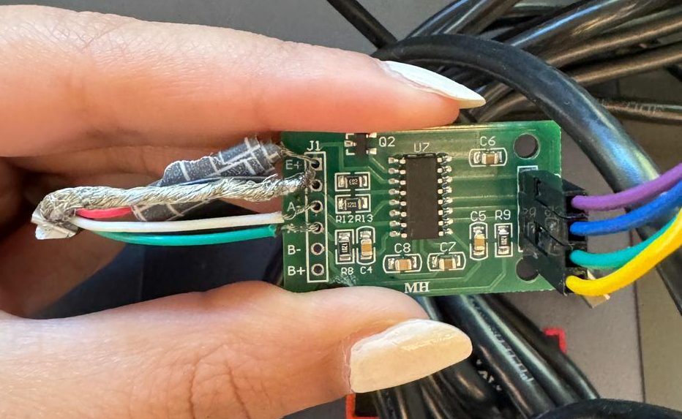

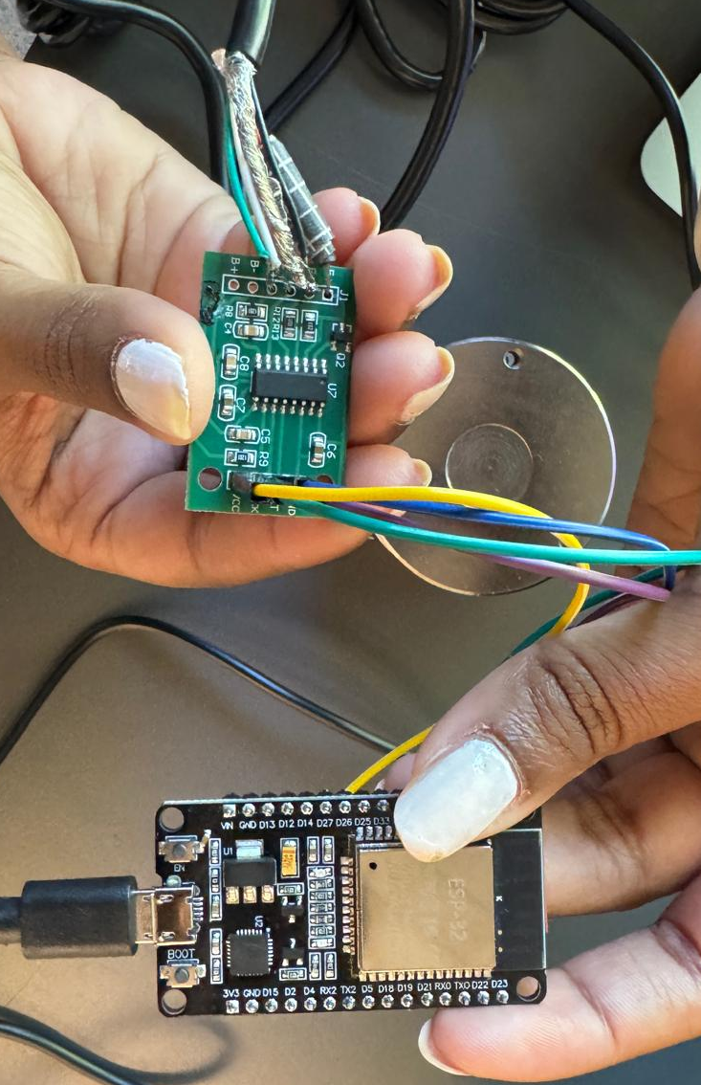

6.5 Relay Output to the Winch
This is the connection that actually moves the Blume. The relay's control side (IN1/IN2, wired in Section 6.1) is driven by the ESP32. The relay's OUTPUT side (the COM/NO contacts) is what switches power to the physical winch and is completely separate from the ESP32's logic wiring.
- Relay 1 (FWD channel) output contacts -> in series with Winch A's power leads
- Relay 2 (REV channel) output contacts -> in series with Winch B's power leads
In the production design, confirm winch voltage/current ratings against the relay/contactor's rated capacity, before energizing anything. Can also switch around the relays connecting to the winches if they appear to be moving backwards.
- Confirm which physical winch (FWD vs. REV) actually corresponds to which real-world rotation direction BEFORE trusting the automatic correction logic — test manually first (Section 7.6).

6.6 Full Shed ESP32 Pin Reference
ESP32 Pin | Connected To | Function
GPIO25 | Relay IN1 | FWD winch trigger
GPIO26 | Relay IN2 | REV winch trigger
GPIO27 | Rain gauge | Tip interrupt
GPIO14 | Anemometer | Speed pulse interrupt
GPIO34 | Wind vane signal node | Direction voltage read (ADC1 only)
GPIO4 | HX711 DOUT | Load cell data
GPIO5 | HX711 SCK | Load cell clock
3.3V / VIN | HX711 VCC, relay VCC | Power
GND | All sensor grounds, relay GND | Common ground — required for every device
Video for how my prototype was connected:

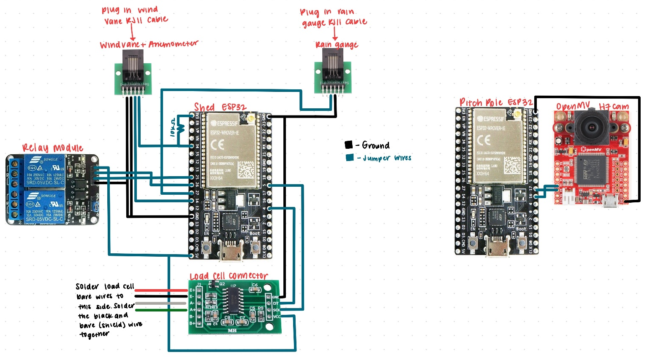

7. Testing Procedure
Test every subsystem in isolation, in this order, before combining them. Do not skip ahead to full-system testing if an earlier step doesn't behave as expected. To test each subsystem listed here, connect the relevant pins to the Shed/receiver ESP32 and follow the instructions.

7.1 OpenMV Camera Angle Measurement
- Flash openmv_tracker.py to the OpenMV Cam as main.py (Tools -> Save file to OpenMV Cam).
- With OpenMV IDE's serial terminal open, physically level the reference edge/line with a real level or protractor while the camera is mounted.
- Note the reported angle, then set CAMERA_OFFSET in the file so a level object reads 0.0. Re-flash.
- Rotate to 2-3 other known angles (protractor-verified) and confirm the corrected output tracks correctly in both magnitude and sign.

7.2 ESP-NOW Wireless Link
- Flash test_esp_now_receiver.ino to the SHED ESP32.
- Flash test_esp_now_sender.ino to the PITCH-POLE ESP32 (with the shed's MAC address already filled in).
- Confirm the shed's Serial Monitor shows "Received: 1, 2, 3..." incrementing steadily, about once per second.

7.3 Rain Gauge
- Flash test_rain_gauge.ino to the shed ESP32.
- Manually tip the bucket mechanism and confirm the Tips count increases by exactly 1 per physical tip (not 0, not multiple).

7.4 Anemometer
- Flash test_anemometer.ino to the shed ESP32.
- Spin the cups by hand and confirm the reported wind speed responds sensibly.

7.5 Wind Vane (also serves as calibration)
- Flash test_windvane.ino to the shed ESP32.
- Rotate the vane by hand to each direction (at minimum due South and due North) and record the voltage shown at each — this builds the real calibration table.
- Transfer these recorded voltages into the vaneTable[] array inside shed_controller.ino before flashing it.

7.6 Relay Wiring (using shed_controller.ino's built-in commands)
- Flash the production shed_controller.ino (Fill in WiFi credentials and vane table).
- Open its Serial Monitor, set line ending to "Newline".
- Type "relay fwd" and confirm the correct relay clicks and the correct winch/direction moves. Repeat with "relay rev".
- If the wrong relay channel activates for a given command, correct the wiring or swap FWD_PIN/REV_PIN in the code — do not proceed until this is verified, since a reversed mapping will make the automatic correction logic drive the Blume the wrong way.

7.7 Load Cell (also serves as calibration)
- Flash test_loadcell.ino to the shed ESP32.
- Confirm a stable near-zero reading at rest, and a clear, repeatable change with gentle hand pressure (confirm the load cell's rated capacity before applying any real test load).
- Apply a known weight in-line with the load cell (matching its real tension-loading direction) and record the calibration factor it prints.
- Update MAX_TENSION in shed_controller.ino using this calibration.

7.8 Full Tracking Loop (manual target)
- With the production shed_controller.ino running and everything connected, type "test <angle>" (e.g. "test 20") into its Serial Monitor.
- Rotate the reference object in front of the OpenMV Cam toward that angle and confirm the relay pulses, pauses, rechecks, and eventually reports IN POSITION.

7.9 Weather and Tension Interlocks
- Rain: tip the rain gauge mid-test and confirm movement pauses, resuming roughly 5 minutes after the last tip.
- Wind speed alone (safe direction): spin the anemometer fast while the vane points away from S/N — confirm stow does NOT trigger.
- Wind direction alone (low speed): point the vane at S or N without spinning the anemometer fast — confirm stow does NOT trigger.
- Wind speed AND direction together: confirm stow DOES trigger, and that it interrupts an in-progress move rather than waiting for it to finish.
- Tension: apply pressure to the load cell mid-test and confirm movement pauses.

7.10 Full End-to-End Test
- With no manual overrides active, let the system run through an actual scheduled time (10am, 2pm, or 7pm) unattended.
- Confirm the complete behavior matches what was validated in isolation: correct schedule trigger, correct angle convergence, and correct interlock behavior if weather or tension conditions occur during the window.

7.11 Summary of Bench Testing Already Completed
The table below records what has already been confirmed working on the bench
Subsystem | Result | Notes
OpenMV angle measurement | Confirmed working | Stable, repeatable angle output after tuning find_lines() parameters and confirming the correct line-object attribute names for this firmware version
OpenMV -> pitch-pole ESP32 (UART) | Confirmed working | Verified with a simple counter message before trusting real angle data
Pitch-pole ESP32 -> shed ESP32 (ESP-NOW) | Confirmed working | Verified with a simple counter message; required reading each board's MAC via esp_read_mac() rather than WiFi.macAddress()
NTP time sync | Confirmed working | Verified independently before combining with tracking logic
Full tracking loop (manual target angle) | Confirmed working | Reliably reaches and reports IN POSITION using the "test <angle>" command
Relay FWD/REV pulsing | Confirmed working | Verified relay clicks correctly via the "relay fwd"/"relay rev" commands; active-low behavior confirmed on the prototype's 2-channel module
Rain gauge | Confirmed working | Correct pins identified via multimeter continuity test; tip counting confirmed accurate by hand
Anemometer | Confirmed working | Wind speed reading responds correctly to manual spinning
Wind vane wiring | Confirmed working | Voltage divider circuit verified; full direction calibration table still needs to be populated with real recorded values (Section 7.5)
Wind speed + direction stow interlock | Confirmed working (simulated) | Verified that stow only triggers when both conditions are met together, and correctly interrupts an in-progress move
Rain interlock | Confirmed working | Verified movement pauses during simulated rain and resumes after the quiet window elapses
Load cell wiring | Confirmed working | Initial flat-zero readings traced to a solder joint issue and resolved; calibration with a known weight still pending

8. Bill of Materials

8.1 Prototype Components
Component | Qty | Notes
OpenMV Cam H7 R2 – provided | 1 | No onboard WiFi — communicates via UART3 (pins P4/P5)
ESP32 dev board – provided | 2 | One at pitch pole (sender), one at shed (controller)
5V 2-channel relay module – from starter kit provided | 1 | Drives FWD/REV winch power
HX711 load cell amplifier | 1 | Required — load cell signal is too small to read directly
Load cell (4-wire + shield) – provided | 1 | EXC+/EXC-/SIG+/SIG- per its wiring diagram
Rain gauge (reed switch, tipping bucket) – provided | 1 | 0.011 in / tip; RJ11 terminated
Anemometer (reed switch) – provided | 1 | 1 closure/sec = 1.492 mph; shares a cable with the wind vane
Wind vane (resistive) – provided | 1 | Reports direction as a voltage via internal resistor network
RJ11 breakout board (6P6C) | 2 | For the rain gauge and the combined anemometer/wind vane cable
10k ohm resistor – from starter kit provided | 1 | Pull-up for the wind vane voltage divider
12V battery + PV trickle charger (pitch pole) | 1 set | Recommended power source — see Section 2.2
12V-to-5V buck converter | 2 | One at pitch pole, one at shed if not using AC/USB directly

9. Open Items — Confirm Before Field Deployment
These are placeholder values or unresolved questions. Confirm each with the mechanical/structural team before running unattended.
Item | Current Placeholder | What's Needed
Directional wind stow threshold | 30 mph trigger / 20 mph resume | Real structural wind-load limit for this rig
Stow tilt angle | 5 degrees | Confirm this is genuinely the lowest-load tilt for the array geometry
Danger wind window | +/-45 deg from due S or due N | Confirm this matches the panel's actual wide-face orientation
Max cable tension | 500 (uncalibrated units) | Real safe tension limit for the control cable, in calibrated units
Relay active-high vs. active-low | Assumed active-low | Confirm empirically per Section 7.6
FWD/REV to physical direction mapping | Assumed, not field-verified | Must be confirmed per Section 7.6 before trusting auto-correction
Winch controller vs. direct motor wiring | Assumed relay -> contactor coil -> motor | Confirm whether a separate "winch controller" unit sits in this chain per the BOM

