AMRITSAR GROUP OF COLLEGES
Synopsis
On
STUDYFORGE AI
Subject Name: Major Project Lab (AGCS-21704)
Bachelor Of Technology
In
COMPUTER ENGINEERING
Academic Session (2026 - 2027)


Submitted To
Er. Ajay Sharma
Associate Professor
Department of CSE

Submitted By
[Student Name (Roll Number)]

DEPARTMENT OF COMPUTER SCIENCE AND ENGINEERING

INTRODUCTION
Overview of the Project: StudyForge AI is a learning-organisation backend that lets authenticated students create personal subjects and store study materials within them. The application exposes REST APIs through FastAPI and persists data through SQLAlchemy and SQLite.
Brief Context and Background: Students often keep notes, subject information and revision material in disconnected places. A lightweight, secure application layer is useful for collecting these resources under a single subject-based structure that can later support richer academic workflows.
Motivation for Choosing the Project: The project focuses on building a clean, maintainable foundation for a student study platform. It combines user security, ownership-aware data access and modular API design so that learning features can be extended safely.
Existing Solutions and Project Differentiation: Generic note and task tools may not enforce subject-level ownership or provide a reusable backend domain model. StudyForge AI provides a focused API with JWT-authenticated access, password hashing, subject separation and material retrieval scoped to the signed-in student.

PROBLEM STATEMENT
Problem Definition: To design and develop a secure, modular backend for a study-management platform in which each student can register, authenticate, organise subjects and store study materials while ensuring that records remain accessible only to their owner.
Importance: A reliable study platform begins with trustworthy identity, data separation and persistent storage. Solving these concerns early makes later additions such as planning, analytics and AI-assisted learning easier to build without compromising privacy or maintainability.

OBJECTIVES
Primary Objectives:
Develop a FastAPI-based REST API with health-check endpoints and automatic OpenAPI documentation.
Implement signup and login using bcrypt password hashing and JWT bearer tokens.
Allow authenticated users to create, list and delete their own subjects.
Allow authenticated users to create and retrieve study materials within subjects they own.
Use SQLAlchemy models and SQLite persistence for a lightweight local deployment.
Planned Extension Objectives:The modular backend can later be extended with PDF processing, quizzes, personalised study plans, progress tracking and AI-assisted academic guidance.

PROPOSED SYSTEM / METHODOLOGY
Proposed Approach: The current system follows an API-first layered approach. A client sends requests to the FastAPI application. Route handlers validate request bodies with Pydantic schemas, authenticate protected actions through JWTs, apply ownership checks, and store or retrieve records through SQLAlchemy.
Detailed Workflow:
Account creation: A student submits name, email and password. The password is hashed with bcrypt before the user record is saved.
Login: The API verifies the stored hash and returns a time-limited JWT bearer token.
Subject management: The authenticated user creates, lists or deletes subjects. Queries are filtered by the authenticated user's ID.
Material management: A material is created only after the system verifies that the requested subject belongs to the current user.
Persistence: Users, subjects and study materials are stored in a SQLite database through SQLAlchemy models.
Development Method: The implementation is modular: authentication, subject management, material management, schemas, models and database configuration are kept in separate files. This separation supports independent testing and future feature growth.

SYSTEM DESIGN
System Architecture: The implemented architecture is centred on a FastAPI service. Authentication, subjects and study materials are separate routers, while SQLAlchemy provides the persistence layer and SQLite stores the application data.
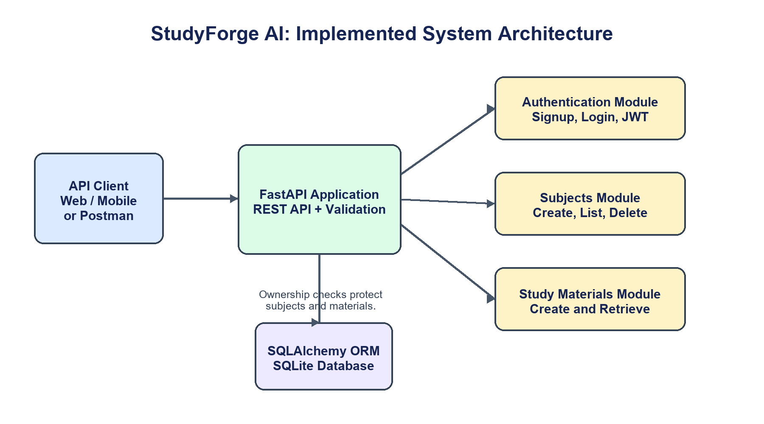
Figure 1: Implemented high-level architecture of StudyForge AI.
Database Schema: The implemented database has three core entities. A user owns one or more subjects, and each subject contains one or more study-material records. Foreign-key fields represent these relationships.
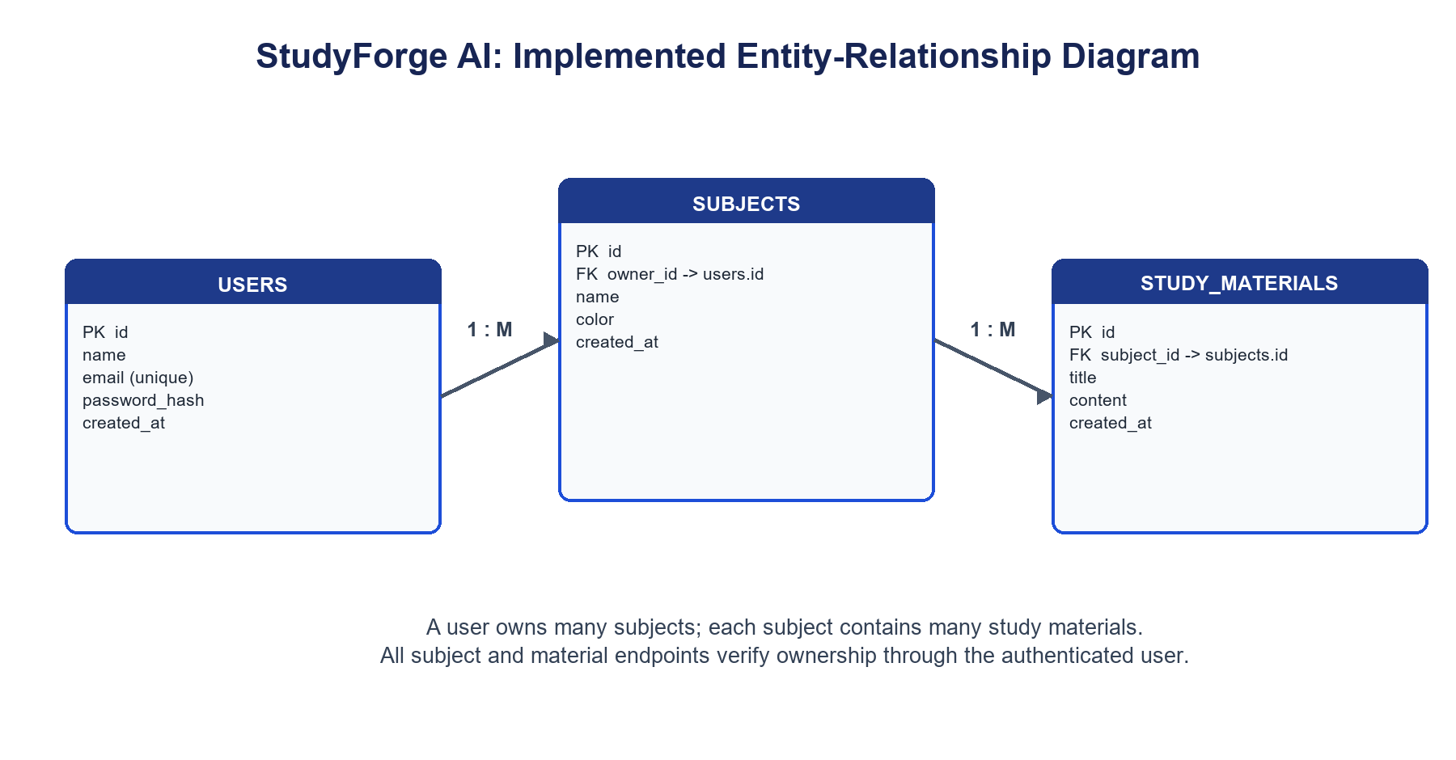
Figure 2: Implemented entity-relationship diagram.

TECHNOLOGIES USED
The current implementation uses the following technologies and libraries:
Technology / Library | Role in StudyForge AI
Python 3 | Primary programming language for backend application logic.
FastAPI | REST API routing, dependency injection, validation integration and OpenAPI documentation.
Uvicorn | ASGI server for running the FastAPI application.
SQLAlchemy | ORM, declarative models, sessions and database queries.
SQLite | Lightweight relational database for local data persistence.
Pydantic + email-validator | Validation for request and response schemas, including email addresses.
passlib with bcrypt | Secure password hashing and verification.
python-jose | Creation and validation of JWT bearer tokens.

HARDWARE & SOFTWARE REQUIREMENTS
Minimum Hardware Requirements: Processor: Intel Core i3 / AMD equivalent or higher; RAM: 4 GB minimum; Storage: approximately 500 MB for source code, virtual environment and SQLite database.
Software Requirements: Windows 10/11, Linux or macOS; Python 3.10+; pip and a virtual environment; VS Code or PyCharm; and a REST API client such as Postman or the FastAPI Swagger UI. Internet access is required only for initial package installation.

EXPECTED OUTCOME / DELIVERABLES
Expected Outcome: A functioning StudyForge AI backend that starts locally, responds to health checks, creates the required database tables, allows secure signup/login and supports owner-protected subject and study-material workflows.
Key Deliverables:
FastAPI backend source code organised into authentication, subjects, materials, schemas, models, database and security modules.
SQLite database schema for users, subjects and study materials.
JWT-based authentication and bcrypt password hashing.
Documented REST endpoints available through Swagger/OpenAPI.
Project synopsis, technical documentation and demonstration of core API workflows.

WORK PLAN / TIMELINE
Phase | Timeline | Key Milestones
Phase 1: Analysis | Weeks 1-2 | Gather requirements and define student, subject and material workflows.
Phase 2: System Design | Weeks 3-4 | Prepare API contracts, database entities and ownership rules.
Phase 3: Authentication | Weeks 5-6 | Implement signup, login, password hashing and JWT security.
Phase 4: Study Modules | Weeks 7-9 | Implement subject and study-material endpoints with ownership checks.
Phase 5: Persistence & Testing | Weeks 10-11 | Configure SQLite/SQLAlchemy and validate API flows.
Phase 6: Future Extension | Weeks 12-14 | Plan optional AI, quiz, study-plan and progress-tracking modules.
Phase 7: Final Delivery | Weeks 15-16 | Prepare synopsis, demonstration and final project documentation.

REFERENCES
FastAPI Documentation. https://fastapi.tiangolo.com/
SQLAlchemy Documentation. https://docs.sqlalchemy.org/
SQLite Documentation. https://www.sqlite.org/docs.html
Pydantic Documentation. https://docs.pydantic.dev/
python-jose Documentation. https://python-jose.readthedocs.io/
Sommerville, I. Software Engineering, 10th Edition, Pearson, 2015.

