AMRITSAR GROUP OF COLLEGES
Synopsis
On
AI RESEARCH DOCUMENT AND INTELLIGENCE (Docly)
Subject Name: Major Project Lab (AGCS-21704)
Bachelor Of Technology
In
COMPUTER ENGINEERING
Batch (2023 – 2027)
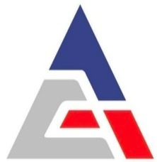

Submitted To
Er. Ajay Sharma
Associate Professor
Department of CSE

Submitted By
Arpit Mahajan (2334146)
Dakshit Arora (2334155)
Devanshu Thakur (2334157)
Mannat Sharma (2342509)

DEPARTMENT OF COMPUTER SCIENCE AND ENGINEERING

INTRODUCTION
Overview of the Project:
Docly is an enterprise-grade AI research and documental intelligence platform designed to transform static documents (PDFs, PPTXs, DOCXs) into dynamic, query able knowledge graphs. It empowers researchers, students, and professionals to interact with vast corpus of scientific literature through an advanced Retrieval-Augmented Generation (RAG) system.
Brief Context and Background:
In modern academia and enterprise research, the sheer volume of scientific papers, reports, and documentation generated daily is overwhelming. Traditional keyword-based search engines are inadequate for deep comprehension, synthesis, and comparative analysis of complex documents. Researchers spend countless hours manually extracting citations, comparing methodologies, and summarizing findings.
Motivation for Choosing the Project:
The motivation stems from the need to democratize access to deep insights hidden within lengthy PDFs. By leveraging modern Generative AI (LLMs) and advanced vector embeddings, this project aims to create an intelligent assistant that "reads" multiple documents simultaneously, understands context, and synthesizes actionable intelligence instantly.
Existing Solutions & Project Differentiation:
- ChatPDF / PDF.ai: These platforms allow chatting with a single PDF but lack multi-document cross-comparison and scientific citation extraction.
- Mendeley / Zotero: Excellent for reference management, but lack native generative AI capabilities to summarize and query the content. Docly differs by offering a complete unified suite: Multi-document RAG, AI-driven Presentation Synthesis, automated citation extraction, and an AI Detection Lab, all built on a highly scalable, cloud-native architecture using Docker and Kubernetes.

PROBLEM STATEMENT
Problem Definition: "To design and develop a scalable, AI-driven document intelligence platform capable of semantically searching, synthesizing, and extracting verifiable insights from unstructured scientific and academic documents using Generative AI and Vector Databases."
Importance: Solving this problem drastically reduces the cognitive load on researchers. It transforms days of manual literature review into a matter of minutes, ensuring higher accuracy in research and accelerating the pace of academic and enterprise innovation.

OBJECTIVES
Primary Objectives:
- Develop a high-performance Retrieval-Augmented Generation (RAG) pipeline for semantic document search.
- Build an intelligent chatbot capable of synthesizing answers with inline source citations from uploaded documents.
- Architect a scalable, containerized microservice infrastructure using Docker.
Secondary Objectives:
- Implement an AI Detection Lab to evaluate the authenticity and AI-generated probability of uploaded texts.
- Develop a Presentation Studio to automatically generate presentation decks from document summaries.
- Provide seamless multi-language translation for scientific abstracts.

PROPOSED SYSTEM / METHODOLOGY
Proposed Approach:
Docly utilizes a highly decoupled, cloud-native Microservice Architecture to ensure maximum scalability and fault tolerance. At its core, the system acts as a high-throughput pipeline converting unstructured data into structured, semantically searchable knowledge.
The methodology revolves around a multi-stage process:
- Security & Validation: Every uploaded file undergoes a rigorous deep-inspection security scan (checking magic bytes, MIME types, and macro viruses) before being accepted into the ecosystem.
- Asynchronous Processing: Heavy machine learning workloads (parsing, chunking, embedding) are decoupled from the main thread and distributed to background Celery workers via a Redis message broker.
- Advanced Natural Language Processing: The system leverages PyMuPDF for layout-aware text extraction and Unstructured for deep semantic chunking. This ensures that tables, headers, and paragraphs are maintained in context rather than blindly split by character count.
- Vector Semantics: Local HuggingFace Transformers generate high-dimensional dense vector embeddings, which are indexed into a Qdrant Vector Database using Hierarchical Navigable Small World (HNSW) algorithms for lightning-fast similarity search.
Detailed Workflow:
- Ingestion & Security Check: The user uploads a PDF or DOCX file via the Next.js (React 19) frontend. The FastAPI backend intercepts the file, performs simulated signature-based malware scans, and registers the document metadata in PostgreSQL.
- Object Storage: The raw, validated binary file is securely saved in a MinIO S3-compatible cloud object store, generating a unique presigned URL for secure access.
- Processing Pipeline (Async): A background Celery worker picks up the task. It parses the document's layout, creates semantically meaningful overlapping text chunks, generates embedding vectors, and pushes them into the Qdrant Vector Database.
- Semantic Retrieval (RAG): When the user interacts with the Chat interface or queries the global search, the FastAPI backend embeds the user's query into the same vector space. It performs a cosine-similarity search against Qdrant to instantly retrieve the top-K most relevant document chunks.
- Generative Synthesis & Citation: An orchestrated LangChain pipeline injects the retrieved chunks into the context window of a Large Language Model (like Google Gemini). The LLM synthesizes a highly accurate, grounded powerpoint presentation. based strictly on the provided context, effectively eliminating AI hallucination. The system also maps the generated insights back to their original chunks to provide inline scientific citations.
- Value-Added AI Services: Alongside chat, the system asynchronously orchestrates secondary LLM pipelines to generate multi-document comparisons, automate PowerPoint presentation creation from summaries, and calculate AI-generation probability scores.

SYSTEM DESIGN
Database Schema (PostgreSQL):
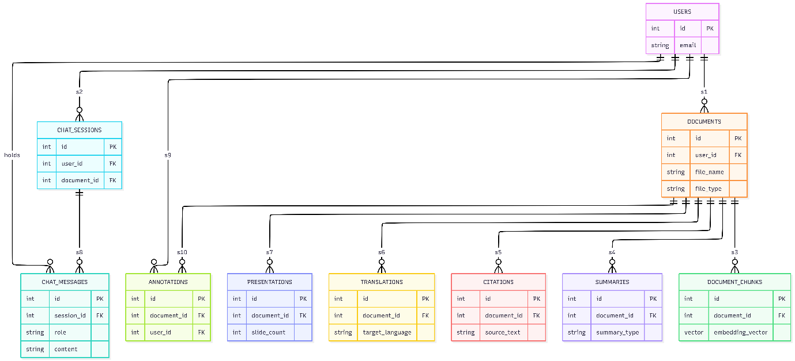

ER Diagram:
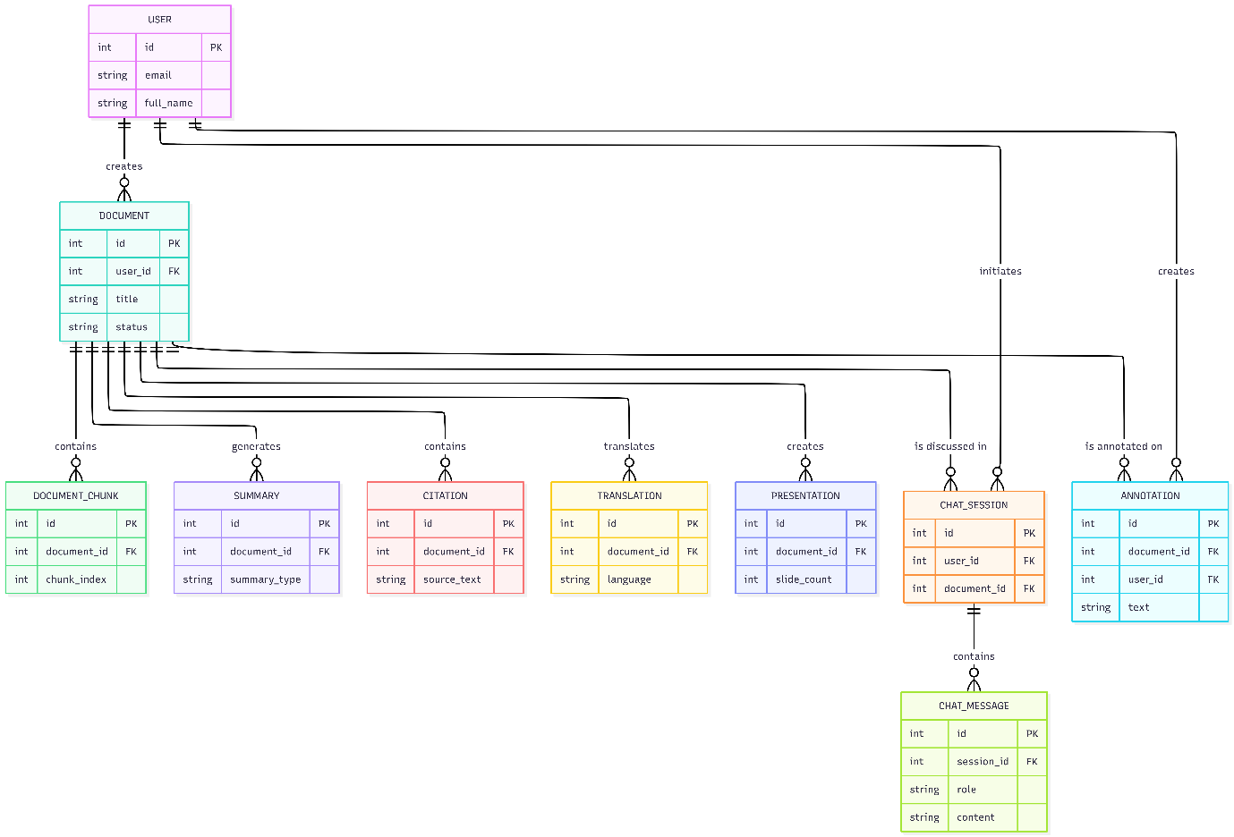

System Architecture Diagram (Conceptual):
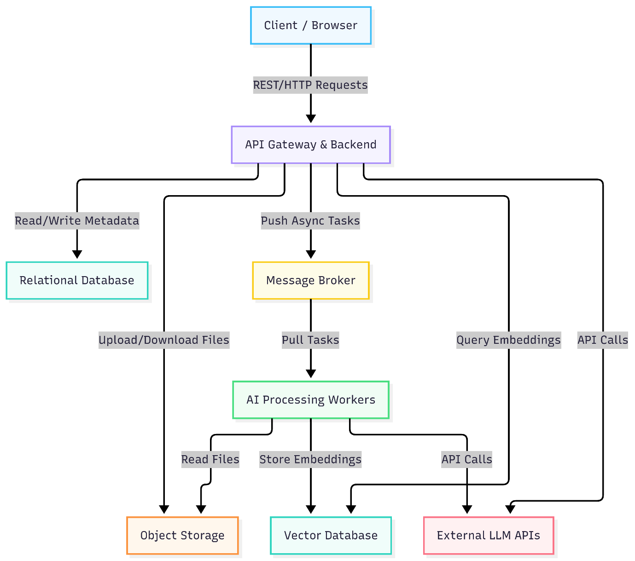

TECHNOLOGIES USED
The project is built on a highly modern, cloud-native, enterprise-grade technology stack:
Frontend:
- Next.js 15 (App Router) & React 19: For server-side rendering and high-performance UI.
- Tailwind CSS & Shadcn/UI: For modern, glassmorphic, and fully responsive styling.
Backend & AI Engine:
- FastAPI (Python 3.11): High-performance asynchronous API framework.
- Celery & Redis: For distributed task queues and asynchronous background processing.
- Grok AI (Groq APIs) & LangChain: For LLM orchestration and RAG synthesis.
- PyTorch & HuggingFace Transformers: For generating local machine learning vector embeddings.
- PyMuPDF & Unstructured: For deep document parsing and text extraction.
- python-pptx: To generate power point presentations after rag synthesis.
- python-magic: To inspect the raw hex header of the file.
Databases & Storage:
- PostgreSQL (with pgvector): Primary relational database.
- Qdrant: Highly optimized Vector Database for semantic search.
- MinIO: S3-compatible cloud object storage for raw PDFs.
DevOps & Deployment:
- Docker & Docker Compose: Full containerization of all 7 microservices ensuring platform-agnostic deployment.
- Kubernetes (K8s) Ready: Architecture is decoupled to support future K8s scaling.

HARDWARE & SOFTWARE REQUIREMENTS
Minimum Hardware Requirements:
- Processor: Intel Core i5 / AMD Ryzen 5 or higher (multi-core recommended for Celery workers)
- RAM: Minimum 8 GB (16 GB highly recommended due to Docker and PyTorch requirements)
- Storage: 20 GB free disk space (SSD preferred)
- GPU (Optional): NVIDIA GPU with CUDA support for accelerated embedding generation.
Software Requirements:
- OS: Windows 10/11, macOS, or Linux (Ubuntu 22.04+)
- Environment: Docker Desktop (Required to run the containerized stack)
- IDE: Visual Studio Code (VS Code)
- Web Browser: Google Chrome / Mozilla Firefox (Latest versions)

EXPECTED OUTCOME / DELIVERABLES
Expected Outcome: A fully functional, containerized web platform accessible via localhost:3000. Users will be able to register, upload complex scientific PDFs, and seamlessly interact with an AI chatbot that provides highly accurate, context-aware answers accompanied by real-time citations pointing to exact pages in the document.
Key Deliverables:
- A production-ready Source Code Repository (Frontend + Backend + Workers).
- A docker-compose.yml file for one-click deployment.
- A responsive UI featuring dark/light modes and mobile compatibility.
- Project Documentation and this Synopsis Report.

WORK PLAN / TIMELINE
Phase | Timeline | Key Milestones
Phase 1: Research & Planning | Weeks 1-2 | Requirement gathering, Technology stack finalization, Architecture design.
Phase 2: UI/UX & Frontend Setup | Weeks 3-5 | Next.js setup, Tailwind styling, Auth pages, Dashboard, and split-screen Chat UI design.
Phase 3: Backend & Database | Weeks 6-8 | FastAPI integration, PostgreSQL schemas, JWT Authentication, MinIO storage setup.
Phase 4: AI Engine & Workers | Weeks 9-11 | Celery worker configuration, PyTorch embeddings, Qdrant integration, LangChain setup.
Phase 5: Dockerization | Week 12 | Writing Dockerfiles, configuring docker-compose, resolving network issues.
Phase 6: Testing & Bug Fixing | Weeks 13-14 | Mobile responsiveness fixes, resolving dependency conflicts (e.g., nmslib), load testing.
Phase 7: Final Delivery | Weeks 15-16 | Project report writing, final presentation deck creation, demo preparation.

REFERENCES
- Vaswani, A. et al. (2017). "Attention Is All You Need." Advances in Neural Information Processing Systems.
- Lewis, P. et al. (2020). "Retrieval-Augmented Generation for Knowledge-Intensive NLP Tasks."
- Next.js Documentation (2025). Vercel. Retrieved from https://nextjs.org/docs
- FastAPI Documentation (2025). Tiangolo. Retrieved from https://fastapi.tiangolo.com/
- Docker Architecture Guidelines (2025). Docker Inc.
- Qdrant Vector Search Engine Documentation. Retrieved from https://qdrant.tech/

