Assignment

- How are inline and block elements different from each other?
Inline Elements:An inline element does not start on a new line and only takes up as much width as necessary.
Block Elements:A block-level element always starts on a new line and takes up the full width available (stretches out to the left and right as far as it can).
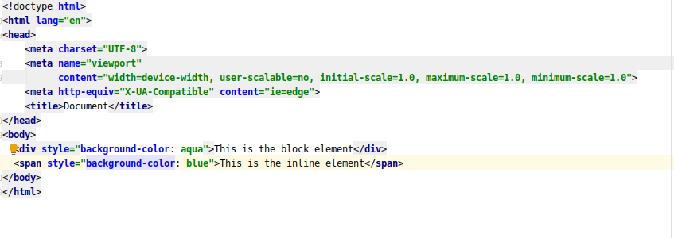
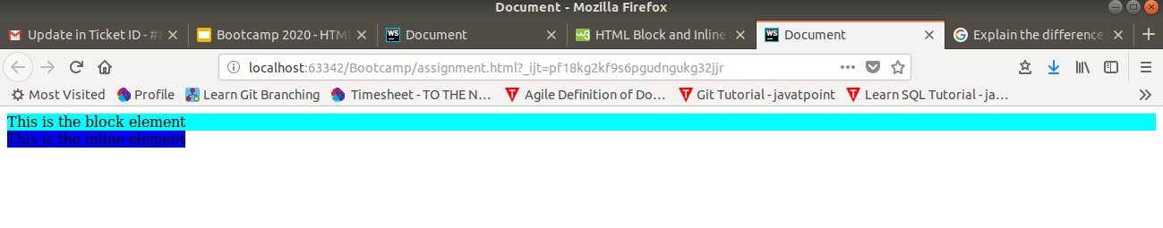
- Explain the difference between visibility:hidden and display:none
display:none :Hiding an element can be done by setting the display property to none. The element will be hidden, and the page will be displayed as if the element is not there.
Visbility:hidden : also hides an element.However, the element will still take up the same space as before. The element will be hidden, but still affect the layout:
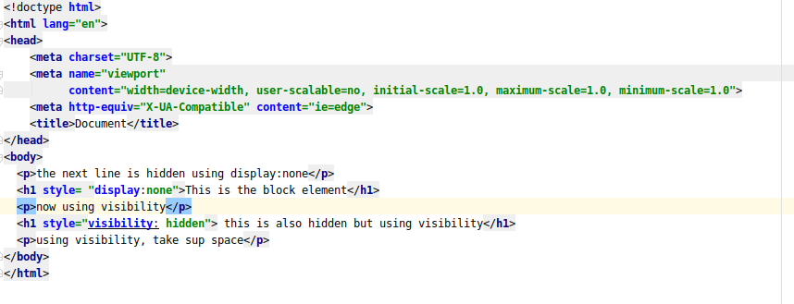

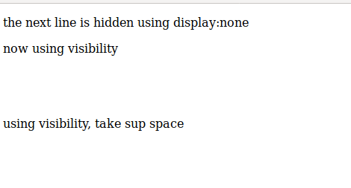

- Explain the clear and float properties.
Float property: The float property is used for positioning and formatting content e.g. let an image float left to the text in a container. In its simplest use, the float property can be used to wrap text around images.
Clear Property: The clear property specifies what elements can float beside the cleared element and on which side.When clearing floats, you should match the clear to the float: If an element is floated to the left, then you should clear to the left. Your floated element will continue to float, but the cleared element will appear below it on the web page.
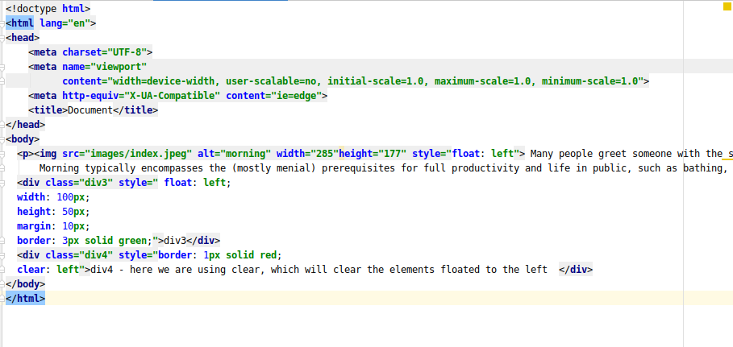
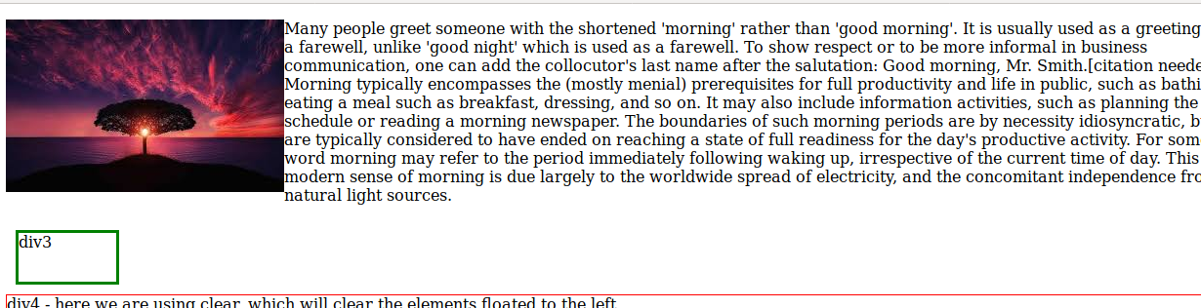
- explain difference between absolute, relative,fixed and static.
Static : HTML elements are positioned static by default.Static positioned elements are not affected by the top, bottom, left, and right properties.An element with position: static; is not positioned in any special way; it is always positioned according to the normal flow of the page
Relative: An element with position: relative; is positioned relative to its normal position.Setting the top, right, bottom, and left properties of a relatively-positioned element will cause it to be adjusted away from its normal position. Other content will not be adjusted to fit into any gap left by the element.
Fixed:An element with position: fixed; is positioned relative to the viewport, which means it always stays in the same place even if the page is scrolled. The top, right, bottom, and left properties are used to position the element.A fixed element does not leave a gap in the page where it would normally have been located.
Absolute:An element with position: absolute; is positioned relative to the nearest positioned ancestor (instead of positioned relative to the viewport, like fixed).However; if an absolute positioned element has no positioned ancestors, it uses the document body, and moves along with page scrolling.
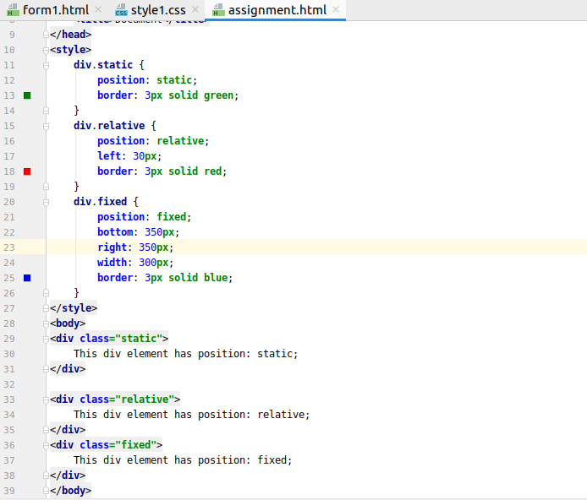

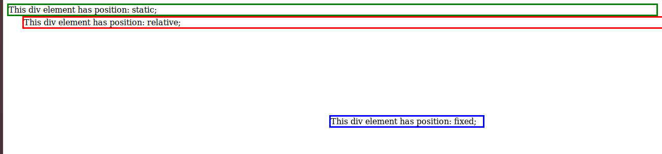
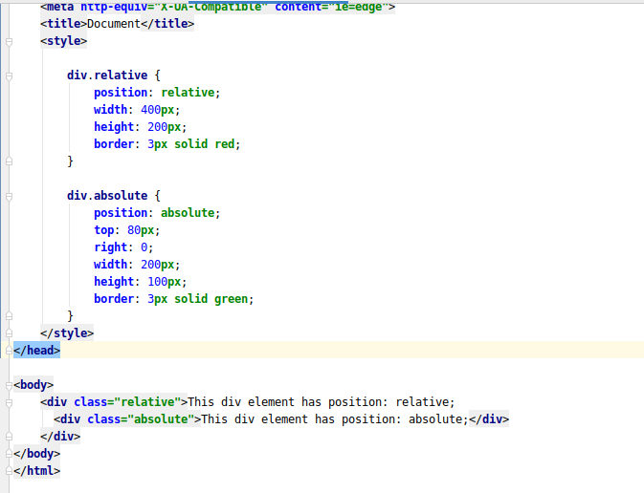
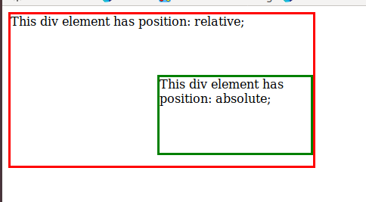

- Write the HTML code to create a table in which there are 4 columns( ID , Employee Name, Designation, Department) and at least 6 rows. Also do some styling to it.
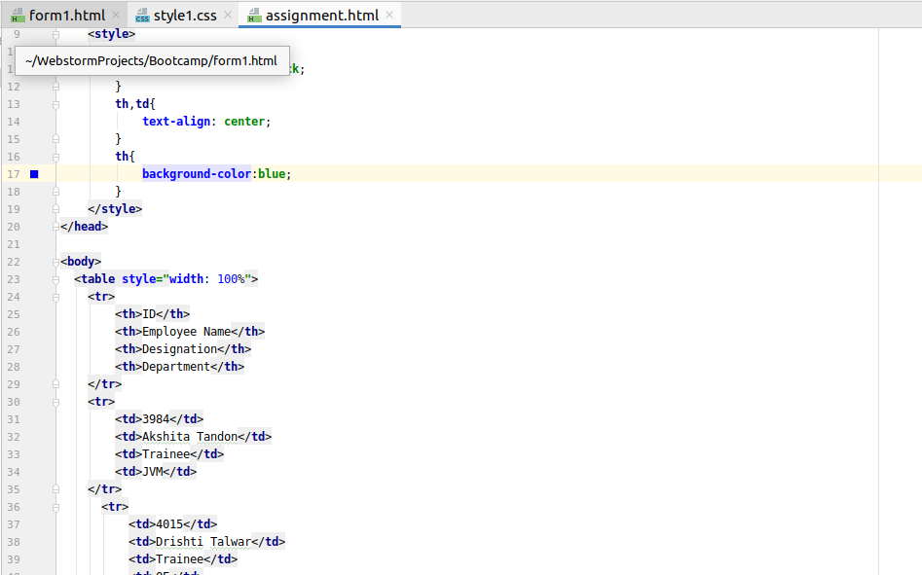
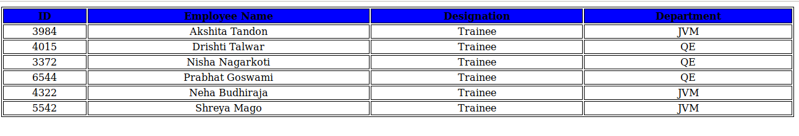
- Why do we use meta tags?
Metadata is data (information) about data.
The <meta> tag provides metadata about the HTML document. Metadata will not be displayed on the page, but will be machine parsable.
Meta elements are typically used to specify page description, keywords, author of the document, last modified, and other metadata.
he metadata can be used by browsers (how to display content or reload page), search engines (keywords), or other web services.
HTML5 introduced a method to let web designers take control over the viewport (the user's visible area of a web page), through the <meta> tag .
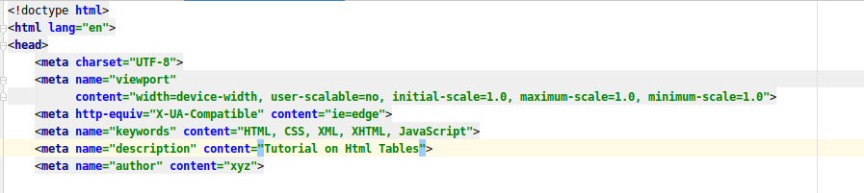

- Explain box model.
The CSS box model is essentially a box that wraps around every HTML element. It consists of: margins, borders, padding, and the actual content.
- Content - The content of the box, where text and images appear
- Padding - Clears an area around the content. The padding is transparent
- Border - A border that goes around the padding and content
- Margin - Clears an area outside the border. The margin is transparent
The box model allows us to add a border around elements, and to define space between elements.
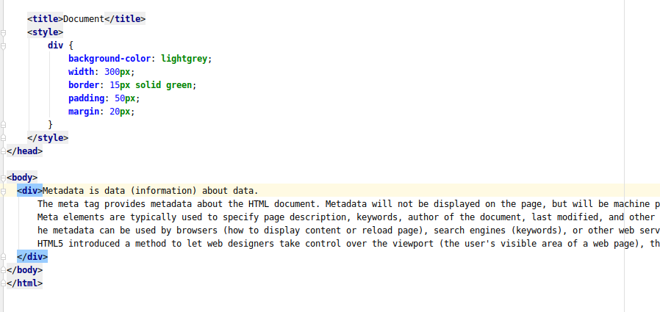
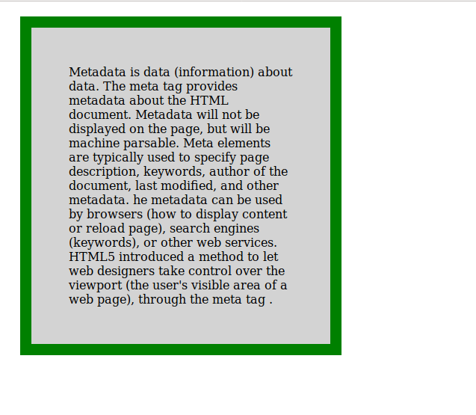
- What are the different types of CSS Selectors?
a) element selector: the element selector selects HTML elements based on the element name.
b) id selector: The id selector uses the id attribute of an HTML element to select a specific element.
c) class selector : The class selector selects HTML elements with a specific class attribute.
d) grouping selector : The grouping selector selects all the HTML elements with the same style definitions.
e)Universal Selector :The universal selector (*) selects all HTML elements on the page.

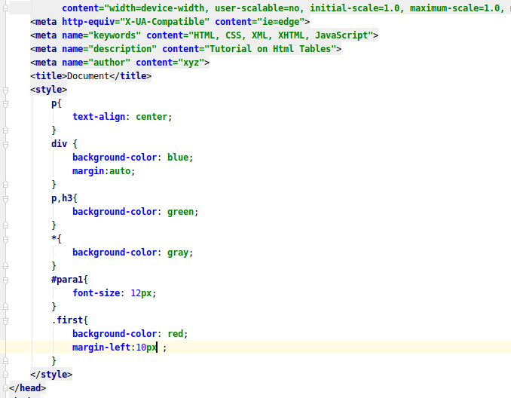
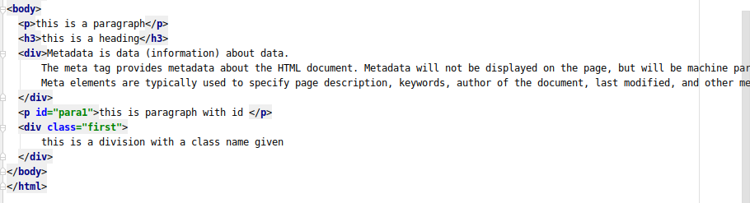
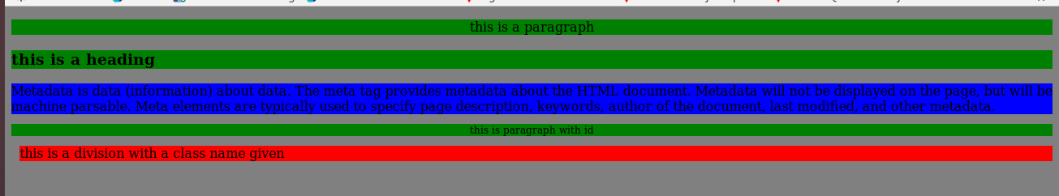
- Define Doctype.
A doctype or document type declaration is an instruction which tells the web browser about the markup language in which the current page is written. The Doctype is not an element or tag, it lets the browser know about the version of or standard of HTML or any other markup language that is being used in the document.
Declaration of a Doctype: A DOCTYPE declaration appears at the top of a web page before all other elements. According to the HTML specification or standards, every HTML document requires a document type declaration to ensure that the pages are displayed in the way they are intended to be displayed.
In the version, HTML 4.01, the usage of DOCTYPE declaration was to create a reference to a document type definition (DTD), since the version HTML 4.01 was completely based on a Standard Generalized Markup Language(SGML).In HTML 5, the DOCTYPE declaration is only required for enabling the standard mode for writing documents.
- Explain 5 HTML5 semantic tags.
<section>: The <section> element defines a section in a document.
<article>: The <article> element specifies independent, self-contained content.An article should make sense on its own, and it should be possible to read it independently from the rest of the web site.
<header>: The <header> element specifies a header for a document or section.The <header> element should be used as a container for introductory content.
<footer>: The <footer> element specifies a footer for a document or section.A <footer> element should contain information about its containing element.A footer typically contains the author of the document, copyright information, links to terms of use, contact information, etc.
<nav>: The <nav> element defines a set of navigation links.
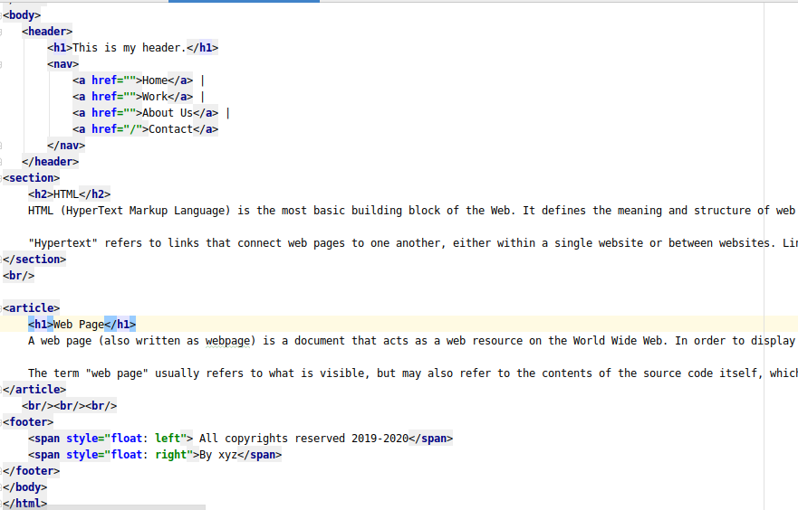
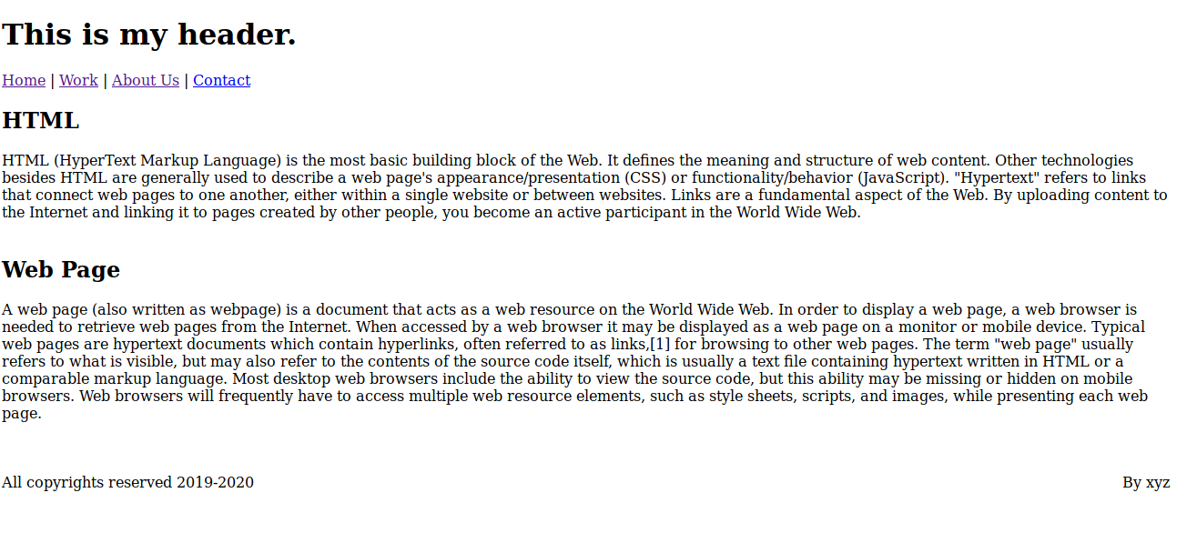

- Create HTML for web-page.jpg (check resources, highest weightage for answers)
webpage1.html
<!doctype html>
<html lang="en">
<head>
<meta charset="UTF-8">
<meta name="viewport"
content="width=device-width, user-scalable=no, initial-scale=1.0">
<meta http-equiv="X-UA-Compatible" content="ie=edge">
<link rel="stylesheet" href="style.css">
<title>TO THE NEW</title>
</head>
<body>
<header>
<h1>To The New</h1>
<div class="nav">
<ul>
<li> <a href=>Home</a></li>
<li> <a href=>About us</a></li>
<li> <a href=>Work</a></li>
<li> <a href=>Contact</a></li>
</ul>
</div>
</header>
<div class="body">
<img src="images/index.jpeg" alt="scenery" width="960" height="360">
<article id="art1">
Morning is the period of time from sunrise to noon.There are no exact times for when morning begins (also true for evening and night) because it can vary according to one's lifestyle and the hours of daylight at each time of year. However, morning strictly ends at noon, which is when afternoon starts. Morning can be defined as starting from midnight to noon, or from sunrise (which varies throughout the year)to noon, or from when one wakes up to noon.
</article>
<br/>
<br/>
<br/>
<div class="image">
<h3>LATEST FROM GALLERY</h3>
<hr/>
<div class="imageshr">
<figure>
<img src="images/index1.jpeg" alt="scenery" width="215" height="315">
<figcaption style="color:black">Image1</figcaption>
</figure>
<figure >
<img src="images/index2.jpeg" alt="scenery" width="215" height="315">
<figcaption style="color:black">Image1</figcaption>
</figure>
<figure >
<img src="images/index3.jpeg" alt="scenery" width="215" height="315">
<figcaption style="color:black">Image1</figcaption>
</figure>
<figure >
<img src="images/index4.jpeg" alt="scenery" width="215" height="315">
<figcaption style="color:black">Image1</figcaption>
</figure>
</div>
</div>
<br/>
<br/>
<br/>
<footer>
<span id="p1">All right reserved.2018-20</span>
<span id="p2">By Akshita Tandon</span>
</footer>
</div>
</body>
</html>
style.css

body{
background: gray;
}
header{
background-color: grey;
margin: auto;
width: 90%;
height: 150px;
}
.body img
{
display: block;
margin:auto;
}
.nav {
margin: auto;
width: 95%;
margin-top: 45px;
padding: 5px 2px 5px 2px;
background-color: black;
}
.nav ul{
background-color: black;
margin-left: 30px;
}
.nav ul li{
background-color: black;
list-style-type: none;
display: inline;
}
.nav ul li a{
background-color: black;
color:white;
text-decoration: none;
margin-left:10px;
}
.imageshr{
display:flex;
background-color: white;
justify-content:space-evenly;
margin:0px;
padding: 0px;
box-sizing: border-box;
}
#p1{
float:left;
margin-left: 40px;
}
#p2{
float: right;
margin-right: 20px;
}
.body{
background-color: white;
width:95%;
margin:auto;
}
.fourimages{
background-color: white;
}
#art1{
background-color: lightgray;
color: black;
margin: auto;
width: 960px;
height:auto;
}
h3{
background-color: white;
}
.image{
width:960px;
height: 360px;
margin:auto;
}
footer{
background-color: black;
margin: auto;
margin-top: 5px;
height: 60px;
display: block;
color: lightgray;
}
.imageshr figure figcaption{
text-align: center;
}
.imageshr figure img
{
max-width: 100%;
margin:auto;
}
.imageshr figure{
margin:14px;
padding:0px;
box-sizing: border-box;
}

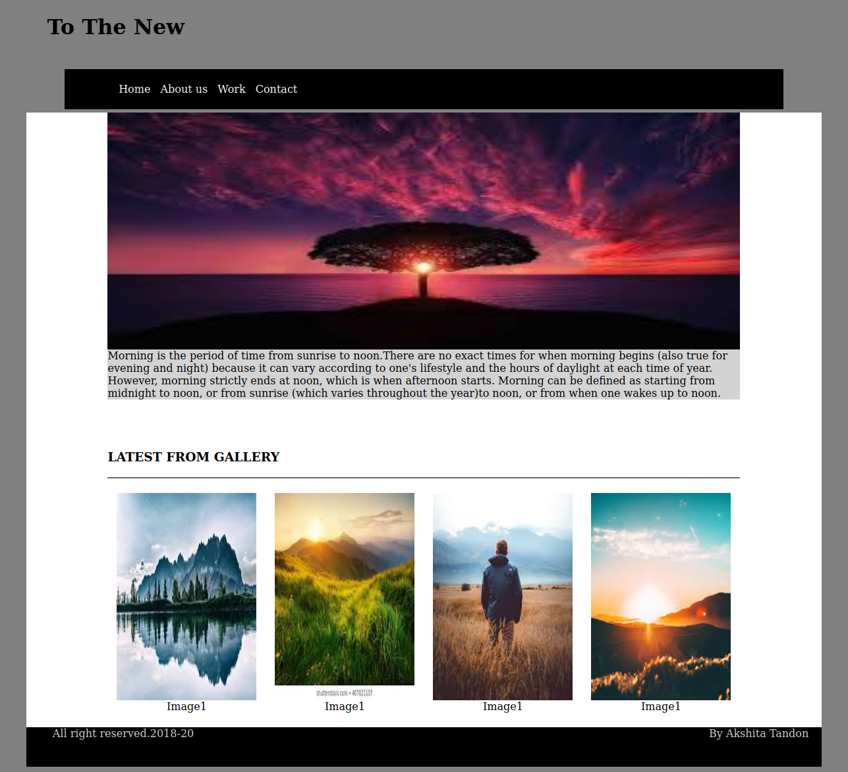

- Create HTML for form.png (check resources, highest weightage for answers)
form.html
<!DOCTYPE html>
<html>
<head>
<meta charset="UTF-8">
<meta name="viewport"
content="width=device-width, user-scalable=no, initial-scale=1.0, maximum-scale=1.0, minimum-scale=1.0">
<meta http-equiv="X-UA-Compatible" content="ie=edge">
<link rel="stylesheet" href="style1.css">
<title>To THE NEW</title>
</head>
<body>
<div id="head">
<span>TO THE NEW</span>
<div id="nav">
<ul>
<li>Quick Help</li>
<li> Home</li>
</ul>
</div>
<h3>Bug Report</h3>
<form class="flex_work"method="post" action="#">
<label>
Title*:
</label>
<input type="text" required>
<label>
Description:
</label>
<textarea name="message" rows="5" cols="20" required></textarea>
<label>
Operating System:
</label>
<select name="Operating System">
<option class="select" value="Windows XP">Windows XP</option>
<option class="select" value="Windows 7">Windows 7</option>
<option class="select" value="Linux">Linux</option>
<option class="select" value="Mac ">Mac</option>
</select>
<label>
Product:
</label>
<select name="Product">
<option value="Windows XP">Laptop</option>
<option value="Windows 7">VS code</option>
<option value="Windows 10">Web Storm</option>
</select>
<label>
Version:
</label>
<input type="number" name="version" min="1" max="2">
<label>
License:
</label>
<fieldset>
<input type="radio" name="license" value="Free"><label>Free </label>
<input type="radio" name="license" value="Business"><label>Business </label>
</fieldset>
<label>
Severity:
</label>
<select name="Severity">
<option class="select" value="Critical">Critical</option>
<option class="select" value="Mild">Mild</option>
<option class="select" value="Moderate">Moderate</option>
</select>
<label>
Attachments:
</label>
<input type="file" name="documents" accept="file/*">
<div class="divide">
<input type="Submit" name="Send" value="Send">
</div>
</form>
<br/>
<br/>
</body>
</html>

style.css
*{
font-family:sans-serif;
}
body{
margin-top:20px;
}
#head{
color:#06A061;
border-bottom:0.5px solid #E7E4E4;
height:50px;
}
#head span{
font-size:20px;
color:#06A061;
}
#nav{
margin-top:-30px;
}
#nav ul li{
display:inline;
margin-left:20px;
float:right;
}
.flex_work{
display:flex;
flex-direction:column;
}
h3{
color:white;
width:30%;
padding: 15px 2.5px 15px 2.5px;
margin:auto;
margin-top:80px;
background-color: #E7E4E4;
}
form{
border:2px solid #E7E4E4;
color:black;
margin:auto;
width:30%;
}
form input,select,textarea{
margin-top:20px;
padding:5px 2px 5px 2px;
width:90%;
margin:auto;
border-radius:5px;
border:1px solid #E7E4E4;
}
form label{
font-size:14px;
margin-left:20px;
margin-top:15px;
}
input[type="radio"]{
display:inline-block;
margin-right:20px;
margin-left:-20px;
width:70px;
}
fieldset{
border:none;
}
.select,select{
background-color:#06A061;
color:white;
border:none;
font-weight:500;
}
input[type="submit"]
{
background-color:#06A061;
color:white;
width:60px;
float:right;
margin-top:25px;
}
.divide{
margin-top:5px;
height:50px;
border-radius:5px;
background-color:#E7E4E4;
}
