Create a list for fruits. It will contain following things,
1. A text box will accept in following pattern eg: "Mango-20". Devide Mango-20 from '-'. Here Mango is the name of the fruit and 20 will be the quantiity.
2. There will be a submit button. Clicking on submit will add a new fruit and will clear the text box. Same functionality should work on pressing Enter also.
3. There will be a delete button on the right side of each row which has been created by you. Deleting that item will delete the respective item.
Apple-30
Submit

Mango | 10 | delete
Apple | 30 | delete
Banana | 45 | delete

App.js
import React, { useState, Component } from 'react';
import './App.css';
import Fruits from './Fruits/Fruits'
import './Fruits/Fruits.css'

class App extends Component{

state={
fruits:[],
name:"",
quantity:"",
fruitsInput: ""
};

submit=()=>{
const {fruits,name,quantity}=this.state;
fruits.push([name,quantity]);
this.setState({fruits: fruits, fruitsInput: ""})
}

keyPressed=(event)=> {
if (event.key === "Enter") {
this.submit();
}
}

deleteFruitHandler=(fruitsIndex)=>{
const fruits=[...this.state.fruits];
//console.log(fruits);
fruits.splice(fruitsIndex,1);
this.setState({fruits:fruits})
}

updateInput=(event)=>{
let input=event.target.value;
let newInput=input.split("-");
debugger
this.setState({name:newInput[0], quantity:newInput[1], fruitsInput: input });
// console.log(newInput);
// console.log(this.state);
}

render(){
const style={
backgroundColor:'white',
display:'block',
font:'inherit',
border:'1px solid blue',
padding: '8px',
cursor:'pointer'
};
const style2= {
display: 'table',
border: '1px solid black',
width: '50%',
borderCollapse: 'collapse'
}
const { fruitsInput } = this.state;
return (
<div className="App">
<input id="fruitsquan" type="text" value={fruitsInput} onChange={this.updateInput} onKeyDown={this.keyPressed} ></input>
<button ref="fruitbutton"
style={style} onClick={this.submit} >Submit</button>
<table style={style2}>
<tbody>
{this.state.fruits.map((fruit,index) =>{
return <Fruits
click={() => this.deleteFruitHandler(index)}
name={fruit[0]}
quantity={fruit[1]}/>
})}
</tbody>
</table>
</div>
)
}
}

export default App;

}

export default App;

////////////////////////////////////////////////////////////////////////////////////////////////

Fruits.js

import React from 'react'

const fruit=(props)=>{
return (

<tr className="Fruits">
<td >{props.name} </td>
<td >{props.quantity}</td>
<td><button className="button" onClick={props.click}>Delete</button></td>
</tr>

)
}

export default fruit;

//////////////////////////////////////////////////////////////

Fruits.css

tr,td{
border: 1px solid black;
padding: 8px;

}

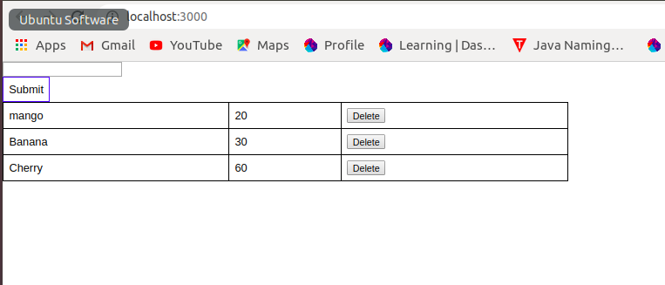
when clicked on delete
