1.Create a class Address for Author with instance variables streetNumber, location, State.
package com.jpaexercise3.exercise.Entity;
import javax.persistence.*;
@Embeddable
public class Address {
private Integer streetnumber;
private String location;
private String state;
public Integer getStreetnumber() {
return streetnumber;
}
public void setStreetnumber(Integer streetnumber) {
this.streetnumber = streetnumber;
}
public String getLocation() {
return location;
}
public void setLocation(String location) {
this.location = location;
}
public String getState() {
return state;
}
public void setState(String state) {
this.state = state;
}
}
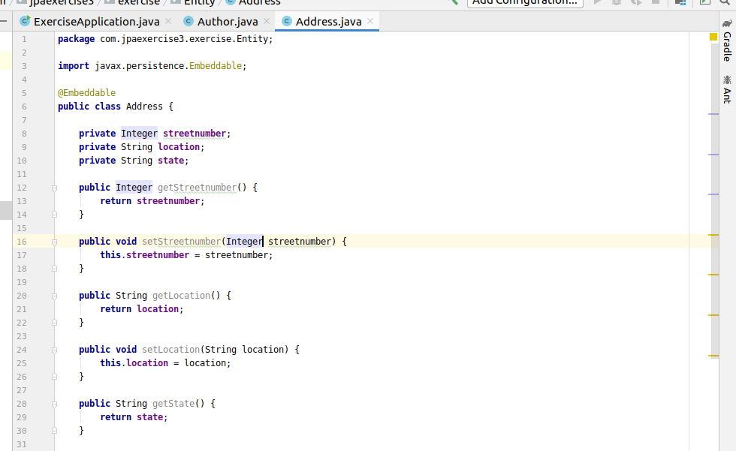
2.Create instance variable of Address class inside Author class and save it as embedded object.
package com.jpaexercise3.exercise.Entity;
import javax.persistence.*;
import java.util.Set;
@Entity
public class Author {
@Id
@GeneratedValue(strategy = GenerationType.AUTO)
private Integer authorid;
private String authorname;
@OneToMany(mappedBy = "author",cascade = CascadeType.ALL)
private Set<Subjects> subjects;
@Embedded
private Address address;
public Integer getAuthorid() {
return authorid;
}
public void setAuthorid(Integer authorid) {
this.authorid = authorid;
}
public String getAuthorname() {
return authorname;
}
public void setAuthorname(String authorname) {
this.authorname = authorname;
}
public Address getAddress() {
return address;
}
public void setAddress(Address address) {
this.address = address;
}
public Set<Subjects> getSubjects() {
return subjects;
}
public void setSubjects(Set<Subjects> subjects) {
this.subjects = subjects;
}
}

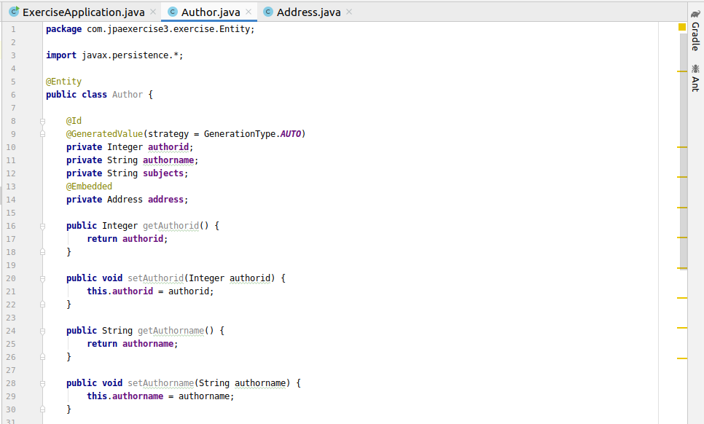
3.Introduce a List of subjects for author.Persist 3 subjects for each author.
Subjects.java
package com.jpaexercise3.exercise.Entity;
import javax.persistence.*;
@Entity
public class Subjects {
@Id
@GeneratedValue(strategy = GenerationType.IDENTITY)
private int id;
private String subjects;
@ManyToOne
@JoinColumn(name = "author_id")
private Author author;
public int getId() {
return id;
}
public void setId(int id) {
this.id = id;
}
public String getSubjects() {
return subjects;
}
public void setSubjects(String subjects) {
this.subjects = subjects;
}
public Author getAuthor() {
return author;
}
public void setAuthor(Author author) {
this.author = author;
}
}
Testing
package com.jpaexercise3.exercise;
import com.jpaexercise3.exercise.Entity.Address;
import com.jpaexercise3.exercise.Entity.Author;
import com.jpaexercise3.exercise.Entity.Subjects;
import com.jpaexercise3.exercise.Repository.AuthorRepository;
import com.jpaexercise3.exercise.Repository.SubjectsRepository;
import org.junit.jupiter.api.Test;
import org.springframework.beans.factory.annotation.Autowired;
import org.springframework.boot.test.context.SpringBootTest;
import java.util.HashSet;
import java.util.Set;
@SpringBootTest
class ExerciseApplicationTests {
@Autowired
AuthorRepository authorRepository;
@Autowired
SubjectsRepository subjectsRepository;
@Test
void contextLoads() {
}
@Test
void createAuthors(){
Author author=new Author();
author.setAuthorname("Chetan Bhagat");
Address address=new Address();
address.setStreetnumber(123);
address.setLocation("Hari Nagar");
address.setState("New Delhi");
author.setAddress(address);
Set<Subjects> subjectsSet=new HashSet<>();
Subjects subjects=new Subjects();
subjects.setSubjects("Romance-Stories");
subjects.setAuthor(author);
Subjects subjects1=new Subjects();
subjects1.setSubjects("Fiction-stories");
subjects1.setAuthor(author);
Subjects subjects2=new Subjects();
subjects2.setSubjects("Non-Fiction-stories");
subjects2.setAuthor(author);
subjectsSet.add(subjects);
subjectsSet.add(subjects1);
subjectsSet.add(subjects2);
author.setSubjects(subjectsSet);
authorRepository.save(author);
Author authorTwo=new Author();
authorTwo.setAuthorname("Ravinder Singh");
Address addressTwo=new Address();
addressTwo.setStreetnumber(111);
addressTwo.setLocation("Tilak Nagar");
addressTwo.setState("New Delhi");
authorTwo.setAddress(addressTwo);
Set<Subjects> subjectsSet2=new HashSet<>();
Subjects subjects3=new Subjects();
subjects3.setSubjects("Non-Fiction-stories");
subjects3.setAuthor(authorTwo);
Subjects subjects4=new Subjects();
subjects4.setSubjects("Fiction-stories");
subjects4.setAuthor(authorTwo);
Subjects subjects5=new Subjects();
subjects5.setSubjects("Philosophy-stories");
subjects5.setAuthor(authorTwo);
subjectsSet2.add(subjects3);
subjectsSet2.add(subjects4);
subjectsSet2.add(subjects5);
authorTwo.setSubjects(subjectsSet2);
authorRepository.save(authorTwo);
}
}
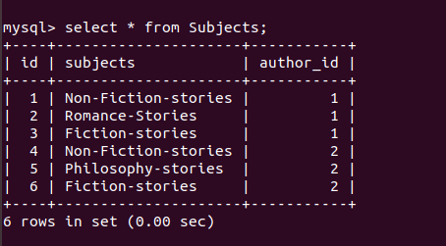

4.Create an Entity book with an instance variable bookName.
Book.java
package com.jpaexercise3.exercise.Entity;
import javax.persistence.Entity;
import javax.persistence.GeneratedValue;
import javax.persistence.GenerationType;
import javax.persistence.Id;
@Entity
public class Book {
@Id
@GeneratedValue(strategy = GenerationType.AUTO)
private Integer bookid;
private String bookname;
public Integer getBookid() {
return bookid;
}
public void setBookid(Integer bookid) {
this.bookid = bookid;
}
public String getBookname() {
return bookname;
}
public void setBookname(String bookname) {
this.bookname = bookname;
}
}
5.Implement One to One mapping between Author and Book.
Author.java
package com.jpaexercise3.exercise.Entity;
import javax.persistence.*;
import java.util.Set;
@Entity
public class Author {
@Id
@GeneratedValue(strategy = GenerationType.AUTO)
private Integer authorid;
private String authorname;
@OneToMany(mappedBy = "author",cascade = CascadeType.ALL)
private Set<Subjects> subjects;
@Embedded
private Address address;
@OneToOne(mappedBy = "author")
private Book book;
public Integer getAuthorid() {
return authorid;
}
public void setAuthorid(Integer authorid) {
this.authorid = authorid;
}
public String getAuthorname() {
return authorname;
}
public void setAuthorname(String authorname) {
this.authorname = authorname;
}
public Address getAddress() {
return address;
}
public void setAddress(Address address) {
this.address = address;
}
public Set<Subjects> getSubjects() {
return subjects;
}
public void setSubjects(Set<Subjects> subjects) {
this.subjects = subjects;
}
}
Book.java
package com.jpaexercise3.exercise.Entity;
import javax.persistence.*;
@Entity
public class Book {
@Id
@GeneratedValue(strategy = GenerationType.AUTO)
private Integer bookid;
private String bookname;
@OneToOne(cascade = CascadeType.ALL)
private Author author;
public Integer getBookid() {
return bookid;
}
public void setBookid(Integer bookid) {
this.bookid = bookid;
}
public String getBookname() {
return bookname;
}
public void setBookname(String bookname) {
this.bookname = bookname;
}
public Author getAuthor() {
return author;
}
public void setAuthor(Author author) {
this.author = author;
}
}

Testing
package com.jpaexercise3.exercise;
import com.jpaexercise3.exercise.Entity.Author;
import com.jpaexercise3.exercise.Entity.Book;
import com.jpaexercise3.exercise.Repository.BookRepository;
import org.junit.jupiter.api.Test;
import org.springframework.beans.factory.annotation.Autowired;
import org.springframework.boot.test.context.SpringBootTest;
import java.util.HashSet;
import java.util.Set;
@SpringBootTest
class ExerciseApplicationTests {
@Autowired

@Autowired
BookRepository bookRepository;

@Test
void createBooks(){
Author author=new Author();
author.setAuthorname("Paulo Coelho");
Book book=new Book();
book.setBookname("The Alchemist");
book.setAuthor(author);
bookRepository.save(book);
}

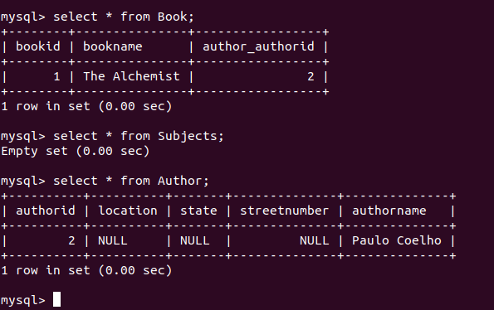
6.Implement One to Many Mapping between Author and Book(Unidirectional, BiDirectional and without additional table ) and implement cascade save.
Bidirectional
Author.java
package com.jpaexercise3.exercise.Entity;
import javax.persistence.*;
import java.util.Set;
@Entity
public class Author {
@Id
@GeneratedValue(strategy = GenerationType.AUTO)
private Integer authorid;
private String authorname;
/*@OneToMany(mappedBy = "author",cascade = CascadeType.ALL)
private Set<Subjects> subjects;
@Embedded
private Address address;*/
@OneToMany(mappedBy = "author",cascade = CascadeType.ALL)
private Set<Book> book;
public Integer getAuthorid() {
return authorid;
}
public void setAuthorid(Integer authorid) {
this.authorid = authorid;
}
public String getAuthorname() {
return authorname;
}
public void setAuthorname(String authorname) {
this.authorname = authorname;
}
public Set<Book> getBook() {
return book;
}
public void setBook(Set<Book> book) {
this.book = book;
}
@Override
public String toString() {
return "Author{" +
"authorid=" + authorid +
", authorname='" + authorname + '\'' +
", book=" + book +
'}';
}
}
Book.java
package com.jpaexercise3.exercise.Entity;
import javax.persistence.*;
@Entity
public class Book {
@Id
@GeneratedValue(strategy = GenerationType.AUTO)
private Integer bookid;
private String bookname;
@ManyToOne
@JoinColumn(name = "author_id")
private Author author;
public Integer getBookid() {
return bookid;
}
public void setBookid(Integer bookid) {
this.bookid = bookid;
}
public String getBookname() {
return bookname;
}
public void setBookname(String bookname) {
this.bookname = bookname;
}
public Author getAuthor() {
return author;
}
public void setAuthor(Author author) {
this.author = author;
}
@Override
public String toString() {
return "Book{" +
"bookid=" + bookid +
", bookname='" + bookname + '\'' +
", author=" + author +
'}';
}
}
Testing
package com.jpaexercise3.exercise;
import com.jpaexercise3.exercise.Entity.Address;
import com.jpaexercise3.exercise.Entity.Author;
import com.jpaexercise3.exercise.Entity.Book;
import com.jpaexercise3.exercise.Entity.Subjects;
import com.jpaexercise3.exercise.Repository.AuthorRepository;
import com.jpaexercise3.exercise.Repository.BookRepository;
import com.jpaexercise3.exercise.Repository.SubjectsRepository;
import org.junit.jupiter.api.Test;
import org.springframework.beans.factory.annotation.Autowired;
import org.springframework.boot.test.context.SpringBootTest;
import java.util.HashSet;
import java.util.Set;
@SpringBootTest
class ExerciseApplicationTests {
@Autowired
AuthorRepository authorRepository;

@Test
void createAuthor(){
Author author=new Author();
author.setAuthorname("Ravinder Singh");
Set<Book>bookSet=new HashSet<>();
Book book=new Book();
book.setBookname("Computer-Science");
book.setAuthor(author);
Book book1=new Book();
book1.setBookname("Chemistry");
book1.setAuthor(author);
Book book2=new Book();
book2.setBookname("Physics");
book2.setAuthor(author);
bookSet.add(book);
bookSet.add(book1);
bookSet.add(book2);
author.setBook(bookSet);
authorRepository.save(author);
}
}

Unidirectional
Author.java
package com.jpaexercise3.exercise.Entity;
import javax.persistence.*;
import java.util.Set;
@Entity
public class Author {
@Id
@GeneratedValue(strategy = GenerationType.AUTO)
private Integer authorid;
private String authorname;
@OneToMany(cascade = CascadeType.ALL)
private Set<Book> book;
public Integer getAuthorid() {
return authorid;
}
public void setAuthorid(Integer authorid) {
this.authorid = authorid;
}
public String getAuthorname() {
return authorname;
}
public void setAuthorname(String authorname) {
this.authorname = authorname;
}
public Set<Book> getBook() {
return book;
}
public void setBook(Set<Book> book) {
this.book = book;
}
@Override
public String toString() {
return "Author{" +
"authorid=" + authorid +
", authorname='" + authorname + '\'' +
", book=" + book +
'}';
}
}
Book.java
package com.jpaexercise3.exercise.Entity;
import javax.persistence.*;
@Entity
public class Book {
@Id
@GeneratedValue(strategy = GenerationType.AUTO)
private Integer bookid;
private String bookname;
public Integer getBookid() {
return bookid;
}
public void setBookid(Integer bookid) {
this.bookid = bookid;
}
public String getBookname() {
return bookname;
}
public void setBookname(String bookname) {
this.bookname = bookname;
}
@Override
public String toString() {
return "Book{" +
"bookid=" + bookid +
", bookname='" + bookname + '\'' +
'}';
}
}
Testing
package com.jpaexercise3.exercise;
import com.jpaexercise3.exercise.Entity.Address;
import com.jpaexercise3.exercise.Entity.Author;
import com.jpaexercise3.exercise.Entity.Book;
import com.jpaexercise3.exercise.Entity.Subjects;
import com.jpaexercise3.exercise.Repository.AuthorRepository;
import com.jpaexercise3.exercise.Repository.BookRepository;
import com.jpaexercise3.exercise.Repository.SubjectsRepository;
import org.junit.jupiter.api.Test;
import org.springframework.beans.factory.annotation.Autowired;
import org.springframework.boot.test.context.SpringBootTest;
import java.util.HashSet;
import java.util.Set;
@SpringBootTest
class ExerciseApplicationTests {
@Autowired
AuthorRepository authorRepository;

@Test
void createAuthor(){
Author author=new Author();
author.setAuthorname("Akash");
Set<Book>bookSet=new HashSet<>();
Book book=new Book();
book.setBookname("Physics");
bookSet.add(book);
Book book1=new Book();
book1.setBookname("Chemistry");
bookSet.add(book1);
author.setBook(bookSet);
authorRepository.save(author);
}
}
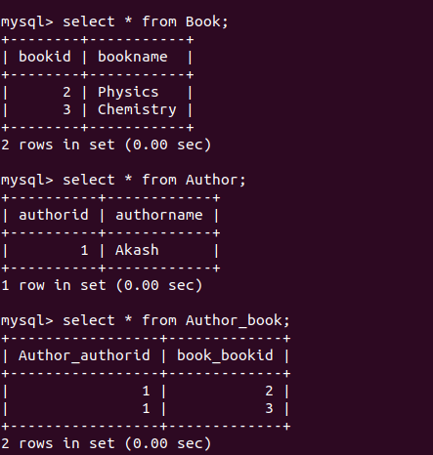

8.Implement Many to Many Mapping between Author and Book.
Author.java
package com.jpaexercise3.exercise.Entity;
import javax.persistence.*;
import java.util.Set;
@Entity
public class Author {
@Id
@GeneratedValue(strategy = GenerationType.AUTO)
private Integer authorid;
private String authorname;
@ManyToMany(cascade = CascadeType.ALL)
@JoinTable(name = "author_books",
joinColumns = @JoinColumn(name = "author_id",referencedColumnName ="authorid"),
inverseJoinColumns = @JoinColumn(name ="book_id",referencedColumnName = "bookid"))
private Set<Book> book;
public Integer getAuthorid() {
return authorid;
}
public void setAuthorid(Integer authorid) {
this.authorid = authorid;
}
public String getAuthorname() {
return authorname;
}
public void setAuthorname(String authorname) {
this.authorname = authorname;
}
public Set<Book> getBook() {
return book;
}
public void setBook(Set<Book> book) {
this.book = book;
}
@Override
public String toString() {
return "Author{" +
"authorid=" + authorid +
", authorname='" + authorname + '\'' +
", book=" + book +
'}';
}
}
Book.java
package com.jpaexercise3.exercise.Entity;
import javax.persistence.*;
import java.util.Set;
@Entity
public class Book {
@Id
@GeneratedValue(strategy = GenerationType.AUTO)
private Integer bookid;
private String bookname;
@ManyToMany(mappedBy = "book")
private Set<Author> author;
public Integer getBookid() {
return bookid;
}
public void setBookid(Integer bookid) {
this.bookid = bookid;
}
public String getBookname() {
return bookname;
}
public void setBookname(String bookname) {
this.bookname = bookname;
}
public Set<Author> getAuthor() {
return author;
}
public void setAuthor(Set<Author> author) {
this.author = author;
}
}
Testing
package com.jpaexercise3.exercise;
import com.jpaexercise3.exercise.Entity.Author;
import com.jpaexercise3.exercise.Entity.Book;
import com.jpaexercise3.exercise.Repository.AuthorRepository;
import org.junit.jupiter.api.Test;
import org.springframework.beans.factory.annotation.Autowired;
import org.springframework.boot.test.context.SpringBootTest;
import java.util.HashSet;
import java.util.Set;
@SpringBootTest
class ExerciseApplicationTests {
@Autowired
AuthorRepository authorRepository;

@Test
void testManyToMany(){
Author author=new Author();
author.setAuthorname("Paulo caelho");
Set<Book>bookSet=new HashSet<>();
Book book=new Book();
book.setBookname("The Alchemist");
bookSet.add(book);
Book book1=new Book();
book1.setBookname("Eleven Minutes");
bookSet.add(book1);
author.setBook(bookSet);
authorRepository.save(author);
}
}
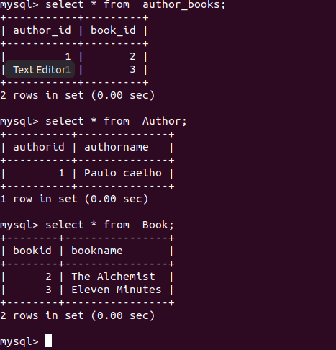

9.Which method on the session object can be used to remove an object from the cache?
package com.example.Transaction.TransactionManagement.Entity;
import javax.persistence.*;
@Entity
public class BankAccount
{
@Id
@GeneratedValue(strategy = GenerationType.IDENTITY)
private int accno;
private String firstname;
private String lastname;
private int bal;
public int getAccno() {
return accno;
}
public void setAccno(int accno) {
this.accno = accno;
}
public String getFirstname() {
return firstname;
}
public void setFirstname(String firstname) {
this.firstname = firstname;
}
public String getLastname() {
return lastname;
}
public void setLastname(String lastname) {
this.lastname = lastname;
}
public int getBal() {
return bal;
}
public void setBal(int bal) {
this.bal = bal;
}
@Override
public String toString() {
return "BankAccount{" +
"accno=" + accno +
", firstname='" + firstname + '\'' +
", lastname='" + lastname + '\'' +
", bal=" + bal +
'}';
}
}
Testing
package com.example.Transaction.TransactionManagement;
import com.example.Transaction.TransactionManagement.Entity.BankAccount;
import com.example.Transaction.TransactionManagement.Repository.BankAccountRepository;
import org.hibernate.Session;
import org.junit.jupiter.api.Test;
import org.springframework.beans.factory.annotation.Autowired;
import org.springframework.boot.test.context.SpringBootTest;
import javax.persistence.EntityManager;
import javax.transaction.Transactional;
import java.util.Optional;
@SpringBootTest
class TransactionManagementApplicationTests {

@Autowired
BankAccountService service;
@Autowired
BankAccountRepository bankAccountRepository;
@Autowired
EntityManager entityManager;
@Test
void contextLoads() {
}
@Test
void createAccount(){
BankAccount bankAccount=new BankAccount();
bankAccount.setFirstname("Akshita");
bankAccount.setLastname("Tandon");
bankAccount.setBal(5000);
bankAccountRepository.save(bankAccount);
BankAccount bankAccount1=new BankAccount();
bankAccount1.setFirstname("Kunal");
bankAccount1.setLastname("Tandon");
bankAccount1.setBal(4000);
bankAccountRepository.save(bankAccount1);
}
@Test
@Transactional
public void testCaching()
{
Session session=entityManager.unwrap(Session.class);
BankAccount bankAccount = bankAccountRepository.findById(1).get();
bankAccountRepository.findById(1);
session.evict(bankAccount);
bankAccountRepository.findById(1);
}
}
(When eviceted, the data is deleted from the cache and it runs again for the data and taken the data from the database.)
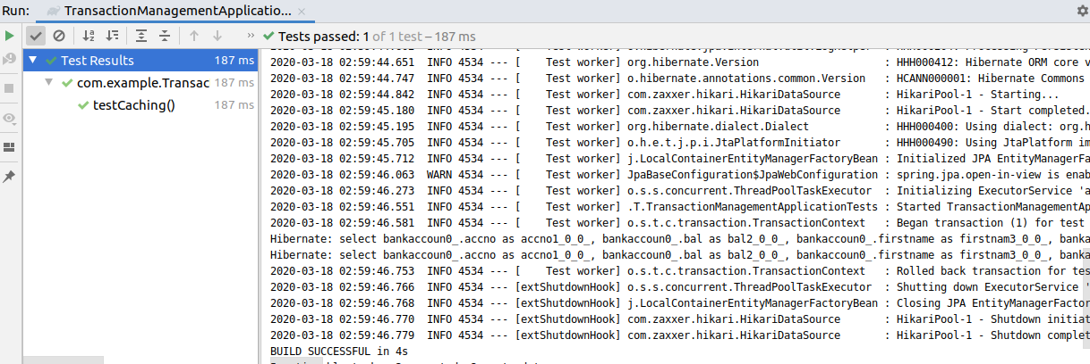

(When evict is not there it will run only one time as it is not deleted from the cache)

package com.example.Transaction.TransactionManagement;
import com.example.Transaction.TransactionManagement.Entity.BankAccount;
import com.example.Transaction.TransactionManagement.Repository.BankAccountRepository;
import org.hibernate.Session;
import org.junit.jupiter.api.Test;
import org.springframework.beans.factory.annotation.Autowired;
import org.springframework.boot.test.context.SpringBootTest;
import javax.persistence.EntityManager;
import javax.transaction.Transactional;
import java.util.Optional;
@SpringBootTest
class TransactionManagementApplicationTests {

@Autowired
BankAccountService service;
@Autowired
BankAccountRepository bankAccountRepository;
@Autowired
EntityManager entityManager;
@Test
void contextLoads() {
}
@Test
void createAccount(){
BankAccount bankAccount=new BankAccount();
bankAccount.setFirstname("Akshita");
bankAccount.setLastname("Tandon");
bankAccount.setBal(5000);
bankAccountRepository.save(bankAccount);
BankAccount bankAccount1=new BankAccount();
bankAccount1.setFirstname("Kunal");
bankAccount1.setLastname("Tandon");
bankAccount1.setBal(4000);
bankAccountRepository.save(bankAccount1);
}
@Test
@Transactional
public void testCaching()
{
Session session=entityManager.unwrap(Session.class);
BankAccount bankAccount = bankAccountRepository.findById(1).get();
bankAccountRepository.findById(1);
//session.evict(bankAccount);
bankAccountRepository.findById(1);
}
}
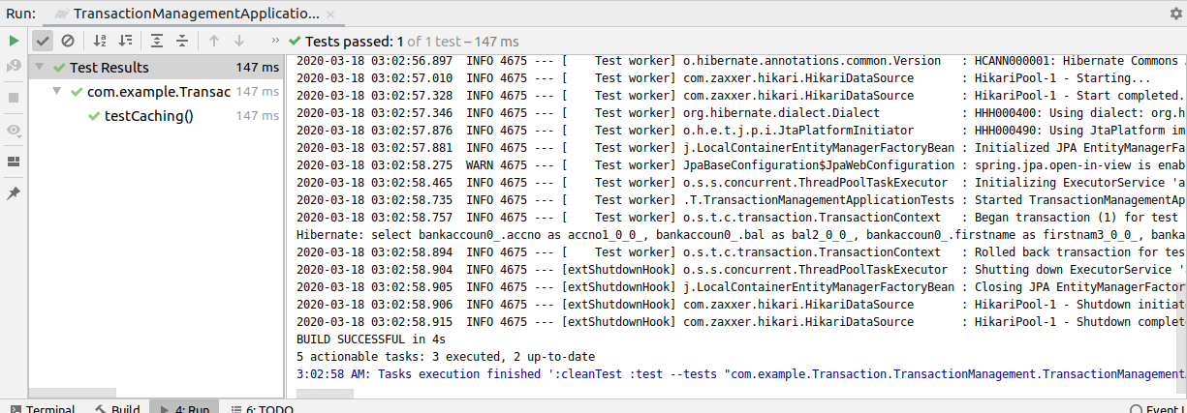
10.What does @transactional annotation do?
Actual balance
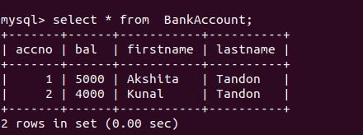

Before using Transaction annotation
- If one transaction throws an exception , then also it would deduct the balance as it wont be rollbacked.

@Test
public void testTransfer()
{
service.transfer(500);
}
@Override
public void transfer(int amount)
{
BankAccount bankAccount=repository.findById(1).get();
bankAccount.setBal(bankAccount.getBal()-amount);
repository.save(bankAccount);
if(true)
{
throw new RuntimeException();
}
BankAccount bankAccount1=repository.findById(2).get();
bankAccount1.setBal(bankAccount1.getBal()+amount);
repository.save(bankAccount1);
}
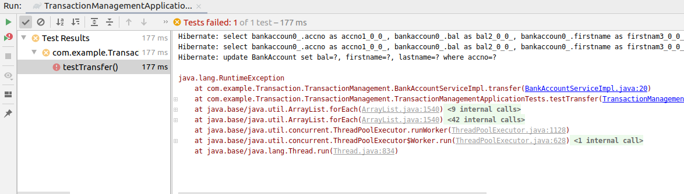
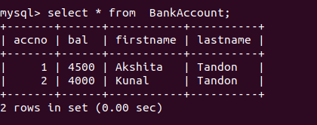

After @Transactional everything will be committed or will be rollback

- If one trandaction fails, the no transaction would be allowed to run and the parent transaction would also be rollbacked as in @transactional either whole of the trnsaction would run or neither of them

@Test
@Transactional
public void testTransfer()
{
service.transfer(500);
}
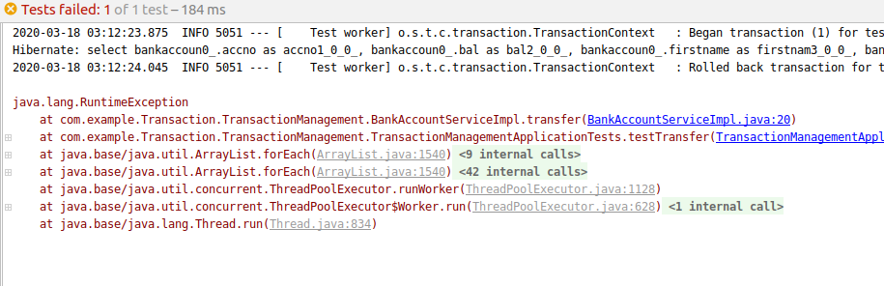

The balance remains the same even if a exception happens.

