Q1.Write Java code to define List . Insert 5 floating point numbers in List, and using an iterator, find the sum of the numbers in List.
package com.Collections;
import java.util.ArrayList;
import java.util.List;
import java.util.Scanner;
public class TestList {
public static void main(String[] args) {
List<Float> list= new ArrayList<Float>();
list.add(1.2f);
list.add(3.2f);
list.add(7.88f);
list.add(4.775f);
list.add(18.6f);
float sum=0;
for(int i=0;i<list.size();i++)
{
sum=sum+list.get(i);
}
System.out.println("Sum of list is: "+sum);
}
}
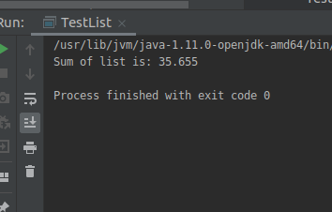

Q2.Write a method that takes a string and returns the number of unique characters in the string.
package com.Collections;
import java.util.HashMap;
import java.util.Map;
import java.util.Scanner;
public class TestHashMap {
public static void main(String[] args) {

HashMap<String,Integer> map=new HashMap<String, Integer>();
Scanner scanner=new Scanner(System.in);
String inputstring = scanner.nextLine();
String[] editedstring=inputstring.split("");
for(int i=0;i<editedstring.length;i++)
{
if(!map.containsKey(editedstring[i]))
{
map.put(editedstring[i],1);

}else
{
map.put(editedstring[i],map.get((editedstring[i]))+1);
}
}
for(Map.Entry<String,Integer> entry: map.entrySet()){
String key=entry.getKey();
int value=entry.getValue();
if(value==1)
System.out.println(key +" : "+ value);
}
}
}
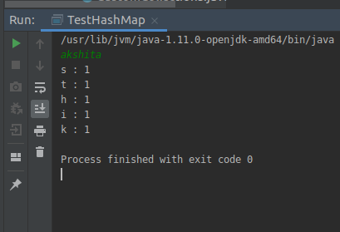

Q3.Write a method that takes a string and print the number of occurrence of each character characters in the string.
package com.Collections;
import java.util.HashMap;
import java.util.Map;
import java.util.Scanner;
public class TestHashMap {
public static void main(String[] args) {
HashMap<String,Integer> map=new HashMap<String, Integer>();
Scanner scanner=new Scanner(System.in);
String inputstring = scanner.nextLine();
String[] editedstring=inputstring.split("");
for(int i=0;i<editedstring.length;i++)
{
if(!map.containsKey(editedstring[i]))
{
map.put(editedstring[i],1);

}else
{
map.put(editedstring[i],map.get((editedstring[i]))+1);
}
}
for(Map.Entry<String,Integer> entry: map.entrySet()){
String key=entry.getKey();
int value=entry.getValue();
System.out.println(key +" : "+ value);
}
}
}
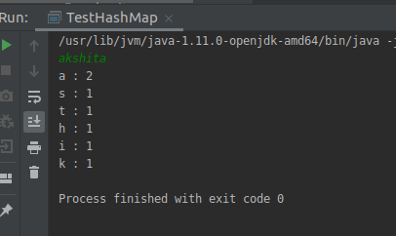

Q4.Write a program to sort HashMap by value.
package com.Collections;
import java.util.*;
import java.util.Map.*;
public class SortHashMap {
public static void main(String[] args) {

Map<Integer, String> hashmap = new HashMap<Integer, String>();
hashmap.put(1, "Akshita");
hashmap.put(2, "Nisha");
hashmap.put(3, "Prabhat");
hashmap.put(4, "Drishti");
hashmap.put(5, "Neha");

for (Map.Entry<Integer, String> entry : hashmap.entrySet()) {
int key = entry.getKey();
String value = entry.getValue();
System.out.println(key + " : " + value);
}
List<Entry<Integer,String>> sortByValue = new ArrayList<Entry<Integer,String>>(hashmap.entrySet());
Collections.sort(sortByValue, new Comparator<Entry<Integer, String>>() {
@Override
public int compare(Entry<Integer, String> e1, Entry<Integer, String> e2) {
return e1.getValue().compareTo(e2.getValue());
}
});
System.out.println();
System.out.println("Sorted By values :");
for(Entry<Integer,String> entry: sortByValue){
System.out.print(entry.getValue()+ " ");
}
System.out.println();
}
}

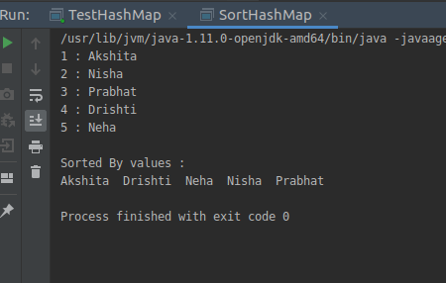

Q5.Write a program to sort Employee objects based on highest salary using Comparator. Employee class{ Double Age; Double Salary; String Name
package com.Threads;
import java.util.*;
import java.lang.*;
class Employee{
public String employeeName;
public double age;
public double salary;

public String getEmployeeName() {
return employeeName;
}

public double getSalary() {
return salary;
}

public Employee(String employeeName, double age, double salary){

this.employeeName=employeeName;
this.age=age;
this.salary=salary;

}

@Override
public boolean equals(Object o) {
if (this == o) return true;
if (o == null || getClass() != o.getClass()) return false;
Employee employee = (Employee) o;
return Double.compare(employee.age, age) == 0 &&
Double.compare(employee.salary, salary) == 0 &&
Objects.equals(employeeName, employee.employeeName);
}

@Override
public int hashCode() {
return Objects.hash(employeeName, age, salary);
}

@Override
public String toString() {
return "Employee{" +
"employeeName='" + employeeName + '\'' +
", age=" + age +
", salary=" + salary +
'}';
}
}
class HighestSalaryComparator implements Comparator<Employee>
{
@Override
public int compare(Employee e1, Employee e2) {
if(e1.getSalary() > e2.getSalary()) {
return 1;
}
else if(e1.getSalary() < e2.getSalary()) {
return -1;
}
return 0;
}
}

public class SortEmployee {

public static void main(String[] args) {

List<Employee> employeeLinkedList= new LinkedList<Employee>();
Employee employeeThree= new Employee("Nisha",22,45100);
Employee employeeOne= new Employee("Akshita",23,15100);
Employee employeeTwo= new Employee("Drishti",23,25100);

Employee employeeFour= new Employee("Prabhat",23,35100);
employeeLinkedList.add(employeeThree);
employeeLinkedList.add(employeeOne);
employeeLinkedList.add(employeeTwo);

employeeLinkedList.add(employeeFour);
System.out.println("Before Sorting");
for(Employee emp:employeeLinkedList){
System.out.println(emp);
}

Collections.sort(employeeLinkedList,new HighestSalaryComparator());
System.out.println("After sorting");
for(Employee emp:employeeLinkedList){
System.out.println(emp);
}
}
}

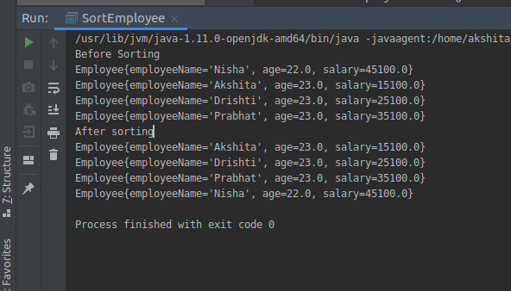

Q6.Write a program to sort the Student objects based on Score , if the score are same then sort on First Name . Class Student{ String Name; Double Score; Double Age
package com.Threads;
import java.util.*;
import java.lang.*;
class Student{
public String studentName;
public double age;
public double score;

public String getStudentName() {
return studentName;
}

public double getScore() {
return score;
}

public Student(String studentName, double age, double score){

this.studentName=studentName;
this.age=age;
this.score=score;

}

@Override
public boolean equals(Object o) {
if (this == o) return true;
if (o == null || getClass() != o.getClass()) return false;
Student student = (Student) o;
return Double.compare(student.age, age) == 0 &&
Double.compare(student.score, score) == 0 &&
Objects.equals(studentName, student.studentName);
}

@Override
public int hashCode() {
return Objects.hash(studentName, age, score);
}

@Override
public String toString() {
return "Student{" +
"studentName='" + studentName + '\'' +
", age=" + age +
", score=" + score +
'}';
}
}
class HighestScoreComparator implements Comparator<Student>
{
@Override
public int compare(Student s1, Student s2) {
if(s1.getScore() > s2.getScore()) {
return 1;
}
else if(s1.getScore() < s2.getScore()) {
return -1;
}else{
return s1.getStudentName().compareTo(s2.getStudentName());
}
}
}

public class SortStudent {

public static void main(String[] args) {

List<Student> studentLinkedList= new LinkedList<Student>();
Student studentThree= new Student("Nisha",22,490);
Student studentOne= new Student("Akshita",23,350);
Student studentTwo= new Student("Drishti",23,250);

Student studentFour= new Student("Prabhat",23,350);
studentLinkedList.add(studentThree);
studentLinkedList.add(studentOne);
studentLinkedList.add(studentTwo);

studentLinkedList.add(studentFour);
System.out.println("Before Sorting");
for(Student student:studentLinkedList){
System.out.println(student);
}

Collections.sort(studentLinkedList,new HighestScoreComparator());
System.out.println("After sorting");
for(Student student:studentLinkedList){
System.out.println(student);
}
}
}

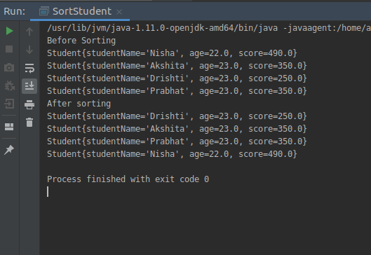

Q7.Print the elements of an array in the decreasing frequency if 2 numbers have same frequency then print the one which came first.
package com.Collections;

import java.util.*;

import static java.util.Map.*;

public class DecreasingFrequency{
public static void main(String[] args) {

Map<Integer,Integer> linkedMap=new LinkedHashMap<Integer, Integer>();
Scanner scanner=new Scanner(System.in);
System.out.println("Enter the size of array");
int size=scanner.nextInt();
int[] array=new int[size];
for(int j=0;j<size;j++){
array[j]=scanner.nextInt();
}
for(int i=0;i<array.length;i++){
if(!linkedMap.containsKey(array[i]))
{
linkedMap.put(array[i],1);
}else{
linkedMap.put(array[i],linkedMap.get(array[i])+1);
}
}

for(Map.Entry<Integer,Integer> entry: linkedMap.entrySet()){

int key=entry.getKey();
int value=entry.getValue();
System.out.println(key+" : "+ value);
}

List<Entry<Integer,Integer>> decreaseFrequency=new ArrayList<>(linkedMap.entrySet());
Collections.sort(decreaseFrequency, new Comparator<Entry<Integer, Integer>>() {
@Override
public int compare(Entry<Integer, Integer> e1, Entry<Integer, Integer> e2) {
return e1.getValue().compareTo(e2.getValue());
}
});

for(Entry<Integer,Integer> entry: decreaseFrequency)
{
int frequency=entry.getValue();
while(frequency>=1){
System.out.print(entry.getKey()+" ");
frequency--;
}
}

}
}
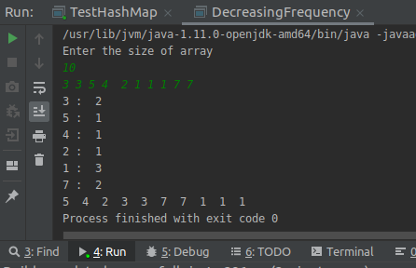

Q8.Design a Data Structure SpecialStack that supports all the stack operations like push(), pop(), isEmpty(), isFull() and an additional operation getMin() which should return minimum element from the SpecialStack. (Expected complexity O(1))
package com.Collections;

import java.util.Stack;

public class SpecialStack extends Stack<Integer> {

Stack<Integer> min=new Stack<>();

public void push(int element){
if(isEmpty()==true){
super.push(element);
min.push(element);
}else{
super.push(element);
int y=min.pop();
min.push(y);
if(element< y){
min.push(element);
}else
min.push(y);

}

}
public Integer pop(){
int x=super.pop();
min.pop();
return x;
}
public Integer getMin(){
int x=min.peek();
return x;
}

public static void main(String[] args) {
SpecialStack specialStack=new SpecialStack();
specialStack.push(30);
specialStack.push(20);

specialStack.push(10);
specialStack.push(5);
specialStack.push(2);
System.out.println("Minimum element : " +specialStack.getMin());
specialStack.pop();
System.out.println("Minimum element : " +specialStack.getMin());
specialStack.pop();
System.out.println("Minimum element : " +specialStack.getMin());
}
}
