Q1. Write a program to replace a substring inside a string with other string ?

package com.firstjava;
import java.util.Scanner;

public class ReplaceString {
public static void main(String[] args) {

Scanner myObj = new Scanner(System.in); // Create a Scanner object
System.out.println("Enter the string");
String str = myObj.nextLine(); // Read user input
System.out.println("Enter the substring to be replaced");
String substr = myObj.nextLine();
System.out.println("Enter the substring to be replaced with");
String substr2 = myObj.nextLine();
String replacestr = str.replace(substr,substr2);
System.out.println("The replaced string is :" +replacestr);

}
}
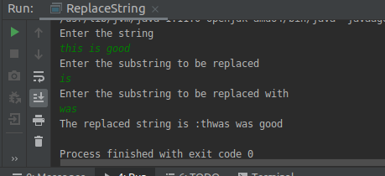

Q2. Write a program to find the number of occurrences of the duplicate words in a string and print them ?

package com.firstjava;
import java.util.Scanner;

public class Duplicatewords {
public static void main(String[] args) {
Scanner sc=new Scanner(System.in);
System.out.println("Enter the String : ");
String str = sc.nextLine();
str=str.toLowerCase();
String[] strarray = str.split("[ .]");
for(int i=0;i<strarray.length;i++) {
int count = 1;
for (int j = i + 1; j < strarray.length; j++) {
if (strarray[i].equals(strarray[j]))
{
count++;
//System.out.println(count);
strarray[j] = "0";
}
}
if (count > 1 && strarray[i]!="0")
{
System.out.println(strarray[i]);
}
}
}
}
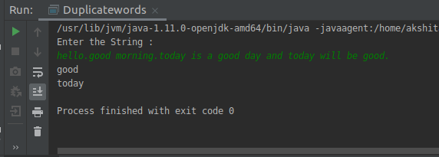
Q3. Write a program to find the number of occurrences of a character in a string without using loop?

package com.firstjava;
import java.util.Scanner;
public class OccurrenceWithoutLoop {
public static void main(String[] args) {
Scanner sc=new Scanner(System.in);
System.out.println("Enter the String : ");
String str = sc.nextLine();
int count = str.length() - str.replace("a", "").length();
System.out.println("Number of occurrences of 'a' in "+str+" = "+count);
}
}
}
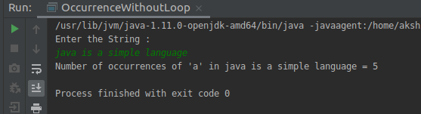
Q4. Calculate the number & Percentage Of Lowercase Letters,Uppercase Letters, Digits And Other Special Characters In A String

package com.firstjava;

import java.util.Scanner;

public class Charpercentage {
public static void main(String[] args) {

Scanner sc=new Scanner(System.in);
System.out.println("enter the String :");
String string=sc.nextLine();
int length=string.length();
System.out.println("Length of the string : "+length);
int countlower=0,countupper=0,countdigit=0,countspecial=0;
char[] charArray=string.toCharArray();
for(int i=0;i<charArray.length;i++) {
if (Character.isLowerCase(charArray[i])) {
countlower++;
} else if (Character.isUpperCase(charArray[i])) {
countupper++;
} else if (Character.isDigit(charArray[i])) {
countdigit++;
} else {
countspecial++;
}
}
float lowerper=(countlower*100)/length;
float upperper=(countupper*100)/length;
float digitper=(countdigit*100)/length;
float specialper=(countspecial*100)/length;

System.out.println("Number of Lowercase character : "+countlower+" percentage : "+lowerper);
System.out.println("Number of Uppercase character : "+countupper+" percentage :"+upperper);
System.out.println("Number of digits : "+countdigit+" percentage :"+digitper);
System.out.println("Number of special character : "+countspecial+" percentage :"+specialper);

}
}

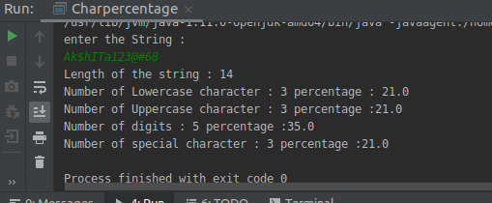
Q5. Find common elements between two arrays.

package com.firstjava;

import java.util.Scanner;

public class CommonElementsInArray {
public static void main(String[] args) {

Scanner sc=new Scanner(System.in);
System.out.println("Enter the size of first array: ");
int size1=sc.nextInt();
System.out.println("Enter the elements of first array: ");
int[] array1=new int[size1];
for(int i=0;i<size1;i++){
array1[i]=sc.nextInt();
}
System.out.println("Enter the size of second array: ");
int size2=sc.nextInt();
int[] array2=new int[size2];
System.out.println("Enter the elements of second array: ");
for(int i=0;i<size2;i++){
array2[i]=sc.nextInt();
}
for(int i=0;i<size1;i++)
{
for(int j=0;j<size2;j++){
if(array1[i]==array2[j])
{
System.out.println("Elements are :"+array1[i]);
break;
}

}
}

}
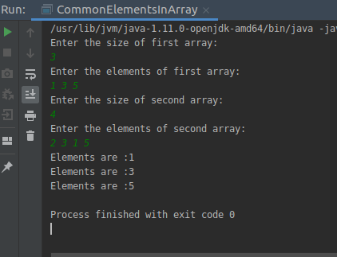
}

Q6. There is an array with every element repeated twice except one. Find that element

package com.firstjava;

import java.util.Scanner;

public class RepeatedTwice {

public static void main(String[] args) {
Scanner sc=new Scanner(System.in);
System.out.println("Enter the size of first array: ");
int size1=sc.nextInt();
System.out.println("Enter the elements of first array: ");
int[] array1=new int[size1];
for(int i=0;i<size1;i++){
array1[i]=sc.nextInt();
}
int res = array1[0];
for (int i = 1; i < size1; i++){
res = res ^ array1[i];
}
System.out.println("Element Occurring once is: "+res);
}
}
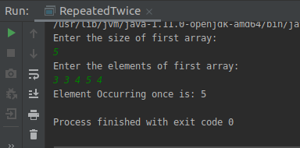

Q7. Write a program to print your Firstname,LastName & age using static block,static method & static variable respectively
package com.firstjava;

class Person
{
public static String firstName;
public static String lastName;
public static int age;
static {
firstName="Akshita";
lastName="Tandon";
age=23;
}
public static String getFirstName(){
return firstName;
}
public static String getLastName(){
return lastName;
}
public static int getAge(){
return age;
}

}
public class StaticQues {
public static void main(String[] args) {
Person p1=new Person();
System.out.println("First Name: "+p1.getFirstName());
System.out.println("Last Name: "+p1.getLastName());
System.out.println("Age: "+p1.getAge());
}
}
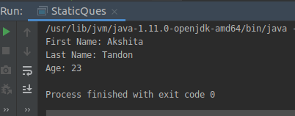

Q8. Write a program to reverse a string and remove character from index 4 to index 9 from the reversed string using String Buffer
package com.firstjava;

import java.util.Scanner;

public class ReverseString {
public static void main(String[] args) {

Scanner sc=new Scanner(System.in);
System.out.println("Enter the string: ");
StringBuffer str=new StringBuffer(sc.nextLine());
//System.out.println(str.hashCode());
str=str.reverse();
System.out.println("The Reversed String is "+str);
//System.out.println(str.hashCode());
System.out.println("Removing from index4 to index9");
str.delete(4,9);
System.out.println(str);

}
}
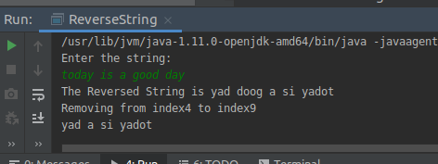

Q9.Write a program to display values of enums using a constructor & getPrice() method (Example display house & their prices)
package com.firstjava;

enum HOUSES{
House1(50000),
House2(60000),
House3(50000),
House4(70000);

private int value;
HOUSES(int value){
this.value=value;
}
public int getPrice() {
return this.value;
}
}
public class EnumHouses {
public static void main(String[] args) {

System.out.println("House 1 "+HOUSES.House1.getPrice());
System.out.println("House 2 "+HOUSES.House2.getPrice());
System.out.println("House 3 "+HOUSES.House3.getPrice());
System.out.println("House 4 "+HOUSES.House4.getPrice());

}
}
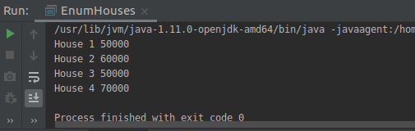
Q10.Write a single program for following operation using overloading
A) Adding 2 integer number
B) Adding 2 double
C) multiplying 2 float
D) multiplying 2 int
E) concate 2 string
F) Concate 3 String
package com.firstjava;

public class Operations {
public void add(int num1,int num2){
int sum=0;
sum=num1+num2;
System.out.println("The sum of two Integer numbers are: "+sum);
}
public void add(double num3,double num4){
double sum=0;
sum=num3+num4;
System.out.println("The sum of two Double numbers are: "+sum);
}
public void multiply(int num1,int num2){
int result=1;
result=num1*num2;
System.out.println("The multiplication of two Integer numbers are: "+result);
}
public void multiply(float num1,float num2){
float result=1;
result=num1*num2;
System.out.println("The multiplication of two floating numbers are: "+result);
}
public void concatenate(String str1, String str2){
System.out.println("Concatenation of two Strings "+str1+str2);
}
public void concatenate(String str1, String str2,String str3){
System.out.println("Concatenation of three Strings "+str1+str2+str3);
}
public static void main(String[] args)
{
Operations op=new Operations();
int num1=10,num2=20;
double num3=40.554,num4=4.55534;
float num5=2.34f,num6=6.9f;
String str1="abc",str2="xyz",str3="mno";
op.add(num1,num2);
op.add(num3,num4);
op.multiply(num1,num2);
op.multiply(num5,num6);
op.concatenate(str1,str2);
op.concatenate(str1,str2,str3);

}
}
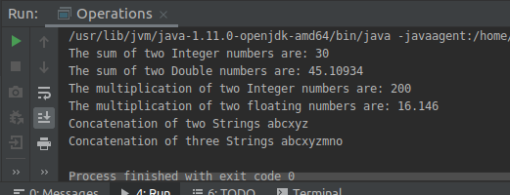
Q11.Create 3 sub class of bank SBI,BOI,ICICI all 4 should have method called getDetails which provide there specific details like rateofinterest etc,print details of every banks

package com.firstjava;

abstract class BankDetails {
public String bankName;
public int rateOfInterest;
public String branch;
public void getBankDetails(){
System.out.println("The name of the Bank: "+bankName);
System.out.println("The ROI of the Bank: "+rateOfInterest);
System.out.println("The branch of the Bank: "+branch);

}
}

public class SBI extends BankDetails{

SBI(String bankName,int rateOfInterest,String branch){
this.bankName=bankName;
this.rateOfInterest=rateOfInterest;
this.branch=branch;
}
}
class ICICI extends BankDetails{
ICICI(String bankName,int rateOfInterest,String branch){
this.bankName=bankName;
this.rateOfInterest=rateOfInterest;
this.branch=branch;
}
}
class BOI extends BankDetails{
BOI(String bankName,int rateOfInterest,String branch){
this.bankName=bankName;
this.rateOfInterest=rateOfInterest;
this.branch=branch;
}
}

class TestBank{
public static void main(String[] args) {
SBI sbi=new SBI("State Bank of India",7,"Hari Nagar");
sbi.getBankDetails();
ICICI icici=new ICICI("ICICI",8,"Noida");
icici.getBankDetails();
BOI boi=new BOI("Bank Of India",6,"Tilak Nagar");
boi.getBankDetails();

}
}
