REACT ASSIGNMENT
ES6 PART-1 AND PART-2

Q1. Given this array: `[3,62,234,7,23,74,23,76,92]`, Using arrow function, create an array of the numbers greater than `70`.
//Question 1
let array=[3,62,234,7,23,74,23,76,92];
console.log("Array",array);
let newArray=array.filter((a)=> a>70);
console.log("Array containing elements greater than 70",newArray);

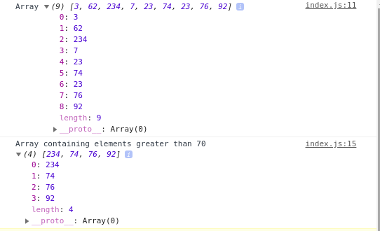

Q2.
<ul>
<li data-time="5:17">Flexbox Video</li>
<li data-time="8:22">Flexbox Video</li>
<li data-time="3:34">Redux Video</li>
<li data-time="5:23">Flexbox Video</li>
<li data-time="7:12">Flexbox Video</li>
<li data-time="7:24">Redux Video</li>
<li data-time="6:46">Flexbox Video</li>
<li data-time="4:45">Flexbox Video</li>
<li data-time="4:40">Flexbox Video</li>
<li data-time="7:58">Redux Video</li>
<li data-time="11:51">Flexbox Video</li>
<li data-time="9:13">Flexbox Video</li>
<li data-time="5:50">Flexbox Video</li>
<li data-time="5:52">Redux Video</li>
<li data-time="5:49">Flexbox Video</li>
<li data-time="8:57">Flexbox Video</li>
<li data-time="11:29">Flexbox Video</li>
<li data-time="3:07">Flexbox Video</li>
<li data-time="5:59">Redux Video</li>
<li data-time="3:31">Flexbox Video</li>
</ul>

a. Select all the list items on the page and convert to array.
//Questin 2
let newArrays=[];
let list=document.getElementById("ListName").getElementsByTagName("li");
for(var i=0;i < list.length; i++) {
newArrays.push(list[i].innerHTML);
}
console.log(newArrays);
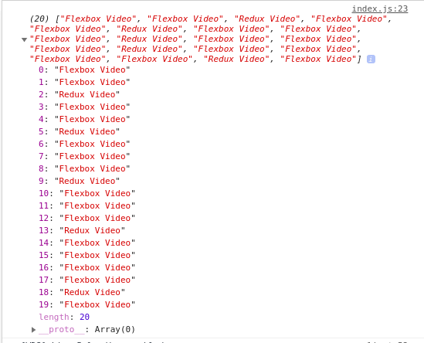
b. Filter for only the elements that contain the word 'flexbox'
console.log("Array containing only Flexbox Video")
let onlyflexBox=newArrays.filter((a) => a.toLowerCase().includes("flexbox"));
console.log(onlyflexBox);

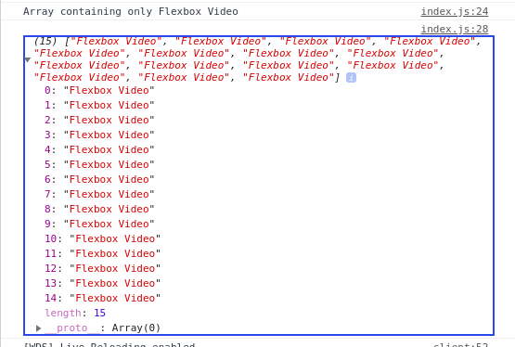
c. Map down to a list of time strings
console.log("List of time ");
let arrayTime=[];
for(var i=0;i < list.length; i++) {
arrayTime.push(list[i].getAttribute("data-time"));
}
console.log(arrayTime);
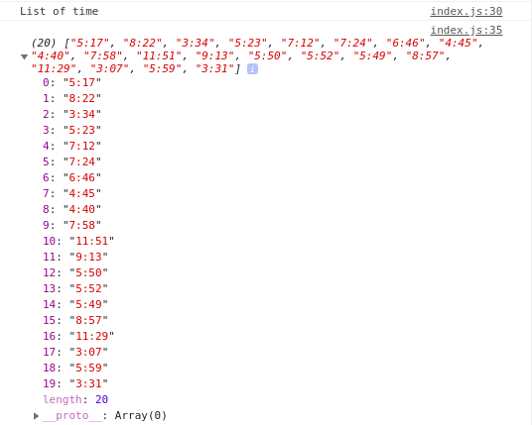

d. Map to an array of seconds
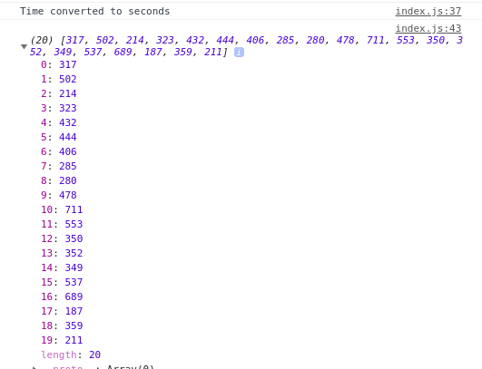
e. Reduce to get total using .filter and .map
console.log("Total time");
let totalTime;
totalTime=arrayTimeSeconds.reduce((a,b)=>a+b,0);
console.log(totalTime);

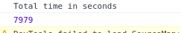

Q3. Create a markup template using string literal
const song = {
name: 'Dying to live',
artist: 'Tupac',
featuring: 'Biggie Smalls'
};

Result:
"<div class="song">
<p>
Dying to live — Tupac
(Featuring Biggie Smalls)
</p>
</div>
“
const song = {
name: 'Dying to live',
artist: 'Tupac',
featuring: 'Biggie Smalls'
};
const markup=
`
<div class="song">
<p>
${song.name} - ${song.artist}
(Featuring ${song.featuring})
</p>
</div>
`
document.getElementById("block").innerHTML=markup;

export {markup}

HTML CONSOLE
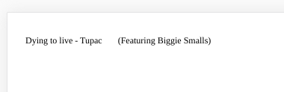
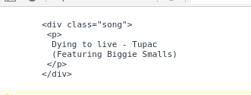

Q4. Extract all keys inside address object from user object using destructuring ?
const user = {
firstName: ‘Sahil’,
lastName: ‘Dua’,
Address: {
Line1: ‘address line 1’,
Line2: ‘address line 2’,
State: ‘Delhi’,
Pin: 110085,
Country: ‘India’,
City: ‘New Delhi’,
},
phoneNo: 9999999999
}
const user = {
firstName: 'Sahil',
lastName: 'Dua',
Address: {
Line1: 'address line 1',
Line2: 'address line 2',
State: 'Delhi',
Pin: 110085,
Country: 'India',
City: 'New Delhi',
},
phoneNo: 9999999999
}

let {Address}=user;
console.log("Address of a user using destructuring",Address);

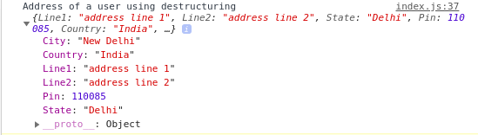

Q5.Filter unique array members using Set.
const arr=[2,3,4,5,2,3,4,10,11,7,5];
console.log("Original Array",arr);
const arrSet=new Set(arr);
console.log("Set made with array",arrSet);

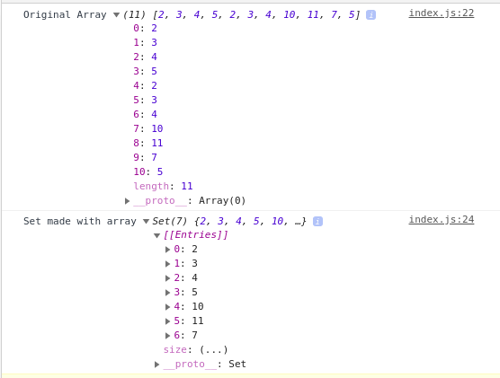
Q6. Write a program to implement inheritance upto 3 classes.The Class must public variables and static functions.
class Person{
constructor(firstName,lastName,age,gender)
{
this.firstName=firstName;
this.lastName=lastName;
this.age=age;
this.gender=gender;
}
description() {
console.log(`Name: ${this.firstName} ${this.lastName} Age:${this.age} Gender:${this.gender}`);
}

}

class Student extends Person{

constructor(firstName,lastName,age,gender,course,college)
{
super(firstName,lastName,age,gender);
this.course=course;
this.college=college;
}
static courseChange(course){
return this.course=course;
}

static collegeChange(college){
return this.college=college;
}

description() {
console.log(`Name: ${this.firstName} ${this.lastName} Age:${this.age} Gender:${this.gender} studying ${this.course} in ${this.college}`);
}
}

class PhdStudent extends Student{
constructor(firstName,lastName,age,gender,course,college,subject){
super(firstName,lastName,age,gender,course,college);
this.subject=subject;
}

static subjectChange(subject){
return this.subject=subject;
}
description() {
console.log(`Name: ${this.firstName} ${this.lastName} Age:${this.age} Gender:${this.gender}
studying ${this.course} in ${this.college} and teaching ${this.subject}`);
}
}

let person=new Person("Akshita","Tandon",24,"Female");
person.description();
let student=new Student("Nisha","Nagarkoti",22,"Female","MCA","LBSIM");
student.description();
let phdStudent=new PhdStudent("Drishti","Talwar",25,"Female","PHD in computer","DU","Data Structures");
phdStudent.description();

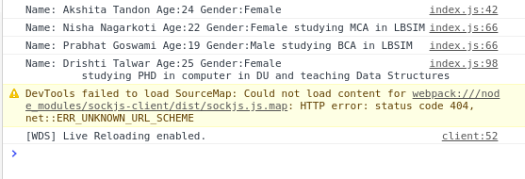
Q7. Write a program to implement a class having static functions
class Calculator{
static multiply(a,b){
return a*b;
}
static add(a,b){
return a+b;
}
static subtract(a,b){
return a-b;
}
static divide(a,b){
return a/b;
}
}

let number=Calculator.multiply(2,5);
console.log("Multiply 2 and 5 ",number);
number=Calculator.add(21,5);
console.log("Addition 21 nad 5",number);
number=Calculator.subtract(1,5);
console.log("Subtraction of 1 and 5",number);
number=Calculator.divide(21,3);
console.log("Divison og 21 and 3",number);

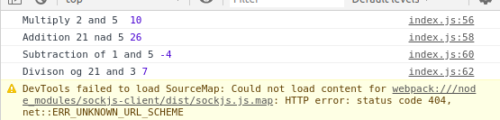

Q8. Import a module containing the constants and method for calculating area of circle, rectangle, cylinder.
Ques8.js
const rectangle={
length:5,
width:7
};
const circle={
radius:7
};
const cylinder={
radius:6,
height:8
}
function findArea() {
console.log("Area of circle",areaCircle(circle));
console.log("Area of reactangle",areaRectangle(rectangle));
console.log("Area of cylinder",areaCylinder(cylinder));
}
function areaCircle(circle) {
var area=3.14*circle.radius*circle.radius;
return area;
}
function areaRectangle(rectangle) {
var area=rectangle.length*rectangle.width;
return area;
}
function areaCylinder(cylinder) {
var area=(2*3.14*cylinder.radius*cylinder.height) +(2*areaCircle(cylinder));
return area;
}

export {findArea}

index.js
import {findArea} from './ques8'
findArea();

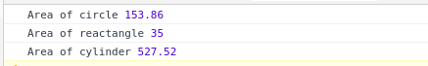

Q9. Import a module for filtering unique elements in an array.
Ques9.js
function printUniqueElements(arr) {
var array = [];
for(var i = 0; i < arr.length; i++) {
if(!array.includes(arr[i])) {
array.push(arr[i]);
}
}
return array;
}
export {printUniqueElements}

index.js
import {printUniqueElements} from './ques9'
let arr=[6,23,4,2,6,4,9,8,6,9];
console.log("OriginalArray",arr);
console.log(printUniqueElements(arr));

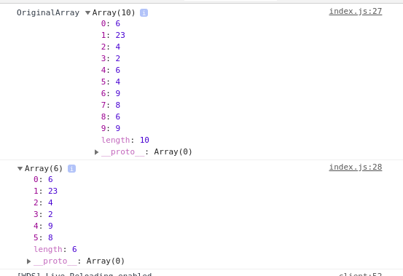

Q10. Write a program to flatten a nested array to single level using arrow functions.
let arr=[6,[23,4],2,[6,[4,9]],8,6,9];
console.log("OriginalArray",arr);
function flatten(arr){
return arr.reduce((a, b) => a.concat(Array.isArray(b) ? flatten(b) : b), []);
}
console.log(flatten(arr));

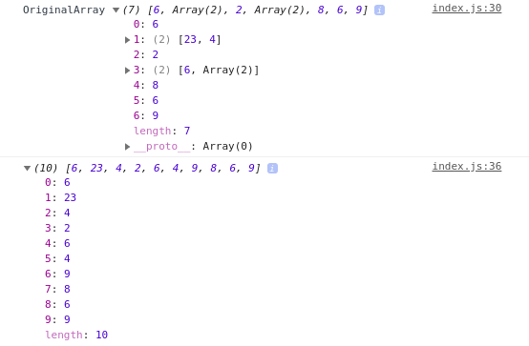
Q11. Implement a singly linked list in es6 and implement addFirst() addLast(), length(), getFirst(), getLast(). (without using array)
class Node{
constructor(data,next=null){
this.data=data;
this.next=next;
}
}

class LinkedList{
constructor(){
this.head=null;
}

addFirst(data){
let newNode = new Node(data);
// The pointer next is assigned head pointer so that both pointers now point at the same node.
newNode.next = this.head;
// As we are inserting at the beginning the head pointer needs to now point at the newNode.
this.head = newNode;
// return this.head;
}
addLast(data){
let newNode = new Node(data);
// When head = null i.e. the list is empty, then head itself will point to the newNode.
if(!this.head){
this.head = newNode;
//return this.head;
}
// Else, traverse the list to find the tail (the tail node will initially be pointing at null), and update the tail's next pointer.
let tail = this.head;
while(tail.next !== null){
tail = tail.next;
}
tail.next = newNode;
// return this.head;
}
lengthOfList(){
var count=1;
let tail = this.head;
while(tail.next !== null){
tail=tail.next;
count+=1;
}
return count;
}
getLast(){
let tail = this.head;
while(tail.next != null)
tail=tail.next;
return tail.data;
}

getFirst(){
return this.head.data;
}
}
function dothis(){
let list=new LinkedList();
list.addFirst(5);
list.addFirst(7);
list.addFirst(8);
list.addLast(9);
console.log(list);
console.log("First",list.getFirst());
console.log("Last",list.getLast());
console.log("Length",list.lengthOfList());

}

export {dothis}

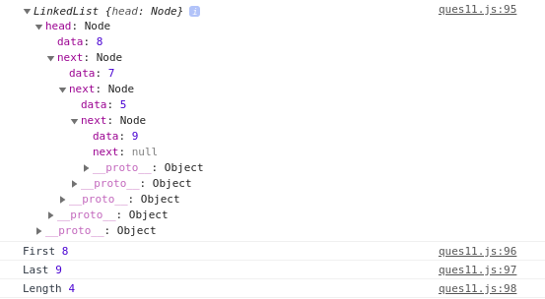
Q12. Implement Map and Set using Es6
//SET

let setImpl=new Set();
setImpl.add(4);
setImpl.add("Akshita");
setImpl.add({x:6,y:7});
console.log(setImpl);
console.log(setImpl.size);

let numbersSet=[2,4,5,6,3,1,8,9,1];
let numberFilter=new Set(numbersSet);
for(let element of numberFilter.values())
{
console.log(element);
}

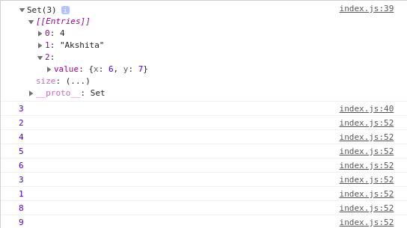
//Map

let mapImpl=new Map();
let key_one="String Key 1";
let key_two="String Key 2";
let key_three={a:'key',b:20};
let key_four=function()
{
return "I am in function";
}
mapImpl.set(key_one,'Returning value from String key 1');
mapImpl.set(key_two,'Returning value from String Key 2');
mapImpl.set(key_three,"Returning value from key value pair")
mapImpl.set(key_four,"Returning value from function");
console.log(mapImpl);

let arrays=[[1,"One"],[2,"Two"],[3,"Three"],[4,"Four"]];
let arrayMap=new Map(arrays);
console.log(arrayMap);
for(let [key,value] of arrayMap.entries())
{
console.log(`${key} point to ${value}`);
}

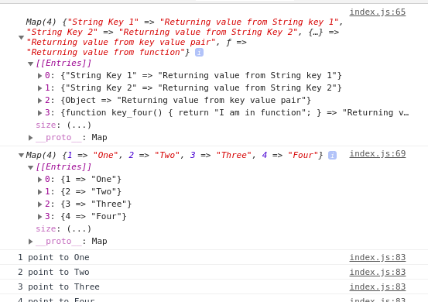
Q13. Implementation of stack (using linked list)

function stackUsingLL(){
//Node defination
let Node = function(elm){
this.element = elm;
this.next = null;
}
//To keep track of the size
let length = 0;
//To keep track of the list
let head = null;
//Push data in the stack
this.push = function(elm){
//Create a new node
let node = new Node(elm),
current;
//Add the new node at the top
current = head;
node.next = current;
head = node;
length++;
}
//Pop the item from the stack
this.pop = function(){
let current = head;
//If there is item then remove it
//and make the next element as the first
if(current){
let elm = current.element;
current = current.next;
head = current;
length--;
return elm;
}
return null;
}
//Return the first element in the stack
this.peek = function(){
if(head){
return head.element;
}
return null;
}
//Convert the stack to an array
this.toArray = function(){
let arr = [];
let current = head;
while(current){
arr.push(current.element);
current = current.next;
}
return arr;
}
//Check if stack is empty
this.isEmpty = function(){
return length === 0;
}
//Return the size of the stack
this.size = function(){
return length;
}
//Clear the stack
this.clear = function(){
head = null;
length = 0;
}
}
let stack = new stackUsingLL(); //creating new instance of Stack
stack.push(1);
stack.push(2);
stack.push(3);

console.log("Peek ",stack.peek());

console.log("Stack is empty?",stack.isEmpty());
console.log("Stack size",stack.size());
console.log(stack.pop());
console.log("Change to Array",stack.toArray());
console.log("Stack Size",stack.size());
stack.clear(); //clear the stack
console.log("after clearing stack");
console.log("Stack is empty?",stack.isEmpty());

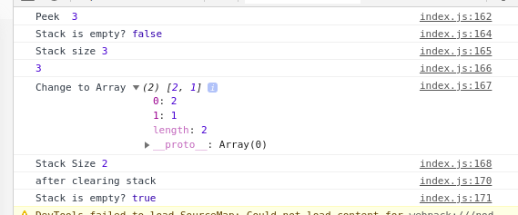

Coding exercise

//Question 1
//To show the use of classes using class Instrument,Guitar

//Question 1
class Instrument {
constructor(name, type) {
this.name = name;
this.type = type;
}
}
class Guitar extends Instrument {
describe() {
return `I'm a ${this.name} from the ${this.type} family.`;
}
}
let fender = new Guitar("Fender", "strings");
console.log(fender);

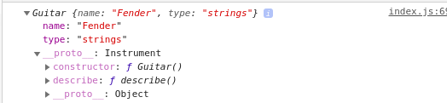

//Question 2
//To show the use of prototype using class Vehicle

//Question 2
function Vehicle(make, year, color) {
this.make = make;
this.year = year;
this.color = color;
this.bio = () => `A ${this.color} ${this.make} made in ${this.year}.`;
}
let s = new Vehicle("Tesla", 2017);
s.color = "black";
console.log(s);

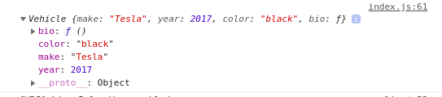

/Question 3
//To show if the word sent contains the letter using Set

// Question 3
const contains = (word, letter) => {
let letters = word.split("");
let letter_set = new Set(letters);
return letter_set.has(letter);
};
let true_check = contains("west", "e");
let false_check = contains("north", "e");
console.log(true_check);
console.log(false_check);

//Question 4
//To show number of times the letter appears using Map
//Question 4
let string = 'supercalifragilisticexpialidocious';
const countLetter = (word, orig_letter) => {
let letters = new Map();
for (let i = 0; i < word.length; i++) {
let letter = word[i];
if (!letters.has(letter)) {
letters.set(letter, 1);
} else {
letters.set(letter, letters.get(letter) + 1);
}
}
return letters.get(orig_letter);
};
let a_count = countLetter(string, 'a');
let x_count = countLetter(string, 'x');
console.log(a_count);
console.log(x_count);

