- Prompt for amount, interest rate and no. of years and calculate simple interest.

Html file:
!doctype html>
<html lang="en">
<head>
<meta charset="UTF-8">
<meta name="viewport"
content="width=device-width, user-scalable=no, initial-scale=1.0, maximum-scale=1.0, minimum-scale=1.0">
<meta http-equiv="X-UA-Compatible" content="ie=edge">
<title>Document</title>
</head>
<body>
<center>
<input type="button" value="calculate" onclick="simple()">
</center>
<script src="./script1.js" charset="UTF-8"></script>
</body>
</html>

function simple()
{
var principal_amount = prompt("Please enter the principal amount:");
var rate=prompt("Please enter the rate");
var time=prompt("Please enter the time");

var simpleinterset= (principal_amount*rate*time)/100;
console.log(simpleinterset);
document.write("Simple Interest is : ",simpleinterset);
};

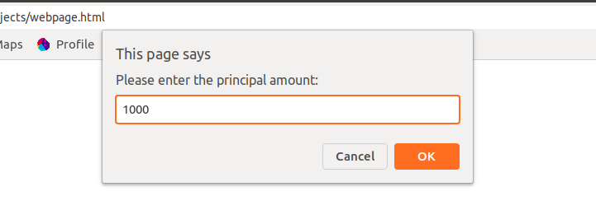
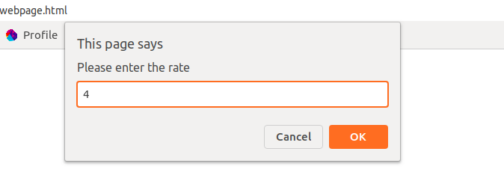
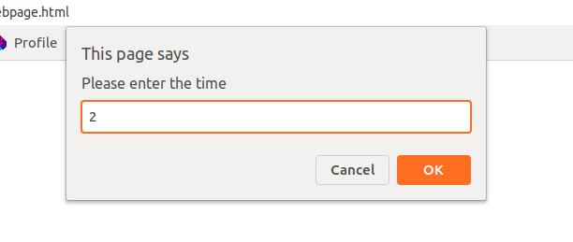
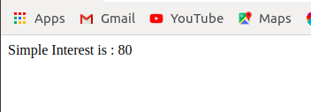

- Is palindrome string

html file:
<!doctype html>
html lang="en">
<head>
<meta charset="UTF-8">
<meta name="viewport"
content="width=device-width, user-scalable=no, initial-scale=1.0>
<meta http-equiv="X-UA-Compatible" content="ie=edge">
<title>Document</title>
</head>
<body>
Name: <input type="text" id ="name">
<input type="button" value="check" onclick="myFunction()">
<script src="./q2js.js" charset="UTF-8"></script>
</body>
</html>

js file:
function myFunction(){
var namecheck=document.getElementById("name").value;
var result=ispalindrome(namecheck);
if(result== true)
{
document.write("string is a palindrome");
}
else{
document.write("string is not a palindrome");
}
};
function ispalindrome(s){
return s == s.split("").reverse().join("") ? true : false;
};

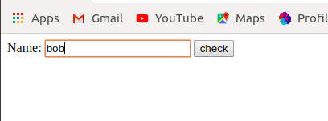
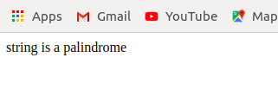

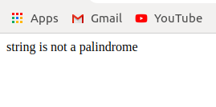
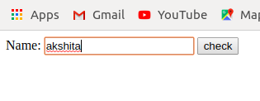

- Area of circle
html file:
<!doctype html>
<html lang="en">
<head>
<meta charset="UTF-8">
<meta name="viewport"
content="width=device-width, user-scalable=no, initial-scale=1.0, maximum-scale=1.0, minimum-scale=1.0">
<meta http-equiv="X-UA-Compatible" content="ie=edge">
<title>Document</title>
</head>
<body>
Enter the radius: <input type="text" id ="radius">
<input type="button" value="calculate" onclick="myFunction()">
<script src="./q2js.js" charset="UTF-8"></script>
</body>
</html>

js file:
function myFunction(){
var rad=document.getElementById("radius").value;
areaofcircle(rad);
};
function areaofcircle(r)
{
var areacircle=3.14*r*r;
document.write("Area of circle is :", areacircle);
}
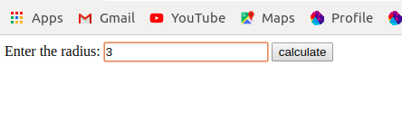

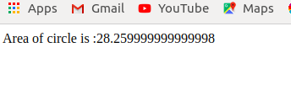

- Copy information of one object to another and log it to console.
<!doctype html>
<html lang="en">
<head>
<meta charset="UTF-8">
<meta name="viewport"
content="width=device-width, user-scalable=no, initial-scale=1.0, maximum-scale=1.0, minimum-scale=1.0">
<meta http-equiv="X-UA-Compatible" content="ie=edge">
<title>Document</title>
</head>
<body>
<script>
var obj={
name:"akshita",
age:"23",
Designation:"trainee"
}
var copyobj=obj;
document.write("print in console")
console.log(copyobj.name);
console.log(copyobj.age);
console.log(copyobj.Designation);

</script>
</body>
</html>
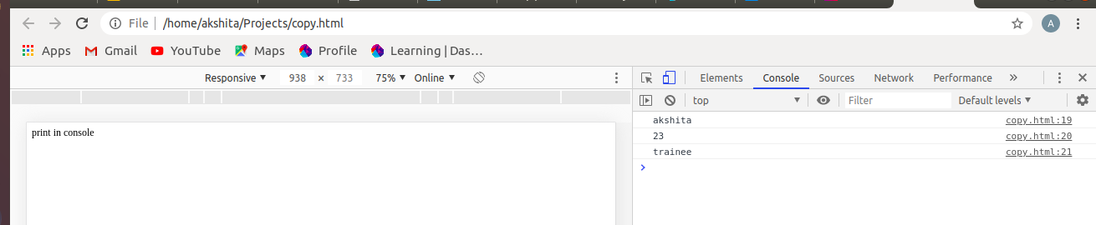

- create a list of objects of Employee with info as follow :
  - Name, age, salary ,DOB
  - filter all employees with salary greater than 5000
  - group employee on the basis of their age
4. fetch employees with salary less than 1000 and age greater than 20. Then give them an increment 5 times their salary.

<!doctype html>
<html lang="en">
<head>
<meta charset="UTF-8">
<meta name="viewport"
content="width=device-width, user-scalable=no, initial-scale=1.0, maximum-scale=1.0, minimum-scale=1.0">
<meta http-equiv="X-UA-Compatible" content="ie=edge">
<title>Document</title>
</head>
<body>
<p id="demo"></p>
<script>
const employee=[{
name:"akshita",
age:23,
Salary:1000,
DOB:"29 jul"
},
{
name:"drishti",
age:22,
Salary:380000,
DOB:"07 oct"

},
{
name:"nisha",
age:22,
Salary:480,
DOB:"07 jan"

},
{
name:"prabhat",
age:25,
Salary:49000,
DOB:"22-07-1995"

},
{
name:"neha",
age:23,
Salary:220,
DOB:"15-07-1996"

},
{
name:"shreya",
age:22,
Salary:440,
DOB:"29-05-1996"

},
{
name:"udit",
age:23,
Salary:5000,
DOB:"07-09-1996"

},
];
console.log(employee);
var employee1=employee.filter(function(check){
return check.Salary >=5000
});
console.log("salary greater than 5000");
console.log(employee1);
var age_group={};
employee.forEach(emp =>{
if(age_group.hasOwnProperty(emp.age)){
age_group[emp.age].push(emp);
}
else{
age_group[emp.age]=[];
age_group[emp.age].push(emp);

}

});
console.log("age groups");
console.log(age_group);
var employee2=employee.filter(function(check2)
{
return check2.Salary <=1000 && check2.age >20;

});
console.log("Salary less than 1000");
console.log(employee2);
var employee4=employee2.map(obj =>
{
var robj= {};
robj[obj.Salary]=obj.Salary * 5;
return robj;
});
console.log("salary increased");
console.log(employee4);

</script>
</body>
</html>
