Instructions for JPQL and Native SQL Query
- Create an employeeTable table with the following fields: empId, empFirstName, empLastName, empSalary, empAge.
- Create an Employee entity having following fields: id, firstName, lastName, salary, age which maps to the table columns given in above.

package com.jpa.JPAExercise.Entity;
import javax.persistence.*;
@Entity
@Table(name = "employeetable")
public class Employee {
@Id
@Column(name = "empId")
@GeneratedValue(strategy = GenerationType.IDENTITY)
private Integer id;
@Column(name = "empFirstName")
private String firstName;
@Column(name = "empLastName")
private String lastName;
@Column(name = "empSalary")
private Integer salary;
@Column(name = "empAge")
private Integer age;
public Integer getId() {
return id;
}
public void setId(Integer id) {
this.id = id;
}
public String getFirstName() {
return firstName;
}
public void setFirstName(String firstName) {
this.firstName = firstName;
}
public String getLastName() {
return lastName;
}
public void setLastName(String lastName) {
this.lastName = lastName;
}
public Integer getSalary() {
return salary;
}
public void setSalary(Integer salary) {
this.salary = salary;
}
public Integer getAge() {
return age;
}
public void setAge(Integer age) {
this.age = age;
}
@Override
public String toString() {
return "Employee{" +
"id=" + id +
", firstName='" + firstName + '\'' +
", lastName='" + lastName + '\'' +
", salary=" + salary +
", age=" + age +
'}';
}
}

JPQL:
- Display the first name, last name of all employees having salary greater than average salary ordered in ascending by their age and in descending by their salary.
package com.jpa.JPAExercise;
import com.jpa.JPAExercise.Entity.Employee;
import com.jpa.JPAExercise.Repository.EmployeeRepository;
import org.junit.jupiter.api.Test;
import org.springframework.beans.factory.annotation.Autowired;
import org.springframework.boot.test.context.SpringBootTest;
import java.util.List;
@SpringBootTest
class JpaExerciseApplicationTests {
@Autowired
EmployeeRepository employeeRepository;
@Test
void contextLoads() {
}
/*Display the first name, last name of all employees having salary greater than average salary ordered in ascending by their age and in descending by their salary.
Update salary of all employees by a salary passed as a parameter whose existing salary is less than the average salary.
Delete all employees with minimum salary.*/
@Test
void testCreateEmployee(){
Employee employee=new Employee();
employee.setId(1);
employee.setFirstName("Akshita");
employee.setLastName("Tandon");
employee.setSalary(15000);
employee.setAge(23);
employeeRepository.save(employee);
Employee employee1=new Employee();
employee1.setId(2);
employee1.setFirstName("Drishti");
employee1.setLastName("Talwar");
employee1.setSalary(16000);
employee1.setAge(23);
employeeRepository.save(employee1);
Employee employee2=new Employee();
employee2.setId(3);
employee2.setFirstName("Shreya ");
employee2.setLastName("Mago");
employee2.setSalary(17000);
employee2.setAge(24);
employeeRepository.save(employee2);
Employee employee3=new Employee();
employee3.setId(4);
employee3.setFirstName("Prabhjot");
employee3.setLastName("Singh");
employee3.setSalary(12000);
employee3.setAge(23);
employeeRepository.save(employee3);
Employee employee4=new Employee();
employee4.setId(5);
employee4.setFirstName("Neha");
employee4.setLastName("Budhiraja");
employee4.setSalary(15000);
employee4.setAge(23);
employeeRepository.save(employee4);
}
@Test
void testFindAllEmployeesHavingSalaryGreaterThanAverageSalary()
{
List<Object[]> list=employeeRepository.findAllEmployeesHavingSalaryGreater();
// list.forEach(e-> System.out.println(e.toString()));
for (Object[] objects:list
) {
System.out.println(objects[0]);
System.out.println(objects[1]);
}
}
}
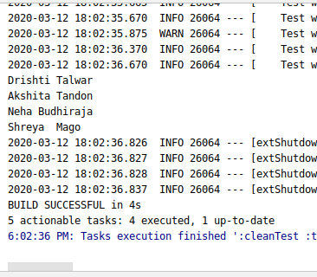

- Update salary of all employees by a salary passed as a parameter whose existing salary is less than the average salary.
@Test
@Transactional
public void testSalaryLesserThanAverageSalary() {
employeeRepository.updateSalaryLesserThanAverageSalary(4532,employeeRepository.returnAverageSalary());
System.out.println("\n\n\n");
employeeRepository.findAll().forEach(p-> System.out.println(p));
}
@Query("select AVG(salary) from Employee")
Integer returnAverageSalary();

@Modifying
@Query("Update Employee SET salary = :upsalary where salary < :avgsalary ")
void updateSalaryLesserThanAverageSalary(@Param("upsalary") int upsalary,@Param("avgsalary")Integer avgsalary);
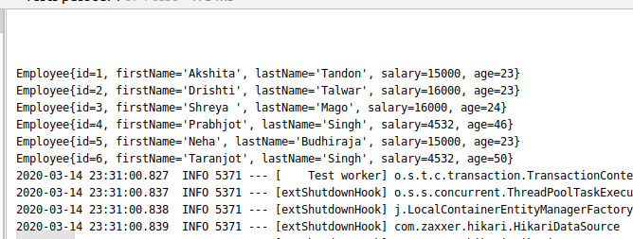

- Delete all employees with minimum salary.
@Query("select MIN(salary) from Employee")
int deletebyMinSalary();
@Modifying
@Query("delete from Employee where salary = :minsalary")
void deleteByMinimumSalary(@Param("minsalary")int minsalary);

@Test
public void testdeleteByMinSalary()
{
employeeRepository.deleteByMinimumSalary(employeeRepository.deletebyMinSalary());
System.out.println("\n\n **********Deleting****************\n\n");
}

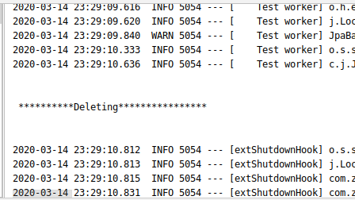

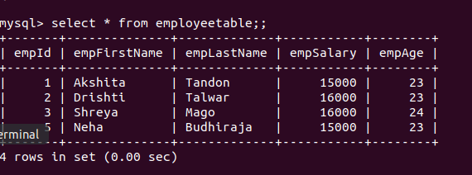
Native SQL Query:
- Display the id, first name, age of all employees where last name ends with "singh"
package com.jpa.JPAExercise.Repository;

public interface EmployeeRepository extends CrudRepository<Employee,Integer> {

@Query(value = "select empId,empFirstName,empAge from employeetable where empLastName like 'Singh' ",nativeQuery = true)
List<Object[]> findEmployeeByLastNameIsSingh();

@Modifying
@Query(value = "delete from employeetable where empAge >:age",nativeQuery = true)
void deleteEmployeeByAgeGreaterThanGiven(@Param("age")Integer age);
}
package com.jpa.JPAExercise;

@SpringBootTest
class JpaExerciseApplicationTests {
@Autowired
EmployeeRepository employeeRepository;
@Test
void contextLoads() {
}

@Test
void testFindEmployeeByLastName(){
List<Object[]> list=employeeRepository.findEmployeeByLastNameIsSingh();
for (Object[] objects:list) {
System.out.println(objects[0] +" "+ objects[1]+" " + objects[2]);
}
}
@Test
@Transactional
@Rollback(false)
void testDeleteEmployeeByAgeGreaterThanGiven()
{
employeeRepository.deleteEmployeeByAgeGreaterThanGiven(45);
}
}

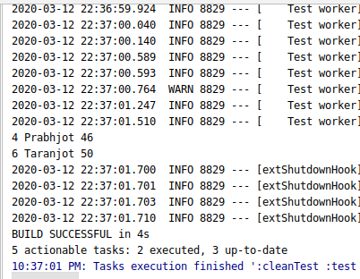

- Delete all employees with age greater than 45(Should be passed as a parameter)
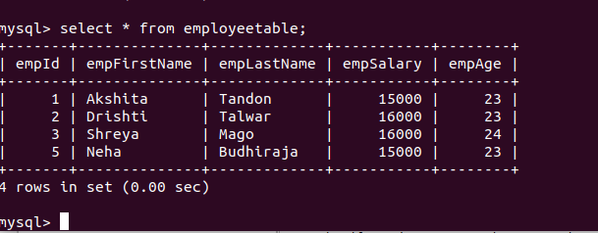
Inheritance Mapping:
- Implement and demonstrate Single Table strategy.
package com.jpa.demojpa.Entity;
import javax.persistence.*;
@Entity
@Inheritance(strategy = InheritanceType.SINGLE_TABLE)
@DiscriminatorColumn(name = "pmode",discriminatorType = DiscriminatorType.STRING)
public abstract class Payment {
@Id
@GeneratedValue(strategy = GenerationType.IDENTITY)
private int id;
private Integer amount;
public int getId() {
return id;
}
public void setId(int id) {
this.id = id;
}
public Integer getAmount() {
return amount;
}
public void setAmount(Integer amount) {
this.amount = amount;
}
}
package com.jpa.demojpa.Entity;
import javax.persistence.DiscriminatorValue;
import javax.persistence.Entity;
@Entity
@DiscriminatorValue(value = "cc")
public class CreditCard extends Payment{
private String creditCard;
public String getCreditCard() {
return creditCard;
}
public void setCreditCard(String creditCard) {
this.creditCard = creditCard;
}
}
package com.jpa.demojpa.Entity;
import javax.persistence.DiscriminatorValue;
import javax.persistence.Entity;
@Entity
@DiscriminatorValue(value = "ch")
public class CheckNumber extends Payment {
private String checkNumber;
public String getCheckNumber() {
return checkNumber;
}
public void setCheckNumber(String checkNumber) {
this.checkNumber = checkNumber;
}
}
package com.jpa.demojpa;
import com.jpa.demojpa.Entity.CheckNumber;
import com.jpa.demojpa.Entity.CreditCard;
import com.jpa.demojpa.Entity.Payment;
import com.jpa.demojpa.Repository.PaymentRepository;
import org.junit.jupiter.api.Test;
import org.springframework.beans.factory.annotation.Autowired;
import org.springframework.boot.test.context.SpringBootTest;
@SpringBootTest
class DemojpaApplicationTests {

@Autowired
PaymentRepository paymentRepository;

@Test
void testCreatePayment(){
CheckNumber checkNumber=new CheckNumber();
checkNumber.setCheckNumber("234555");
checkNumber.setAmount(1999);
CreditCard creditCard=new CreditCard();
creditCard.setCreditCard("5378993Q");
creditCard.setAmount(200000);
paymentRepository.save(checkNumber);
paymentRepository.save(creditCard);
}
}
package com.jpa.demojpa;
import com.jpa.demojpa.Entity.CheckNumber;
import com.jpa.demojpa.Entity.CreditCard;
import com.jpa.demojpa.Entity.Payment;
import com.jpa.demojpa.Entity.Student;
import com.jpa.demojpa.Repository.PaymentRepository;
import com.jpa.demojpa.Repository.StudentRepository;
import org.junit.jupiter.api.Test;
import org.springframework.beans.factory.annotation.Autowired;
import org.springframework.boot.test.context.SpringBootTest;
import org.springframework.data.domain.PageRequest;
import org.springframework.data.domain.Sort;
import java.util.List;
@SpringBootTest
class DemojpaApplicationTests {
@Autowired
StudentRepository studentRepository;
@Autowired
PaymentRepository paymentRepository;
@Test
void contextLoads() {
}
@Test
void testCreateStudent(){
Student student=new Student();
student.setFirstName("Neha");
student.setLastName("Budhiraja");
student.setScore(78);
Student student1=new Student();
student1.setFirstName("Shreya");
student1.setLastName("Mago");
student1.setScore(88);
studentRepository.save(student);
studentRepository.save(student1);
}
@Test
void testFindAllStudent(){
System.out.println(studentRepository.findAllStudents(PageRequest.of(1,4, Sort.Direction.DESC,"firstName")));
}
@Test
void testFindAllStudentsNQ(){
System.out.println(studentRepository.findAllStudentsNQ(PageRequest.of(0,4, Sort.Direction.DESC,"fname")));
}
@Test
void testFindAllStudentPartialData(){
List<Object[]> list=studentRepository.findAllStudentsPartialData();
for (Object[] objects:list) {
System.out.println(objects[0]);
System.out.println(objects[1]);
}
}
@Test
void testFindAllStudentByFirstName(){
System.out.println(studentRepository.findAllStudentsByFirstName("Akshita"));
}
@Test
void testFindAllStudentByFirstNameAndId(){
System.out.println(studentRepository.findAllStudentsByFirstNameAndId("Akshita",1));
}
@Test
void testCreatePayment(){
CheckNumber checkNumber=new CheckNumber();
checkNumber.setCheckNumber("234555");
checkNumber.setAmount(1999);
CreditCard creditCard=new CreditCard();
creditCard.setCreditCard("5378993Q");
creditCard.setAmount(200000);
paymentRepository.save(checkNumber);
paymentRepository.save(creditCard);
}
}
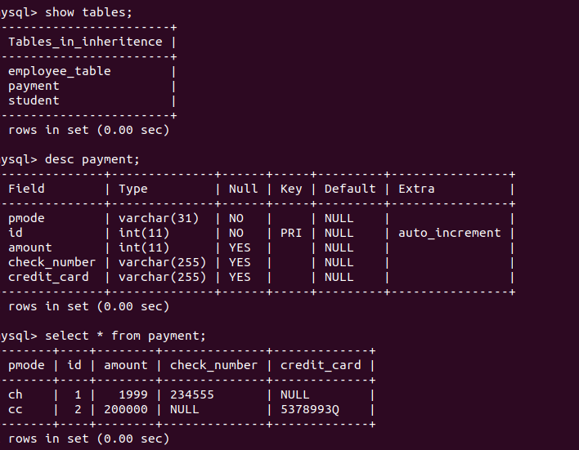
- Implement and demonstrate Joined strategy.
package com.jpa.demojpa.Entity;
import javax.persistence.*;
@Entity
@Inheritance(strategy = InheritanceType.JOINED)
//@DiscriminatorColumn(name = "pmode",discriminatorType = DiscriminatorType.STRING)
public abstract class Payment {
@Id
// @GeneratedValue(strategy = GenerationType.IDENTITY)
private int id;
private Integer amount;
public int getId() {
return id;
}
public void setId(int id) {
this.id = id;
}
public Integer getAmount() {
return amount;
}
public void setAmount(Integer amount) {
this.amount = amount;
}
}
package com.jpa.demojpa.Entity;
import javax.persistence.DiscriminatorValue;
import javax.persistence.Entity;
import javax.persistence.PrimaryKeyJoinColumn;
@Entity
@PrimaryKeyJoinColumn(name="id")
public class CreditCard extends Payment{
private String creditCard;
public String getCreditCard() {
return creditCard;
}
public void setCreditCard(String creditCard) {
this.creditCard = creditCard;
}
}
package com.jpa.demojpa.Entity;
import javax.persistence.DiscriminatorValue;
import javax.persistence.Entity;
import javax.persistence.PrimaryKeyJoinColumn;
@Entity
@PrimaryKeyJoinColumn(name="id")
public class CheckNumber extends Payment {
private String checkNumber;
public String getCheckNumber() {
return checkNumber;
}
public void setCheckNumber(String checkNumber) {
this.checkNumber = checkNumber;
}
}

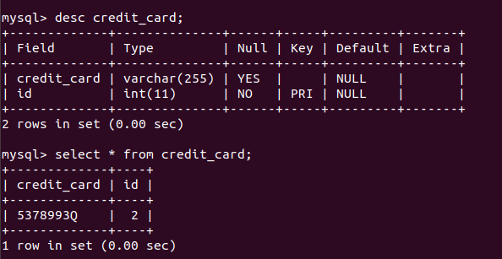

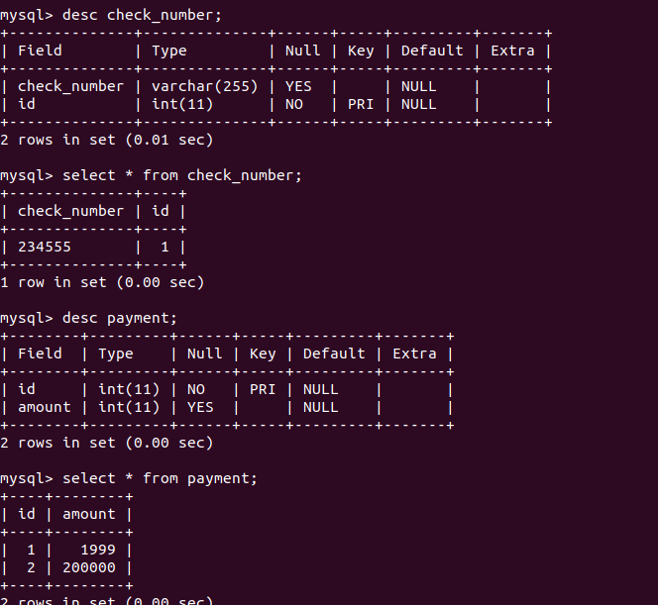

- Implement and demonstrate Table Per Class strategy.
package com.jpa.demojpa.Entity;
import javax.persistence.*;
@Entity
@Inheritance(strategy = InheritanceType.TABLE_PER_CLASS)
//@DiscriminatorColumn(name = "pmode",discriminatorType = DiscriminatorType.STRING)
public abstract class Payment {
@Id
// @GeneratedValue(strategy = GenerationType.IDENTITY)
private int id;
private Integer amount;
public int getId() {
return id;
}
public void setId(int id) {
this.id = id;
}
public Integer getAmount() {
return amount;
}
public void setAmount(Integer amount) {
this.amount = amount;
}
}
package com.jpa.demojpa.Entity;
import javax.persistence.DiscriminatorValue;
import javax.persistence.Entity;
@Entity
public class CreditCard extends Payment{
private String creditCard;
public String getCreditCard() {
return creditCard;
}
public void setCreditCard(String creditCard) {
this.creditCard = creditCard;
}
}
package com.jpa.demojpa.Entity;
import javax.persistence.DiscriminatorValue;
import javax.persistence.Entity;
@Entity
public class CheckNumber extends Payment {
private String checkNumber;
public String getCheckNumber() {
return checkNumber;
}
public void setCheckNumber(String checkNumber) {
this.checkNumber = checkNumber;
}
}
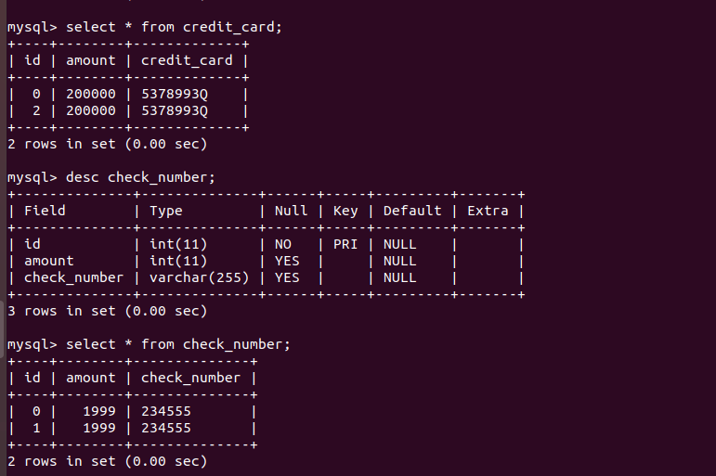

Component Mapping:
- Implement and demonstrate Embedded mapping using employee table having following fields: id, firstName, lastName, age, basicSalary, bonusSalary, taxAmount, specialAllowanceSalary.
package com.jpa.demojpa.Entity;
import javax.persistence.*;
@Entity
public class Employee {
@Id
@GeneratedValue(strategy = GenerationType.IDENTITY)
private Integer id;
private String firstName;
private String lastName;
private Integer age;
@Embedded
private Salary salary;
public Salary getSalary() {
return salary;
}
public void setSalary(Salary salary) {
this.salary = salary;
}
public Integer getId() {
return id;
}
public void setId(Integer id) {
this.id = id;
}
public String getFirstName() {
return firstName;
}
public void setFirstName(String firstName) {
this.firstName = firstName;
}
public String getLastName() {
return lastName;
}
public void setLastName(String lastName) {
this.lastName = lastName;
}
public Integer getAge() {
return age;
}
public void setAge(Integer age) {
this.age = age;
}
}
package com.jpa.demojpa.Entity;
import javax.persistence.Embeddable;
@Embeddable
public class Salary {
private Integer basicsalary;
private Integer bonussalary;
private Integer taxamount;
private Integer specialallowancesalary;
public Integer getBasicsalary() {
return basicsalary;
}
public void setBasicsalary(Integer basicsalary) {
this.basicsalary = basicsalary;
}
public Integer getBonussalary() {
return bonussalary;
}
public void setBonussalary(Integer bonussalary) {
this.bonussalary = bonussalary;
}
public Integer getTaxamount() {
return taxamount;
}
public void setTaxamount(Integer taxamount) {
this.taxamount = taxamount;
}
public Integer getSpecialallowancesalary() {
return specialallowancesalary;
}
public void setSpecialallowancesalary(Integer specialallowancesalary) {
this.specialallowancesalary = specialallowancesalary;
}
}
package com.jpa.demojpa;
import com.jpa.demojpa.Entity.*;
import com.jpa.demojpa.Repository.EmployeeRepository;
import com.jpa.demojpa.Repository.PaymentRepository;
import com.jpa.demojpa.Repository.StudentRepository;
import org.junit.jupiter.api.Test;
import org.springframework.beans.factory.annotation.Autowired;
import org.springframework.boot.test.context.SpringBootTest;
import org.springframework.data.domain.PageRequest;
import org.springframework.data.domain.Sort;
import java.util.List;
@SpringBootTest
class DemojpaApplicationTests {
@Autowired
StudentRepository studentRepository;
@Autowired
PaymentRepository paymentRepository;
@Autowired
EmployeeRepository employeeRepository;
@Test
void contextLoads() {
}
@Test
void testCreateEmployee(){
Employee employee=new Employee();
employee.setFirstName("Akshita");
employee.setLastName("Tandon");
employee.setAge(23);
Salary salary=new Salary();
salary.setBasicsalary(15000);
salary.setBonussalary(3000);
salary.setTaxamount(1000);
salary.setSpecialallowancesalary(800);
employee.setSalary(salary);
employeeRepository.save(employee);
Employee employee1=new Employee();
employee1.setFirstName("Drishti");
employee1.setLastName("Talwar");
employee1.setAge(23);
Salary salary1=new Salary();
salary1.setBasicsalary(15000);
salary1.setBonussalary(3000);
salary1.setTaxamount(1000);
salary1.setSpecialallowancesalary(800);
employee1.setSalary(salary1);
employeeRepository.save(employee1);
}

