Q1.Create a simple REST fulservice in Spring Boot which returns the Response "Welcome to spring boot".
WelcomeController
package com.springboot.SpringBootDemo.Controllers;
import org.springframework.web.bind.annotation.GetMapping;
import org.springframework.web.bind.annotation.RestController;
@RestController
public class EmployeesController {
@GetMapping("/welcome")
public String welcome(){
return "Welcome to Spring Boot";
}
}

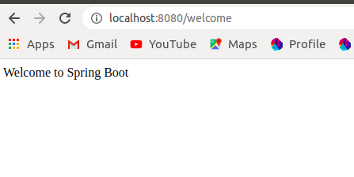

Q2.Create an Employee Bean(id, name, age) and service to perform different operations related to employee.
package com.springboot.SpringBootDemo.Model;
public class Employees {
private Integer employeeId;
private String employeeName;
private Integer employeeAge;
public Integer getEmployeeId() {
return employeeId;
}
public void setEmployeeId(Integer employeeId) {
this.employeeId = employeeId;
}
public String getEmployeeName() {
return employeeName;
}
public void setEmployeeName(String employeeName) {
this.employeeName = employeeName;
}
public Integer getEmployeeAge() {
return employeeAge;
}
public void setEmployeeAge(Integer employeeAge) {
this.employeeAge = employeeAge;
}
public Employees(Integer employeeId, String employeeName, Integer employeeAge) {
this.employeeId = employeeId;
this.employeeName = employeeName;
this.employeeAge = employeeAge;
}
@Override
public String toString() {
return "Employees{" +
"employeeId=" + employeeId +
", employeeName='" + employeeName + '\'' +
", employeeAge=" + employeeAge +
'}';
}
}

package com.springboot.SpringBootDemo.Service;
import com.springboot.SpringBootDemo.Model.Employees;
import org.springframework.beans.factory.annotation.Autowired;
import org.springframework.stereotype.Component;
import java.util.ArrayList;
import java.util.List;
@Component
public class EmployeesService {
private static List<Employees> employees=new ArrayList<>();
public List<Employees> findAll(){
return employees;
}
public Employees addEmployee(Employees employee){
employees.add(employee);
return employee;
}
public Employees findOne(Integer id){
for(Employees employees:employees)
{
if (employees.getEmployeeId() == id) {
return employees;
}
}
return null;
}
}

Q3.Implement GET http request for Employee to get list of employees.
Q4.Implement GEThttp request using path variable top get one employee
Q5.Implement POST http request for Employee to create a new employee.

package com.springboot.SpringBootDemo.Controllers;
import com.springboot.SpringBootDemo.Model.Employees;
import com.springboot.SpringBootDemo.Service.EmployeesService;
import org.springframework.beans.factory.annotation.Autowired;
import org.springframework.http.ResponseEntity;
import org.springframework.web.bind.annotation.*;
import org.springframework.web.servlet.support.ServletUriComponentsBuilder;
import java.net.URI;
import java.util.List;
@RestController
public class EmployeesController {
@Autowired
private EmployeesService employeesService;
@GetMapping("/welcome")
public String welcome(){
return "Welcome to Spring Boot";
}
@GetMapping("/employees")
public List<Employees> retrieveAllEmployees(){
return employeesService.findAll();
}
@GetMapping("/employees/{id}")
public Employees retrieveOneEmployee(@PathVariable Integer id){
return employeesService.findOne(id);
}
@PostMapping("/employees")
public ResponseEntity<Object> createEmployees(@RequestBody Employees emp){
Employees addedEmployee = employeesService.addEmployee(emp);
//response sent to client
URI location = ServletUriComponentsBuilder.
fromCurrentRequest().
path("/{id}").
buildAndExpand(addedEmployee.getEmployeeId())
.toUri();
return ResponseEntity.created(location).build();
}
}

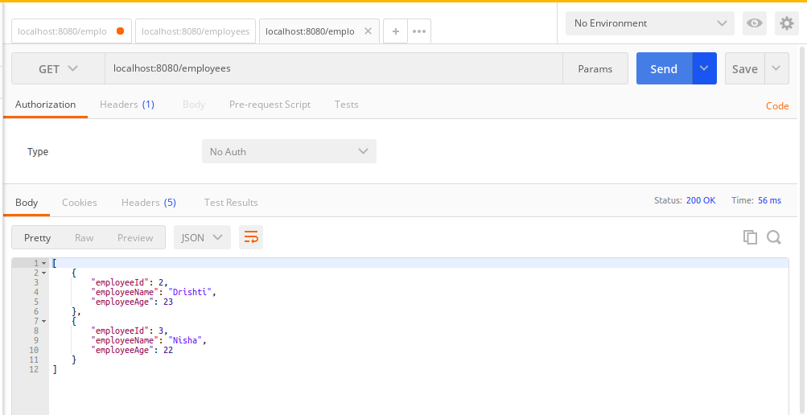

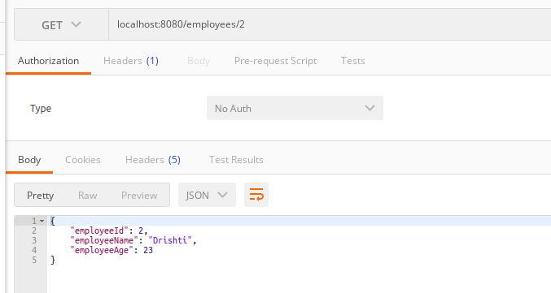

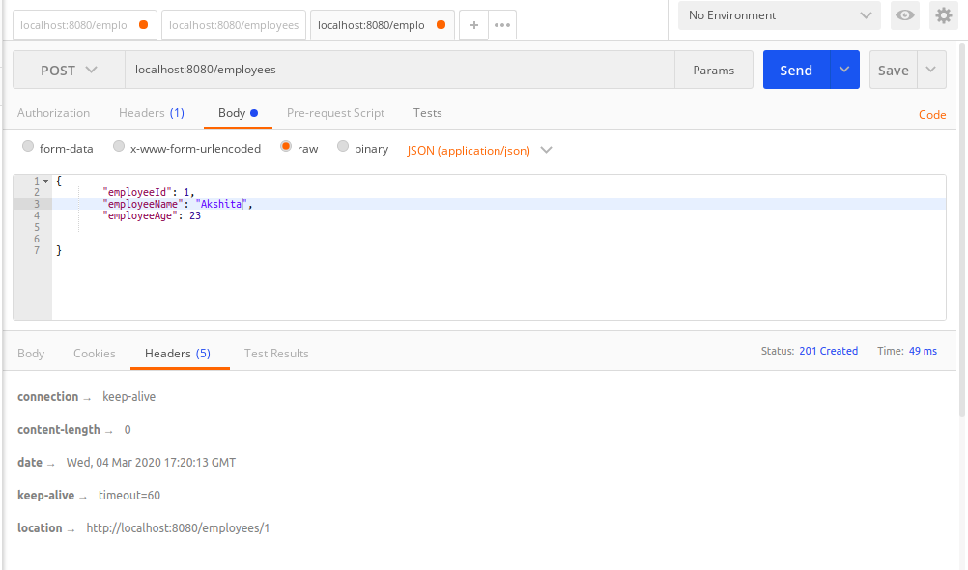

Q6.Implement Exception Handling for resource not found
package com.springboot.SpringBootDemo.Controllers;
import com.springboot.SpringBootDemo.EmployeeNotFoundException;
import com.springboot.SpringBootDemo.Model.Employees;
import com.springboot.SpringBootDemo.Service.EmployeesService;
import org.springframework.beans.factory.annotation.Autowired;
import org.springframework.http.ResponseEntity;
import org.springframework.web.bind.annotation.*;
import org.springframework.web.servlet.support.ServletUriComponentsBuilder;
import java.net.URI;
import java.util.List;
@RestController
public class EmployeesController {
@Autowired
private EmployeesService employeesService;
@GetMapping("/welcome")
public String welcome(){
return "Welcome to Spring Boot";
}
@GetMapping("/employees")
public List<Employees> retrieveAllEmployees(){
return employeesService.findAll();
}
@GetMapping("/employees/{id}")
public Employees retrieveOneEmployee(@PathVariable Integer id){
Employees empFound = employeesService.findOne(id);
if(empFound==null)
throw new EmployeeNotFoundException("id " + id);
return empFound;
}
@PostMapping("/employees")
public ResponseEntity<Object> createEmployees(@RequestBody Employees emp){
Employees addedEmployee = employeesService.addEmployee(emp);
//response sent to client
URI location = ServletUriComponentsBuilder.
fromCurrentRequest().
path("/{id}").
buildAndExpand(addedEmployee.getEmployeeId())
.toUri();
return ResponseEntity.created(location).build();
}
}
Exception handler
package com.springboot.SpringBootDemo;
import org.springframework.http.HttpStatus;
import org.springframework.web.bind.annotation.ResponseStatus;
@ResponseStatus(HttpStatus.NOT_FOUND)
public class EmployeeNotFoundException extends RuntimeException {
public EmployeeNotFoundException(String message) {
super(message);
}
}

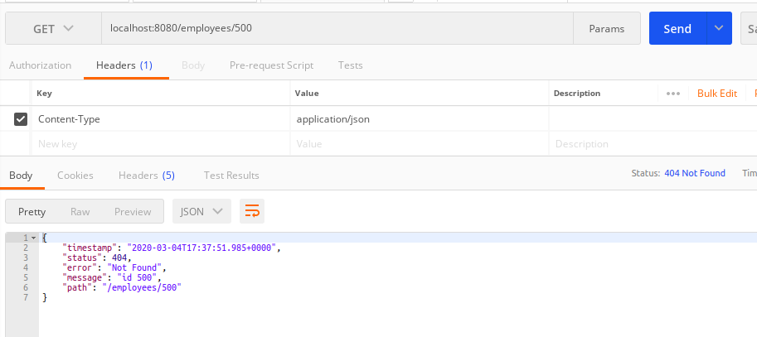

Q7.Implement DELETE http request for Employee to delete employee

package com.springboot.SpringBootDemo.Controllers;
import com.springboot.SpringBootDemo.EmployeeNotFoundException;
import com.springboot.SpringBootDemo.Model.Employees;
import com.springboot.SpringBootDemo.Service.EmployeesService;
import org.springframework.beans.factory.annotation.Autowired;
import org.springframework.http.ResponseEntity;
import org.springframework.web.bind.annotation.*;
import org.springframework.web.servlet.support.ServletUriComponentsBuilder;
import java.net.URI;
import java.util.List;
@RestController
public class EmployeesController {
@Autowired
private EmployeesService employeesService;
@GetMapping("/welcome")
public String welcome(){
return "Welcome to Spring Boot";
}
@GetMapping("/employees")
public List<Employees> retrieveAllEmployees(){
return employeesService.findAll();
}
@GetMapping("/employees/{id}")
public Employees retrieveOneEmployee(@PathVariable Integer id){
Employees empFound = employeesService.findOne(id);
if(empFound==null)
throw new EmployeeNotFoundException("id " + id);
return empFound;
}
@PostMapping("/employees")
public ResponseEntity<Object> createEmployees(@RequestBody Employees emp){
Employees addedEmployee = employeesService.addEmployee(emp);
//response sent to client
URI location = ServletUriComponentsBuilder.
fromCurrentRequest().
path("/{id}").
buildAndExpand(addedEmployee.getEmployeeId())
.toUri();
return ResponseEntity.created(location).build();
}
@DeleteMapping("/employees/{id}")
public void deleteEmployee(@PathVariable Integer id){
Employees empFound = employeesService.deleteById(id);
if(empFound==null)
throw new EmployeeNotFoundException("id " + id);
}
}

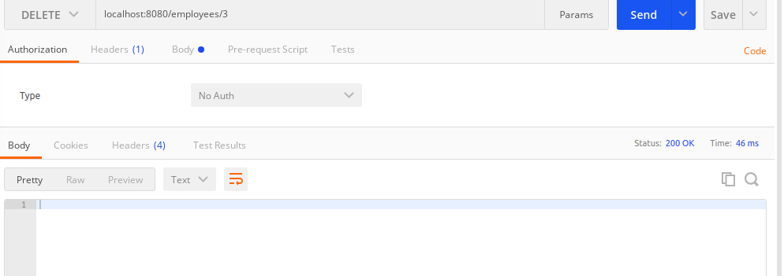
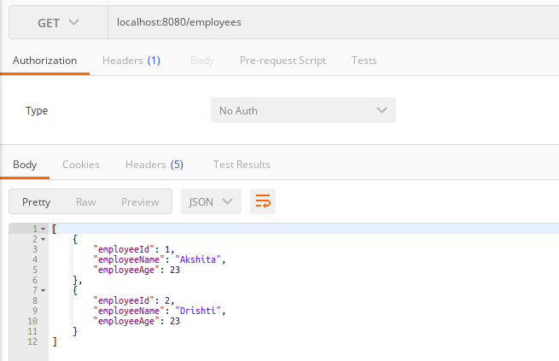

Q8.Implement PUThttp request for Employee to update employee
package com.springboot.SpringBootDemo.Controllers;
import com.springboot.SpringBootDemo.EmployeeNotFoundException;
import com.springboot.SpringBootDemo.Model.Employees;
import com.springboot.SpringBootDemo.Service.EmployeesService;
import org.springframework.beans.factory.annotation.Autowired;
import org.springframework.http.ResponseEntity;
import org.springframework.web.bind.annotation.*;
import org.springframework.web.servlet.support.ServletUriComponentsBuilder;
import java.net.URI;
import java.util.List;
@RestController
public class EmployeesController {
@Autowired
private EmployeesService employeesService;
@GetMapping("/welcome")
public String welcome(){
return "Welcome to Spring Boot";
}
@GetMapping("/employees")
public List<Employees> retrieveAllEmployees(){
return employeesService.findAll();
}
@GetMapping("/employees/{id}")
public Employees retrieveOneEmployee(@PathVariable Integer id){
Employees empFound = employeesService.findOne(id);
if(empFound==null)
throw new EmployeeNotFoundException("id " + id);
return empFound;
}
@PostMapping("/employees")
public ResponseEntity<Object> createEmployees(@RequestBody Employees emp){
Employees addedEmployee = employeesService.addEmployee(emp);
//response sent to client
URI location = ServletUriComponentsBuilder.
fromCurrentRequest().
path("/{id}").
buildAndExpand(addedEmployee.getEmployeeId())
.toUri();
return ResponseEntity.created(location).build();
}
@DeleteMapping("/employees/{id}")
public void deleteEmployee(@PathVariable Integer id){
Employees empFound = employeesService.deleteById(id);
if(empFound==null)
throw new EmployeeNotFoundException("id " + id);
}
@PutMapping("/employees/{id}")
public void updateEmployee(@RequestBody Employees changedEmp, @PathVariable Integer id){
Employees newChange=employeesService.findOne(id);
newChange.setEmployeeAge(changedEmp.getEmployeeAge());
newChange.setEmployeeId(changedEmp.getEmployeeId());
newChange.setEmployeeName(changedEmp.getEmployeeName());
}
}

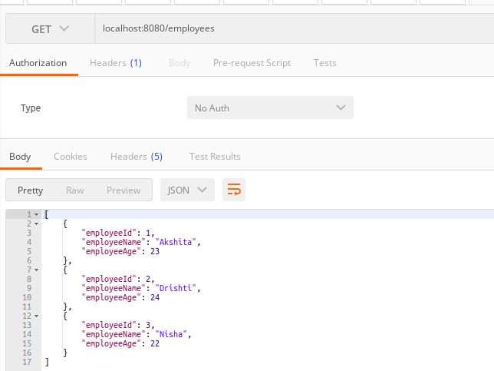
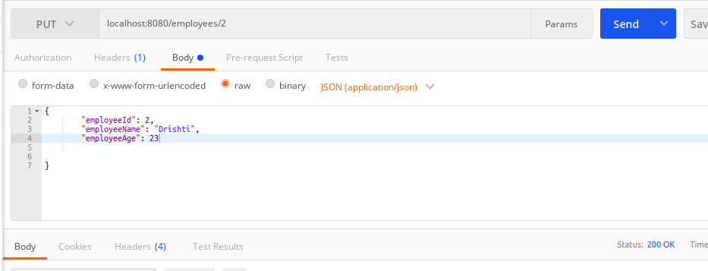
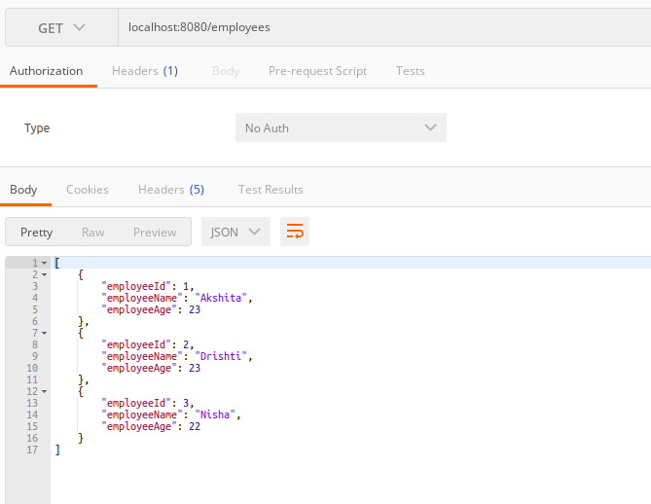

Q9.Apply validation while create a new employee using POST http Request.
Employee.java
package com.springboot.SpringBootDemo.Model;
//import net.minidev.json.annotate.JsonIgnore;
import javax.validation.constraints.Min;
import javax.validation.constraints.NotBlank;
import javax.validation.constraints.NotNull;
import javax.validation.constraints.Size;
public class Employees {
private Integer employeeId;
@NotBlank(message = "name should not be blank")
@Size(min=2,message = "Name should be greater than 2 characters")
private String employeeName;
//@JsonIgnore
@NotNull
@Min(18)
private Integer employeeAge;
public Integer getEmployeeId() {
return employeeId;
}
public void setEmployeeId(Integer employeeId) {
this.employeeId = employeeId;
}
public String getEmployeeName() {
return employeeName;
}
public void setEmployeeName(String employeeName) {
this.employeeName = employeeName;
}
public Integer getEmployeeAge() {
return employeeAge;
}
public void setEmployeeAge(Integer employeeAge) {
this.employeeAge = employeeAge;
}
public Employees(Integer employeeId, String employeeName, Integer employeeAge) {
this.employeeId = employeeId;
this.employeeName = employeeName;
this.employeeAge = employeeAge;
}
@Override
public String toString() {
return "Employees{" +
"employeeId=" + employeeId +
", employeeName='" + employeeName + '\'' +
", employeeAge=" + employeeAge +
'}';
}
}

EmployeeController.java
package com.springboot.SpringBootDemo.Controllers;
//import static org.springframework.hateoas.server.mvc.WebMvcLinkBuilder.*;
import com.springboot.SpringBootDemo.EmployeeNotFoundException;
import com.springboot.SpringBootDemo.Model.Employees;
import com.springboot.SpringBootDemo.Service.EmployeesService;
import org.springframework.beans.factory.annotation.Autowired;
//import org.springframework.hateoas.EntityModel;
//import org.springframework.hateoas.server.mvc.WebMvcLinkBuilder;
import org.springframework.http.ResponseEntity;
import org.springframework.web.bind.annotation.*;
import org.springframework.web.servlet.support.ServletUriComponentsBuilder;
import javax.validation.Valid;
import java.net.URI;
import java.util.List;
@RestController
public class EmployeesController {
@Autowired
private EmployeesService employeesService;
@GetMapping("/welcome")
public String welcome(){
return "Welcome to Spring Boot";
}
@GetMapping("/employees")
public List<Employees> retrieveAllEmployees()
{
return employeesService.findAll();
}
@GetMapping("/employees/{id}")
public Employees retrieveOneEmployee(@PathVariable Integer id){
Employees empFound = employeesService.findOne(id);
if(empFound==null)
throw new EmployeeNotFoundException("id " + id);
/*EntityModel<Employees> model= new EntityModel<>(empFound);
WebMvcLinkBuilder linkTo = linkTo(methodOn(this.getClass()).retrieveAllEmployees());
model.add(linkTo.withRel("all-employees"));
return model;*/
return empFound;
}
@PostMapping("/employees")
public ResponseEntity<Object> createEmployees(@Valid @RequestBody Employees emp){
Employees addedEmployee = employeesService.addEmployee(emp);
//response sent to client
URI location = ServletUriComponentsBuilder.
fromCurrentRequest().
path("/{id}").
buildAndExpand(addedEmployee.getEmployeeId())
.toUri();
return ResponseEntity.created(location).build();
}
@DeleteMapping("/employees/{id}")
public void deleteEmployee(@PathVariable Integer id){
Employees empFound = employeesService.deleteById(id);
if(empFound==null)
throw new EmployeeNotFoundException("id " + id);
}
@PutMapping("/employees/{id}")
public void updateEmployee(@RequestBody Employees changedEmp, @PathVariable Integer id){
Employees newChange=employeesService.findOne(id);
employeesService.updateEmployee(newChange,changedEmp);
}
}

CustomizedResponseExceptionHandler.java
package com.springboot.SpringBootDemo;
import org.springframework.http.HttpHeaders;
import org.springframework.http.HttpStatus;
import org.springframework.http.ResponseEntity;
import org.springframework.web.bind.MethodArgumentNotValidException;
import org.springframework.web.bind.annotation.ControllerAdvice;
import org.springframework.web.bind.annotation.ExceptionHandler;
import org.springframework.web.bind.annotation.RestController;
import org.springframework.web.context.request.WebRequest;
import org.springframework.web.servlet.mvc.method.annotation.ResponseEntityExceptionHandler;
import java.util.Date;
@RestController
@ControllerAdvice
public class CustomizedResponseExceptionHandler extends ResponseEntityExceptionHandler {
@ExceptionHandler(Exception.class)
public final ResponseEntity<Object> handleAllException(Exception ex, WebRequest request){
ExceptionResponse exceptionResponse=new ExceptionResponse(new Date(),ex.getMessage(),request.getDescription(false));
return new ResponseEntity(exceptionResponse, HttpStatus.INTERNAL_SERVER_ERROR);
}
@ExceptionHandler(EmployeeNotFoundException.class)
public final ResponseEntity<Object> handleEmployeeException(EmployeeNotFoundException ex, WebRequest request){
ExceptionResponse exceptionResponse=new ExceptionResponse(new Date(),ex.getMessage(),request.getDescription(false));
return new ResponseEntity(exceptionResponse, HttpStatus.NOT_FOUND);
}
@Override
protected ResponseEntity<Object> handleMethodArgumentNotValid(
MethodArgumentNotValidException ex, HttpHeaders headers, HttpStatus status, WebRequest request) {
ExceptionResponse exceptionResponse=new ExceptionResponse(new Date(),ex.getMessage(),ex.getBindingResult().toString());
return new ResponseEntity(exceptionResponse,HttpStatus.BAD_REQUEST);
}
}

Configure actuator in your project to check the health of application and get the information about various beans configured in your application
health of application
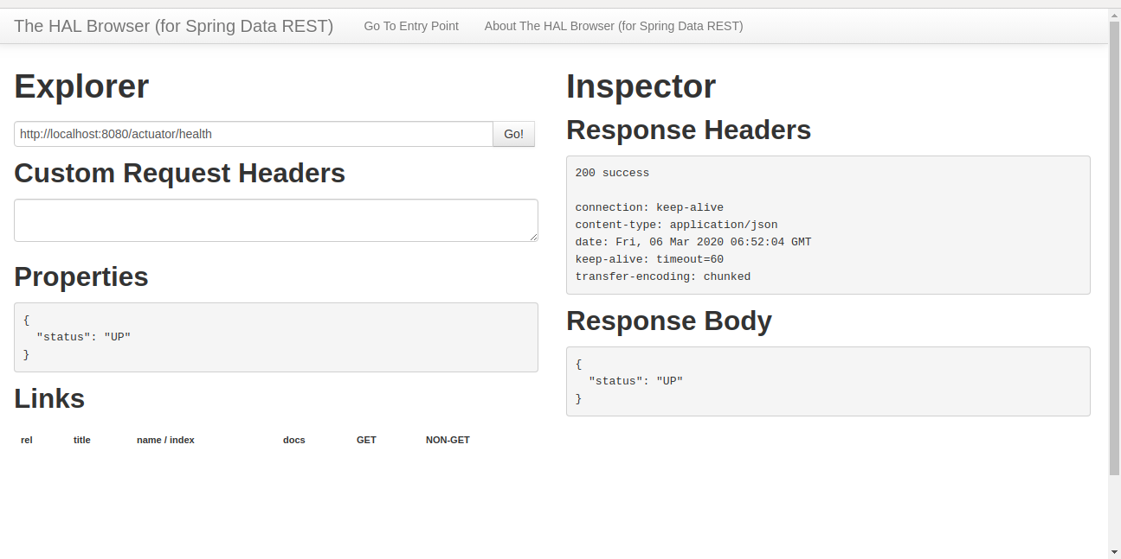

Beans

