(1) Write a program to demonstrate Tightly Coupled code.
//In this code if you want to add a new Worker,you need to make changes in the manager class. It’s constructor and manageWork and in main while creating a new object.
package com.bootcamp.spring.springFramework;
public class TightCoupling {
public static void main(String[] args) {
new Manager(new LazyWorker(),new ExcellentWorker(),new ExtraordinaryWorker()).manageWork();
}
}
class Manager{
private LazyWorker lazyWorker;
private ExcellentWorker excellentWorker;
private ExtraordinaryWorker extraordinaryworker;
public Manager(LazyWorker lazyWorker, ExcellentWorker excellentWorker, ExtraordinaryWorker extraordinaryworker) {
this.lazyWorker = lazyWorker;
this.excellentWorker = excellentWorker;
this.extraordinaryworker = extraordinaryworker;
}
public void manageWork(){
lazyWorker.doWork();
excellentWorker.doWork();
extraordinaryworker.doWork();
}
}
class LazyWorker{
public void doWork(){
System.out.println("Lazy worker is doing work");
}
}
class ExcellentWorker{
public void doWork(){
System.out.println("Excellent worker is doing work");
}
}
class ExtraordinaryWorker{
public void doWork(){
System.out.println("Extraordinary worker is doing work");
}
}
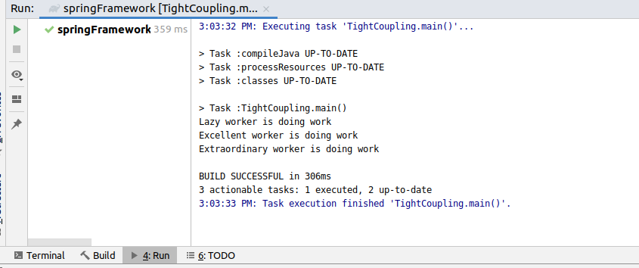

(2) Write a program to demonstrate Loosely Coupled code.
//In this code, when we create a new class ,we dont have to make changes in the manager class, we just have to create a new class and in main we have to create a new object.
package com.bootcamp.spring.springFramework;
public class LooseCoupling {
public static void main(String[] args) {
new Managers(new LazyWorkers()).manageWorks();
new Managers(new Excellentworkers()).manageWorks();
new Managers(new ExtraordinaryWorkers()).manageWorks();
}
}
interface Worker{
public void dowork();
}
class Managers{
private Worker worker;
public Managers(Worker worker) {
this.worker = worker;
}
public void manageWorks(){
worker.dowork();
}
}
class LazyWorkers implements Worker{
@Override
public void dowork() {
System.out.println("lazy Worker is working");
}
}
class Excellentworkers implements Worker{
@Override
public void dowork() {
System.out.println("Excellent Worker is working");
}
}
class ExtraordinaryWorkers implements Worker{
@Override
public void dowork() {
System.out.println("Extraordinary Worker is working");
}
}
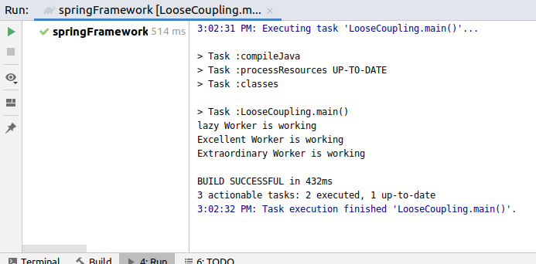

(3) Use @Compenent and @Autowired annotations to in Loosely Coupled code for dependency management
Manager class
package com.bootcamp.spring.springFramework.beans;
import org.springframework.beans.factory.annotation.Autowired;
import org.springframework.stereotype.Component;
@Component
public class Manager {
@Autowired
private Worker worker;
public Manager(Worker worker) {
this.worker = worker;
}
public void manageWork(){
worker.doWork();
}
}
LazyWorker class
package com.bootcamp.spring.springFramework.beans;
import org.springframework.context.annotation.Primary;
import org.springframework.stereotype.Component;
@Component
public class LazyWorker implements Worker{
@Override
public void doWork() {
System.out.println("Lazy worker is working");
}
}
SpringFrameworkApplication class
package com.bootcamp.spring.springFramework;
import com.bootcamp.spring.springFramework.beans.Manager;
import org.springframework.boot.SpringApplication;
import org.springframework.boot.autoconfigure.SpringBootApplication;
import org.springframework.context.ApplicationContext;
@SpringBootApplication
public class SpringFrameworkApplication {
public static void main(String[] args) {
ApplicationContext applicationContext=SpringApplication.run(SpringFrameworkApplication.class, args);
Manager mn=applicationContext.getBean(Manager.class);
mn.manageWork();
}
}
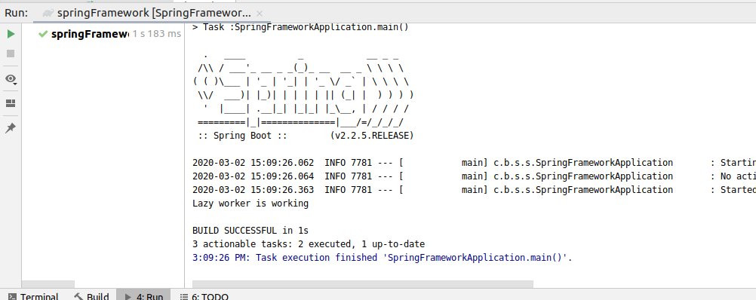
(4) Get a Spring Bean from application context and display its properties.
Manager class
package com.bootcamp.spring.springFramework.beans;
import org.springframework.beans.factory.annotation.Autowired;
import org.springframework.stereotype.Component;
@Component
public class Manager {
@Autowired
private Worker worker;
public Manager(Worker worker) {
this.worker = worker;
}
public void manageWork(){
worker.doWork();
}
}
Worker Interface
package com.bootcamp.spring.springFramework.beans;
public interface Worker {
public void doWork();
}
LazyWorker class
package com.bootcamp.spring.springFramework.beans;
import org.springframework.context.annotation.Primary;
import org.springframework.stereotype.Component;
@Component
public class LazyWorker implements Worker{
@Override
public void doWork() {
System.out.println("Lazy worker is working");
}
}

SpringFrameworkApplication class
package com.bootcamp.spring.springFramework;
import com.bootcamp.spring.springFramework.beans.Manager;
import org.springframework.boot.SpringApplication;
import org.springframework.boot.autoconfigure.SpringBootApplication;
import org.springframework.context.ApplicationContext;
@SpringBootApplication
public class SpringFrameworkApplication {
public static void main(String[] args) {
ApplicationContext applicationContext=SpringApplication.run(SpringFrameworkApplication.class, args);
for(String name:applicationContext.getBeanDefinitionNames())
{
System.out.println(name);
}
Manager mn=applicationContext.getBean(Manager.class);
mn.manageWork();
}
}

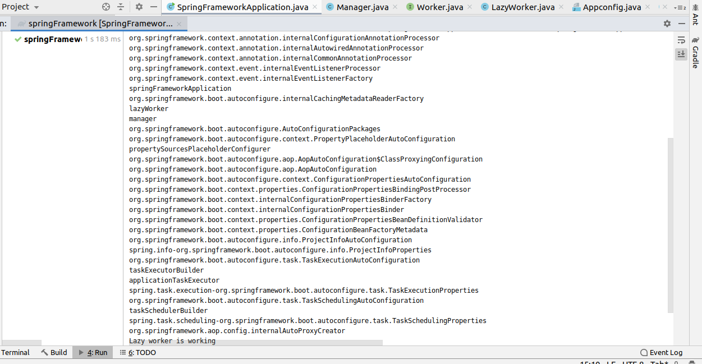
(5) Demonstrate how you will resolve ambiguity while autowiring bean (Hint : @Primary)
ExcellentWorker class
package com.bootcamp.spring.springFramework.beans;
import org.springframework.context.annotation.Primary;
import org.springframework.stereotype.Component;
@Component
@Primary
public class ExcellentWorker implements Worker {
@Override
public void doWork() {
System.out.println("Excellent worker is working");
}
}
Manager class
package com.bootcamp.spring.springFramework.beans;
import org.springframework.beans.factory.annotation.Autowired;
import org.springframework.stereotype.Component;
@Component
public class Manager {
@Autowired
private Worker worker;
public Manager(Worker worker) {
this.worker = worker;
}
public void manageWork(){
worker.doWork();
}
}
Worker Interface
package com.bootcamp.spring.springFramework.beans;
public interface Worker {
public void doWork();
}

LazyWorker class
package com.bootcamp.spring.springFramework.beans;
import org.springframework.context.annotation.Primary;
import org.springframework.stereotype.Component;
@Component
public class LazyWorker implements Worker{
@Override
public void doWork() {
System.out.println("Lazy worker is working");
}
}

SpringFrameworkApplication class
package com.bootcamp.spring.springFramework;
import com.bootcamp.spring.springFramework.beans.Manager;
import org.springframework.boot.SpringApplication;
import org.springframework.boot.autoconfigure.SpringBootApplication;
import org.springframework.context.ApplicationContext;
@SpringBootApplication
public class SpringFrameworkApplication {
public static void main(String[] args) {
ApplicationContext applicationContext=SpringApplication.run(SpringFrameworkApplication.class, args);
for(String name:applicationContext.getBeanDefinitionNames())
{
System.out.println(name);
}
Manager mn=applicationContext.getBean(Manager.class);
mn.manageWork();
}
}
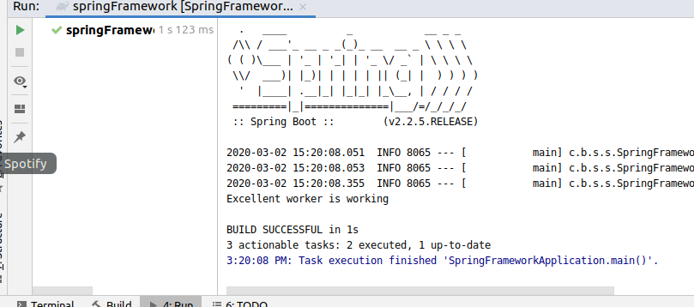
(6) Perform Constructor Injection in a Spring Bean
DemoApplication.java
package com.bootcamp.spring.springFramework.constructorinjection;
import org.springframework.boot.SpringApplication;
import org.springframework.boot.autoconfigure.SpringBootApplication;
import org.springframework.boot.web.servlet.server.Session;
import org.springframework.context.ApplicationContext;
@SpringBootApplication
public class DemoApplication {
public static void main(String[] args) {
ApplicationContext applicationContext=SpringApplication.run(DemoApplication.class, args);
DemoService demoService=(DemoService) applicationContext.getBean("demoService");
demoService.createDemo();
SessionService sessionService=(SessionService) applicationContext.getBean("sessionService");
sessionService.createSession();
}
}
DemoConfig.java
package com.bootcamp.spring.springFramework.constructorinjection;
import org.springframework.context.annotation.Bean;
import org.springframework.context.annotation.Configuration;
@Configuration
public class DemoConfig {
@Bean
DemoService demoService() {
return new DemoService();
}
}

DemoService.java
package com.bootcamp.spring.springFramework.constructorinjection;
public class DemoService {
public void createDemo(){
System.out.println("Demo Created...");
}
}
SessionService.java
package com.bootcamp.spring.springFramework.constructorinjection;
import org.springframework.beans.factory.annotation.Autowired;
import org.springframework.stereotype.Component;
@Component
public class SessionService {
@Autowired
DemoService demoService;
public void createSession(){
System.out.println("Session created");
demoService.createDemo();
}
}

